State of OT Vulnerability Exposure in US Oil and Natural Gas, 2026
Annual report, 2026 edition. Covers CISA ICS advisories published 1 Jan - 10 Sep 2026, with a 2012-2025 baseline.
Friday Ogochukwu Ikwuogu (corresponding author)
Independent Researcher, Odessa, Texas, USA · ORCID 0009-0009-2222-1318 · Friday.ikwuogu@gmail.com
Abidemi Orimogunje
Electrical and Electronic Engineering Department, Redeemer's University, Ede, Osun State, Nigeria · orimogunjea@run.edu.ng
Eria Othieno Pinyi
Computer Science and Engineering Department, University of Fairfax, USA · eriaothienopinyi@gmail.com
David Mike-Ewewie
Computer Science Department, University of Texas Permian Basin, Odessa, Texas, USA · mike_d63291@utpb.edu

Version 1.0.0 · Release date 2026-09-26 · DOI https://doi.org/10.5281/zenodo.22974795
Input snapshot ONG-OT Vulnerability Prioritization Dataset v1.1, doi:10.5281/zenodo.22729882; KEV, EPSS and CISA SSVC values as of 2026-09-12; last advisory in the snapshot published 2026-09-10.
Series First edition of an annual series. The 2027 edition is scheduled for December 2027 and will be built by re-running this repository against a new frozen snapshot.
License Report text and figures: CC BY 4.0. Code: MIT. Derived tables: ODbL v1.0 (inherited from the ICS Advisory Project).
Suggested citation Ikwuogu, F. O., Orimogunje, A., Pinyi, E. O., Mike-Ewewie, D. (2026). State of OT Vulnerability Exposure in US Oil and Natural Gas, 2026. Annual report, 2026 edition, v1.0.0. Zenodo. https://doi.org/10.5281/zenodo.22974795

Key findings
All comparisons use the same calendar window (1 Jan - 10 Sep) in each year, so 2026 is compared like-for-like with 2025. "ONG-relevant" is defined in Section 2.3.
- Advisory volume reached a series high. CISA published 155 ONG-relevant ICS advisories in 1 Jan - 10 Sep 2026, +12.3% on the same window of 2025 (138) and the highest of the 15 years in the series. 2025 as a whole produced 186.
- The CVE count doubled, but almost entirely through roll-ups. Unique CVEs rose from 568 to 1,143 (+101.2%). Set aside the 5 advisories that each list more than 50 CVEs, typically bundled third-party components in one firmware image, and growth falls to +4.9% (387 to 406).
- The vendor base widened sharply. 49 vendors appeared, against 31 in the same window of 2025 (+58.1%). Concentration roughly halved (Herfindahl-Hirschman index 1,857 to 922), although the top five vendors still account for 60.6% of advisories, led by Siemens (20.0%).
- Exploitation evidence remains concentrated in a small set. 7 CVEs (0.6%) are in CISA's Known Exploited Vulnerabilities catalog, the same count as in 2025. Including CISA SSVC exploitation flags and the top 5% of EPSS, 74 CVEs (6.5%) carry some exploitation evidence, against 12.1% in 2025.
- Known-exploited exposure is inherited, not native. All 7 KEV-listed CVEs are attributed to third-party software embedded in OT products (operating-system kernel, database, browser engine, SSH stack, web runtime, firewall OS), and 0 to vendor-native OT firmware.
- Missing authentication is the leading weakness. CWE-306 (missing authentication for a critical function) appears in 20 advisories (12.9%), up from a 4.8% share across 2012-2025, and ranks first in 2026.
- The patch signal is thin. A vendor remediation statement is machine-readable in the CVE record for only 12.4% of in-scope 2026 CVEs, so "no patch available" cannot be measured reliably from public data; 3 CVEs carry an explicit no-fix statement.

1. Purpose and scope of the series
Operational technology (OT) in the US oil and natural gas (ONG) sector, including controllers, remote terminal units, SCADA servers, flow computers and the engineering software around them, is disclosed through a public vulnerability pipeline: vendor and researcher reports, coordinated by CISA and published as ICS advisories, then enriched by CISA's Known Exploited Vulnerabilities (KEV) catalog, CISA's Vulnrichment decision points and FIRST's Exploit Prediction Scoring System (EPSS). Operators, regulators and researchers each read this pipeline, but the sector has no fixed, reproducible yardstick for how much exposure it discloses in a year, where that exposure concentrates, or how much of it is actually exploited.
This report provides that yardstick. It is designed as an annual series. The measurement definitions (scope, windows, tiers) are fixed in one configuration file and the whole report is regenerated from a frozen, DOI-registered input snapshot, so each edition can be compared with the last and any reader can reproduce every number. First edition of an annual series. The 2027 edition is scheduled for December 2027 and will be built by re-running this repository against a new frozen snapshot.
The report measures disclosed exposure, meaning what the public advisory record says about products used in ONG operations. It does not measure the installed base, how many of these products any operator runs, or whether a given site is patched. Section 5 sets out what that distinction means for interpretation.

2. Data and methods

2.1 Input snapshot
The single input is the ONG-OT Vulnerability Prioritization Dataset v1.1 (doi:10.5281/zenodo.22729882), a published join of (i) CISA ICS advisories as mirrored by the ICS Advisory Project (ODbL v1.0); (ii) the CISA KEV catalog; (iii) FIRST EPSS scores; (iv) CISA Vulnrichment CVE records, including CNA solution and workaround text and CISA's SSVC decision points; and (v) MITRE ATT&CK for ICS group and software profiles. All sources were pulled on 2026-09-12. The file was ingested unchanged and its SHA-256 is recorded in data/raw/PROVENANCE.txt.

2.2 De-duplication
The published v1.1 file contains 27,944 rows, but its ingestion step read both the ICS Advisory Project's master file (13,972 rows) and its per-year files (13,972 rows). The master file is a superset of the per-year files, so every CVE-advisory pair appears twice. This report keeps only master-file rows and drops 181 further repeated pairs within that file, leaving 13,791 unique CVE-advisory pairs across 3,976 advisories. The QA report confirms that no pair is lost. Counts published with v1.1 itself should be read as roughly double the unique totals. A corrected dataset release is listed in the series' next steps.

2.3 Scope: what counts as ONG-relevant and US-relevant
An advisory is ONG-relevant if CISA tags it with the Energy sector (the sector that contains oil and natural gas) or "oil and gas", or if the v1.1 product taxonomy maps any of its products to an ONG process-control class (ONG-specific product lines such as flow computers and tank gauging; PLC, RTU and SCADA platforms common in production, pipelines and refining). It is US-relevant if CISA's distribution field includes the United States, worldwide or an unspecified multi-country footprint. EV-charging platforms and chargers, which CISA also tags as Energy but which are not ONG operational technology, are excluded.
Applied to all 3,976 advisories, the sector test admits 1,566, the product-class test 449 (216 pass both), 121 are removed for non-US distribution and 16 for EV charging (13 of them in 2026). This leaves 1,662 ONG-relevant advisories. In 1 Jan - 10 Sep 2026 they are 41.4% of all 374 CISA ICS advisories. Every threshold and pattern is set in config/scope.json.

2.4 Windows and units
The snapshot's last advisory was published on 2026-09-10, so the 2026 edition covers 1 Jan - 10 Sep 2026, and every other year is measured over the same window. Full-year figures are shown only for 2012-2025. Two units are used. Advisory-level measures (CISA severity, advisory CVSS, CWE) count each advisory once, because CISA publishes severity and weakness classes per advisory rather than per CVE. CVE-level measures (KEV, EPSS, SSVC, remediation text, priority tier) count each unique CVE once within the scope and window described; a CVE listed in several advisories takes its earliest publication date and its strongest exploitation evidence.

2.5 Exploitation-first priority tiers
Each CVE is assigned to one of four tiers. The tiers put evidence of exploitation ahead of severity, following the logic of CISA's KEV and SSVC guidance.
- Tier 1: listed in CISA KEV (exploitation confirmed).
- Tier 2: not in KEV, but CISA's SSVC "Exploitation" decision point is active or poc, or the CVE's EPSS percentile is at least 0.95 (top 5% of all scored CVEs).
- Tier 3: no exploitation evidence, but the advisory is rated Critical.
- Tier 4: everything else.
KEV, EPSS and SSVC are applied as of 2026-09-12 to every year. Older CVEs have therefore had longer to accumulate exploitation evidence than 2026 CVEs, which is why the tier comparison in Section 3.3 is limited to adjacent years.

3. Findings
Table 1 summarises the 2026 window against the same window of 2025 and against 2025 as a whole.
Measure (ONG-relevant scope) | 2026, 1 Jan - 10 Sep | 2025, 1 Jan - 10 Sep | 2025, full year
Advisories | 155 | 138 | 186
Advisories listing <= 50 CVEs | 150 | 135 | 183
Vendors | 49 | 31 | 43
Unique CVEs | 1,143 | 568 | 651
Unique CVEs outside roll-up advisories | 406 | 387 | 473
Advisories rated Critical | 29.0% | 32.6% | 29.0%
Median advisory CVSS | 8.0 | 8.6 | 8.6
CVEs in CISA KEV | 7 | 7 | 9
CVEs with EPSS >= 0.1 | 40 | 47 | 53
CVEs with CISA SSVC exploitation = active | 7 | 7 | 9
CVEs with CISA SSVC exploitation = poc | 35 | 31 | 34
CVEs in Tier 1 or 2 | 74 | 69 | 78
CVEs with machine-readable remediation text | 12.4% | 16.0% | 18.1%
CVEs with explicit no-fix statement | 3 | 3 | 7
Table 1. Headline measures. Percentages are shares of advisories (severity) or of unique CVEs (remediation text). Source: report/stats.json.

3.1 Volume
Disclosed ONG-relevant exposure has grown in steps rather than smoothly (Figure 1). Full-year advisory counts ranged between 40 and 186 over 2012-2025, with the largest full year in 2025 (186). On the fixed 1 Jan - 10 Sep window, 2026 is the highest year in the series (155), +74.2% above 2021 (89).
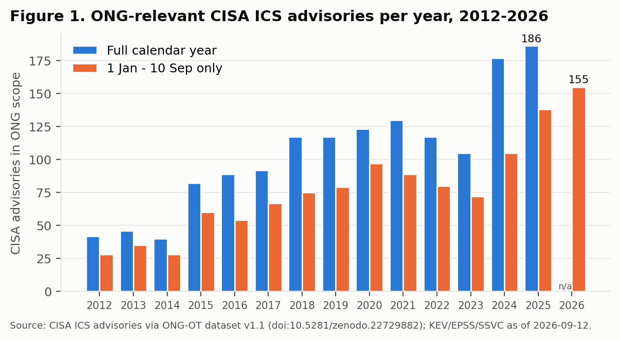
Figure 1. ONG-relevant advisories per year. Blue: full calendar year (2012-2025). Orange: 1 Jan - 10 Sep only, the like-for-like window used for 2026.
CVE counts need more care (Figure 2). A small number of advisories bundle hundreds of CVEs, usually open-source and third-party components shipped inside a single firmware image or appliance. In 2026, 5 such roll-ups account for most of the rise to 1,143 unique CVEs. Outside them the count grew +4.9%. A year-over-year CVE figure without that split overstates how fast new, distinct weaknesses are appearing. It does show something real, though: component inventories inside OT products are large, and a single product line can carry hundreds of inherited CVEs at once.
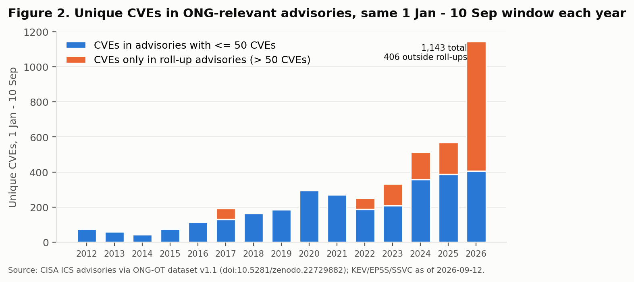
Figure 2. Unique CVEs in ONG-relevant advisories over the same 1 Jan - 10 Sep window each year, split by whether a CVE appears only in roll-up advisories (more than 50 CVEs each).

3.2 Severity
29.0% of 2026 ONG-relevant advisories are rated Critical by CISA and 77.4% are Critical or High, with a median advisory CVSS of 8.0. The severity mix has been broadly stable since 2017 (Figure 3), so severity alone does little to separate one year's exposure from another, or one advisory from the next. This is the case for the exploitation-first ordering below.
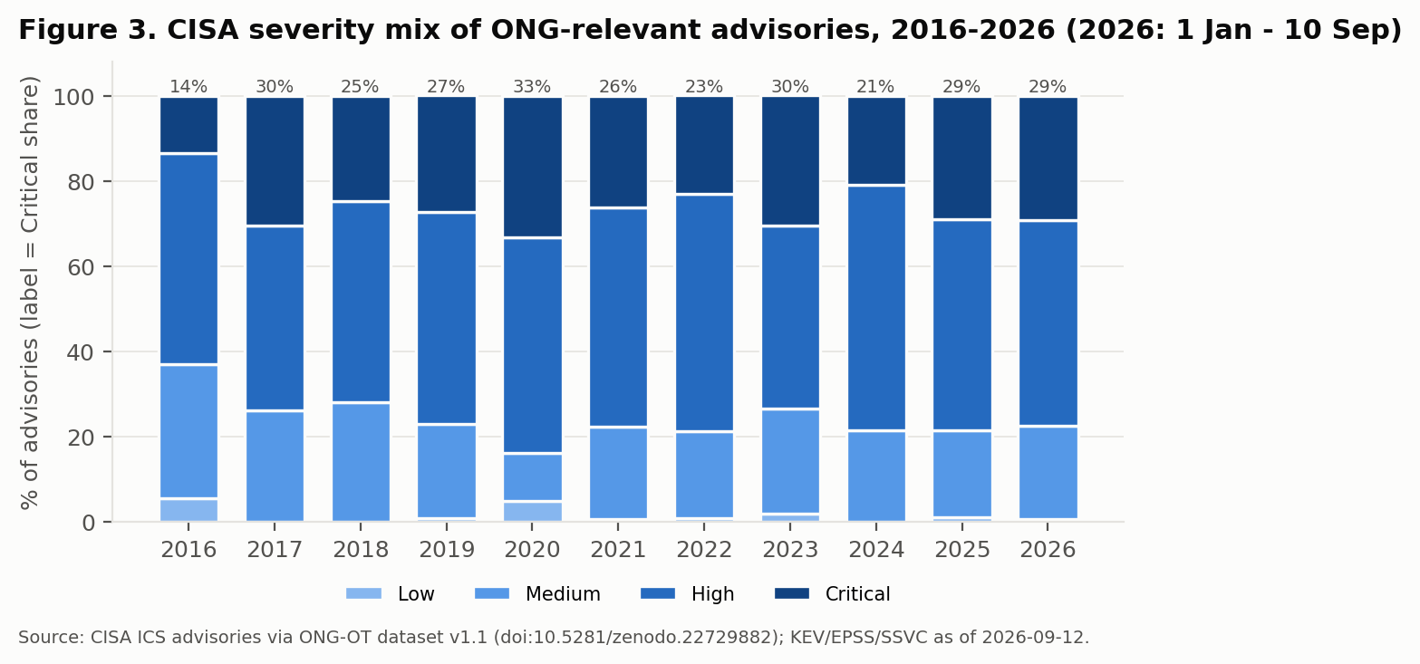
Figure 3. CISA severity labels on ONG-relevant advisories, 2016-2026 (2026: 1 Jan - 10 Sep). The label above each bar is the Critical share.

3.3 Exploitation evidence and priority tiers
Against 1,143 unique CVEs, 7 are known exploited (Tier 1) and a further 67 carry SSVC or EPSS evidence of exploitation activity (Tier 2). 826 sit in Critical advisories with no exploitation evidence (Tier 3), and 243 are in Tier 4 (Figure 4). The Tier 1-2 share fell from 12.1% to 6.5% between the two windows. Part of that fall is timing: exploitation evidence accumulates after publication, and CISA's SSVC decision points cover 51.4% of 2026 CVEs against 87.0% of 2025 CVEs at the same pull date. Part is dilution: the roll-up advisories add many CVEs that have little exploitation activity. The 2026 figure should be re-read in the 2027 edition, once it has matured.
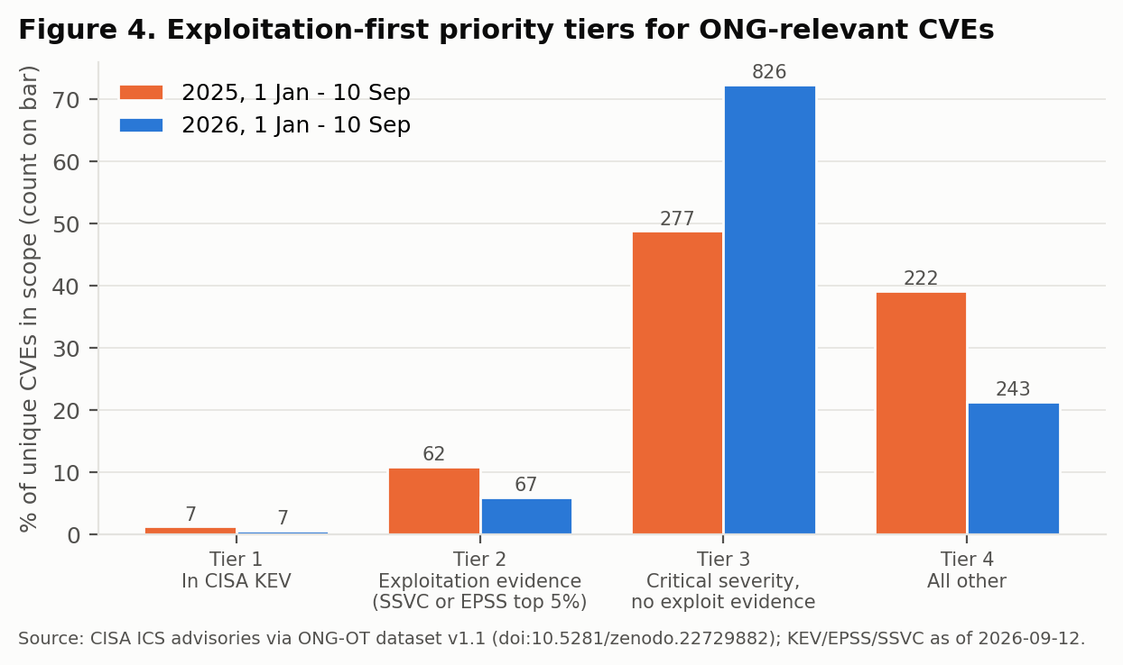
Figure 4. Priority tiers as shares of unique ONG-relevant CVEs in each window; counts are shown on the bars. Tier definitions are in Section 2.5.
Table 2 lists the 7 KEV-listed CVEs. All of them are attributed to software the OT vendor did not write: the Linux kernel's crypto interface, a document database, a browser engine, an SSH server library, a PHP runtime and a firewall operating system hosted on an industrial appliance. 3 of the 7 sit in roll-up advisories. For ONG operators the practical point is that the exposure most likely to be exploited sits in the IT software shipped inside OT products, and the vendor's own OT firmware accounts for none of it here. A software bill of materials that reaches those embedded components is the input needed to find it.
CVE | Advisory | Vendor / product | Embedded component | EPSS
CVE-2025-14847 | ICSA-26-218-01 | ABB: Ability Zenon | MongoDB Server (out-of-bounds read / memory disclosure) | 0.832
CVE-2026-31431 | ICSA-26-209-04 | Siemens: SIMATIC S7-1500 CPU 1518(F)-4 PN/DP MFP | Linux kernel crypto API (algif_aead / AF_ALG AEAD interface) | 0.999
CVE-2025-10585 | ICSA-26-202-06 | Siemens: CADRA | Google Chromium V8 engine (type confusion) | 0.054
CVE-2025-13223 | ICSA-26-202-06 | Siemens: CADRA | Google Chromium V8 engine (type confusion) | 0.050
CVE-2026-24858 | ICSA-26-071-02 | Siemens: RUGGEDCOM APE1808 Devices | Fortinet FortiOS (RUGGEDCOM APE1808 hosts a Fortinet NGFW) | 0.861
CVE-2025-32433 | ICSA-26-043-06 | Siemens: SINEC OS | Erlang/OTP SSH server (unauthenticated RCE) | 0.988
CVE-2019-11043 | ICSA-26-027-02 | Festo Didactic SE: MES PC | PHP-FPM (env_path_info underflow RCE) | 0.998
Table 2. KEV-listed CVEs in ONG-relevant 2026 advisories (1 Jan - 10 Sep). Component attributions are in config/kev_component_attribution.csv and were each confirmed against the NVD record by the authors.

3.4 Vendor concentration
Exposure disclosure is concentrated among a handful of automation majors (Figure 5), but less so than a year earlier. Siemens alone published 20.0% of 2026 ONG-relevant advisories, and the top five published 60.6%. The number of distinct vendors rose to 49, and the Herfindahl-Hirschman index of advisory counts fell from 1,857 to 922. More vendors are entering the public disclosure process, which widens the set of suppliers an ONG asset owner must track. Advisory counts partly reflect vendor maturity: firms with established product security teams publish more. A high count is not evidence of weaker products.
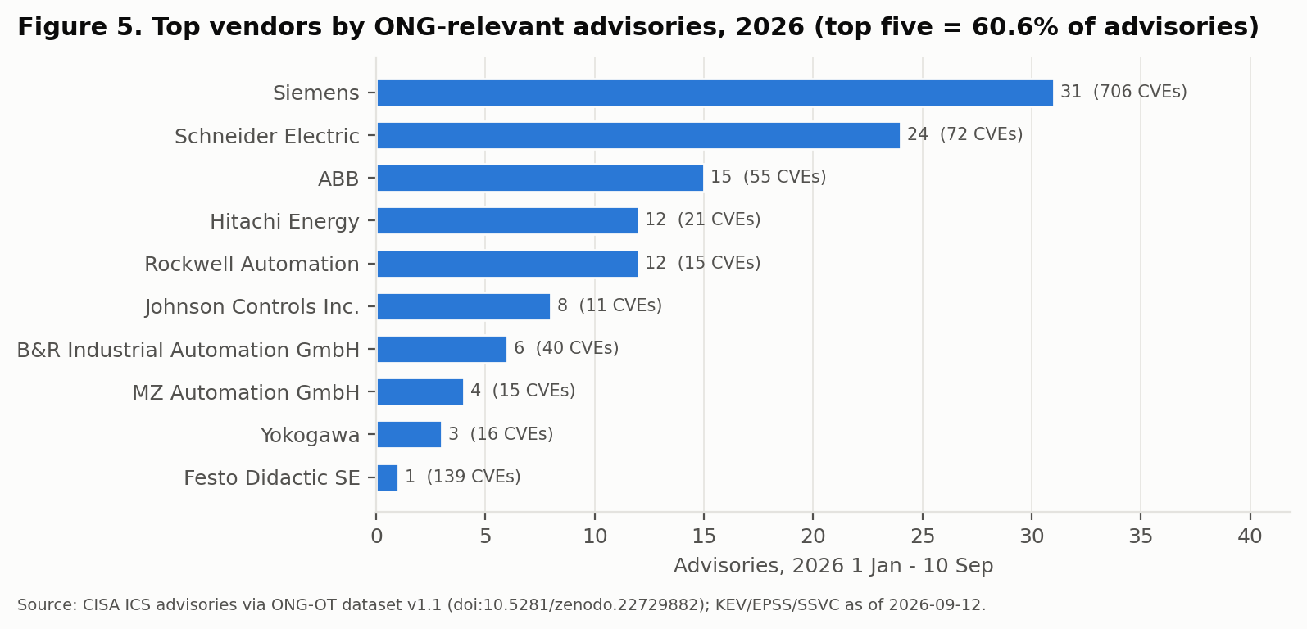
Figure 5. Top ten vendors by ONG-relevant advisories in 2026 (1 Jan - 10 Sep); the number of CVEs across those advisories is shown in brackets.

3.5 Weakness classes
CWE-306, missing authentication for a critical function, leads 2026 with a 12.9% share of advisories, against 4.8% over 2012-2025 (Figure 6). It is also first when roll-up advisories are excluded (the top three then are CWE-306, CWE-787, CWE-79). For ONG networks this is the most directly actionable class. A function reachable without authentication is exposed to anyone who can reach the device, so network segmentation and remote-access control, not only patching, determine real exposure. Memory-safety classes (out-of-bounds write and read, integer overflow, use-after-free, NULL dereference) also rose above their historical shares. Generic input validation (CWE-20) fell well below its historical share, which may reflect more specific CWE assignment in recent advisories rather than fewer input-handling flaws.
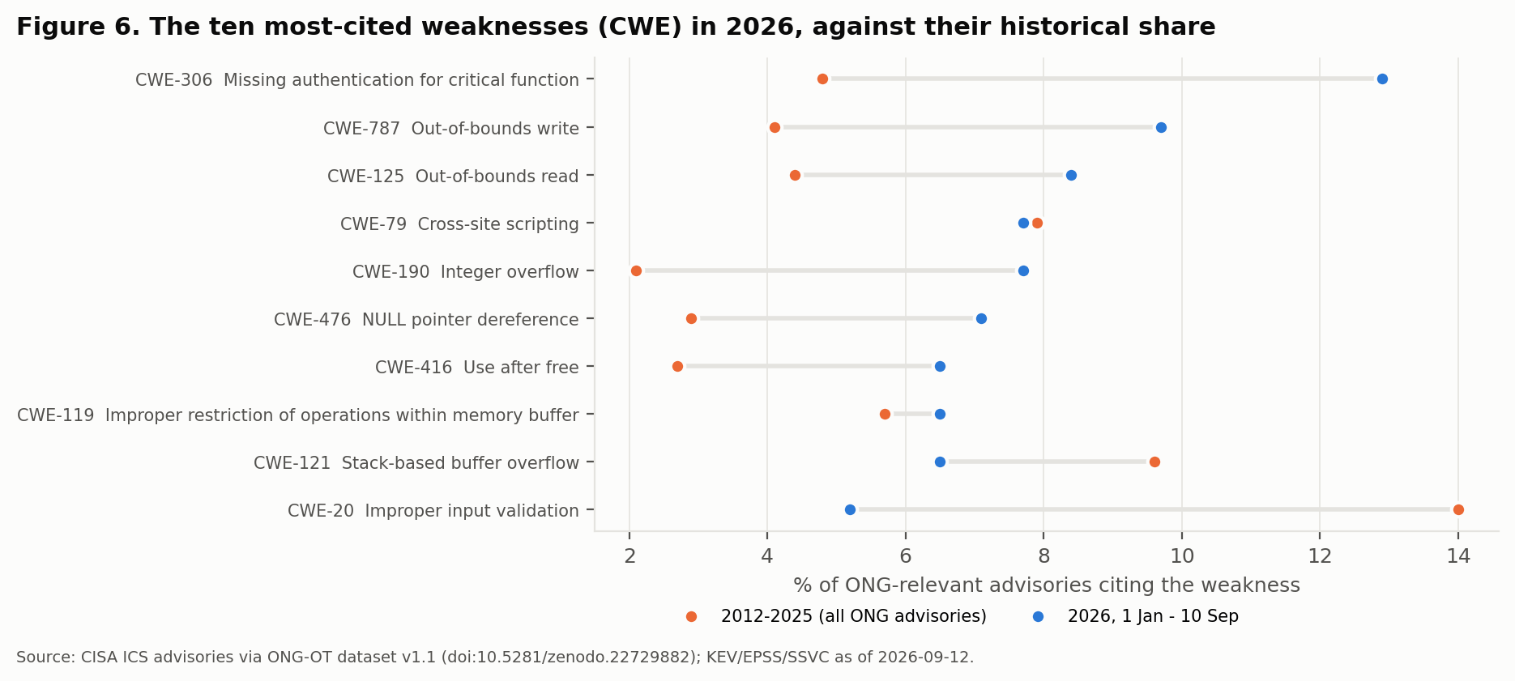
Figure 6. Share of ONG-relevant advisories citing each CWE in 2026 (blue) against 2012-2025 (orange). An advisory is counted once per CWE it cites.

3.6 Remediation signal, product classes and threat context
Remediation. Whether a fix exists is the question operators most need answered, and the public record answers it poorly. CNA-supplied solution or workaround text is present in the CVE record for 12.4% of in-scope 2026 CVEs. 3 CVEs carry an explicit statement that no fix is or will be available. CISA's advisory pages usually contain mitigation text, but the machine-readable mirror used here does not carry it. The series treats "no remediation text" as unknown, not as patched.
Product classes. Among 2026 in-scope CVEs, 572 map to process-control PLC platforms, 7 to RTUs, 1 to SCADA platforms and 2 to ONG-specific product lines; 561 fall outside the curated taxonomy. The ONG-specific product-line count is small in every year. That reflects how rarely ONG-exclusive products (flow computers, tank gauging, gas chromatographs) appear in advisories relative to shared automation platforms, rather than an absence of risk in them.
Threat context. 37 in-scope 2026 CVEs are in products that a MITRE ATT&CK for ICS software profile names directly (INCONTROLLER), through the CODESYS runtime used across several PLC families. INCONTROLLER (also reported as PIPEDREAM) is a publicly documented ICS attack toolkit built to target programmable controllers, including CODESYS-based devices. The overlap is a pointer to where a known capability meets disclosed weaknesses. It is not evidence of use against these CVEs. Compensating controls from CISA's Cross-Sector Performance Goals map to 50.9% of in-scope 2026 CVEs through their product class.

4. What the measurements imply
The findings suggest four practical readings. They are implications of the data, not prescriptive guidance.
- For operators: triage by exploitation evidence first. In 2026, 6.5% of ONG-relevant CVEs carry any exploitation evidence. Working Tier 1-2 first (74 CVEs) and then Critical advisories gives a much shorter first queue than ranking by severity alone, which would put 1,090 CVEs from Critical or High advisories at the front.
- For operators and vendors: inventory what is inside the box. Known-exploited exposure in 2026 came through embedded third-party components. Component-level SBOMs for OT products, and procurement terms that require them, are the control that matches this finding.
- For regulators: count advisories, not raw CVEs, and publish the window. Raw CVE totals doubled while distinct advisories and non-roll-up CVEs grew modestly. Metrics in pipeline and energy-sector security reporting should state their unit and time window, or they will describe roll-up packaging rather than risk.
- For researchers: the remediation gap is the measurement gap. Machine-readable fix status covers a small fraction of ONG-relevant CVEs. Structured remediation data in CSAF advisories, joined at scale, is the next improvement the series needs.

5. Limitations
- Disclosed, not deployed. Advisory counts measure what vendors and CISA disclose. They say nothing about how many affected products run in US ONG facilities, or how many are patched. Vendors with mature disclosure programs appear more often.
- Scope is a proxy. CISA's Energy tag covers electricity as well as oil and natural gas, and the product taxonomy is a curated allowlist. Some electricity-only products remain in scope, and some ONG-used products tagged only "Critical Manufacturing" and not in the taxonomy are excluded. The EV-charging exclusion is pattern-based.
- Advisory-level severity and CWE. CISA publishes severity and CWE per advisory. A roll-up advisory contributes many CWEs, and all of its CVEs inherit its severity.
- Point-in-time enrichment. KEV, EPSS and SSVC are as of 2026-09-12, and recent CVEs have had less time to acquire exploitation evidence or SSVC coverage.
- Mirror dependency. Advisories come through the ICS Advisory Project mirror (ODbL). Transcription differences from CISA's pages are possible, and the spot checks in the QA report are the control for them.
- Partial year. The 2026 edition covers 1 Jan - 10 Sep. The annual rebuild in December will extend the window to year end, and every number here will change.
- KEV component attribution. The attribution of KEV-listed CVEs to embedded components is a manual reading of CVE descriptions, recorded CVE by CVE in config/kev_component_attribution.csv and checked by the authors against NVD. It identifies the component, not whether the OT product's configuration exposes it.

6. Reproducibility and the series plan
Every number in this report is read from report/stats.json, which code/03_stats_qa.py writes, and every figure is drawn from the same file. Running the numbered scripts in code/ against the frozen snapshot rebuilds the report. The repository's README gives the commands. The QA report (data/processed/qa_report.txt) records row counts at each stage, range checks and ten named spot checks against CISA advisory pages. Each annual edition will be released as a new version under one Zenodo concept DOI, with the prior edition's configuration unchanged unless a change is documented in the release notes.

Declarations
Data availability. Input: doi:10.5281/zenodo.22729882. Code, configuration, derived tables and this report: https://github.com/foikwuogu/ong-ot-exposure-report-2026 and https://doi.org/10.5281/zenodo.22974795.
Author contributions (CRediT). Friday Ogochukwu Ikwuogu: Conceptualization, Methodology, Software, Data curation, Formal analysis, Validation, Visualization, Writing - original draft, Writing - review and editing. Abidemi Orimogunje: Validation, Writing - review and editing. Eria Othieno Pinyi: Validation, Writing - review and editing. David Mike-Ewewie: Validation, Writing - review and editing.
Competing interests. None declared.
Funding. No external funding.
Use of AI tools. An AI assistant (Claude, Anthropic) was used to write analysis code, draft figures and draft text. The authors specified the analysis, made every scope and threshold decision recorded in config/scope.json, verified the numbers against the QA report and CISA source pages, and take full responsibility for the content.

References
- Ikwuogu, F. O., Abutu, S., and Orimogunje, A. (2026). ONG-OT Vulnerability Prioritization Dataset, v1.1. Zenodo. https://doi.org/10.5281/zenodo.22729882
- ICS Advisory Project. CISA ICS advisory dataset (ODbL v1.0). https://github.com/icsadvprj/ICS-Advisory-Project
- Cybersecurity and Infrastructure Security Agency. Known Exploited Vulnerabilities Catalog. https://www.cisa.gov/known-exploited-vulnerabilities-catalog
- Cybersecurity and Infrastructure Security Agency. Vulnrichment. https://github.com/cisagov/vulnrichment
- Cybersecurity and Infrastructure Security Agency. Stakeholder-Specific Vulnerability Categorization (SSVC). https://www.cisa.gov/stakeholder-specific-vulnerability-categorization-ssvc
- Jacobs, J., Romanosky, S., Edwards, B., Adjerid, I., and Roytman, M. (2021). Exploit Prediction Scoring System (EPSS). Digital Threats: Research and Practice, 2(3). https://doi.org/10.1145/3436242
- FIRST. Exploit Prediction Scoring System. https://www.first.org/epss/
- MITRE. ATT&CK for ICS. https://attack.mitre.org/matrices/ics/
- MITRE. Common Weakness Enumeration. https://cwe.mitre.org/
- Cybersecurity and Infrastructure Security Agency. Cross-Sector Cybersecurity Performance Goals. https://www.cisa.gov/cross-sector-cybersecurity-performance-goals

Appendix A. Year-by-year series
Year | Advisories (full year) | Advisories (1 Jan - 10 Sep) | Unique CVEs (1 Jan - 10 Sep) | Critical % | Vendors
2012 | 42 | 28 | 76 | 2.4% | 23
2013 | 46 | 35 | 60 | 2.2% | 32
2014 | 40 | 28 | 43 | 0.0% | 25
2015 | 82 | 60 | 75 | 17.1% | 39
2016 | 89 | 54 | 116 | 13.5% | 33
2017 | 92 | 67 | 193 | 30.4% | 30
2018 | 117 | 75 | 166 | 24.8% | 26
2019 | 117 | 79 | 186 | 27.4% | 24
2020 | 123 | 97 | 295 | 33.3% | 27
2021 | 130 | 89 | 270 | 26.2% | 23
2022 | 117 | 80 | 253 | 23.1% | 31
2023 | 105 | 72 | 332 | 30.5% | 29
2024 | 177 | 105 | 514 | 20.9% | 34
2025 | 186 | 138 | 568 | 29.0% | 43
2026 | n/a | 155 | 1,143 | 29.0% | 49
Table A1. Series values; the full table with additional columns is report/tables/t1_trend_by_year.csv. Critical % and vendors are for the full year (2026: 1 Jan - 10 Sep).

