A Human-Adjudicated Semantic Alignment Framework for Regulatory Crosswalks: Mapping TSA Pipeline Security Requirements to NIST CSF 2.0, SP 800-53, and CISA CPG
Friday Ogochukwu Ikwuogu1 *
David Mike-Ewewie2
Osorachukwu Maurice Ayozie3
1. Independent Researcher, Odessa, Texas, USA
2. Computer Science Department, University of Texas Permian Basin, Odessa, Texas, USA
3. MSc Computer Science Cybersecurity, University of Texas Permian Basin, Odessa, Texas, USA
* Corresponding author: Friday.ikwuogu@gmail.com

Abstract
Regulatory and cybersecurity-standards documents describe overlapping obligations in incompatible language, forcing compliance analysts to reconcile them by hand with no durable record of the reasoning. We present a framework that pairs transparent, reproducible semantic-similarity scoring with a structured human-adjudication log, and apply it to a real, worked case: mapping 130 atomic requirement statements from the TSA Pipeline Security Guidelines onto NIST Cybersecurity Framework (CSF) 2.0 (106 subcategories), a 54-control base subset of NIST SP 800-53 Rev 5, and CISA's Cross-Sector Cybersecurity Performance Goals (CPG) v1.0.1 (38 sub-goals). TF-IDF cosine similarity scoring over 1170 candidate pairs surfaced a review queue of 149 candidate matches, of which 31 are flagged high-priority for mandatory human review. We report the method's honest failure mode — a 66% rank-1 "no match" rate driven by lexical mismatch rather than a true absence of overlap — and argue that this is precisely the case for keeping a human adjudicator, and a transparent log of their decisions, in the loop.

1. Introduction
Operators of critical infrastructure are frequently subject to several overlapping regulatory and voluntary-standards regimes at once. A pipeline operator, for instance, must reconcile TSA security guidance with the NIST Cybersecurity Framework, NIST SP 800-53 (if it touches federal systems or is used as a de facto baseline), and CISA's Cross-Sector Cybersecurity Performance Goals. Each document uses its own vocabulary, granularity, and structure for what is often the same underlying control intent. Analysts currently perform this reconciliation ad hoc, and the reasoning behind any given mapping decision is rarely written down, which makes crosswalks hard to audit, hard to update when a framework revises, and hard to reproduce across analysts.
This paper contributes (1) a general framework for producing a crosswalk between two or more regulatory/standards corpora that separates transparent machine scoring from accountable human adjudication, with every decision logged and attributable; (2) a reproducible, open-source implementation of that framework; and (3) a real, worked crosswalk between TSA pipeline security guidance and three federal cybersecurity frameworks, released as an open dataset alongside this manuscript.

2. Related Work
Framework-to-framework mappings are commonly published as static tables by standards bodies and vendors (e.g., NIST's own Informative References program, and numerous vendor-produced 'crosswalk' spreadsheets). These are useful but typically opaque: the mapping methodology, confidence level, and disagreement cases are not published alongside the result. Separately, a body of NLP work applies sentence-embedding and semantic-textual-similarity techniques to legal and regulatory text alignment. This project sits between the two traditions: it uses a lightweight, fully transparent lexical scorer (deliberately avoiding an opaque embedding model for this first release, see Section 5) as a triage aid for a human adjudicator, and it publishes the adjudication log itself as the citable artifact, not just the final mapping table.

3. Methods

3.1 Corpora
Four public corpora were used (full provenance — URLs, access dates, and content hashes — in data/raw/PROVENANCE.txt): the TSA Pipeline Security Guidelines (March 2018, Change 1 April 2021), NIST CSF 2.0 (NIST CSWP.29, February 2024), a 54-control base-control subset of the NIST SP 800-53 Rev 5.2.0 control catalog spanning 18 control families, and CISA's Cross-Sector Cybersecurity Performance Goals v1.0.1 (March 2023). All four are U.S. Government works in the public domain. Each corpus was decomposed into atomic requirement/outcome statements — one bullet, subcategory, control, or sub-goal per row — yielding 130 TSA statements, 106 CSF 2.0 subcategories, 54 SP 800-53 base controls, and 38 CPG sub-goals.
Note on scope: the TSA corpus used here is the public Pipeline Security Guidelines, not the enforceable Security Directive Pipeline-2021-01/02 series, most of whose substantive text remains posted with Sensitive-Security-Information redactions. This is a defensible and commonly used public proxy for TSA policy language, but it is not the binding directive text, and results should not be read as a directive-to-control crosswalk in the regulatory-compliance sense. See Section 5 for further discussion.

3.2 Semantic similarity scoring
For each TSA statement and each target corpus, we computed TF-IDF (unigram and bigram, English stopwords removed) cosine similarity against every candidate statement in that corpus, over the combined vocabulary of the TSA corpus and the target corpus, and kept the top-3 candidates per pair. This produced 1170 scored candidate rows. Each candidate was assigned a tentative alignment-type bucket — Direct, Partial, Related, or No Match — from empirically calibrated thresholds (cosine ≥ 0.3 = Direct, ≥ 0.18 = Partial, ≥ 0.08 = Related; documented in BUILD_SPEC.md). These thresholds and buckets are a triage aid for the human adjudicator, not a validated classifier — see Section 5.

3.3 Human adjudication protocol
The rank-1 candidate for every TSA statement against every target corpus (390 rows) was assigned a review priority: high for every tentative Direct or Partial match (these are the boundary cases that most need a human call), medium for a Related match with cosine ≥ 0.10, low for a weaker Related match, and low for a random 15-row spot-check sample of confident No Match rows. This produced a review queue of 149 rows (31 high, 66 medium, 52 low priority). Each row carries the machine's tentative call and a short shared-terms hint, and empty fields for the human adjudicator's final alignment type, name, rationale, and date — the filled-in log is the project's core evidentiary artifact (data/processed/adjudication_log.csv).

4. Results
Table 1 summarizes the rank-1 tentative alignment-type distribution by target corpus. Overall, 34% of TSA statements had at least a "Related" or stronger tentative match against at least one target corpus at rank 1, while 66% did not clear even the lowest similarity threshold against any of the three target corpora.
Target corpus | Direct | Partial | Related | No Match | Mean cosine | Max cosine
NIST CSF 2.0 | 1 | 11 | 33 | 85 | 0.0815 | 0.3479
NIST SP 800-53 | 2 | 14 | 42 | 72 | 0.0955 | 0.3852
CISA CPG v1.0.1 | 0 | 3 | 28 | 99 | 0.0626 | 0.2409
Table 1. Rank-1 tentative alignment-type counts and score statistics by target corpus (n = 130 TSA statements each). Source: paper/stats.json.
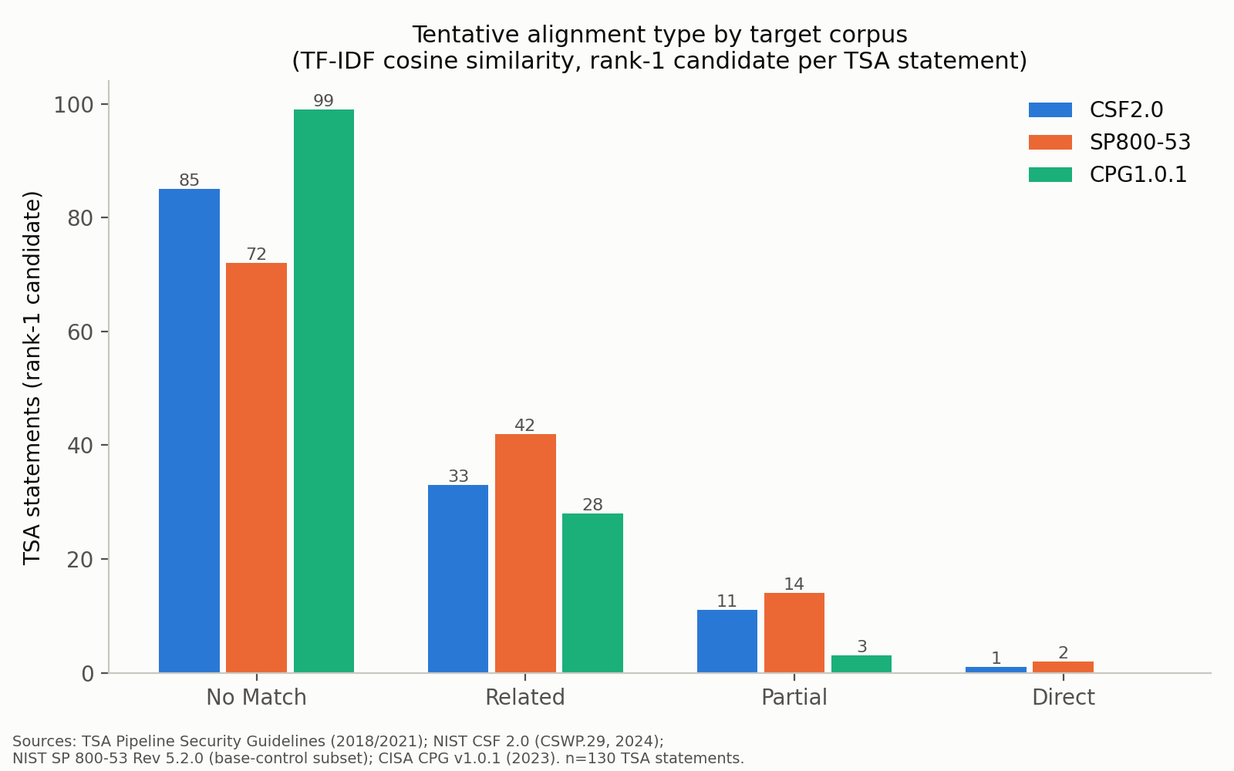
Figure 1. Tentative alignment type by target corpus, rank-1 candidate per TSA statement.
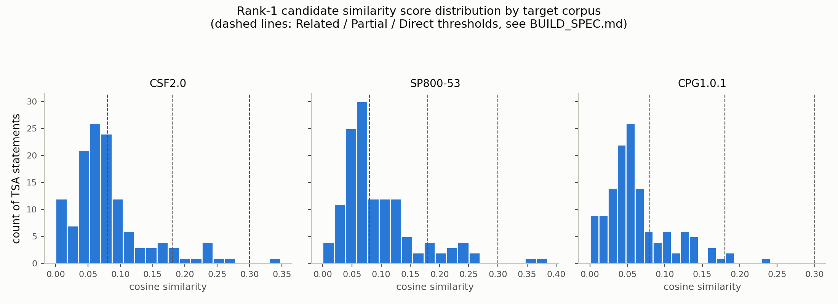
Figure 2. Rank-1 cosine similarity score distribution by target corpus, with Related/Partial/Direct thresholds marked.
NIST SP 800-53 produced the strongest scoring overall (mean cosine 0.0955, 16 Direct/Partial matches), plausibly because its control language is written at a comparable level of procedural specificity to the TSA Guidelines' bulleted requirements. CISA CPG produced the weakest scoring (mean cosine 0.0626, 3 Direct/Partial matches, zero Direct matches), consistent with the CPGs' outcome-oriented, differently-worded phrasing even where the underlying practice overlaps substantially with a TSA requirement (see the shared-terms hints and adjudicator rationale in the adjudication log for qualitative examples).

5. Limitations
Full limitations are maintained in docs/LIMITATIONS.md and summarized here. (1) The SP 800-53 corpus is a 54-control curated subset of the full catalog, and its statement text is flagged for verbatim verification rather than independently re-fetched and diffed against the primary source in this release. (2) The CSF 2.0 subcategory count used here should be cross-checked against the source publication before being cited as an exact figure elsewhere. (3) The TSA corpus is the public Guidelines document, not the enforceable Security Directive text. (4) TF-IDF cosine similarity is a lexical method: it scores shared vocabulary, not paraphrase or conceptual equivalence, and is the primary driver of the 66% rank-1 No Match rate — this should be read as a property of the scoring method, not as evidence that most TSA requirements genuinely lack any NIST/CPG counterpart. (5) The similarity-bucket thresholds are heuristic and calibrated against this corpus's own score distribution, not against an external ground truth. (6) This release includes one adjudicator's decisions per row; no independent inter-rater reliability statistic is yet reported.

6. Discussion and Future Work
The framework's central design claim is that machine scoring and human adjudication play different, complementary roles: the scorer's job is to surface candidates cheaply and transparently, not to decide; the adjudicator's job is to decide, and to leave a record of why. The high rank-1 No Match rate observed here is itself informative: it quantifies how much of a naive lexical crosswalk a human reviewer needs to correct, and argues for embedding-based scoring as a near-term improvement (see docs/NEXT_STEPS.md) that could be evaluated directly against this same adjudicated log as ground truth — turning this v0.1 release into the baseline for a future validation study with a measurable precision/recall comparison and inter-rater reliability statistic.

7. Data and Code Availability
All code, raw source captures with provenance hashes, processed data tables, the adjudication log, and this manuscript are released together under an open-source license (code: MIT; data and documents: CC BY 4.0) at the repository and DOI given on the title page once published. See README.md for run instructions and CITATION.cff for the citable reference.

Disclosure of AI Assistance
AI assistance (Claude, Anthropic) was used for code generation, data extraction and wrangling, similarity-scoring implementation, figure generation, and drafting mechanics of this manuscript. The corresponding author made all analytic decisions (corpus scope, similarity method, threshold calibration, alignment-type taxonomy) and is responsible for verifying the adjudication log and every quoted figure before release, per docs/VERIFY_CHECKLIST.md. No claim in this manuscript should be treated as final until that verification is complete and the DRAFT banner above has been removed.

Author Contributions (CRediT)
Friday Ogochukwu Ikwuogu: Conceptualization, Methodology, Software, Data Curation, Writing – Original Draft, Writing – Review & Editing.
David Mike-Ewewie: Validation, Writing – Review & Editing.
Osorachukwu Maurice Ayozie: Validation, Data Curation.

References
Transportation Security Administration. (2021). Pipeline Security Guidelines (rev. April 2021). https://www.tsa.gov/sites/default/files/pipeline_security_guidelines.pdf
National Institute of Standards and Technology. (2024). The NIST Cybersecurity Framework (CSF) 2.0 (NIST CSWP 29). https://doi.org/10.6028/NIST.CSWP.29
National Institute of Standards and Technology. (2020, upd. 2025). Security and Privacy Controls for Information Systems and Organizations (NIST SP 800-53 Rev. 5.2.0). https://csrc.nist.gov/pubs/sp/800/53/r5/upd1/final
Cybersecurity and Infrastructure Security Agency. (2023). Cross-Sector Cybersecurity Performance Goals, v1.0.1. https://www.cisa.gov/sites/default/files/2023-03/CISA_CPG_REPORT_v1.0.1_FINAL.pdf

