- Russian language pack:
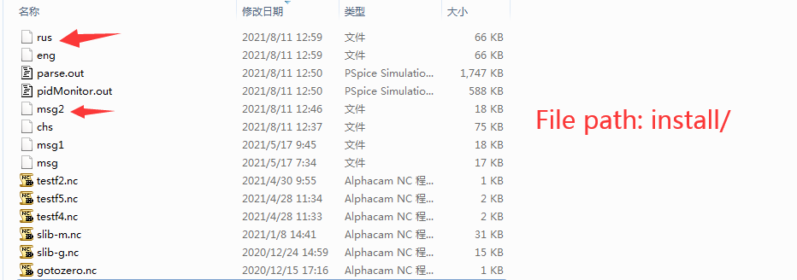
rus | Russian parameter configuration file
msg2 | Russian interface character display configuration
E.g：
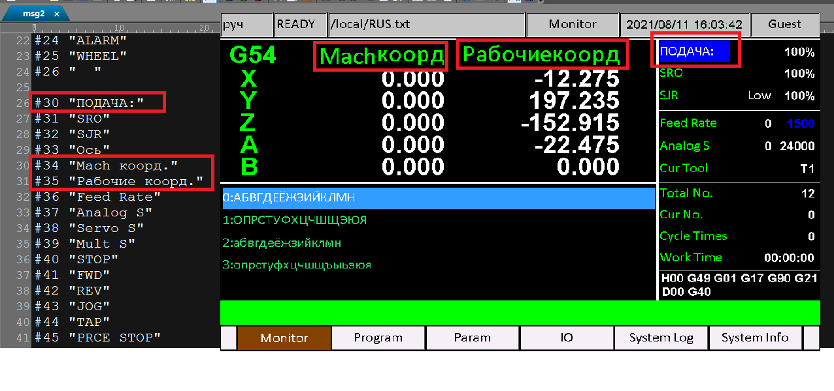
- parameter settings
