* 词汇
* commercial [kə'mɜːʃ(ə)l]商业广告
* e.g. The TV show was interrupted by too many commercials.
* prospect ['prɒspekt] 前景，潜在客户
* e.g. He called on some prospects but failed to make a sale.
* 他拜访了很多客户，但是没有谈成一笔生意
* make 牌子 制造
* These products are of Chinese make
* The factory manufacured five makes of tractors
* 短语
* soft selling 软销售
* hard selling 硬销售
* Some sales people adopt a direct ‘hard sell’ approach, while others use a more indirect ‘soft sell’ approach.
* have a bad year
* The corporation is having a bad year and it will probably be necessary to dismiss a few office staff.
* lay off v 解雇，停止工作，休息，划出
* make someone redundant 使某人多余
* dismiss vt 解散，下课，开除，解职，使（或让）离开 vi. 解散
* break into/penetrate the market 打入市场
* There is a chance that we’ll manage to break into the UK market.
* 这是大好的机会，我们可以打入英国市场
* **句型**

1. I am writing to you concerning….
2. I can’t agree with you more.
3. You can always reach me at the number….
4. We would very much appreciate it if you could ….
5. I notice with interest you advertsement for …
6. That’s exactly what I think = My opinion exaclly
7. You are wanted on the phone. 有你的电话
8. As requested, we enclose for your attention…

* **熟悉世界贸易组织**
* APEC n 亚太经贸合作组织 简称亚太经合组织

（The Asia-Pacific Economic Cooperation）

WTO 世界贸易组织（World Trade Organization）

GATT abbr.关贸总协定（General Agreement on Tariffs and Trade）

**熟悉国际商务英语有关行业的基础术语及其内涵意义**

letter of credit n【商】银行发行的信用证

Product price promotion place（分销） 四个P，研究市场

FOB free on Board 船上交货价格，离岸价格

CIF 【商】Cost Insurance and Freight 到岸价格

学习国际商务知识，略知相关专业知识

一个中心：国际贸易知识

四个基本点：国际经济、国际金融、营销策略、国际商法。

国际经济：4C(Competition，Contradiction，Coordination，Cooperation)等

国际金融：外汇、国际收支、货币的一般知识

营销策略：市场调研、营销组合、目标市场、战略营销等。

国际商法：合同、WTO协定文本（基本常识）、知识产权等。

**密切了解国际商务最新动态 因特网查看**

* Introducing yourself & Introducing someone else
  + Good morning,Ladies and gentlemen
  + I’m so happy to be here today
  + I’d like to introduce myself
  + My name is Jennifer.
  + I come fomr Kaosiung.
  + I’ve been living in Taipei for three years.
  + I am a student
  + I like outdoor life.
  + I’m interested in sports,especially mountain-climbing.
  + I like making friends with people from all over the world.
  + I hope we’ll become good friends.
  + Thank you, everybody!

E.G.2

* + Good morning,ladies and gentlemen.
  + This is Michael Wang.
  + You’ve all heard about him.
    - VIP: very important Person 贵宾，大人物
    - big shot:权贵之人，大亨，大人物
    - big cheese:重要人物，具有影响力的人
    - big wheel:要人，一个非常重要的人
  + He’s good friend of mine.
  + You’ll have a chance to chat with him.
  + Let’s make hime feel at home.
    - make sb. feel at home
  + Here he is.
  + Michael Wang
  + Let’s give him a big hand. 让我们热烈欢迎他

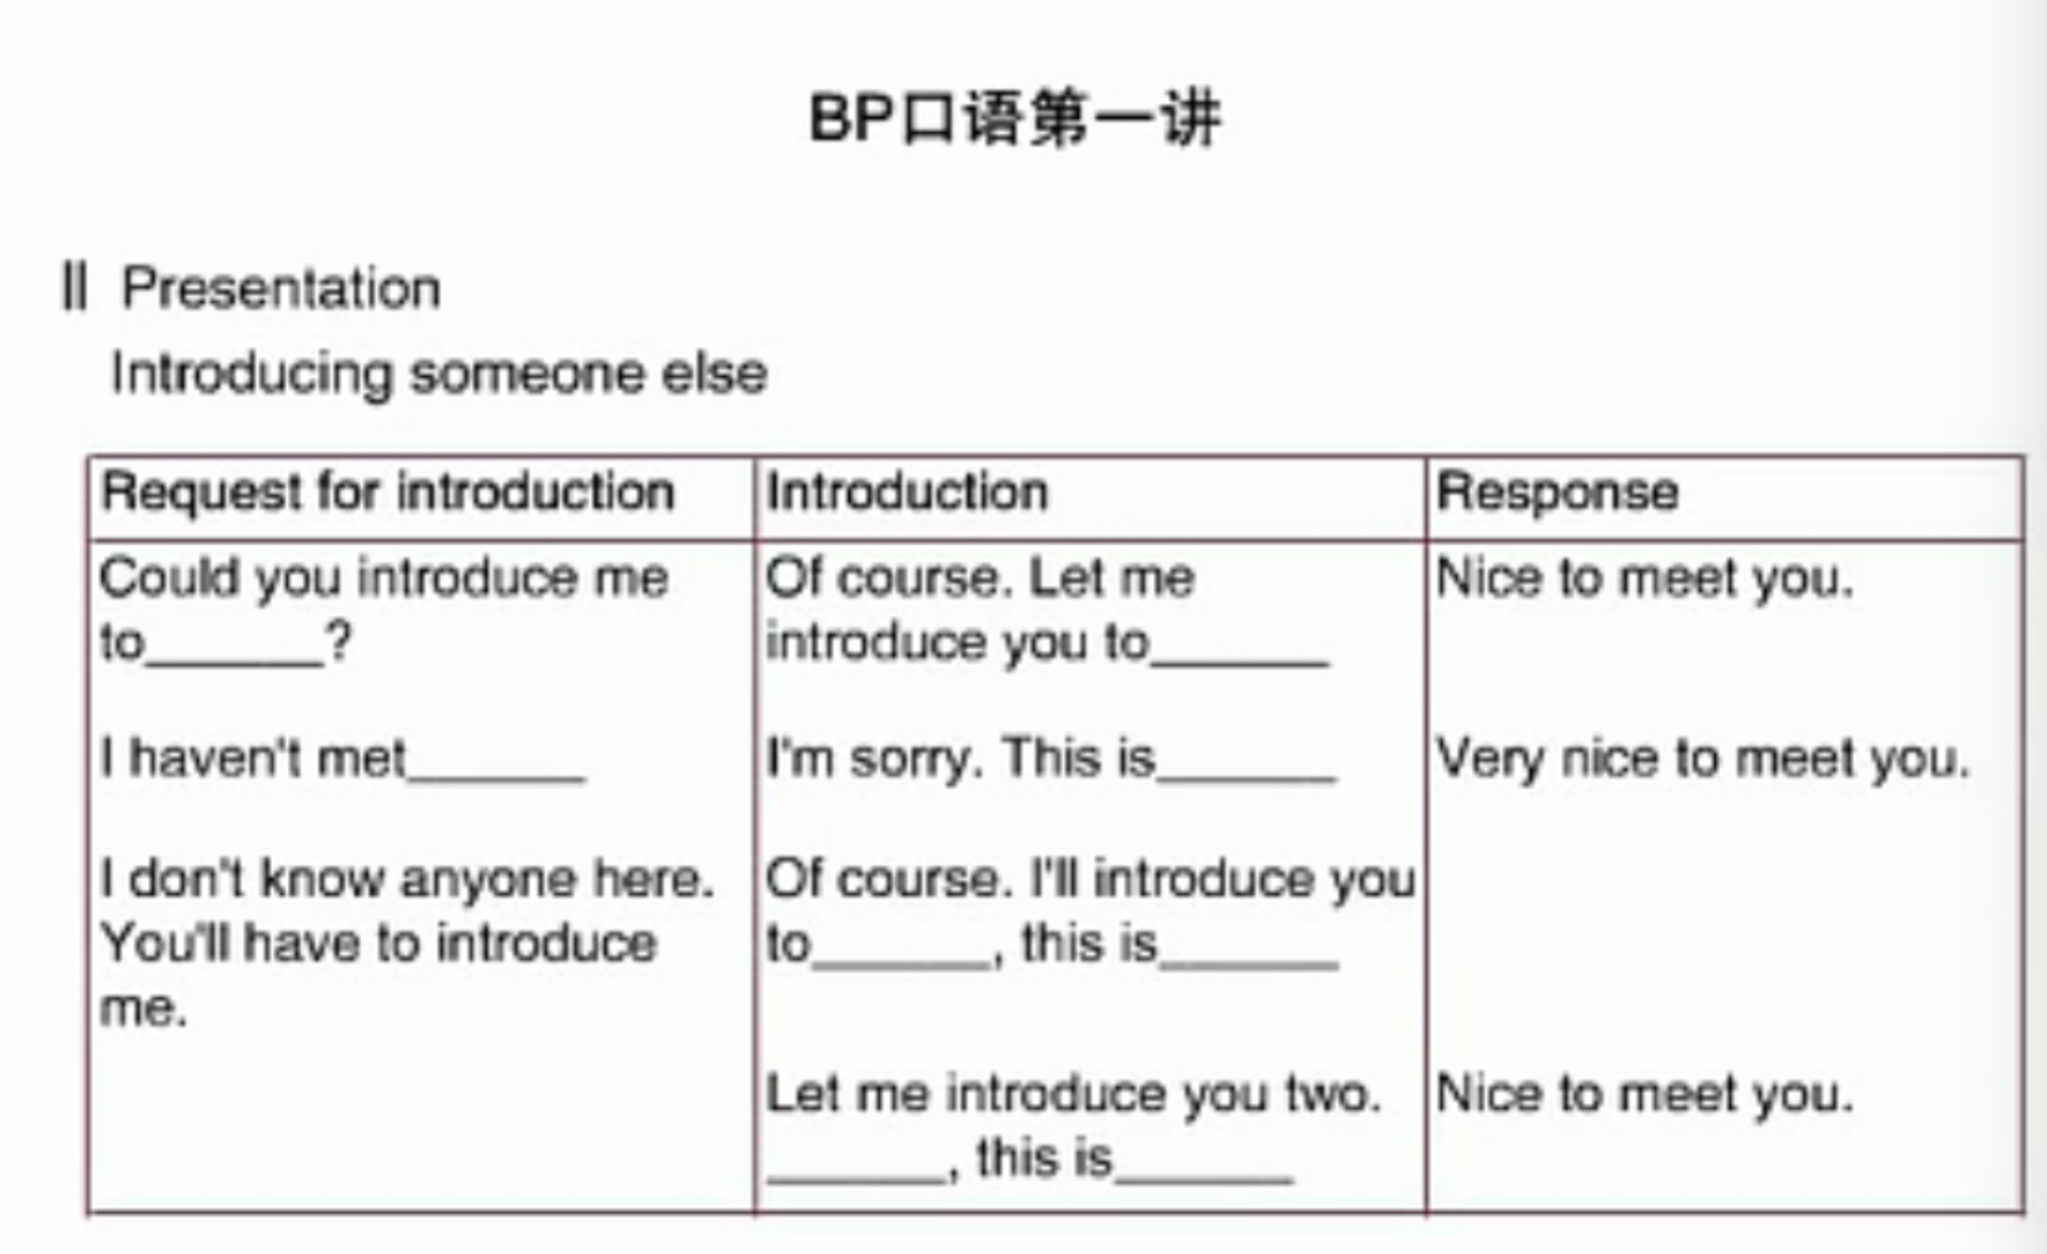

Business Dialogue

* + Dialogue 1 Introducing an Acquaintance
  + Mr.Lee: We’ll get Miss Lewis’ opinion on this ,I think.
  + Mr.Jones:Miss Lewis…I’ve heard that name.Oh yes! I heard she is one of the secrets of this company’s success.Everyone was raving about what a great job she’s done in motivating the …(interrupted by Mr.Lee)

raving about

motivating 激励

* + Mr.Lee:Uh,Mike... speak of the devil … th famous Miss Lewis is statnding right behind you.Mary,Let me introduce our new Accounting Manager Mike Jones.Mike,This is Mary Lewis.
  + Mr.Jones:So you’re the famous Miss Lewis! So nice to meet you at last! I’ve heard so much about you.