

ASSIGNMENT COVER SHEET

Student Name: Piotr Masior and Aaron Flanagan

ID Number: B00064347 and B00062454

Course: Bachelor of Science in Computing in Information Technology

Year: 3

Lecturer: Orla McMahon

Title of Assignment: _________________________________________

___________________________________________________________

___________________________________________________________

Due Date: ____________________________________________

Date Submitted: ____________________________________________

The material contained in this assignment is the author’s original work, except where work quoted is duly acknowledged in the text. No aspect of this assignment has been previously submitted for assessment in any other unit or course.
Signed: _______________________________ Date: ______/______/______

Signed: _______________________________ Date: ______/______/_____

Table of contents:

- Application purpose....................................................3
- Abstract......................................................................3
- Design of Application..................................................4
- Page Descriptions......................................................4
  - Home......................................................................4
  - Style........................................................................5
  - Classes...................................................................6
  - Instructor.................................................................6
  - Contact...................................................................7
  - YouTube.................................................................7
  - Flicker.....................................................................8
  - Blog........................................................................8
- Conclusion..................................................................9

Exercise Overview

College: Institute of Technologies in Blanchardstown

Given on: 4nd November 2014

Deliver on: 6th November 2014

Student: Piotr Masior B00064347 and Aaron Flanagan B00062454

Report Overview: The web application should be designed for a mobile and use the jQuery Mobile Themeroller

Applications purpose:

The purpose of this assignment is to create a professional and engaging mobile web application that will enhance the users experience when using this mobile application, while drawing attention to our business. The technologies used to develop this mobile web application are HTML5, CSS, JavaScript, JQuery and XML/JSON.

Abstract:

For this project we have chosen Kung Fu (marital arts) as the web application topic, which is something more than hobby for Piotr. Piotr have been doing Kung Fu Dragon Style training since 2012.
Dragon Style focuses mainly on self-defence and fitness, so the target audience for this mobile web application is people who are looking to practice martial arts, people who are interested in their healthy life style and people who are looking to discover a new culture (southern Chinese style of Kung Fu). In this mobile web application people are able to navigate around the web pages easily; each dynamic page provides the most information possible about Dragon Style Kung Fu, the venue where we train and Instructor Sifu. This should answer any questions and hopefully it will encourage people to join the club.

Design of Application:

This mobile web application has 8 main pages. The home page contains a dynamic list what is offered and a picture of two men sparring and Facebook “like” on the right top of the web app. The style page contains the motto (toggle) and information about the approach we use in our techniques. The classes page displays a time table for when we take place and an accordion widget with information about our facilities. The instructors page give you details on who you will be training with and displays a picture of him so you know who to approach with any questions, Our contact page displays a map with direction button to the club. We have videos up on our YouTube page showing what we do in training.

Page descriptions:

Home
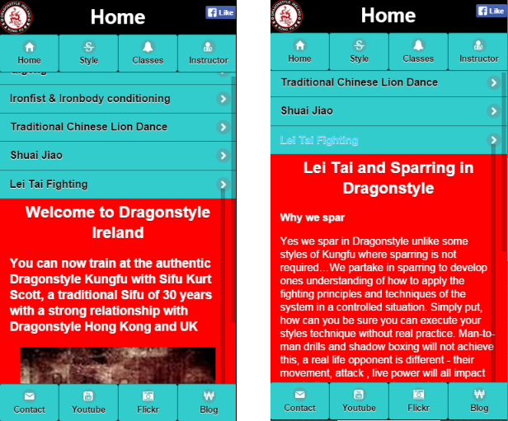Illustration 1: Home page
The home page displays a dynamic list and an image of two men about to spar. Once a list item is selected the image will disappear and some information about the selected technique will appear in its place. The page has two navigation bars. The top is for the main pages home, style, classes and instructor. The bottom is for our resource sites, contact, YouTube, Flicker and our blog. The Facebook “like” icon is in the header.

Styles
The styles page displays a green field with our motto that extends when clicked (toggle). It also contains information about the styles and techniques we train in and learn in our practices. The page has two navigation bars. The top is for the main pages home, style, classes and instructor. The bottom is for our resource sites, contact, YouTube, Flicker and our blog.

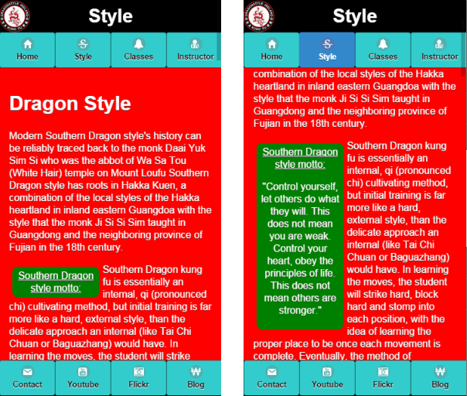Illustration 2: Style page

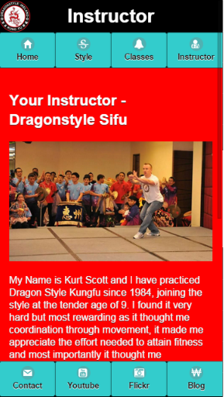
Classes
The class’s page displays a table field with the times for when we do our training classes. It also contains an accordion with information about our facilities, our training hall and our conditioning room. It also has a link called free lessons that brings you to another page with a dialog box explaining how to get your free lessons. The page has two navigation bars. The top is for the main pages home, style, classes and instructor. The bottom is for our resource sites, contact, YouTube, Flicker and our blog.

Instructor
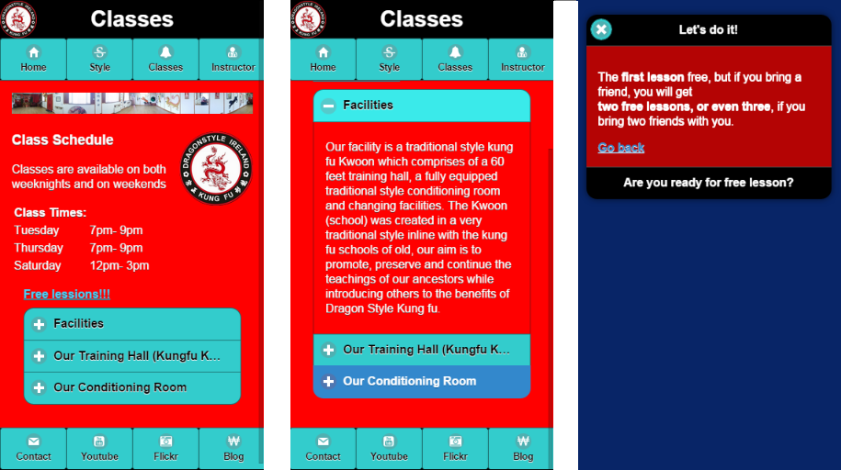Illustration 3: Classes page
Illustration 4: Instructor page
The instructor page displays a picture of our instructor Kurt Scott. Then it gives a bit of information on Kurt’s background and how he started doing dragon style. The page has two navigation bars. The top is for the main pages home, style, classes and instructor. The bottom is for our resource sites, contact, YouTube, Flicker and our blog.

Contact
The contact page displays a contact details and Google map (google api3), with marker at the club address. Marker is clickable and show description with image on click. Visitors are able to click the button “Get Directions” to find the way to the club. Also the page has button to open new page with the message form and link to Facebook.
The page has two navigation bars. The top is for the main pages home, style, classes and instructor. The bottom is for our resource sites, contact, YouTube, Flicker and our blog.
Illustration 5: Contact page
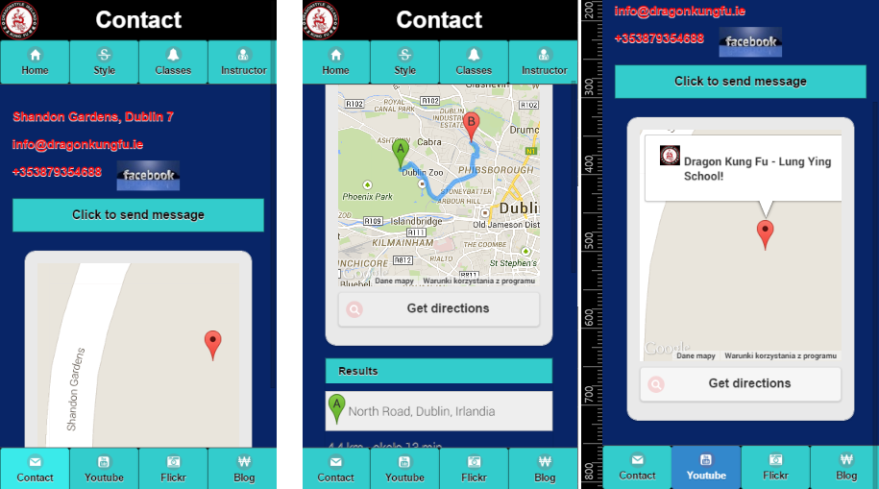

YouTube
The YouTube page displays list of embedded videos taken straight from Dragonstylenorthside YouTube page. This was done by making a call to the YouTube data API v3 to stream, the videos directly to our website. After a video is clicked on you are inked to another page where the video will play internally on our website. The page has two navigation bars. The top is for the main pages home, style, classes and instructor. The bottom is for our resource sites, contact, YouTube, Flicker and our blog.
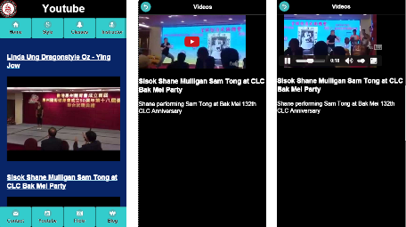Illustration 6: YouTube page

Flicker
The Flicker page displays list of photos taken straight from the Dragon style KungFu Flicker account. This was done by making a call with the user ID to the Flicker API, the photos stream directly to our website. The page has two navigation bars. The top is for the main pages home, style, classes and instructor. The bottom is for our resource sites, contact, YouTube, Flicker and our blog.

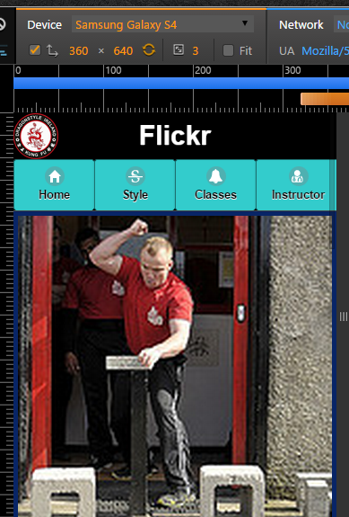Illustration 7: Flicker page

Blog
The blog page displays list of posts. This is done using word press (wordpress.org) and displayed using the word press API. The page has two navigation bars. The top is for the main pages home, style, classes and instructor. The bottom is for our resource sites, contact, YouTube, Flicker and our blog.

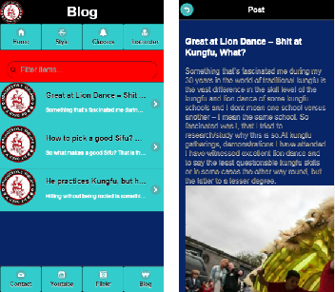
Conclusion:

We have learned a lot from this project using new technologies like AJAX, JSON, JQuery and the JQuery Mobile, the YouTube API, Flicker API and word press.
AJAX is an abbreviation of Asynchronous JavaScript and XML and is about Traditional Web Communication Process and Client/Server Side Technologies. Is a technique that enables JavaScript to communicate with the web server. It will update only required data on the web page, instead of refreshing the entire page.
JSON stand for JavaScript Object Notation and is syntax for passing an object that contains name/value pairs, arrays and other objects. Commonly used in AJAX applications.
JQuery is an already written library of reusable code. Is a free open JavaScript library, which works on all modern browsers and is the most popular technique for web designers. All of those methods allow me to build friendly usable and modern web application.
YouTube Data API allows developers to make a call to their YouTube account and provide a list and an embedded player of your videos on your website.
Flicker API allows you to make a call and stream all of your photos onto your website. Streaming them directly from your Flick account to your application.
Word press enables people to write blogs and post them online for other developers or enthusiasts of the field to read up on the most recent news.

