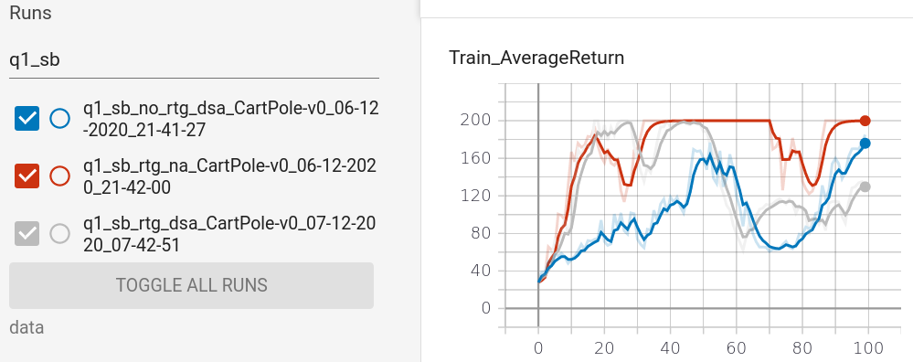
HW2 report
1.q1

1.1 q1_sb:
using reward-to-go(gray) is better than trajectory-centric one(blue curve)
advantage standardization helps. (red one > gray one)

1.2 q1_lb:
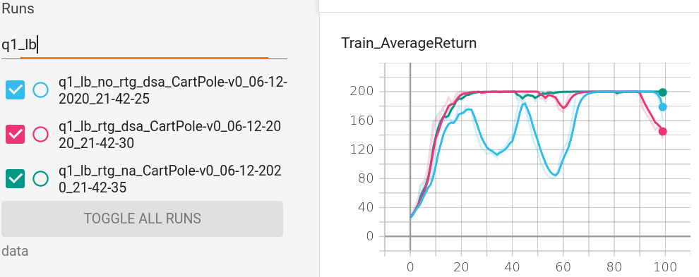
using reward-to-go(pink) is better than trajectory-centric one(blue curve)
advantage standardization helps. (green one > pink one)

1.3
larger batch size performs better (5000 vs 1000)

2.find the smallest batch size b*and largest learning rate r* that gets to optimum(maximum score of 1000) in less than 100 iterations

3. learn a controllerforLunarLanderContinuous-v2.

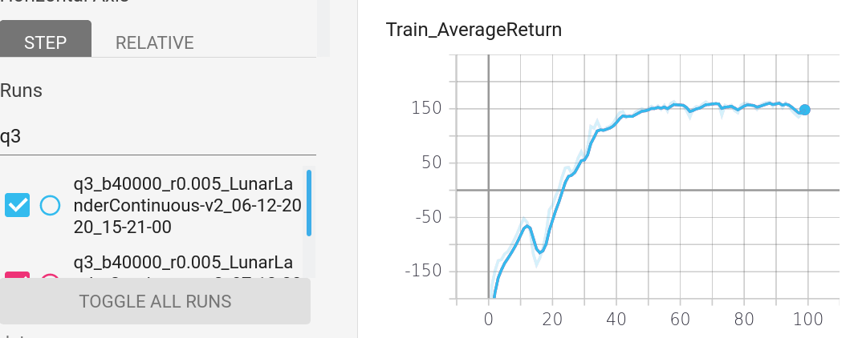

4.
4.1 hyperperams: lr, bs
for HalfCheetah, b5000_lr0.02 is best
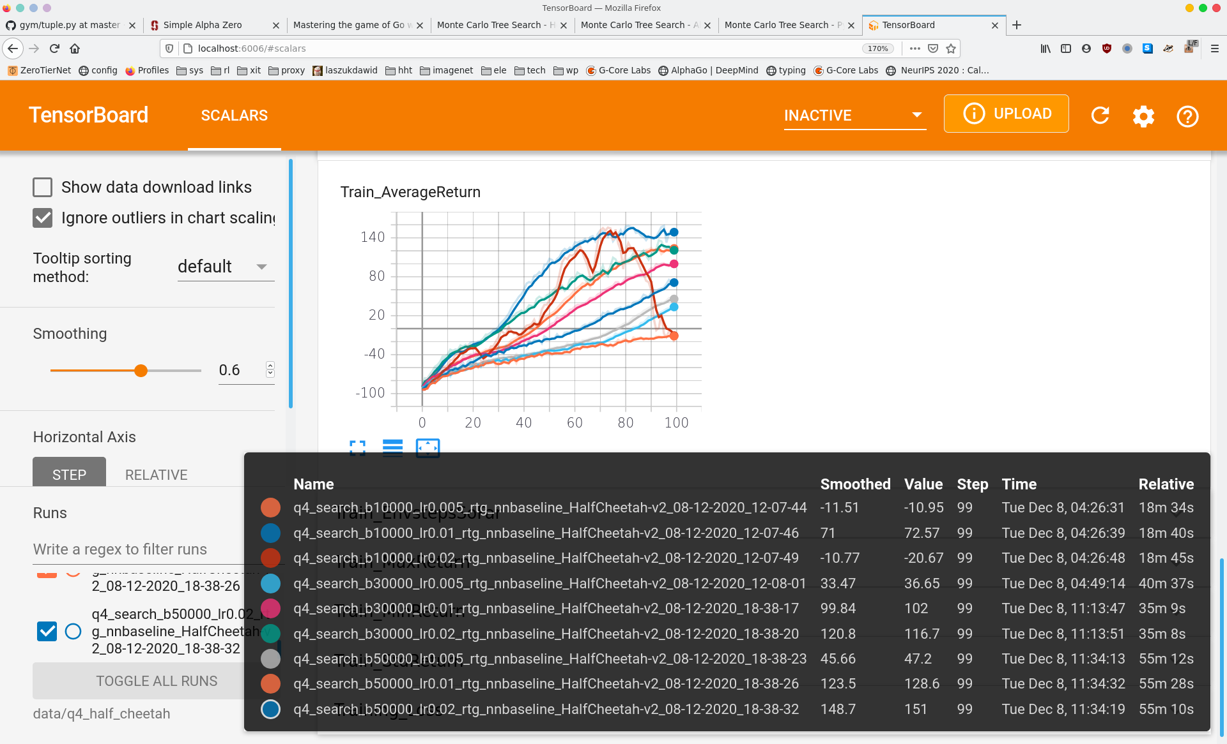
for Inverted Pendulum, b5000_lr0.03&0.02 is best
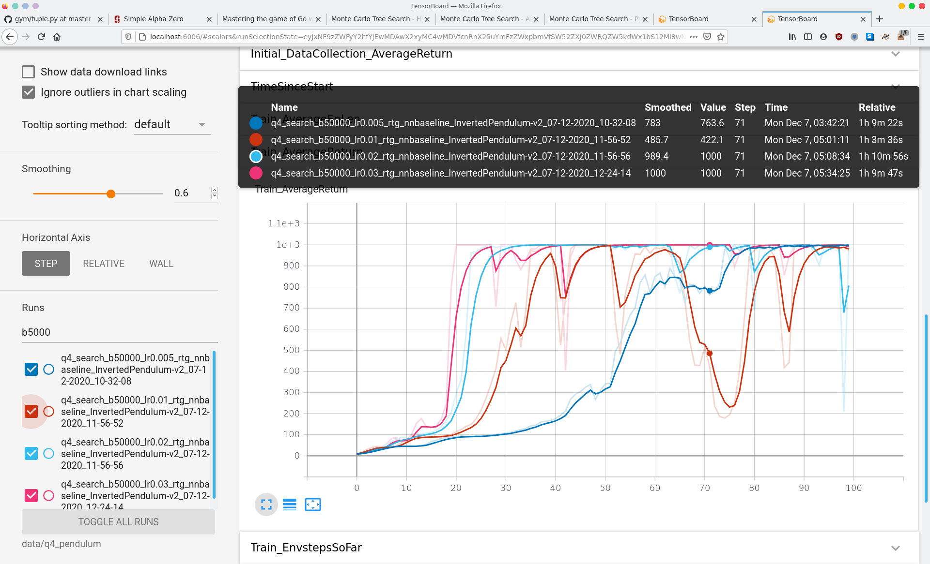
comparison of lr=0.005: (even if the lr is small enough, the curve also fluctuates after reaching maximum return of 1000)
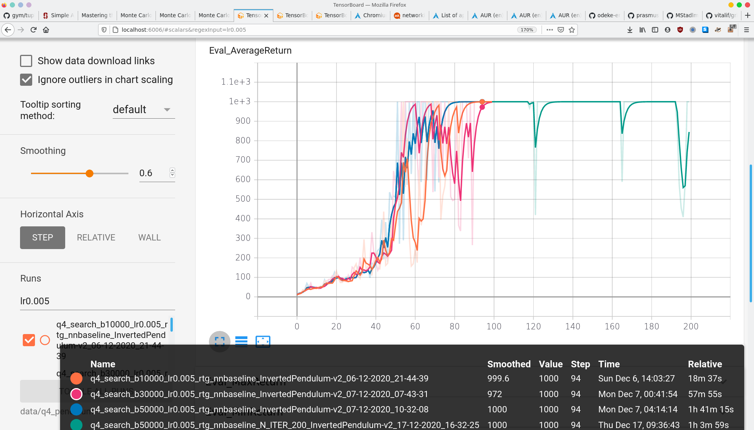
4.2 comparison of rtg, nn_baseline
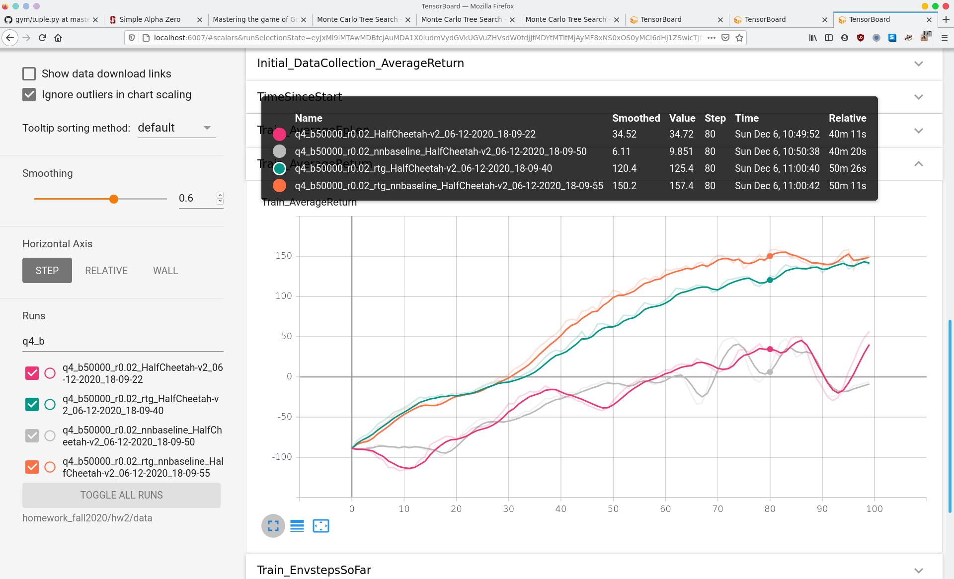
rtg_nnbaseline > rtg > (nnbaseline = original)

