Bayesian Optimisation Capstone
Week 4 Reflection | Hyperparameter Tuning and Neural Networks

1. Hyperparameter Effects on Model Behaviour
Hyperparameters are configuration values set before training that control how a model learns. Unlike weights, they are not updated by backpropagation. The three most consequential in neural networks are the learning rate, regularisation strength, and network architecture.
Learning rate is the most influential single setting. Too high and the loss oscillates or diverges; too low and training stalls before the optimum is reached. A rate of 0.1 typically converges well on standard tasks, while 0.5 produces the instability shown in Figure 1. The recommended practice, supported by the Adam optimiser literature (Kingma and Ba, 2015), is to start at 0.001 and schedule a decay.
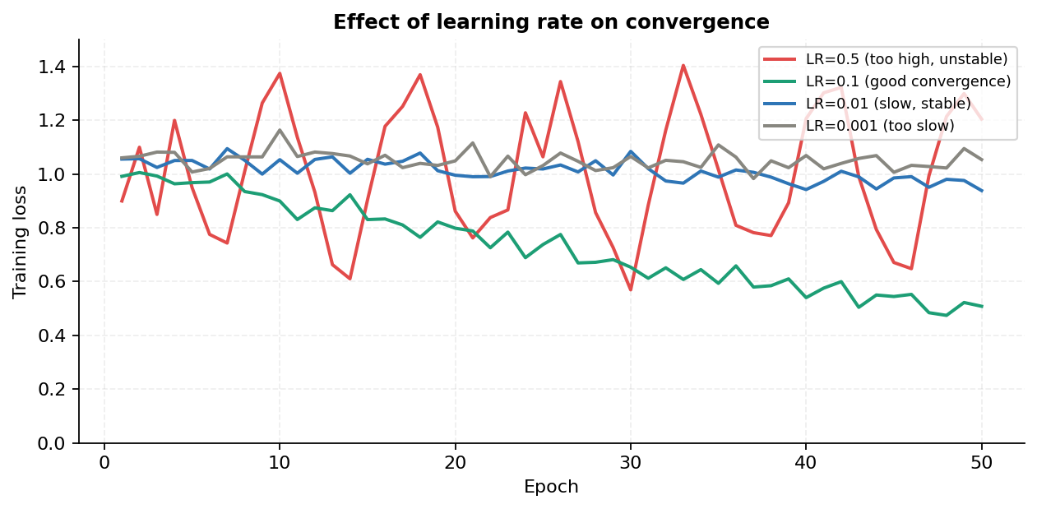
Figure 1: Simulated training loss for four learning rates. LR=0.1 converges cleanly; LR=0.5 oscillates and fails to settle.
Dropout rate controls regularisation. Values between 0.2 and 0.5 reduce overfitting by randomly deactivating neurons during training, forcing the network to learn redundant representations. Setting dropout too high (above 0.6) prevents the network from learning meaningful patterns at all.
Batch size affects both speed and generalisation. Smaller batches (16 to 64) introduce noise that acts as implicit regularisation and often generalise better, while larger batches are computationally efficient but can converge to sharp local minima (Keskar et al., 2017).

2. Discrete vs Continuous Hyperparameters
The distinction matters because it determines which tuning methods are appropriate. Continuous hyperparameters can be optimised with gradient-free methods such as Bayesian optimisation or random search over a log-uniform prior. Discrete hyperparameters require combinatorial search strategies.
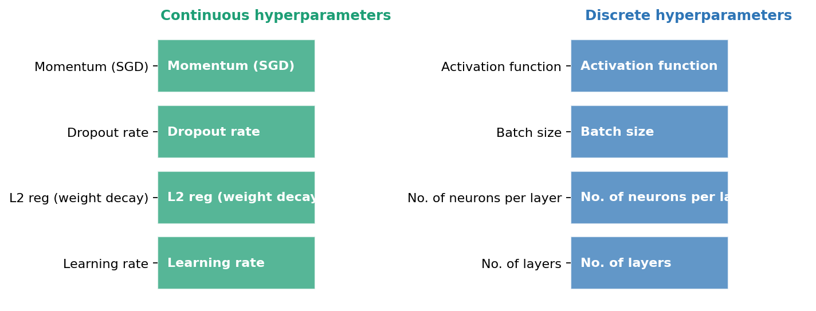
Figure 2: Categorisation of key neural network hyperparameters into continuous and discrete types.
Hyperparameter | Type | Typical tuning method | Sensitivity
Learning rate | Continuous | Log-uniform random / BO | Very high
L2 regularisation | Continuous | Log-uniform random / BO | Moderate
Dropout rate | Continuous (0 to 1) | Uniform random / BO | Moderate
Number of layers | Discrete (integer) | Grid or random search | High
Neurons per layer | Discrete (integer) | Grid or random search | Moderate
Batch size | Discrete (power of 2) | Grid search | Moderate
Activation function | Discrete (categorical) | Manual / grid search | High

Continuous hyperparameters respond well to Bayesian optimisation because the GP surrogate can model the smooth response surface and EI or UCB can guide the next query efficiently. Discrete and categorical hyperparameters are harder to handle with a GP directly and are typically addressed through grid search or by encoding them as integers in the search space.

3. Applying BBO Insights to Neural Network Tuning
The capstone uses a Gaussian Process surrogate rather than a neural network for the main optimisation task, for a well-grounded reason: with 12 to 43 observations per function, a neural network would overfit rather than generalise. However, the BBO methodology itself is directly applicable to neural network hyperparameter tuning, and the lessons learnt here translate directly.
The parallel is direct. In the capstone, each function evaluation is a query that returns a scalar output from an unknown surface. In hyperparameter tuning, each training run is an evaluation that returns a validation accuracy from an unknown performance surface. Both are expensive, both have limited budgets, and both benefit from a surrogate model that can predict promising configurations without exhaustive search.
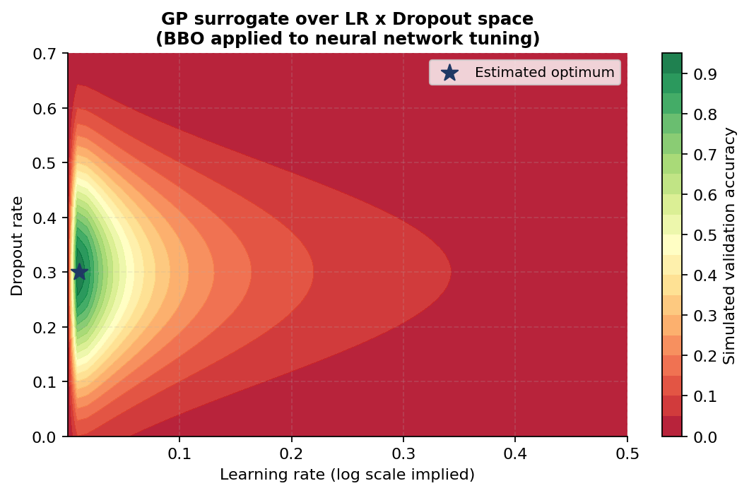
Figure 3: GP surrogate modelling the validation accuracy surface over learning rate and dropout space. The star marks the estimated optimum found by EI.
Constrained search boxes apply here too. In the capstone, F5 improved consistently once the search was constrained to the high-dim-2-to-4, low-dim-1 corner. The equivalent in hyperparameter tuning is restricting the learning rate search to a log range of [1e-4, 1e-1] once early experiments confirm that higher values are unstable. Both cases use prior evidence to narrow the search space and concentrate the query budget.
EI over UCB for exploitation. Once the learning rate and dropout combination producing the best validation accuracy is identified, EI with a low xi (around 0.001 to 0.01) targets fine-tuning in that neighbourhood rather than exploring distant configurations. This mirrors the approach applied to F4 and F5 in W4, where EI replaced the more exploratory UCB after the peak region was confirmed.
The core lesson from the capstone is that method selection should be driven by empirical evidence rather than defaults. The same principle applies to neural network tuning: start with random search to map the surface broadly, identify the promising region, then switch to EI-guided Bayesian optimisation for precise exploitation within that region.

Week 4 Reflection | Hyperparameter Tuning | Bayesian Optimisation Capstone

