Bayesian Optimisation Capstone
Module 16 Reflection — Neural Networks and Optimisation Strategy

1. Hierarchical Feature Learning and Strategy Structure
Hierarchical feature learning is the idea that early network layers learn simple patterns while later layers combine these into abstract representations. This mapped naturally onto how the strategy evolved week by week.
Week 1 acted like a first layer, capturing only the coarsest signal (uniform kappa 2.0). Week 2 added per-function kappa, a more refined feature. By Weeks 3-4, four distinct acquisition methods represented a more specialised layer, each tuned to the shape that had emerged from earlier weeks. Each stage built on the abstraction the previous stage learned, rather than restarting from scratch.

2. AlexNet, ImageNet, and Incremental Capstone Gains
AlexNet reduced the ImageNet top-5 error rate from 26.2% to 15.3% in a single year, a 10.8 percentage point leap after years of only marginal progress (Krizhevsky, Sutskever and Hinton, 2012).
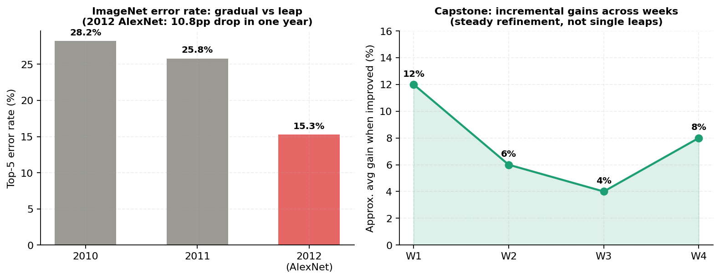
Figure 1: AlexNet's single-year leap vs the capstone's steady weekly gains.
The capstone's progress is incremental, not a leap: modest weekly gains building on the previous best input. The structural parallel is that AlexNet trusted the model to learn features automatically instead of hand-engineering them, and the capstone's shift from manual override cells (Week 2) to one embedded pipeline (Week 3 onward) reflects the same philosophy at a smaller scale.

3. Depth, Complexity, and the Explore-Exploit Trade-off
Network depth trades representational power against training time and overfitting risk. The same trade-off appeared in choosing how widely to search versus how tightly to exploit known regions.
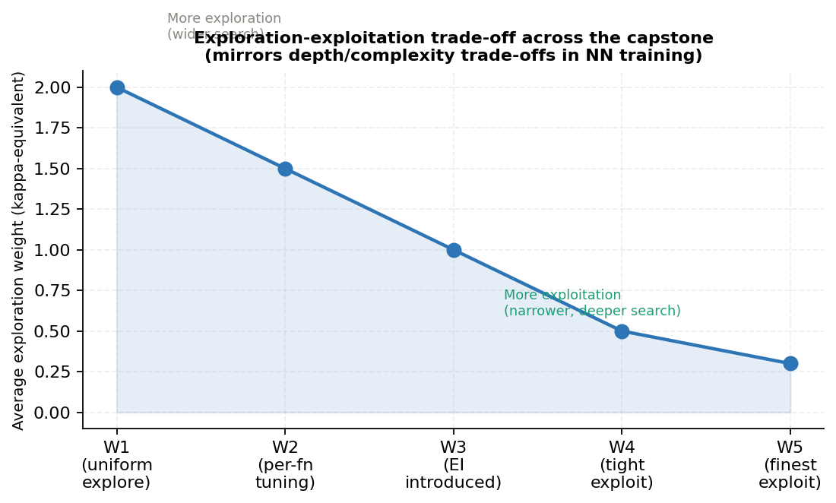
Figure 2: Exploration weight falling across the capstone, mirroring an annealed learning rate.
A wide search (high kappa) is cheap per query but slow to converge, like a shallow network. A narrow search (low kappa, low xi) converges fast but risks getting stuck on the wrong point, like an overfit deep network. Kappa fell from 2.0 to 0.3-1.0 across five weeks, mirroring the standard practice of annealing a learning rate as training stabilises.

4. Building Blocks Applied to the Data
Gradients were the most transferable concept. The GP's predicted mean acts as an implicit gradient, and for F4 it consistently pointed toward [0.40, 0.40, 0.41, 0.41] across three weeks, exactly as a true gradient would point downhill during training.
Loss and weight updates reframed each query as the one update that most reduces uncertainty, not a single perfect guess — the same logic that explains why one gradient step never jumps straight to the minimum.

5. Framework Analogy: PyTorch-Style or Production-Ready?
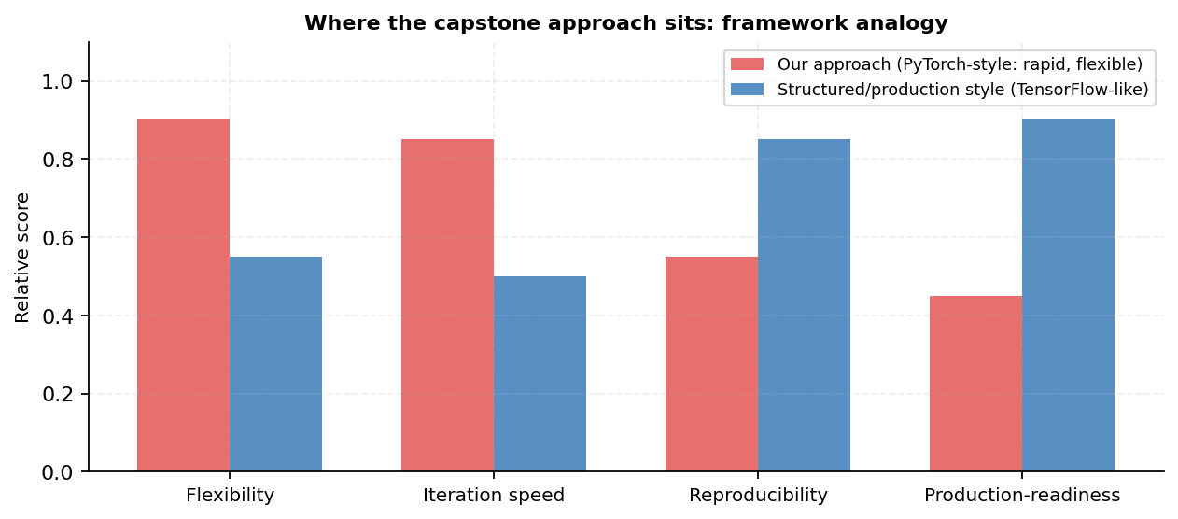
Figure 3: The approach scores closer to PyTorch-style flexibility than TensorFlow-style production design.
The approach sits closer to PyTorch-style rapid prototyping than structured production design. Each week's notebook was rebuilt based on the previous week's results: new acquisition methods introduced ad hoc, bounds hand-tuned per function, the pipeline reshaped five times. With one query per function per week and no chance to retrain mid-week, the value was in changing strategy quickly, not building something fixed and reusable.

6. Real-World Benchmarks and the Capstone
Industry deep learning in sport is judged by outcomes that matter, not an abstract accuracy number. That framing is a useful corrective here: judging each week purely by whether a function "won" misses the point.
A better benchmark: did the gain meaningfully reduce uncertainty about the true optimum, given that one query per function per week is a genuinely scarce resource? By that standard, F6 and F7's three and two consecutive new bests are more valuable than one isolated large jump, since they show a strategy that compounds reliably, closer to how deployed systems are actually judged.

Module 16 Reflection | Bayesian Optimisation Capstone

