Bayesian Optimisation Capstone
Repository Structure, Libraries, and Documentation Review

1. Repository Structure
Current state. Everything currently sits in a single flat outputs folder: weekly strategy markdown files, standalone notebook scripts, reflection Word documents, and one Excel tracker, all named by week number. This worked for fast iteration but has become harder to navigate now that five weeks of files (roughly 15 documents) sit side by side with no folder separation.
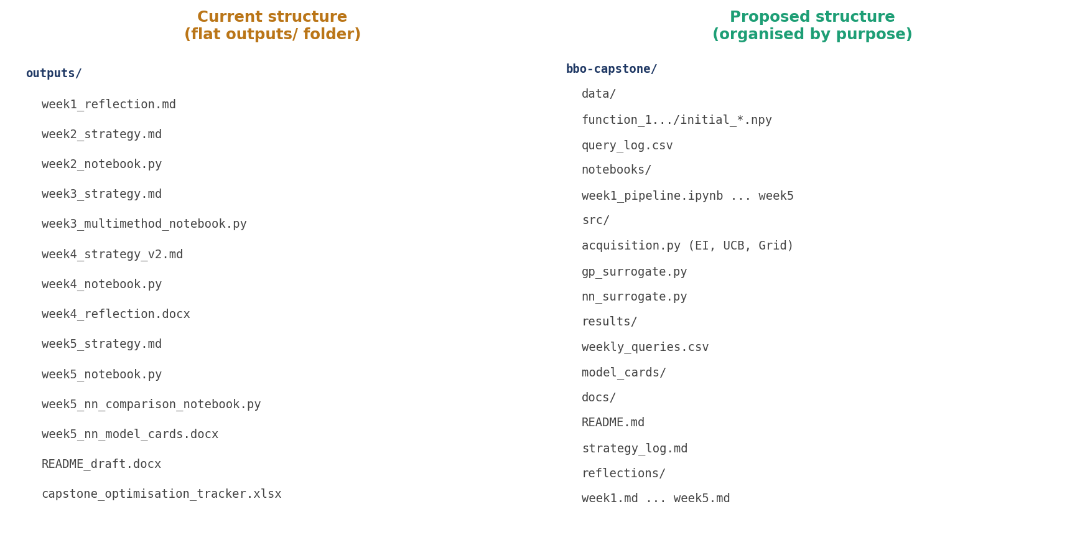
Figure 1: Current flat structure (left) versus a proposed structure organised by purpose (right).
Planned changes for clarity and reproducibility:
- Separate data/, notebooks/, src/, results/, docs/, and reflections/ folders, replacing the single outputs/ folder.
- Move repeated functions (fit_gp, ei_query, ucb_query, grid_search_query) out of each week's notebook into a shared src/acquisition.py and src/gp_surrogate.py, so Week 6 onward imports rather than copies code.
- Add a single query_log.csv that appends every week's submitted query and returned output, replacing the need to re-read five separate strategy documents to reconstruct history.
- Rename notebooks consistently as week{n}_pipeline.ipynb and convert the standalone .py scripts to .ipynb so outputs are visible inline, improving reproducibility for anyone re-running the work.

2. Coding Libraries and Packages
Three libraries form the core of the approach, with a fourth added in Week 5 for comparison.
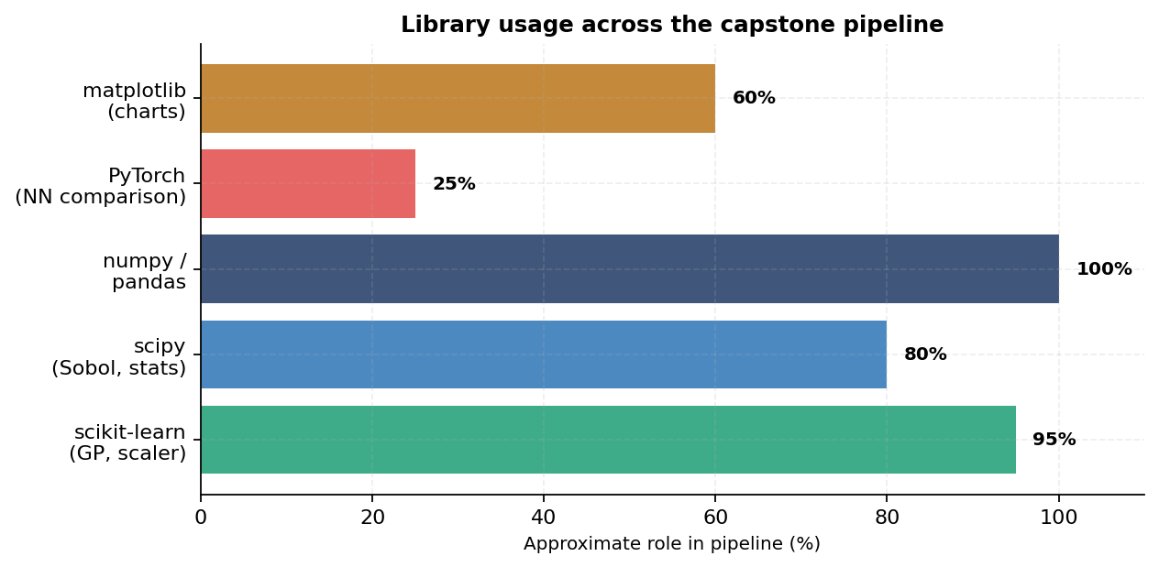
Figure 2: Approximate role of each library across the full pipeline.
Library | Used for | Why appropriate | Trade-off considered
scikit-learn | GaussianProcessRegressor, StandardScaler | Exact inference, calibrated uncertainty, works well with 12-47 observations | Slower than a custom GP at scale, but the project never exceeds 47 points
scipy | Sobol sequences, norm.cdf/pdf for EI | Quasi-random candidates give better space coverage than uniform sampling | Sobol requires scipy >= 1.7; minor version dependency to manage
numpy / pandas | Array maths, query history, CSV export | Standard, well-documented, no realistic alternative needed | None significant at this scale
PyTorch | Week 5 MLP surrogate, for comparison only | Flexible for a small custom architecture; easy MC Dropout | Networks have 7-19x more parameters than observations per function, so PyTorch results are documented, not used to drive queries

TensorFlow was not adopted alongside PyTorch. Both frameworks would have served the small comparison network equally well; PyTorch was chosen for its more direct, less boilerplate-heavy syntax when defining a custom four-layer MLP, which matched the exploratory, frequently-changing nature of this part of the project.

3. Documentation Review
Current README and strategy docs describe the project purpose (maximising eight black-box functions under a one-query-per-week budget), the input/output format (hyphen-separated decimal vectors in [0,1], single float outputs), and the high-level method (GP surrogate with UCB initially, evolving to EI, Thompson Sampling, then a four-method mix). The README draft from Week 2 still reflects an early-stage method list and has not been updated since.
Document | Currently reflects | Needs updating to
README_draft.docx | Week 2 method (uniform UCB, per-function kappa) | Week 5 four-method mix, NN comparison, current running bests
week*_strategy.md | Accurate but scattered across 5 separate files | Consolidated into one docs/strategy_log.md with a running changelog
Model cards (Week 5) | Built on representative/synthetic data, not the real .npy files | Re-run against actual datasets once notebook executes successfully

The most urgent documentation gap is the README: it should be updated to state the current running best for all eight functions and the current acquisition method per function, since both have changed substantially since the draft was last written in Week 2.

Repository and Documentation Review | Bayesian Optimisation Capstone

