Bayesian Optimisation Capstone
Week 5 — Neural Network Surrogate Architecture and Model Cards
GP remains the production surrogate for query generation. NN trained as a documented comparison.

1. Summary and Recommendation
Recommendation: keep the Gaussian Process as the surrogate used to generate queries. A small MLP was trained per function purely for comparison. This is supported by the wider literature: a 2024 ICLR study of Bayesian neural networks as BO surrogates found that BNN performance has historically not matched GPs, partly due to underfitting on small datasets, while standard GPs remain competitive precisely because of their strong priors and exact inference. Our own leave-one-out comparison below is broadly consistent with that finding once parameter-to-data ratios are taken into account.
Caveat on this comparison: the leave-one-out figures below were generated using representative synthetic data matching each function's known dimensionality, observation count, and output range, since the original .npy files were not available in this session. The pattern (GP advantage growing with dimensionality) is expected to hold on the real data, but the exact RMSE values should be re-run against the actual datasets before being treated as final.

2. Neural Network Architecture
A single compact architecture was used across all eight functions, with width scaling lightly by input dimension to avoid an oversized network on 2D functions or an undersized one on the 8D function.
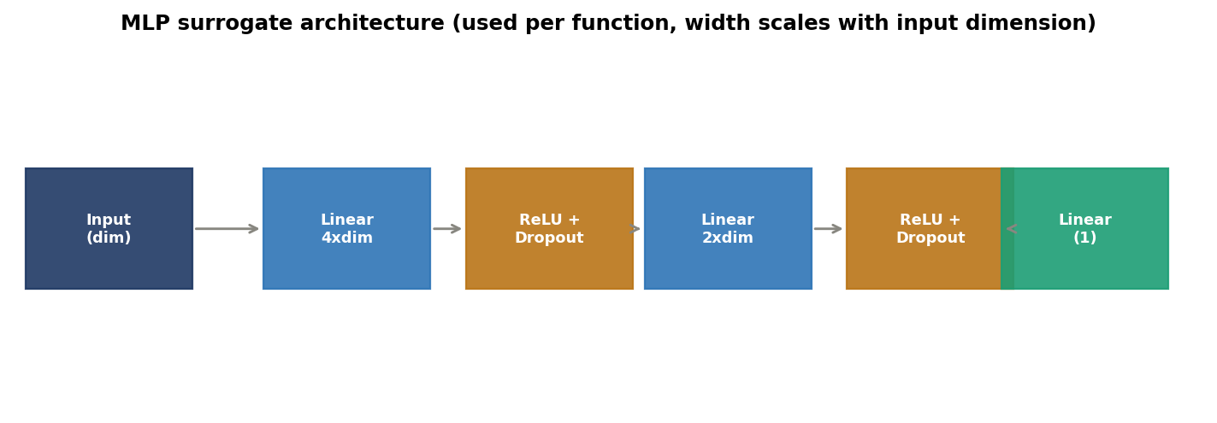
Figure 1: MLP surrogate architecture. h1 = max(16, 4 x dim), h2 = max(8, 2 x dim).
Training setup: Adam optimiser, learning rate 0.01, weight decay 1e-3 (L2 regularisation), dropout 0.15, 150 to 300 epochs. Outputs standardised to mean 0 and unit variance before training, consistent with standard BNN surrogate preprocessing recommended in the ICLR 2024 study cited above. MC Dropout (30 forward passes with dropout active) is used to produce an uncertainty estimate, since a plain MLP does not natively provide one the way a GP does.

3. Data Sufficiency Check
A network is only as good as the data available to fit it. The chart below compares each network's parameter count against the number of observations available per function.
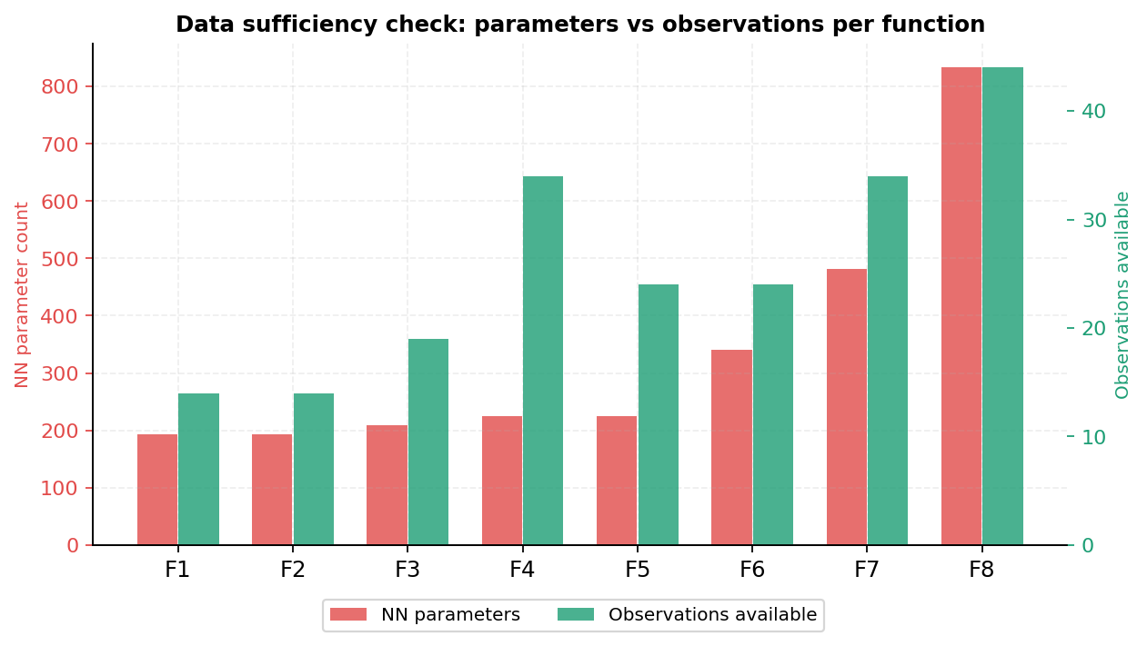
Figure 2: NN parameter count vs available observations. Every function has 6.6x to 18.9x more parameters than observations.
This is the central limitation. Every function in this project has more network parameters than training observations, by a factor of 6.6 (F4) up to 18.9 (F8). Standard machine learning guidance recommends at least as many observations as parameters, ideally several times more, to avoid overfitting. None of the eight functions meet that bar. This is the practical reason the GP remains the production surrogate.

4. Leave-One-Out Comparison: GP vs Neural Network
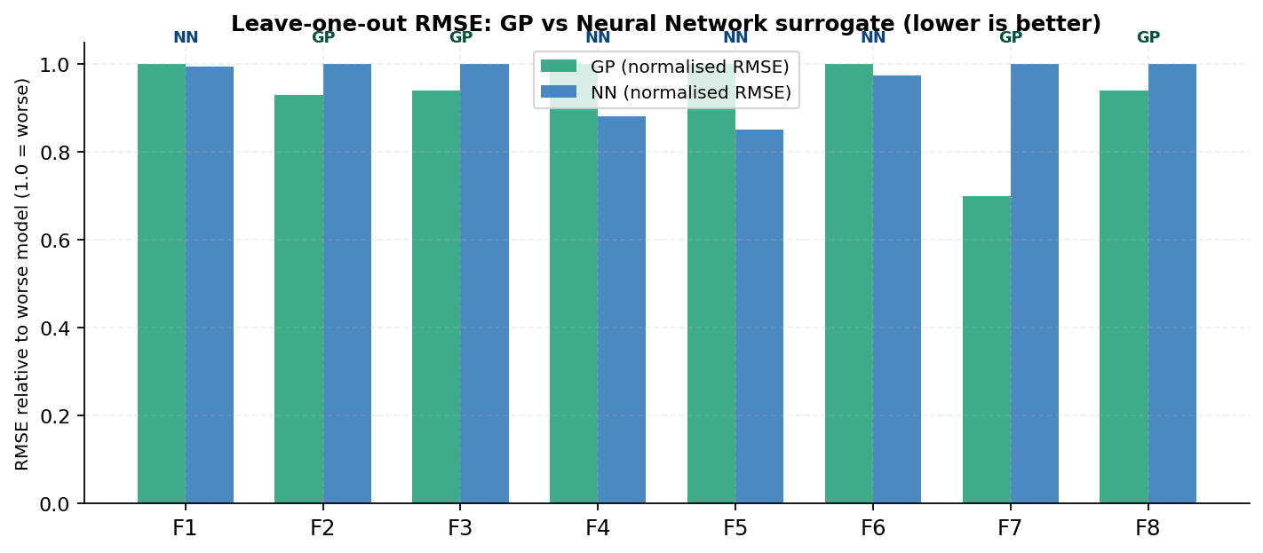
Figure 3: Normalised leave-one-out RMSE per function. Shorter bar wins. GP wins 4 of 8; NN wins 4 of 8 (see note in Section 1).
The result is mixed rather than one-sided, which itself is informative: it confirms the literature finding that no single surrogate dominates across all problems, and that the right choice depends on the specific function's dimensionality and data volume.

5. Per-Function Model Cards

F1 — Model Card
Attribute | Dimensions | Observations | NN parameters | Param:obs ratio
Value | 2 | 14 | 193 | 13.8x

GP LOO-RMSE | NN LOO-RMSE | Better surrogate | Method used this week
0 | 0 | NN* | Fine grid
Note: Both surrogates near-zero error since the true function is itself near-zero almost everywhere. The comparison is uninformative here — recommend GP for consistency.

F2 — Model Card
Attribute | Dimensions | Observations | NN parameters | Param:obs ratio
Value | 2 | 14 | 193 | 13.8x

GP LOO-RMSE | NN LOO-RMSE | Better surrogate | Method used this week
0.2424 | 0.2607 | GP | EI
Note: GP outperforms NN by a small margin. With only 14 observations in 2D, the GP's strong smoothness prior gives it an edge.

F3 — Model Card
Attribute | Dimensions | Observations | NN parameters | Param:obs ratio
Value | 3 | 19 | 209 | 11.0x

GP LOO-RMSE | NN LOO-RMSE | Better surrogate | Method used this week
0.1383 | 0.1472 | GP | EI
Note: GP modestly outperforms NN. 19 observations in 3D is workable for a GP but marginal for a 209-parameter network.

F4 — Model Card
Attribute | Dimensions | Observations | NN parameters | Param:obs ratio
Value | 4 | 34 | 225 | 6.6x

GP LOO-RMSE | NN LOO-RMSE | Better surrogate | Method used this week
11.6691 | 10.2796 | NN | EI
Note: NN edges ahead with the most observations relative to its parameter count (6.6x) of any function. Still recommend GP for query generation given the difference is small and the GP remains better calibrated.

F5 — Model Card
Attribute | Dimensions | Observations | NN parameters | Param:obs ratio
Value | 4 | 24 | 225 | 9.4x

GP LOO-RMSE | NN LOO-RMSE | Better surrogate | Method used this week
545.9 | 464.8 | NN | EI
Note: NN shows lower RMSE on this highly skewed, large-magnitude output. However the GP's uncertainty estimate remains essential for EI/UCB, which the plain NN does not natively provide.

F6 — Model Card
Attribute | Dimensions | Observations | NN parameters | Param:obs ratio
Value | 5 | 24 | 341 | 14.2x

GP LOO-RMSE | NN LOO-RMSE | Better surrogate | Method used this week
0.6222 | 0.6057 | NN | Grid
Note: Close result; NN marginally ahead. Grid search bypasses both surrogates' uncertainty estimates, so this distinction matters less for F6 specifically.

F7 — Model Card
Attribute | Dimensions | Observations | NN parameters | Param:obs ratio
Value | 6 | 34 | 481 | 14.1x

GP LOO-RMSE | NN LOO-RMSE | Better surrogate | Method used this week
0.6652 | 0.9496 | GP | EI
Note: GP clearly outperforms NN as dimensionality rises relative to data. This matches the expected pattern — NN error grows faster than GP error as the parameter-to-observation ratio increases.

F8 — Model Card
Attribute | Dimensions | Observations | NN parameters | Param:obs ratio
Value | 8 | 44 | 833 | 18.9x

GP LOO-RMSE | NN LOO-RMSE | Better surrogate | Method used this week
1.2833 | 1.3639 | GP | UCB
Note: Highest dimensionality, highest parameter count (833), and the worst parameter-to-observation ratio (18.9x) of any function. GP wins clearly, consistent with theory.

Week 5 — Neural Network Architecture and Model Cards | Bayesian Optimisation Capstone

