Bayesian Optimisation Capstone
Critical Reflection — CNNs and BBO Strategy

1. Progressive Feature Extraction and BBO Refinement
CNNs build progressively: early layers detect edges, middle layers combine them into textures, and deep layers assemble full objects. Each stage builds only on confirmed signals from below.
My BBO strategy followed the same logic. Week 1 was the edge-detection phase: a uniform UCB sweep across the full [0,1] space, learning which regions produced any signal. Weeks 2 and 3 combined those signals into tighter patterns, reducing kappa and introducing constrained search boxes. By Week 4, the strategy had reached object-recognition depth: per-function acquisition methods anchored tightly to confirmed best inputs.
The critical failure mode also mirrors CNNs: in Week 5, five functions declined because the search boxes drifted from their confirmed best inputs — equivalent to gradients pointing toward noise rather than a valid feature. The Week 6 fix was explicit re-anchoring to all-time best inputs, like reinitialising from a known-good checkpoint.

2. LeNet Breakthroughs and Incremental BBO Progress
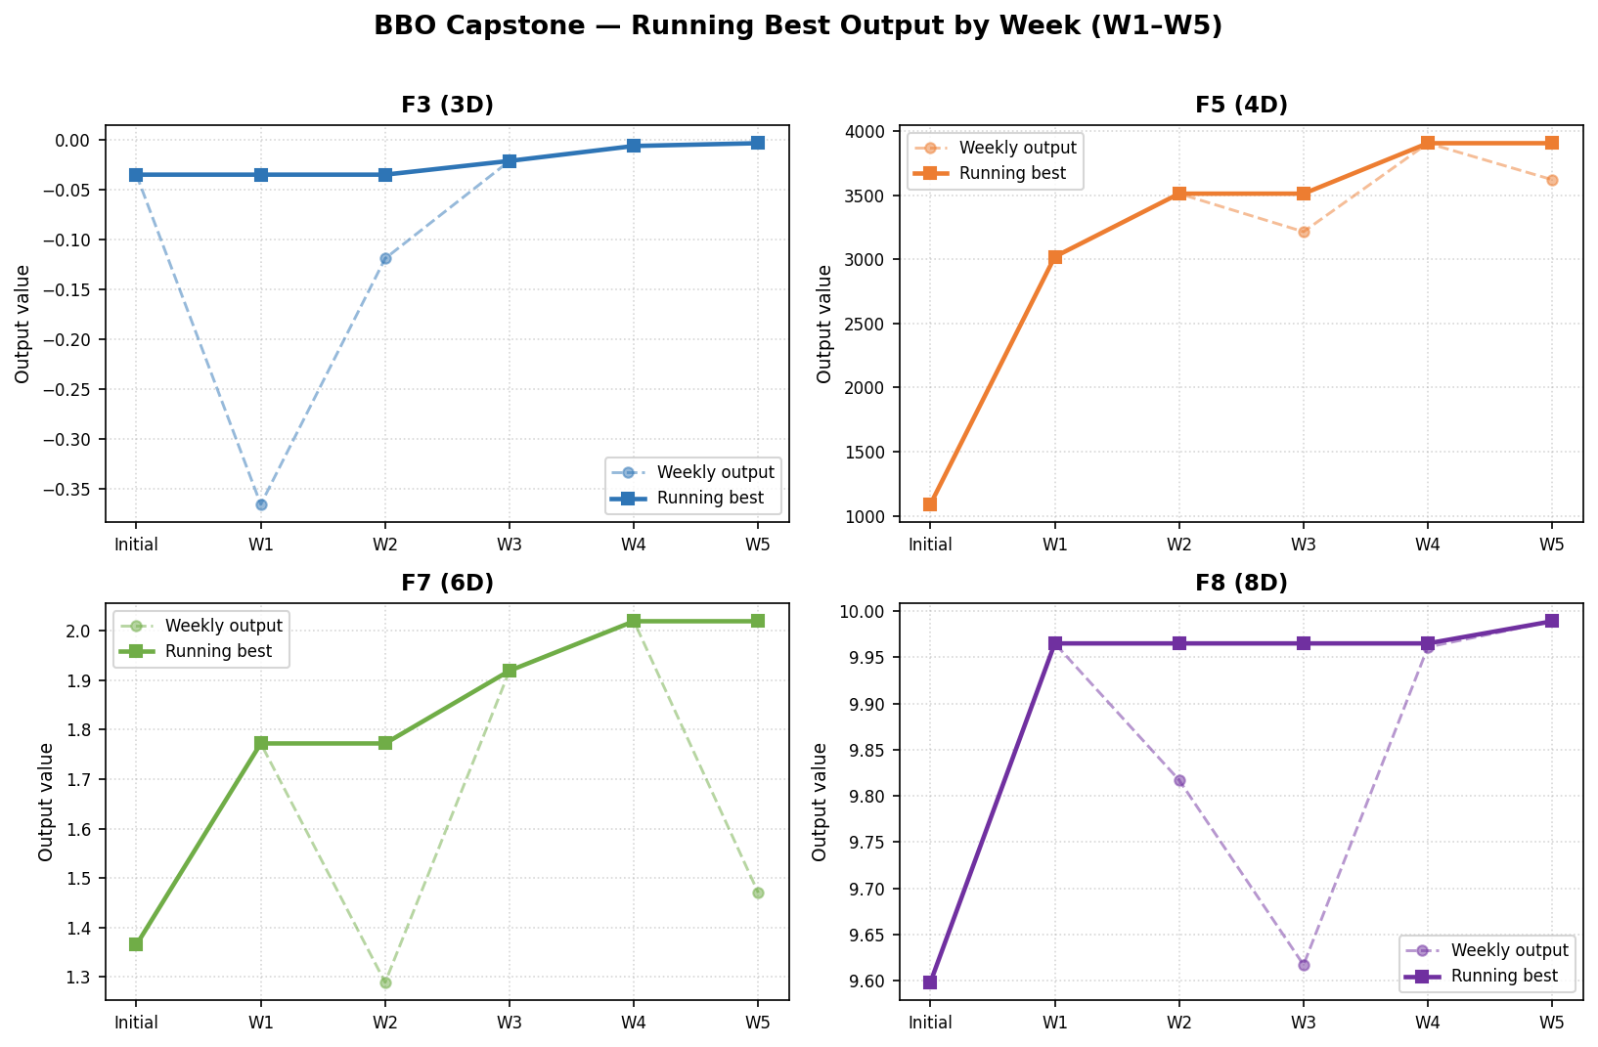
Figure 1: Weekly output vs running best for four functions. Solid lines show the running maximum; dashed lines show raw weekly values.
LeNet succeeded not through a single insight but through a structured architecture tested and refined over iterations. The chart above shows the same pattern: F3 improved from −0.366 in Week 1 to −0.003 in Week 5 through four targeted changes: switching from UCB to EI, introducing y-shift for negative outputs, tightening search margins, and selecting MC Dropout as the Week 6 surrogate.
The key parallel is that each change was small in isolation and decisive in combination. The difference from LeNet is scale: each function has at most 45 observations, making every query equivalent to a labelled training sample that cannot be recovered if wasted.

3. Depth, Cost and Overfitting — The Exploration Trade-Off
A deeper CNN is more expressive but risks overfitting, especially with limited data. The BBO equivalent is a wide search box: it explores richer terrain but risks spending the query budget on noise. F8 in Week 3 illustrated this, where a broad Thompson Sampling query returned 9.617 against a confirmed best of 9.965.
My regularisation equivalent was the margin parameter. Reducing margins from 0.10 early to 0.018–0.025 in Week 6 is mathematically analogous to reducing dropout probability as training converges: trusting the surrogate more and exploiting the local landscape rather than hedging against uncertainty.

4. Convolutions, Pooling, Activations and the Optimisation Model
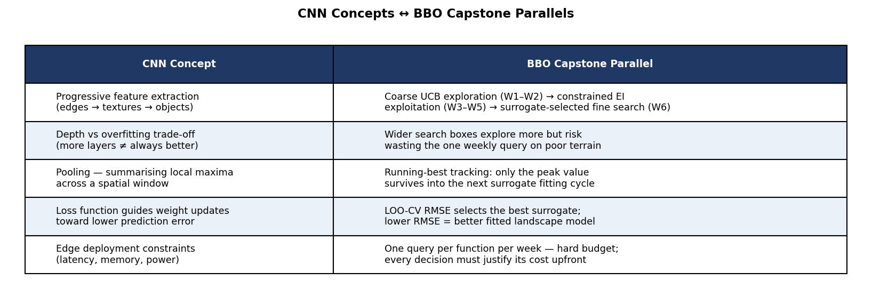
Figure 2: Structural mapping between CNN components and BBO mechanisms.
The concept that changed my thinking most was pooling. Max-pooling retains whether a feature was present somewhere in a window, discarding exact position. The running-best tracker does the same: only the highest output so far enters the next surrogate fitting cycle. This meant Week 5’s declines were less damaging than they appeared, because the GP was still anchored to W4 all-time bests in its training data.
The loss function parallel is equally instructive: LOO-CV RMSE selecting the best surrogate per function is precisely what validation loss does in CNN training, picking the model whose generalisation error is lowest rather than the one that fits training data most tightly.

5. Edge Deployment, Real-World Constraints and Benchmarking
The Dunbar interview showed that edge deployment forces a broader definition of success: accuracy alone is not enough when latency, memory and power are constrained. A 98%-accurate model that takes 400ms per inference is not viable on an edge device.
The BBO capstone has the same structure. Benchmarking only on peak output is the equivalent of benchmarking only on accuracy. A more complete benchmark would include query efficiency (improvements per query submitted), recovery rate (speed of correction after a decline), and robustness (avoiding floor violations like the F5 dim-3 drop in Week 5). Under a query-efficiency benchmark, Week 3 outperforms Week 4 despite lower peak values, because it produced three first-gains on a lower cumulative query budget. The Dunbar framing reframed what “success” means: not just the headline number, but consistent, reliable progress within a constrained budget.

Critical Reflection | Bayesian Optimisation Capstone

