Bayesian Optimisation Capstone
Week 7 Reflection: Hyperparameter Tuning Strategy

1. Hyperparameters Chosen and How They Changed the Strategy
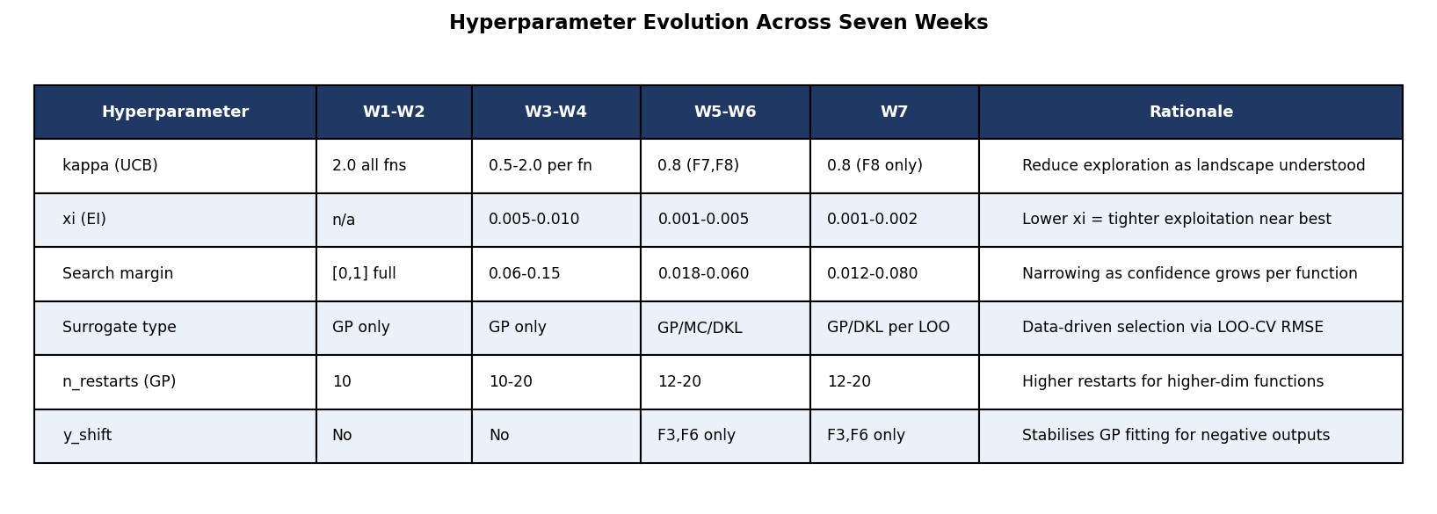
Figure 1: Hyperparameter settings across all seven weeks, from uniform early values to function-specific fine-tuning.
Three hyperparameters drove the most meaningful changes: the search margin, the acquisition parameter (kappa for UCB or xi for EI), and the surrogate type. These were prioritised because they directly determined where each query landed. Kernel length scales were tuned automatically by marginal likelihood maximisation inside scikit-learn.
The shift from Week 1 to Week 7 is significant. Week 1 used kappa=2.0 uniformly across all eight functions. By Week 7, F5 has a search margin of 0.003 while F1 has 0.080, a twenty-fold difference that reflects how differently each function responded to prior queries.

2. Tuning Methods and Trade-offs
Manual adjustment was the primary method. Each week the margin and acquisition parameter were updated by inspecting per-dimension drift in the previous query. This is slow but preserves domain knowledge that an automated method might overlook.
LOO-CV RMSE automated surrogate selection from Week 5 onward. The F3 case in Week 6 showed the main trade-off: LOO-CV selected MC Dropout, which produced a regression. Automated selection fits historical data well but cannot always guarantee safe extrapolation toward the true optimum, which is why the selection was manually overridden in Week 7.

3. Limitations at 16 Observations
Three limitations became clearer as the dataset grew. Sharp-peak functions like F4 show diminishing EI returns because GP uncertainty near the confirmed best drops to near zero, leaving little signal to guide the next query. Higher-dimensional functions such as F7 at 6D and F8 at 8D remain data-sparse even at 16 observations, and the GP cannot reliably identify which input dimensions matter most. Early exploratory queries from the first two weeks also persist in the training set and can pull the GP mean slightly away from the true optimum.

4. Future Applications and Practitioner Mindset
At larger scale the manual margin schedule would be replaced by a statistical convergence monitor on the EI series, which signals when the search has stabilised. BoTorch Monte Carlo acquisition functions handle batch queries and noisy observations more naturally, and k-fold cross-validation would replace LOO-CV above a few hundred observations.
The most transferable skill from this project is anchoring every decision to confirmed empirical evidence rather than surrogate model predictions. Every week a submitted query drifted from the confirmed best input, the output declined. That lesson applies directly to any production ML context where evaluations are expensive, feedback arrives slowly, and there is no opportunity to rerun a bad decision.

5. Performance Summary: Initial Best to Week 6 All-Time Best
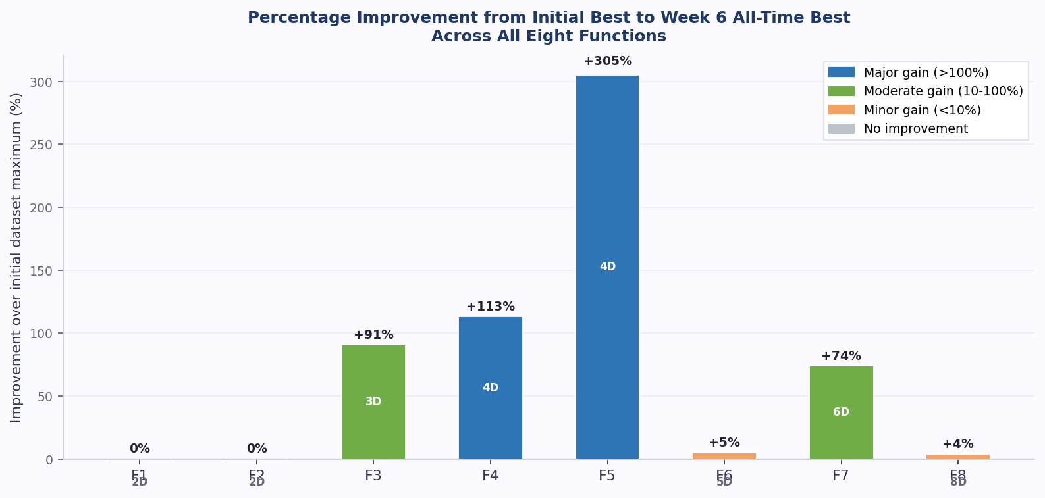
Figure 2: Percentage improvement from the initial dataset maximum to the Week 6 all-time best for each function. Dimension shown inside each bar. F1 and F2 show 0% as no submitted query beat the initial best.
Six of the eight functions improved beyond their initial best. F5 achieved the largest gain at +305%, driven by the DKL surrogate finding a new surface region in Week 6. F4 crossed from negative to positive territory at +113%. F7 gained +73.9% through consistent GP exploitation. F6 and F8 improved modestly at under 5%, suggesting the search is approaching a ceiling in both cases. F1 and F2 remain unchanged, representing the two most persistent challenges in the project.
The individual charts below show each function's output at every stage from the initial dataset through to Week 6, with the running best trajectory overlaid and the all-time best marked as a dashed red line.

F1 (2D) | ATB: 7.71e-16 (Initial) | Gain: 0.0%
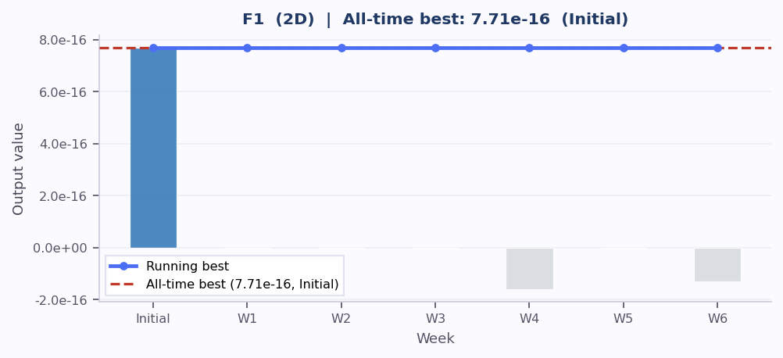
F1: bars show weekly output (blue = at or above all-time best, green = above initial, grey = below initial). Line = running best. Red dashed = all-time best.
No query has beaten the initial best. The function appears near-flat around the initial best input at [0.731, 0.733]. W7 widens the search margin to 0.080 to test whether a better region exists further away.

F2 (2D) | ATB: 0.611 (Initial) | Gain: 0.0%
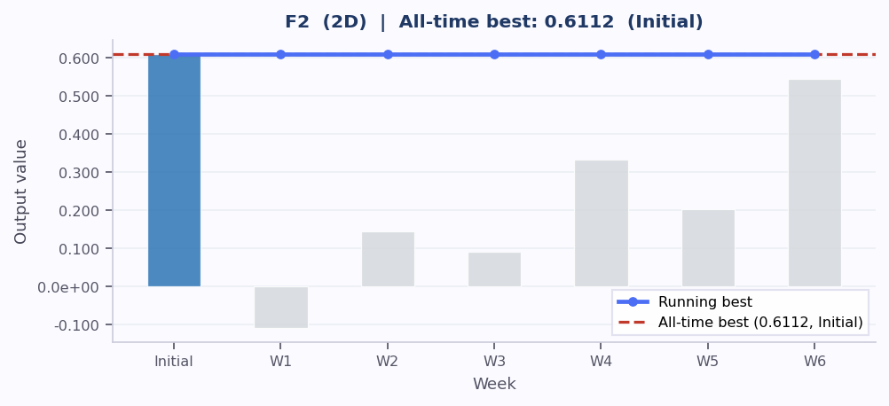
F2: bars show weekly output (blue = at or above all-time best, green = above initial, grey = below initial). Line = running best. Red dashed = all-time best.
Initial best unbeaten despite six queries. W6 returned 0.545, the closest yet. Every week dim2 was below 0.92 the output stayed below 0.55. W7 enforces a hard dim2 floor at 0.92.

F3 (3D) | ATB: -0.003 (W5) | Gain: +90.8%
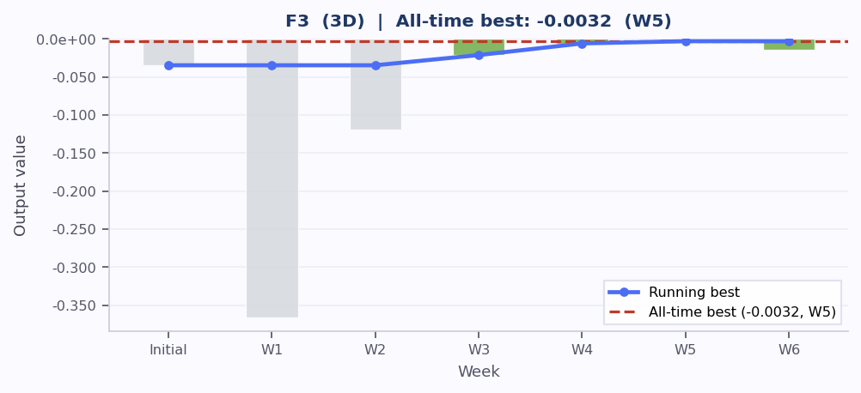
F3: bars show weekly output (blue = at or above all-time best, green = above initial, grey = below initial). Line = running best. Red dashed = all-time best.
Three consecutive gains in W3, W4 and W5. W6 regression occurred when MC Dropout moved dims 2 and 3 away from the W5 best input. GP restored in W7 with a tighter 0.025 margin.

F4 (4D) | ATB: 0.534 (W2) | Gain: +113.3%
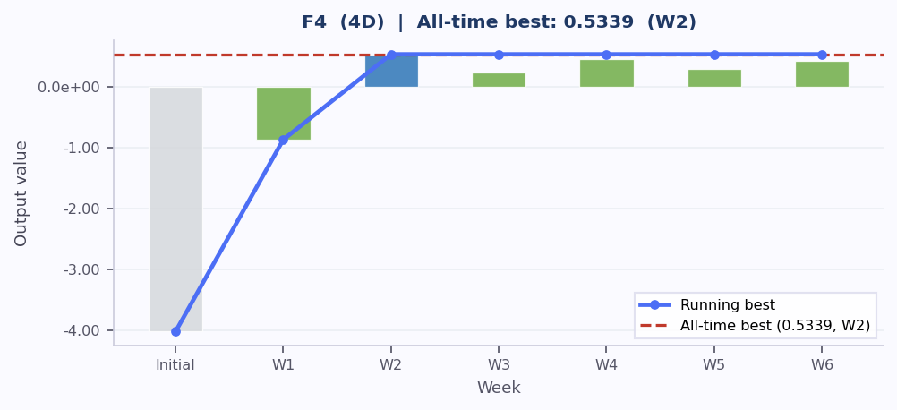
F4: bars show weekly output (blue = at or above all-time best, green = above initial, grey = below initial). Line = running best. Red dashed = all-time best.
Crossed from strongly negative to positive in W2 and held for five weeks. The W2 best at [0.404, 0.398, 0.413, 0.412] suggests a very sharp peak. W7 uses the tightest margin applied to any function: 0.012.

F5 (4D) | ATB: 4413 (W6) | Gain: +305.3%
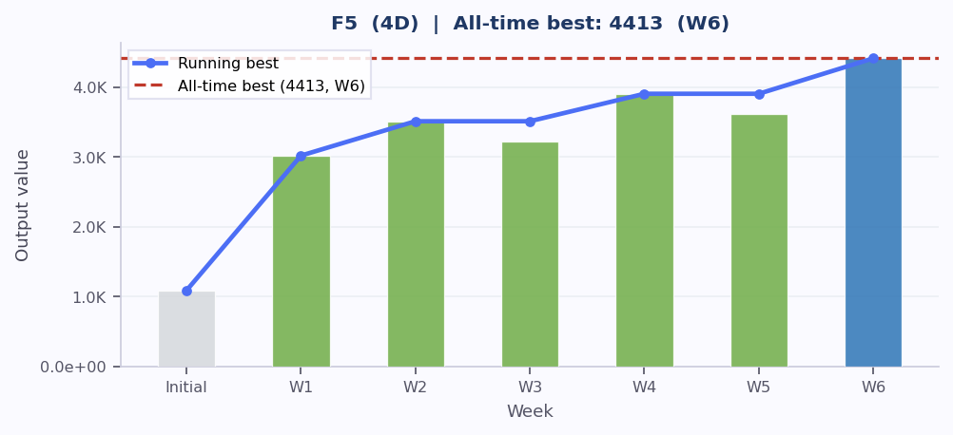
F5: bars show weekly output (blue = at or above all-time best, green = above initial, grey = below initial). Line = running best. Red dashed = all-time best.
Largest gain in the project. DKL discovered in W6 that dim1 near zero is a qualitatively different and superior surface region. W7 constrains dim1 to [0.000, 0.003] to exploit this fully.

F6 (5D) | ATB: -0.680 (W4) | Gain: +4.8%
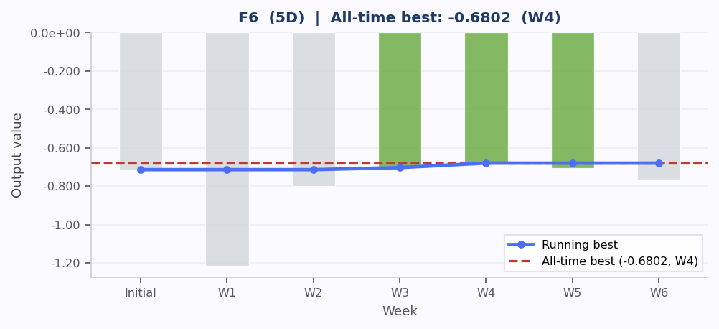
F6: bars show weekly output (blue = at or above all-time best, green = above initial, grey = below initial). Line = running best. Red dashed = all-time best.
Grid search improved consistently through W4 then plateaued. W5 and W6 minor regressions suggest the grid cells are moving in the wrong direction. W7 switches to EI around the W4 best input.

F7 (6D) | ATB: 2.374 (W6) | Gain: +73.9%
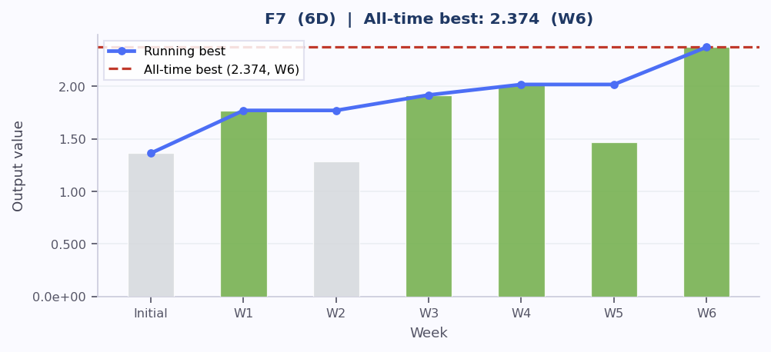
F7: bars show weekly output (blue = at or above all-time best, green = above initial, grey = below initial). Line = running best. Red dashed = all-time best.
Volatile surface with a sharp W6 gain of 17.6% above the prior best. W5 decline was caused by EI drifting 0.22 from the W4 best input. W7 uses a 0.020 margin to stay close to the W6 result.

F8 (8D) | ATB: 9.989 (W5) | Gain: +4.1%
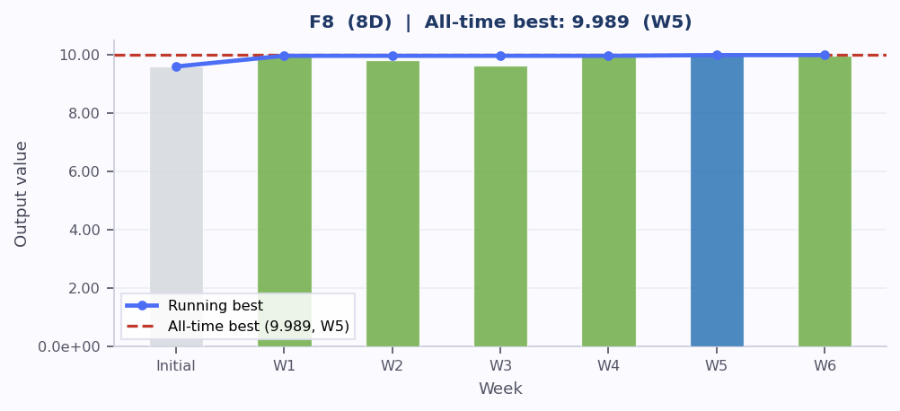
F8: bars show weekly output (blue = at or above all-time best, green = above initial, grey = below initial). Line = running best. Red dashed = all-time best.
Narrow output range suggesting the function approaches a ceiling near 10. W3 Thompson Sampling broad search produced the only below-baseline result. W7 tightens the margin to 0.035 anchored to the W5 best.

Week 7 Reflection | Bayesian Optimisation Capstone

