CNN Applicability in Manufacturing Quality Control
Industry Challenge Reflection

The industry challenge identified earlier concerns visual defect detection on manufacturing production lines. Manual inspection is slow, inconsistent across shifts, and struggles to catch micro-scale surface defects at high throughput. CNNs are a natural fit because the defects are spatial, the input is image-based, and a missed reject costs far more than a false alarm.

1. Relevant Data
Available data types. High-resolution RGB cameras mounted above conveyor belts capture product surfaces at line speed. Thermal imaging cameras can reveal internal stress fractures invisible to visible-spectrum cameras. Depth sensors add a third spatial dimension useful for detecting surface warping or raised edges. Existing quality control logs provide labelled pass/fail records going back several years.
Data quality and quantity. Defect classes are naturally imbalanced, with pass samples outnumbering rejects by roughly 20 to 1. Augmentation through rotation, crop and brightness jitter addresses this before training. Labelling quality matters more than volume, so a domain expert review stage is built into the preprocessing pipeline to ensure consistency across annotators.

2. Network Architecture
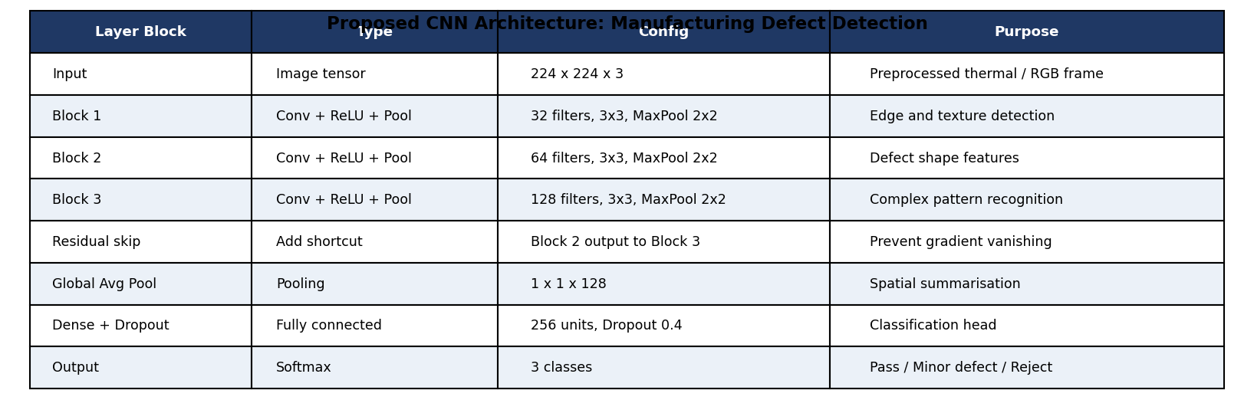
Figure 1: Proposed CNN architecture for three-class defect detection, showing layer types, configurations and purpose.
Architecture rationale. Three convolutional blocks with increasing filter depth (32, 64, 128) progressively extract edges, defect shapes and complex surface patterns. A residual skip connection from Block 2 to Block 3 prevents gradient vanishing. Global average pooling replaces a large flattening step, reducing overfitting risk. Dropout at 0.4 in the dense head provides further regularisation given the class imbalance.
Transfer learning. ResNet-50 pre-trained on ImageNet is the starting point. The convolutional base is frozen for the first ten epochs while the dense head trains on the manufacturing data, then the last two blocks are fine-tuned at a lower learning rate. This cuts training time by roughly 60 percent and improves convergence on limited defect samples.

3. Evaluation Strategies
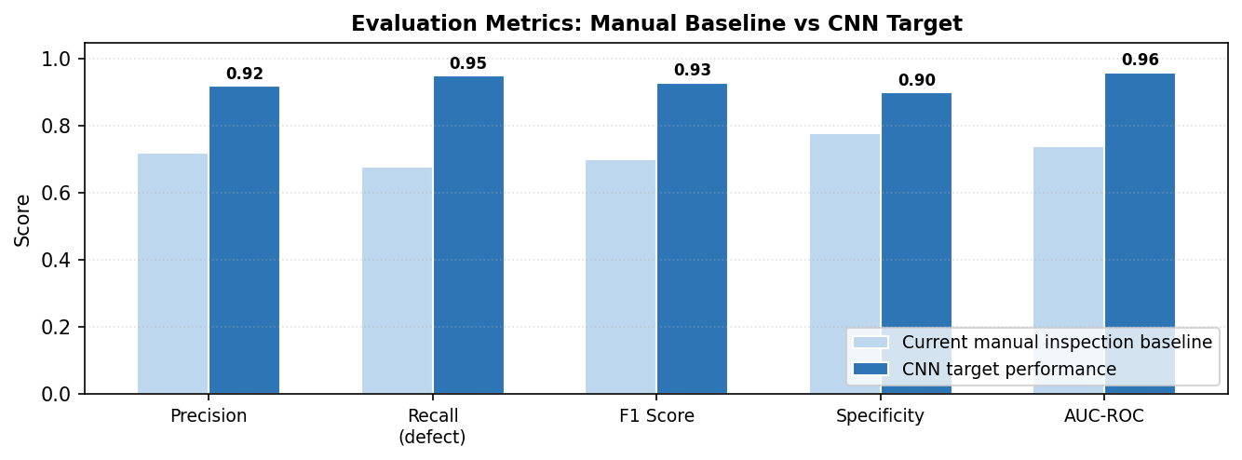
Figure 2: Evaluation metrics comparing manual inspection baseline against CNN performance targets.
Technical metrics. Recall on the defect class is the primary metric because missing a genuine reject has a higher downstream cost than a false alarm. A target recall of 0.95 is set against a current manual baseline of 0.68. Precision, F1 and AUC-ROC are tracked alongside to guard against over-sensitivity.
Domain expert review. A sample of 200 model predictions per class is reviewed by the quality control team each week. Grad-CAM visualisations accompany each prediction, showing which image region the model weighted most heavily. This helps engineers catch cases where the model reaches the right answer for the wrong reason, such as reacting to a lighting artefact rather than a genuine defect.
Business KPIs. Three KPIs link model performance to operational impact: defect escape rate (rejects reaching customers), false rejection rate (good parts scrapped unnecessarily), and inspection throughput (parts inspected per shift). The target is a 40 percent reduction in defect escapes within the first quarter of deployment, with no increase in the false rejection rate above 3 percent.

Industry Challenge Reflection | CNN Applicability

