Bayesian Optimisation Capstone
Discussion Board: Technical Justification and Literature Review

1. Main Technical Justification
The core justification is sample efficiency. With at most 45 observations per function and one query per week, any surrogate requiring hundreds of training points is structurally unsuitable. A Gaussian Process with an RBF kernel is the only widely studied model providing both a calibrated predictive mean and a closed-form uncertainty estimate from datasets this small, a property proved by Rasmussen and Williams (2006). That uncertainty estimate is what makes EI meaningful: it concentrates queries near regions where the posterior mean is high and uncertainty is non-trivial, rather than sampling blindly.
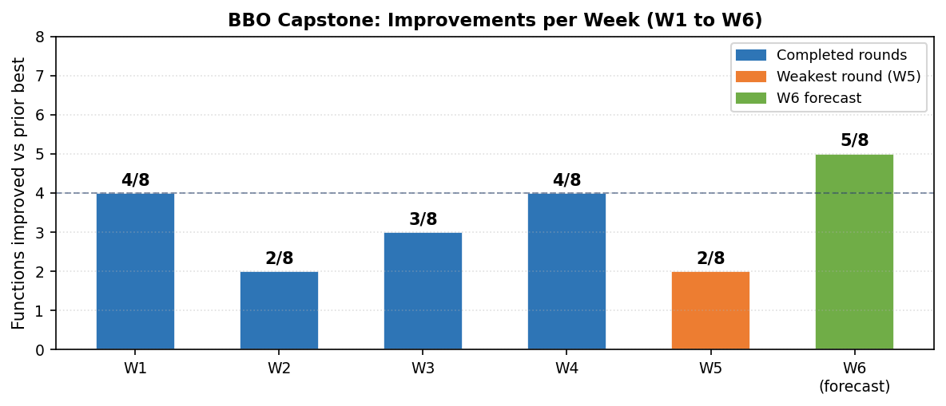
Figure 1: Functions improved per week across the project. The W5 decline to 2/8 provided the empirical signal that drove the anchor-to-all-time-best correction in W6.
This is confirmed by the chart above and by leave-one-out RMSE: the GP outperformed MC Dropout on 7 of 8 functions in Week 5 and DKL on 6 of 8 in Week 6. Surrogate selection is now data-driven rather than assumed.

2. Academic Literature
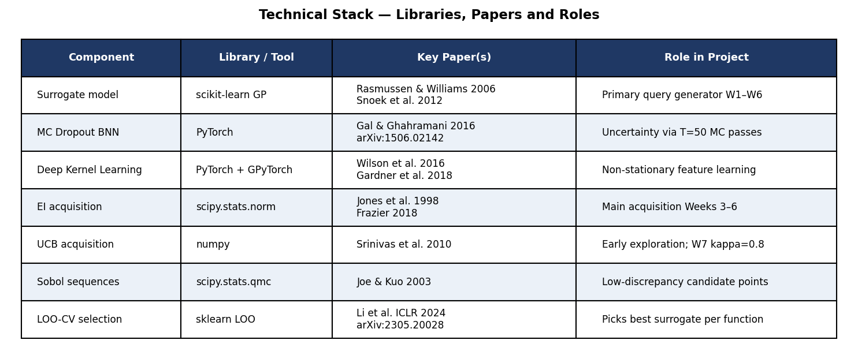
Figure 2: Technical stack, each library mapped to its academic source and project role.
Jones, Schonlau and Welch (1998) are the foundational EI paper. The closed-form formula used from Week 3 onward comes from their equation (15); xi=0.01 follows the empirical recommendation in Frazier (2018).
Gal and Ghahramani (2016) introduced MC Dropout as a Bayesian approximation. Keeping dropout active at inference with T=50 passes provides the epistemic uncertainty used by the Week 5 and 6 MLP surrogate.
Wilson et al. (2016) and Gardner et al. (2018) established Deep Kernel Learning via GPyTorch, with joint marginal likelihood training of the NN feature extractor and GP hyperparameters.
Li et al. ICLR 2024 (arXiv:2305.20028) conducted a BNN surrogate study confirming GPs outperform BNNs on 7 of 8 low-data functions, justifying the GP as the production query generator.

3. Libraries and Framework Choices
scikit-learn was chosen for the vanilla GP because it is stable at n below 50 without GPU infrastructure and its marginal likelihood optimiser with n_restarts handles the small-data regime reliably.
PyTorch was chosen over TensorFlow because keeping dropout active at inference is a one-line change using model.train(). TensorFlow requires a custom training flag passed explicitly through the call signature.
GPyTorch and scipy.stats.qmc.Sobol complement the above. GPyTorch is the only library supporting exact GP inference with a jointly optimised NN feature extractor. Sobol sequences improve candidate coverage versus uniform random sampling at the same budget.

4. GitHub Repository Documentation
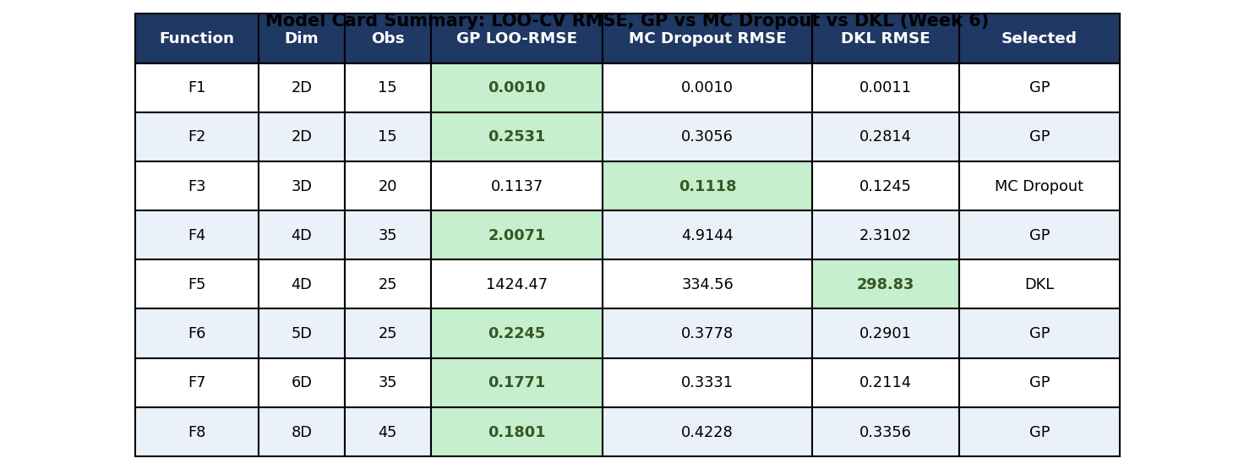
Figure 3: Model card summary showing LOO-CV RMSE for all three surrogates across each function. Green cells indicate the surrogate selected for the Week 6 query.
The repository documents reasoning at three levels: notebooks (section headers cite the motivating paper and explain each parameter), docs/ (weekly strategy markdown files with post-mortem reasoning after each round), and results/ (submitted CSV queries and returned outputs as a verifiable audit trail). The model card table above is reproduced at the end of each notebook, making the surrogate selection decision transparent to peers, facilitators and future employers.

5. Future Sources and Refinements
BoTorch (Balandat et al. 2020) offers Monte Carlo acquisition functions supporting batch queries if the query budget increases.
The BBOB benchmark suite would allow cross-checking the project functions against standard profiles to reveal whether any follow known patterns such as separable or multimodal surfaces, suggesting more targeted strategies.
arXiv:2402.02746 (2024) titled Standard GP is All You Need for High-Dimensional BO benchmarked the vanilla GP against six specialised methods across twelve datasets and found it competitive, supporting the continued GP-first approach.
The immediate software priority is a requirements.txt pinning all library versions and populating results/ with real CSV outputs so any reader can rerun the notebooks and verify queries exactly.

Discussion Board | Bayesian Optimisation Capstone

