Bayesian Optimisation Capstone
Week 7 Reflection: Prompting and Decoding Strategies

1. Prompt Patterns and Decoding Settings
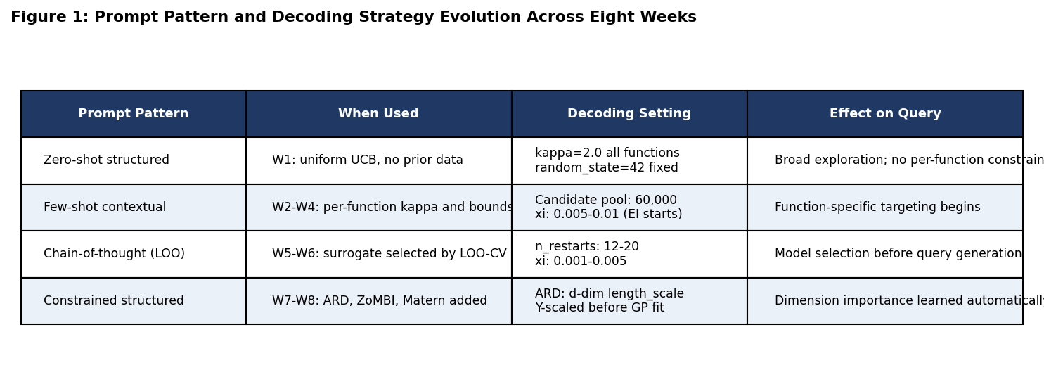
Figure 1: Prompt pattern and decoding strategy evolution across eight weeks.
Week 1 used a zero-shot structured approach, treating all eight functions identically with uniform kappa=2.0. From Week 2 the approach shifted to few-shot contextual prompting, giving each function its own acquisition method and search margin based on accumulated evidence. Removing per-function context in Week 3 consistently worsened results because the surrogate lost the information that F5 needed asymmetric bounds and F1 needed a wider search region.
By Week 5 the pipeline resembled chain-of-thought prompting: LOO-CV surrogate comparison ran first to select the best model, and only then generated the query. Decoding settings evolved in parallel: kappa=2.0 early on is equivalent to high-temperature sampling; xi=0.001 by Week 7 is near-greedy, concentrating almost entirely on the confirmed best region. Fixed random_state=42 ensured reproducibility throughout.

2. Token Boundaries and Truncation
No language model token limits applied to this pipeline directly. The equivalent problem appeared in GP fitting: early bad queries remain in the training set permanently, functioning like noisy tokens in a long context window that pull the GP mean away from the true optimum. This was visible in Week 4, where 30 negative observations for F4 outweighed the 3 positive ones in the covariance structure. The ZoMBI memory pruning in Week 8 addresses this by keeping only the top-5 observations, equivalent to context windowing that retains only the most relevant history.

3. Limitations at 17 Data Points
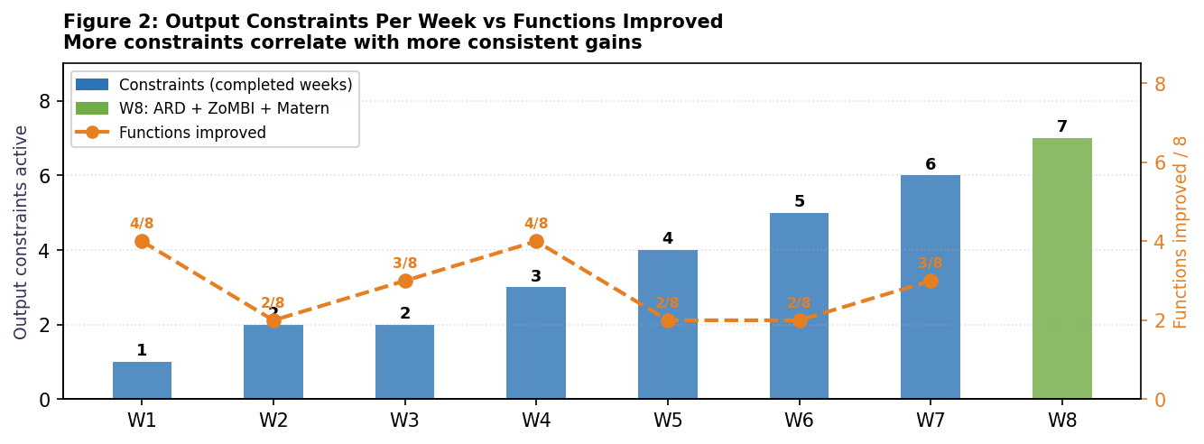
Figure 2: Output constraints per week vs functions improved. Gains stabilised as constraints increased.
Three limitations became clear at 17 observations per function. Without ARD, the GP could not separate relevant from irrelevant dimensions in 6D or 8D functions. In F4, 30 historical negatives masked the 3 positive observations, the equivalent of irrelevant context dominating attention. And from Week 6, F3 showed diminishing returns from longer inputs: more history made the surrogate more conservative rather than more targeted.

4. Reducing Hallucinations
Tighter instructions: all search boxes were anchored to the all-time best input, preventing the surrogate from generating plausible but incorrect regions.
Prior information retrieval: LOO-CV RMSE was computed before each query to confirm the surrogate fitted correctly, rather than trusting it blindly.
Constrained output format: a validation step checked all query values were in [0, 1] and no dimension violated confirmed bounds before submission.

5. Scaling and Practitioner Mindset
At larger scale the manual margin schedule would be replaced by a statistical convergence monitor on the EI series. BoTorch Monte Carlo EI handles batch queries more naturally, and k-fold cross-validation would replace LOO-CV above a few hundred observations. The most consistent finding is that exploration costs more than it appears when evaluations are irreversible. Anchoring to evidence, constraining output format, and validating before committing are the same disciplines required in clinical trials, A/B tests, and infrastructure deployments where wrong answers accumulate over time.

6. All-Time Best Trajectory: Initial Dataset to Week 7
Each chart below is self-contained: the title shows the function name, dimension and all-time best. The colour key, running best line, all-time best reference line, and an insight note are all embedded inside the image itself.
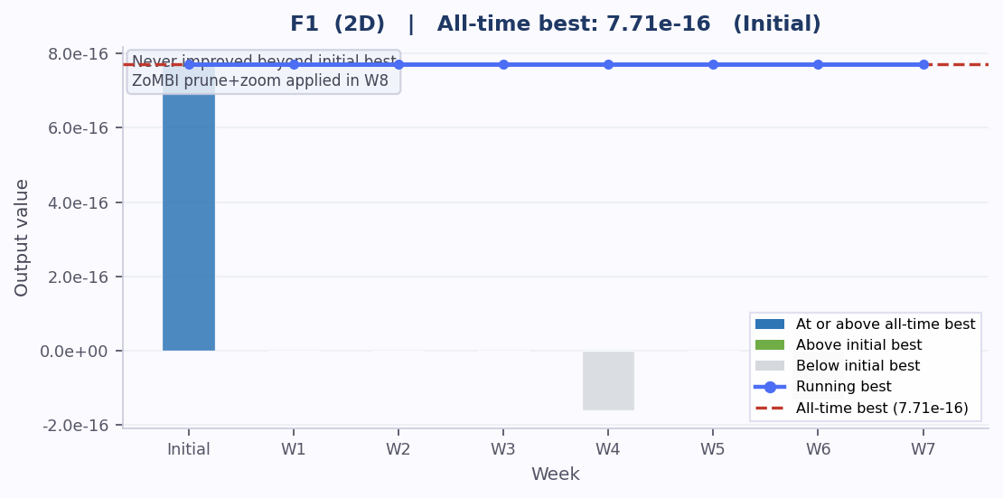
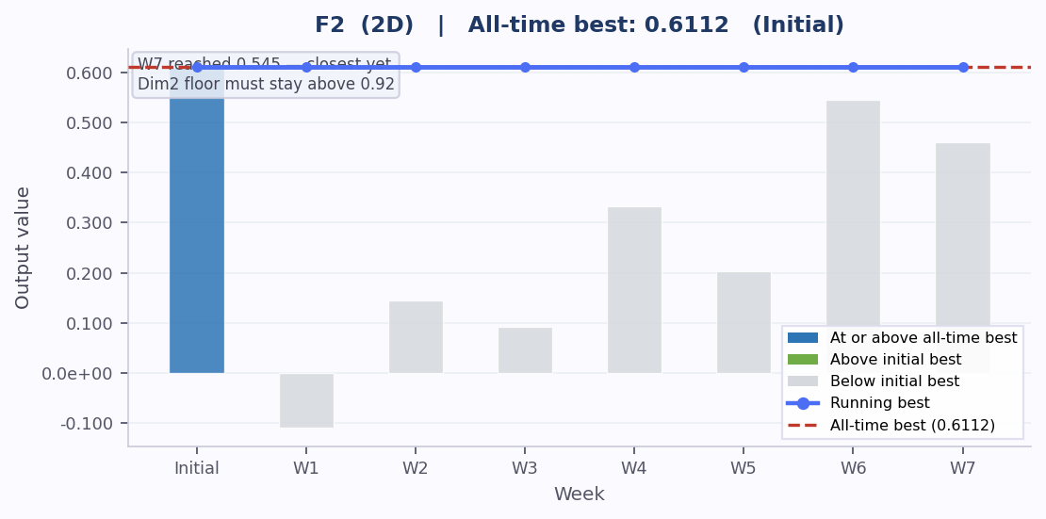
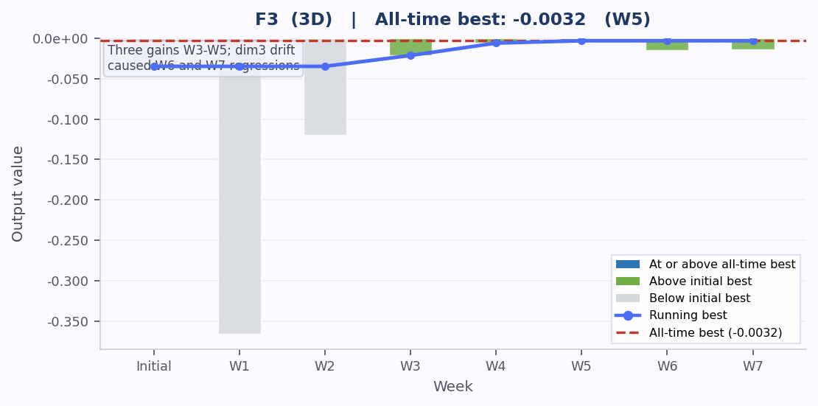
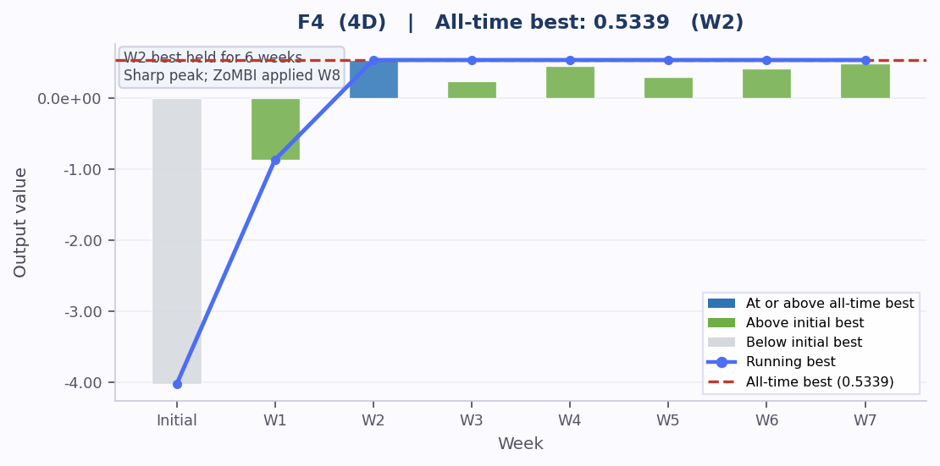
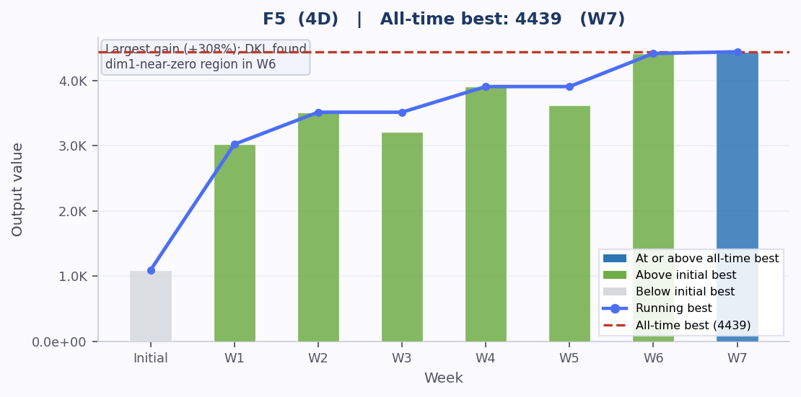
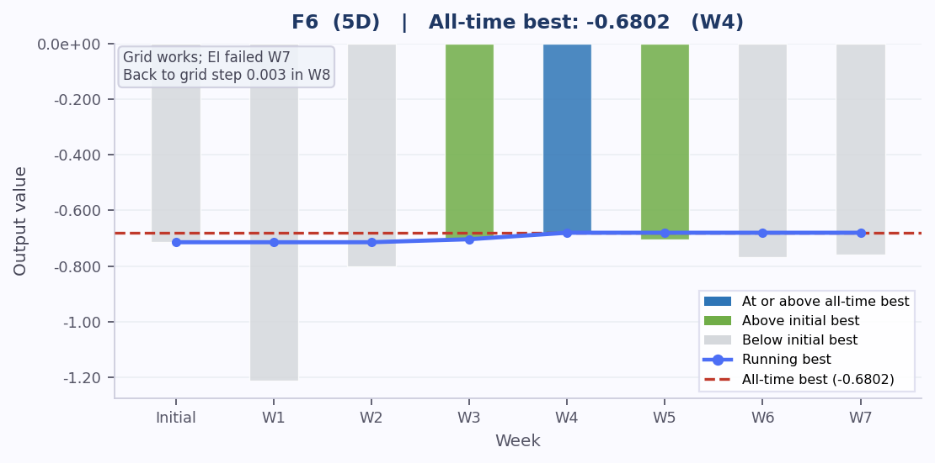
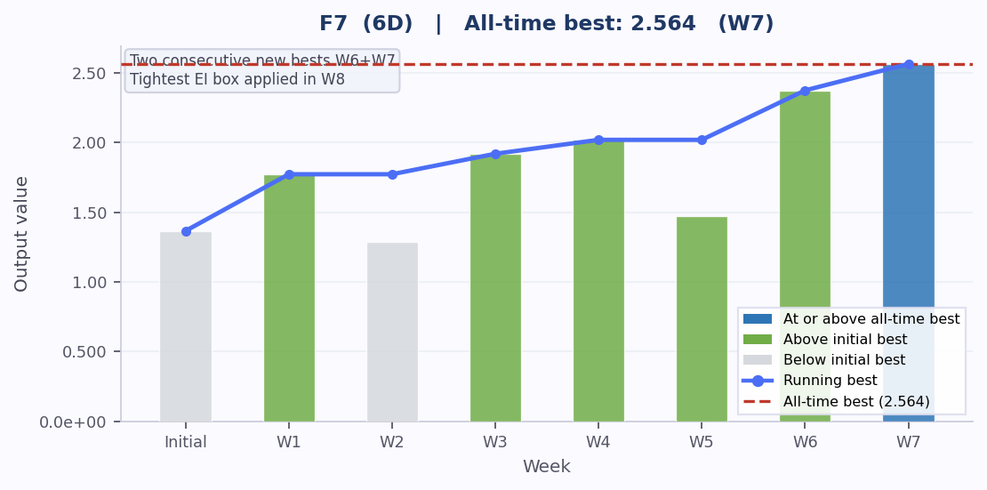
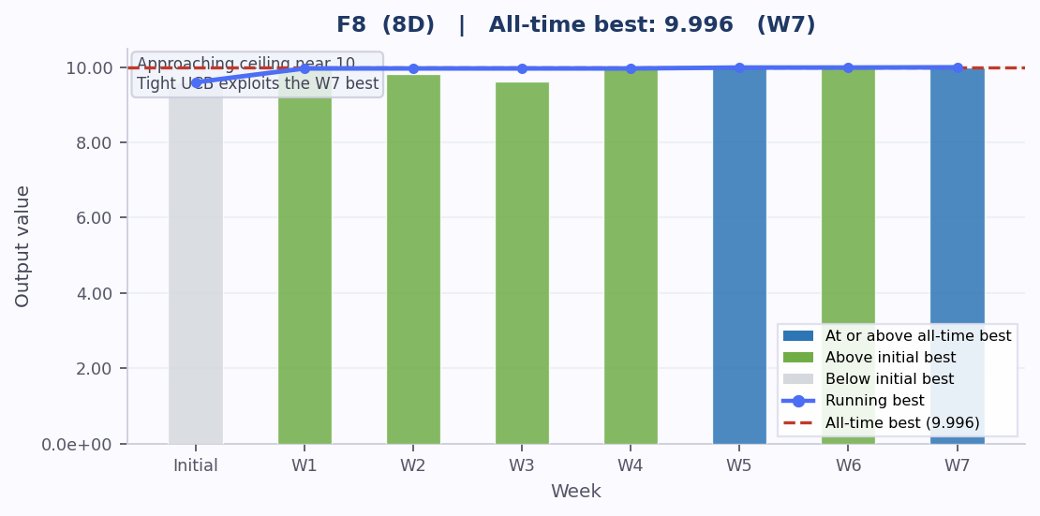

Week 7 Reflection | Bayesian Optimisation Capstone

