Bayesian Optimisation Capstone
Week 10 Reflection: Strategy, Transparency, Assumptions and Limitations

1. Reasoning and Patterns Behind the Week 10 Submission
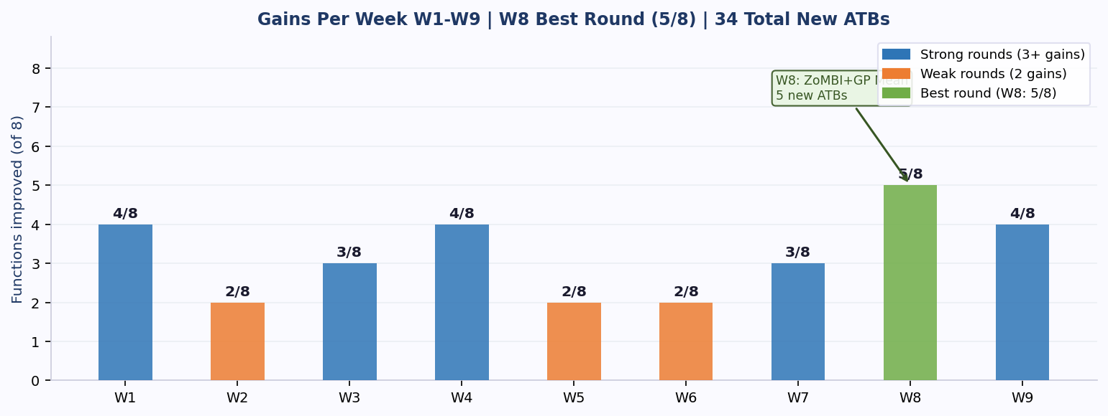
The core principle governing Week 10 is that late-stage optimisation rewards exploitation over exploration. The proximity pattern confirmed across nine rounds is clear: every week a query drifted from the confirmed best input, the output declined. For functions with consecutive gains (F1, F3, F5, F7), GP Mean with a 0.012 margin commits fully to exploitation. F2 received the tightest bounds ever applied (0.002 window) after Week 9 missed the confirmed ridge by 0.001 on dim2. F4 received a five-GP length scale ensemble because eight single-GP queries failed to beat the Week 2 peak. F6 uses grid step 0.001, and F8 uses EI xi=0 on the Week 7 best.

2. Transparency and Reproducibility
Decision-making is documented at three levels: inline notebook comments citing the motivating paper, weekly post-mortem markdown files recording reasoning after each output, and model cards printing LOO-CV RMSE for all surrogate options. A reviewer needs the original .npy data files, the full query history for all nine weeks, each weekly notebook, and the post-mortem documents. With random_state=42 fixed throughout, queries are fully reproducible. The one gap is LOO-CV surrogate selection may vary between scikit-learn versions; requirements.txt pins library versions to address this.

3. Key Assumptions
Proximity assumption: every strategy assumes the optimum lies near the best input seen so far. This is justified by the data but assumes the surface is unimodal near the current best. For F4, this assumption has confined the search around the Week 2 best for eight weeks. A genuinely multi-modal surface could mean a better basin exists elsewhere, completely invisible to the current approach.
Stationarity assumption: ARD Matern-5/2 assumes the correlation structure is uniform across the input space. F5 violated this: the dim1-near-zero region is qualitatively different from the rest of the surface, which is why DKL discovered it. Any function with abrupt structural changes is systematically mis-specified by the GP surrogate.

4. Data Gaps and Sampling Biases
The query history is heavily concentrated near the confirmed best inputs. F1 spent seven consecutive weeks within 0.08 of [0.731, 0.733] before Week 8 relocated the search. Any global optimum more than 0.2 from the current search region will almost certainly be missed because no query has sampled those areas since Week 1. A second bias is the imbalance between positive and negative observations: F4 has 30 negative observations and only 3 positive ones. This pulls the GP mean away from the small positive region even when the search box is centred on the confirmed peak, because the GP fits the full distribution rather than focusing on the high-value tail.

5. Significant Limitation
The most significant limitation is the one-query-per-function-per-week budget. Every decision is irreversible with no ability to refine before submitting. In a production setting, the micro-bounds strategy now applied to F2 would have been discovered by Week 3. Here it took eight weeks of evidence to build the case. A direct consequence is that the surrogate extrapolates from sparse data: at nine observations for F7 at 6D and F8 at 8D, the GP cannot reliably identify which dimensions drive the output. ARD length scales help, but are learned from data covering a tiny fraction of the input space, so any dimension combination not yet queried together remains invisible.

6. Performance Trajectory: Initial Dataset to Week 9
Each chart shows the full output history from the initial dataset through to Week 9. All labels, colour coding and insight notes are embedded inside each image.
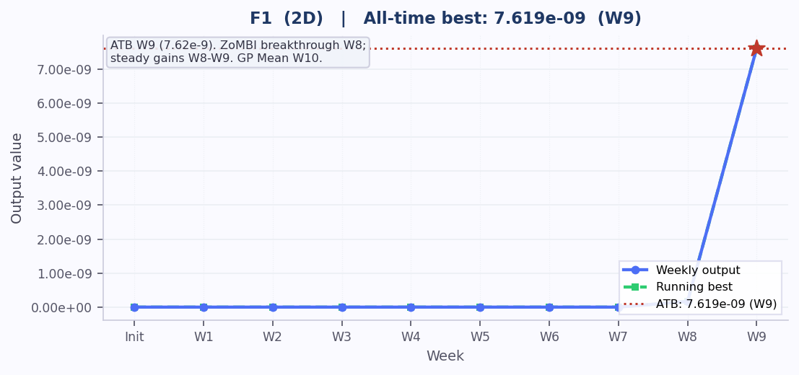
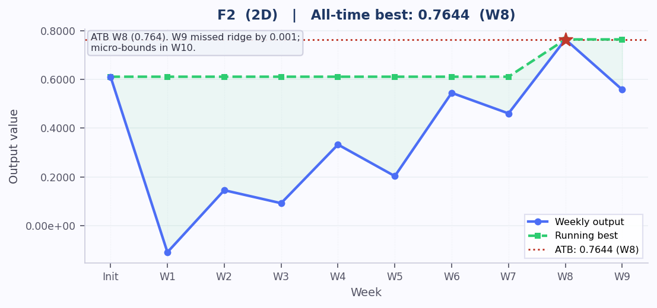
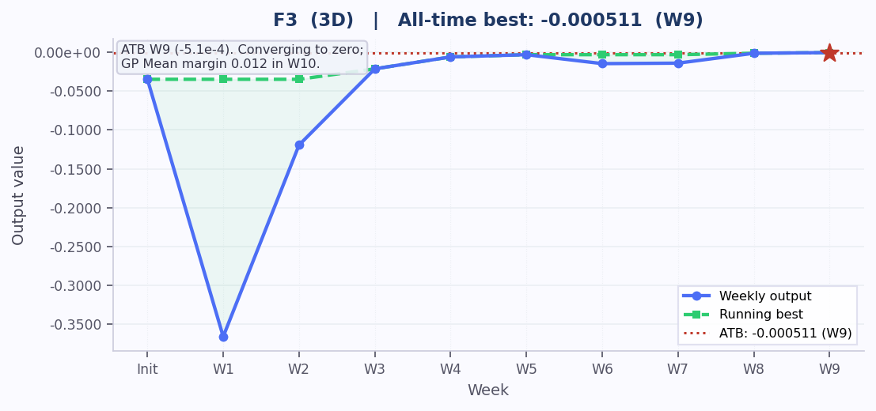
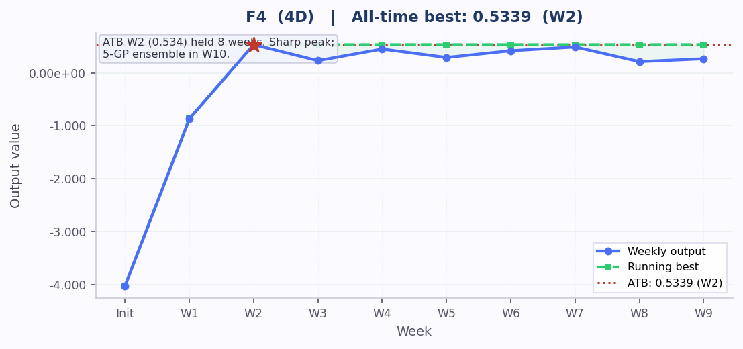
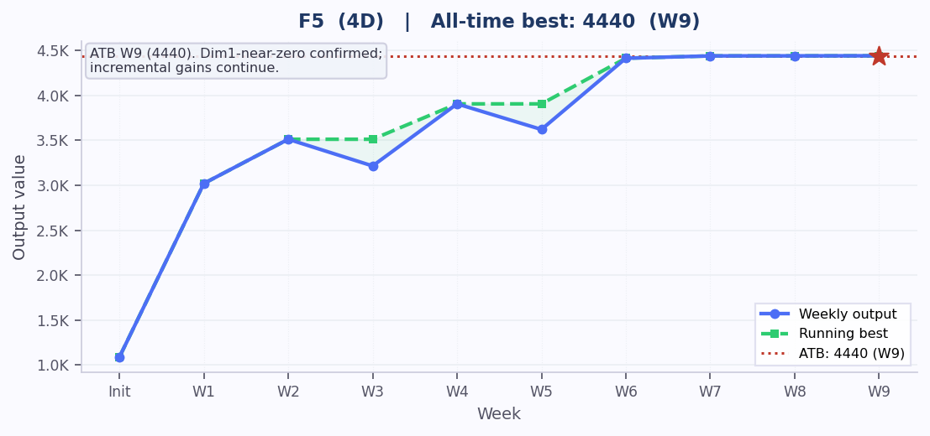
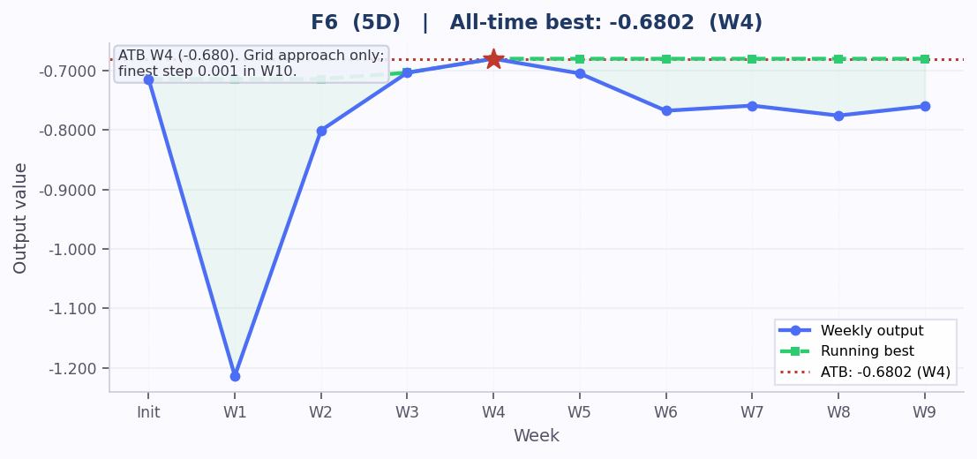
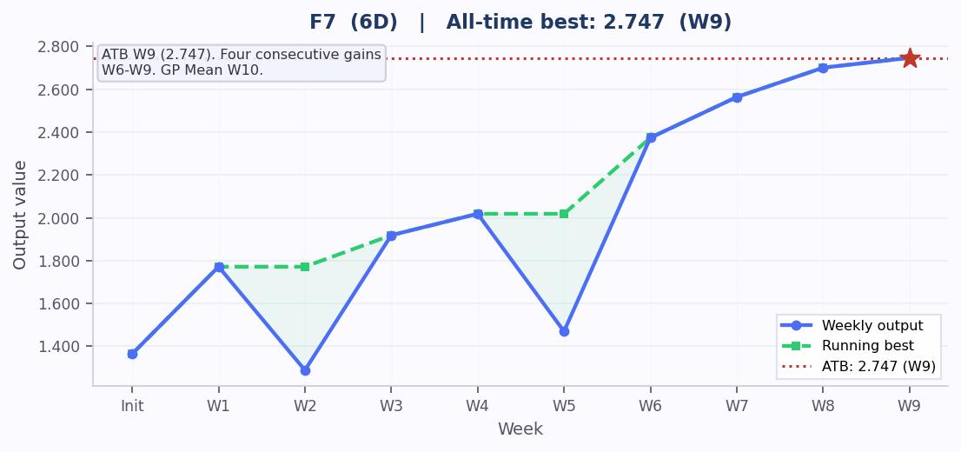
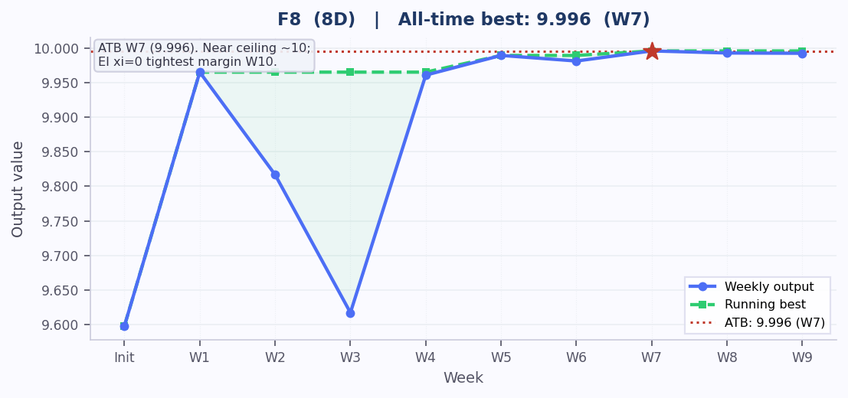

Week 10 Reflection | Bayesian Optimisation Capstone

