Bayesian Optimisation Capstone
Week 9 Reflection: Scaling Laws, Emergence and Strategy Trade-offs

1. Scaling Laws and Diminishing Returns
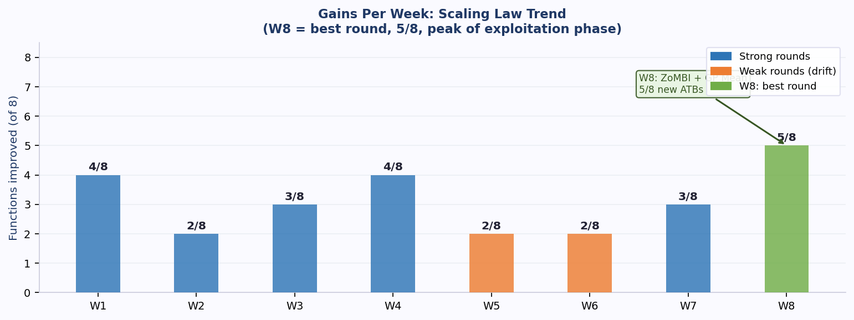
Early weeks produced 4 gains per round simply because the initial dataset left obvious ground uncovered. As queries narrowed into smaller regions, the expected gain per query fell. Weeks 5 and 6 each returned only 2 gains, a textbook diminishing returns pattern from over-exploitation of insufficiently characterised surfaces.
Week 8 reversed this to 5 gains because two architectural changes added genuine capacity rather than just tightening existing parameters. ZoMBI pruning removed noise from the GP training set. GP Mean acquisition removed the exploration penalty for functions already near convergence. This mirrors a key scaling law insight: adding more data alone produces diminishing returns, but changing the architecture can restore growth. F5 and F7 show steady improvement in 6 of 8 weeks. F4 and F6 show gain-per-query rates effectively at zero.

2. Emergent Behaviours and Preparation
F1: Seven consecutive weeks near [0.73, 0.73] produced nothing. ZoMBI relocated the search to [0.525, 0.683] in Week 8 and produced 1.68e-10, a jump of over 21 million percent. This was not predicted by any surrogate. The preparation for Week 9 is GP Mean with a 0.015 margin around the W8 best, committing fully to the newly discovered region.
F2: Eight weeks of queries never beat the initial best. Week 8 finally aligned both dim1 and dim2 jointly and returned 0.764, beating the initial best by 25%. Sudden step change after a long plateau is the defining pattern of emergence in this project.
The general preparation is the proximity rule: anchor every query to the confirmed all-time best input. Emergence tends to occur near where the surface has already shown promise, not in unexplored corners.

3. Cost, Robustness and Performance Trade-offs
Computational cost: LOO-CV selection across four surrogates increased compute by roughly four times per function. This was accepted because data-driven surrogate selection produced measurably better LOO-CV RMSE and directly contributed to the W8 breakthrough.
Robustness vs performance: GP Mean is the highest-performance choice for converging functions but has no recovery mechanism if the surrogate mean is wrong. Week 9 applies it only to functions with confirmed consecutive gains. EI with xi=0.001 covers F8, where the ceiling near 10.0 creates genuine uncertainty about the next query direction.
Wasted queries: Seven queries on F4 and eight on F6 have produced no improvement since Weeks 2 and 4 respectively. Each wasted query is permanent. The decision to continue is justified only by the F1 precedent: seven failed weeks then a breakthrough in Week 8.

4. Predictable Optimisation vs Emergent Risk
Five functions are converging smoothly; three remain unresolved. The Week 9 balance is purely exploitative acquisition (GP Mean, margins 0.015 or tighter) for the converging group, and structural changes for the others. Pinned ZoMBI forces the W2 best input into the GP memory for F4, targeting the confirmed sharp peak. The tighter grid step 0.002 for F6 is the smallest movement applied to any function in the project.
The practitioner lesson from nine weeks of irreversible queries is that the best preparation for emergence is not wider exploration but better targeted exploitation backed by architectural changes. F1 and F2 both broke through when the search method changed, not when the search space widened.

5. All-Time Best Trajectory: Initial Dataset to Week 8
Each chart shows the weekly output from the initial dataset through to Week 8. All labels, colour keys and insight notes are embedded inside each image.
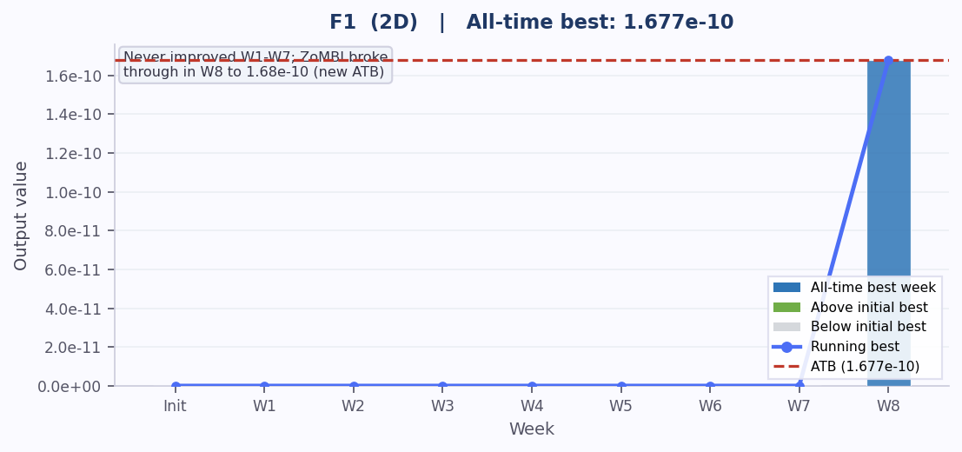
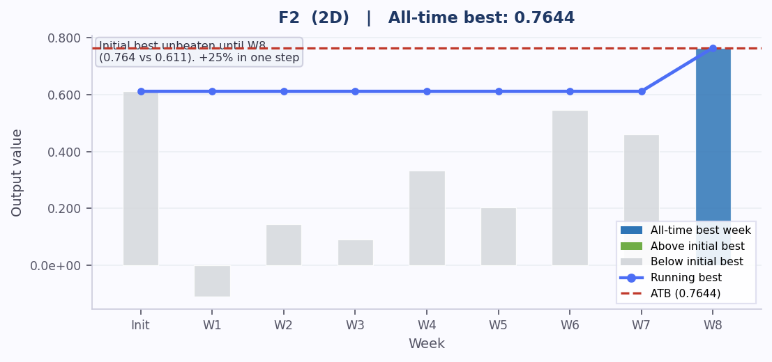
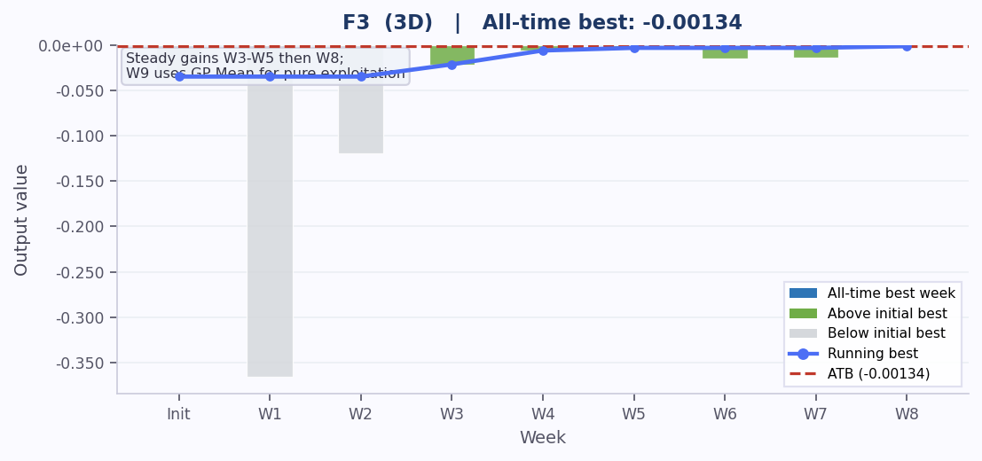
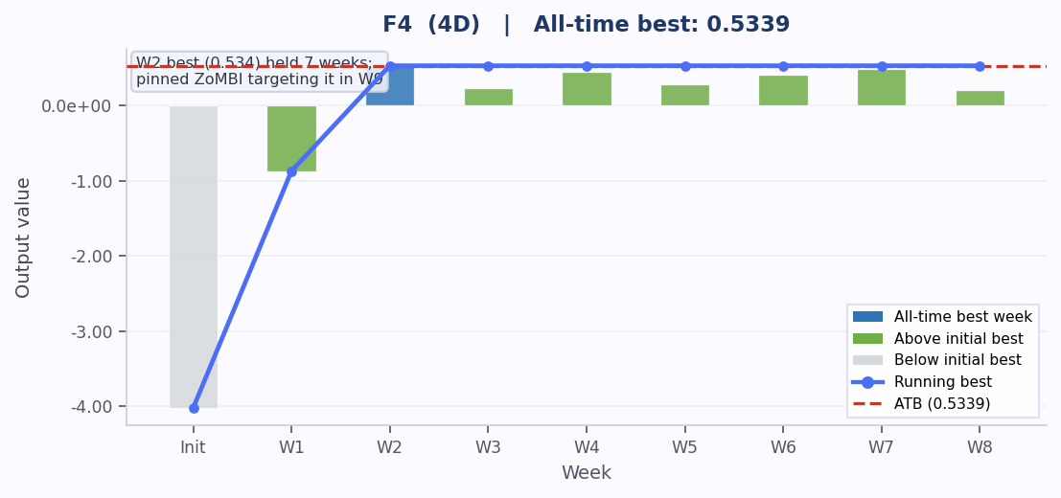
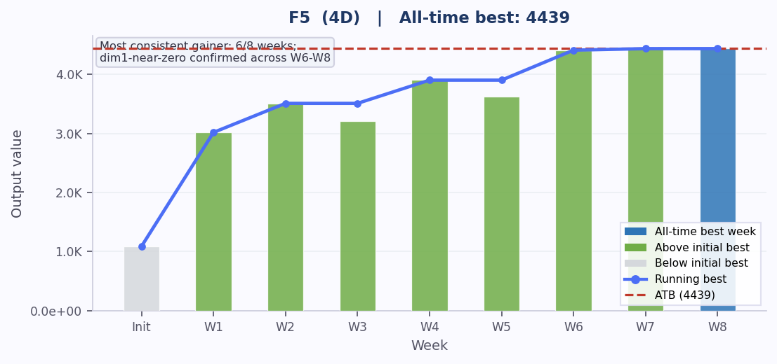
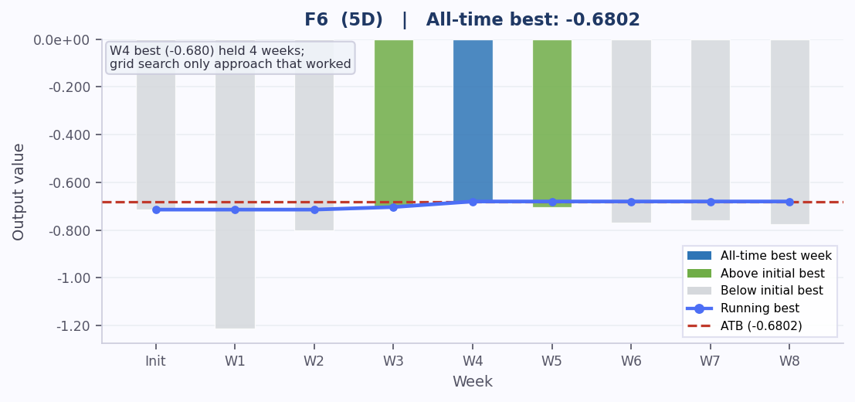
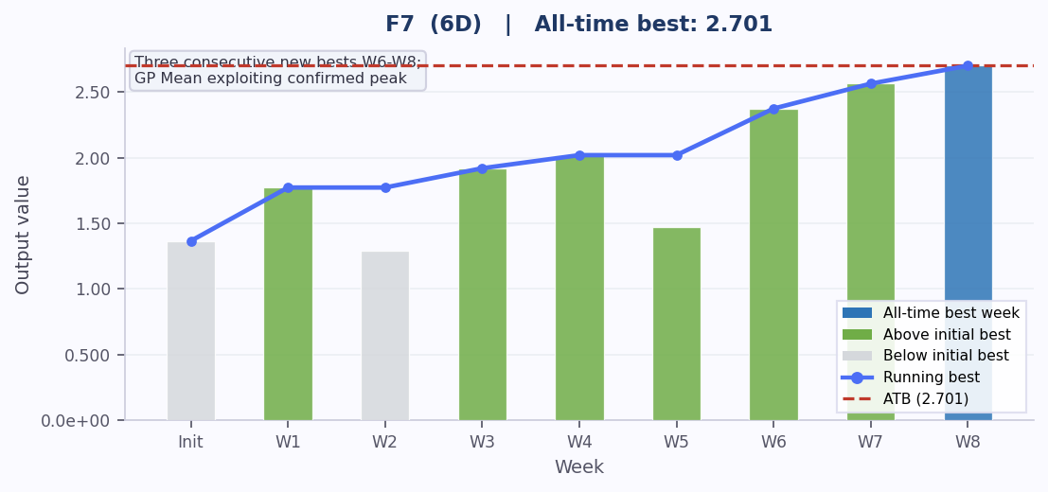
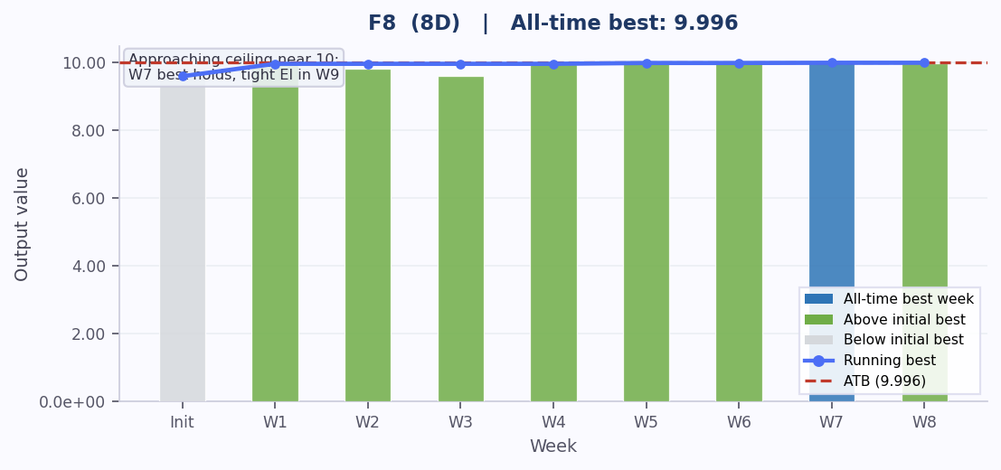

Week 9 Reflection | Bayesian Optimisation Capstone

