Bayesian Optimisation Capstone
Week 3 Strategy Reflection
Gaussian Process Surrogate Modelling | Multi-Method Acquisition
Functions improved | Methods used | F5 cumulative gain | F4 breakthrough
4 of 8 (likely) | UCB, EI, Thompson, Grid | +222% from initial | -4.03 to +0.53

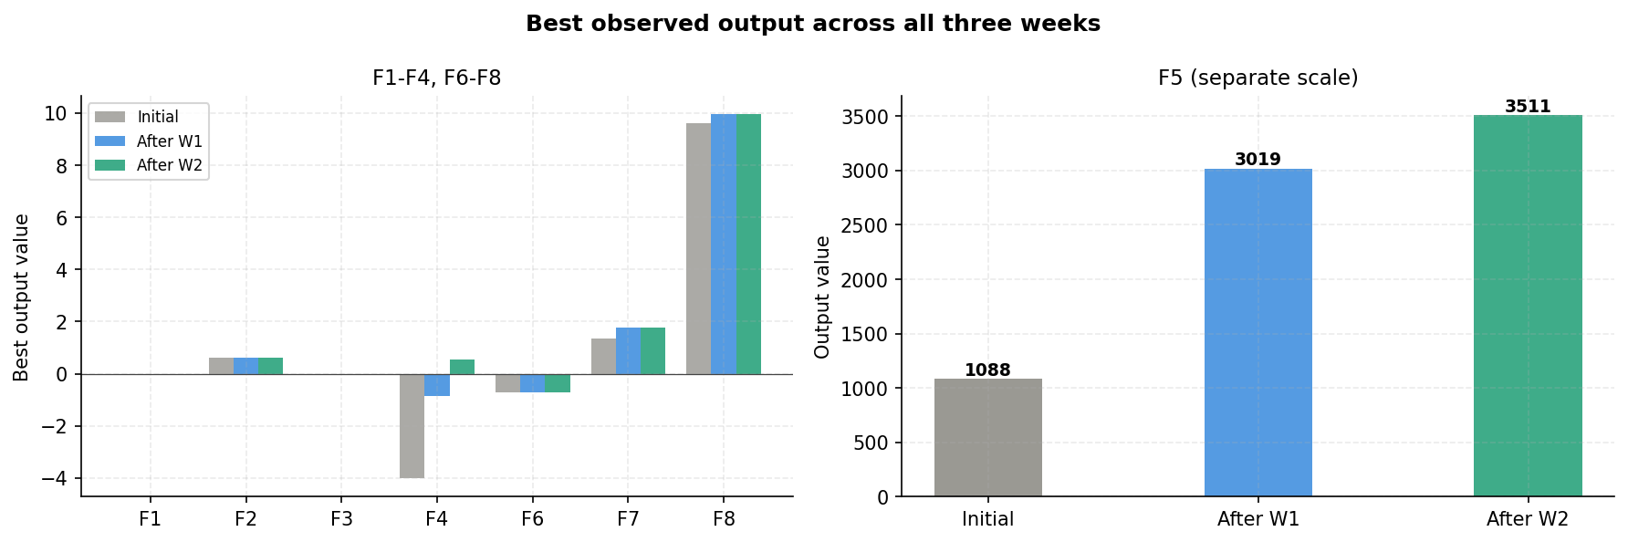
Figure 1: Best observed output across all three weeks

1. How has the query strategy changed across iterations?
Week 1 applied uniform kappa 2.0 with no constraints across all eight functions. Five improved but three wasted queries chasing boundary uncertainty. That outcome shaped everything that followed.
Week 2 introduced per-function kappa, constrained search boxes, and Sobol candidate generation. Five functions still needed manual overrides, and F6 required bypassing the GP entirely after the dictionary reference problem persisted across multiple attempts.
Week 3 replaced the single acquisition function with four distinct methods: UCB for well-characterised surfaces, Expected Improvement for functions where UCB kept drifting from confirmed peaks, Thompson Sampling where high-kappa UCB caused drift, and a deterministic grid search for F6 after three consecutive GP failures. All constraints were built directly into the pipeline loop, removing the need for override cells.
Hyperparameter tuning: kappa and xi have been adjusted empirically at each iteration rather than set by theory. F5 moved from kappa 2.0 in Week 1 to 0.5 in Week 3 as the peak became better characterised. Using outcomes to inform method selection is itself a form of meta-optimisation.
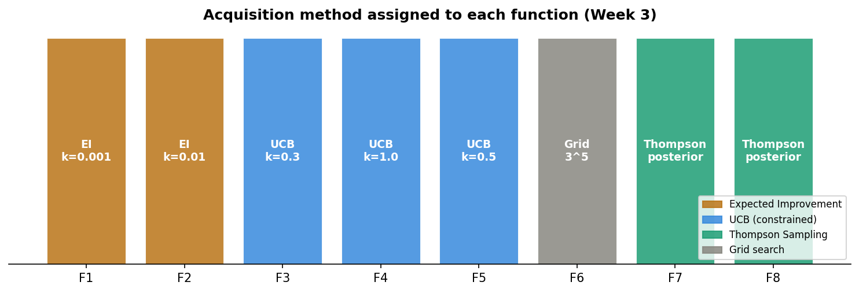
Figure 2: Acquisition method per function in Week 3

2. How is exploration balanced against exploitation?
The balance shifted toward exploitation as evidence accumulated, but not uniformly across functions. Each one reached a different point in that trade-off by Week 3.
Function | W3 stance | Reason
F1, F2, F6 | Maximum exploitation | No gains after 2 queries; surface too narrow for exploration
F3, F4, F5 | Targeted exploitation | Interior or peak region confirmed; refine close to known best
F7 | Exploit W1 best | W2 drifted from the W1 location that produced +30%
F8 | Broad exploration | 8D sparse data; consecutive modest gains suggest local max

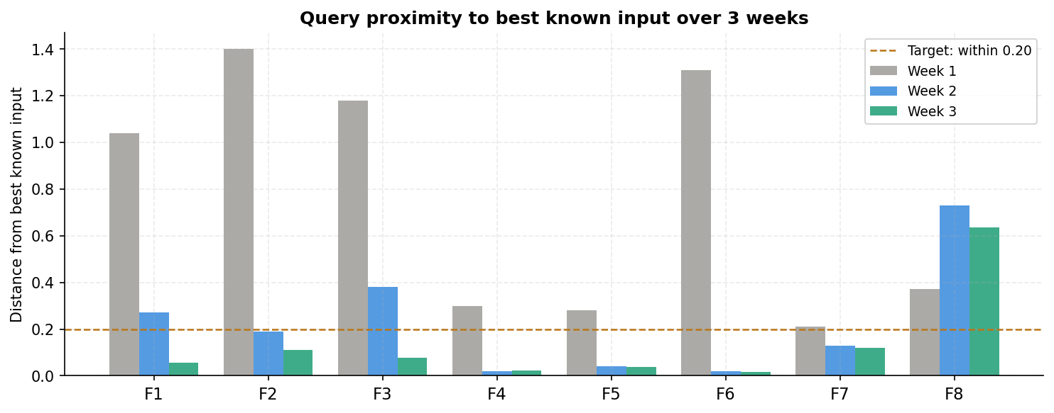
Figure 3: Query distance from best known input across three weeks

3. How would SVMs change the approach?
An SVM reframes the problem: instead of asking where the maximum is, it asks where the boundary between good and poor output regions sits. That is a useful complement to the GP rather than a replacement.
Soft-margin SVM: binarising F5 outputs above 500 as high produces a plausible linear boundary in 4D roughly separating the low-dim-1, high-dims-2-4 corner from everything else. With 22 observations the classifier would be sparse, and class imbalance is a concern since most of the input space produces low outputs. A kernel SVM with an RBF kernel would handle F4's curved surface more naturally, where the output shifted from -4.03 to +0.53 over three weeks.
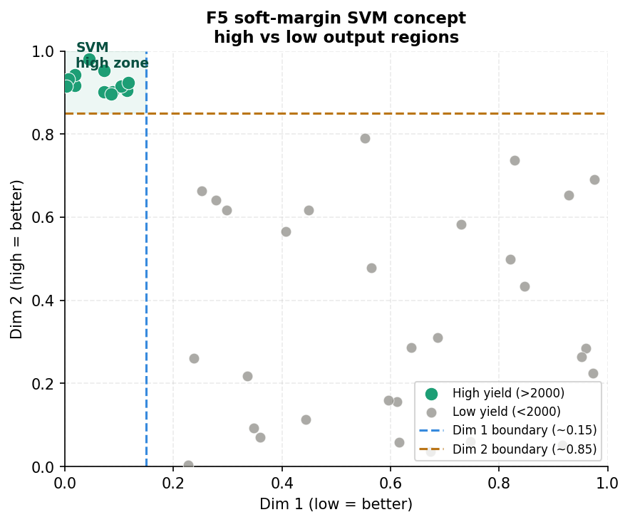
Figure 4: Conceptual SVM boundary for F5 in two dimensions

4. What limitations appear as data grows?
GP overfitting: F6 is the clearest case. With 22 observations in 5D, the RBF length scale hit its upper bound during kernel optimisation, producing a near-flat surrogate. Any acquisition function built on that surface is unreliable.
Irrelevant dimensions: F4's best inputs all cluster between 0.39 and 0.42, raising the possibility that some dimensions contribute little. An ARD kernel would assign separate length scales per dimension, revealing which ones the GP actually uses.
Diminishing returns: F5 gained +177% in Week 1 and +16% in Week 2. As observations accumulate near the peak, GP uncertainty collapses and UCB scores are driven almost entirely by the mean. Each additional query adds less new information than the last.

5. What does this prepare you for as a data scientist?
The core skill this project develops is making defensible decisions without complete information and updating those decisions as evidence arrives. In practice that looks like three things.
Manual inspection beats automation sometimes. Noticing that dim 1 low and dims 2-4 high produced F5's big gain was a hand-crafted insight that the GP alone did not surface. Applied data science regularly requires reading the data before fitting a model.
Knowing when to distrust a model matters more than finding another method. F6 went through five different GP-based approaches across two weeks and none of them improved on the original best. The right call was a grid search near the known best point, not a sixth acquisition strategy.
Constraints sharpen thinking. One query per function per week mirrors production conditions where experiments are expensive and time is limited. That constraint turned careful reasoning about prior evidence from an academic exercise into a practical necessity.

Week 3 reflection | Bayesian Optimisation Capstone

