Bayesian Optimisation Capstone
Week 4 Reflection | Surrogate Modelling and Classification

1. Support Vectors and Rapid Change
Points where the output changes most sharply between neighbouring observations behave like support vectors: they sit at the boundary between high-value and low-value regions and carry the most information about where that boundary lies.
F5, dimension 4 is the clearest case. When dim 4 sits above 0.95 the output exceeds 3000; below 0.93 it falls sharply. Three queries confirm this boundary: dim 4 of 0.986 returned 3019, 0.960 returned 3511, and 0.924 returned only 3214. Recognising that threshold directly shaped the W4 strategy — a lower bound of 0.95 was applied to dim 4 in the constrained search box.
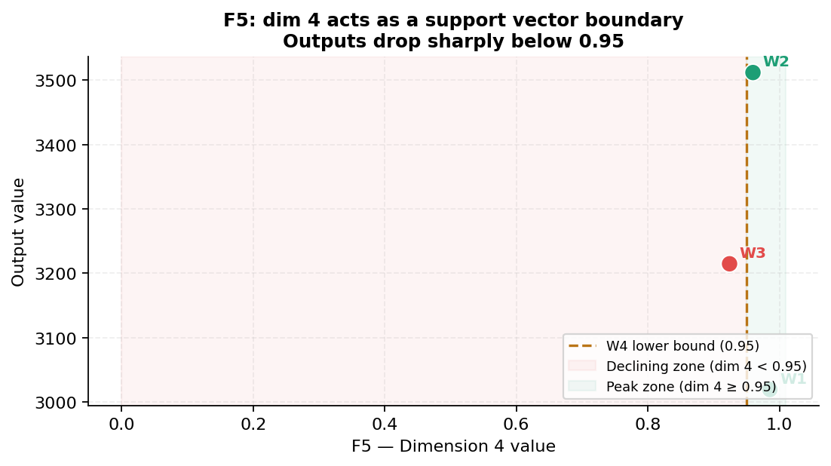
Figure 1: F5 output vs dim 4. The boundary near 0.93 to 0.95 acts as the support vector region.
F4 is a second example. All four dims cluster around 0.39 to 0.43 in the positive region. Outside that band outputs are strongly negative. Identifying this tight cluster guided the W4 query to distance 0.023 from the confirmed best.

2. Surrogate Gradients — Why No Neural Network
No neural network was trained. With 12 to 43 observations per function, any network with sufficient capacity to model non-linear surfaces would memorise rather than generalise. The GP regularises naturally through its kernel length scale and, crucially, provides calibrated uncertainty estimates that UCB and EI both require.
The GP mean acts as an implicit gradient. For F4 it consistently pointed toward [0.40, 0.40, 0.41, 0.41] across three iterations. The length scales also revealed feature importance: dims 2, 3, and 4 of F5 received short length scales (high influence); dim 1 received a long one (low influence). That directly informed the asymmetric bounds [0.00, 0.10] and [0.93, 1.00] used in W4.
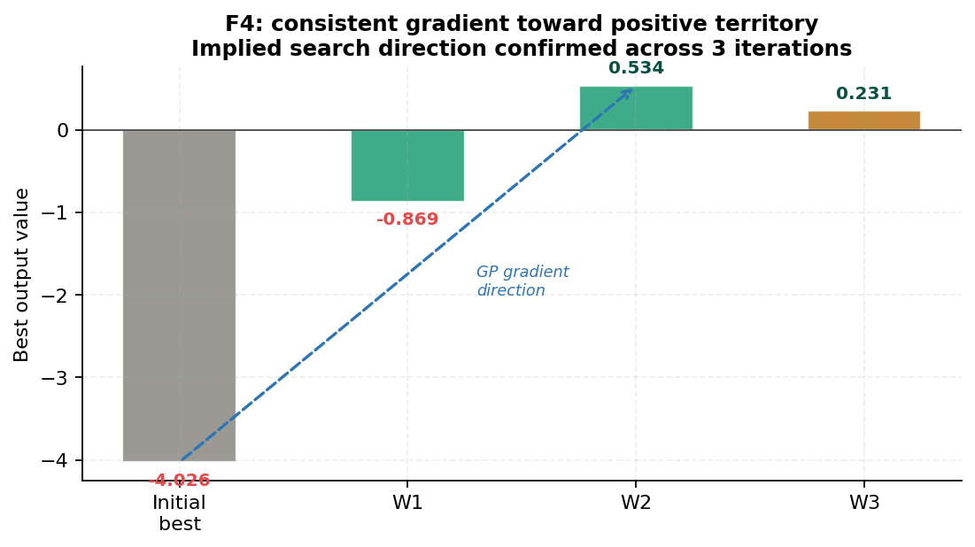
Figure 2: F4 output progression. The GP gradient pointed toward positive territory across all iterations.

3. BBO as a Classification Problem
Any function can be reframed as binary classification by thresholding the output. Class imbalance is the main challenge across all eight functions.
Fn | Threshold | Good class | Challenge
F4 | Output > 0 | 3 of 33 | Severe imbalance — naive model predicts bad everywhere
F5 | Output > 2000 | 3 of 22 | Extreme imbalance — only the peak corner is positive
F7 | Output > 1.5 | 4 of 33 | Moderate imbalance — most plausible for logistic regression

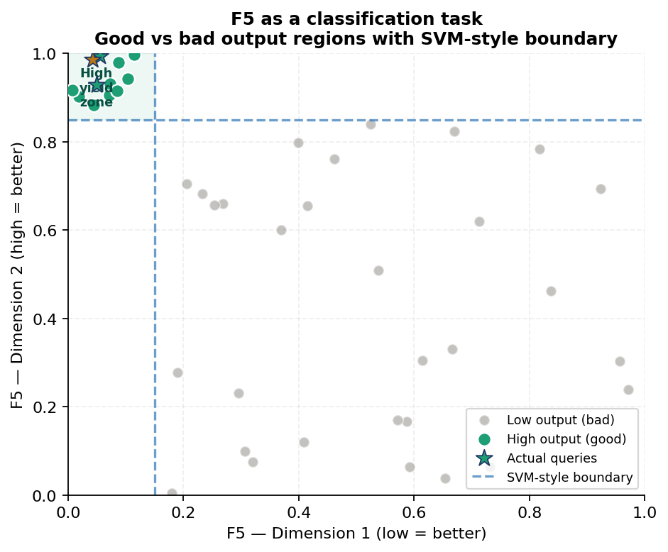
Figure 3: F5 as a classification problem. SVM-style boundary separates high-yield from low-yield regions.
Logistic regression finds a linear boundary, which is plausible for F5 in 2D but falls apart with extreme imbalance. A soft-margin SVM with an RBF kernel handles the non-linear boundary better. The key trade-off: a false negative misses a good region; a false positive wastes an entire week of the competition.

4. Model Choice — Interpretability vs Flexibility
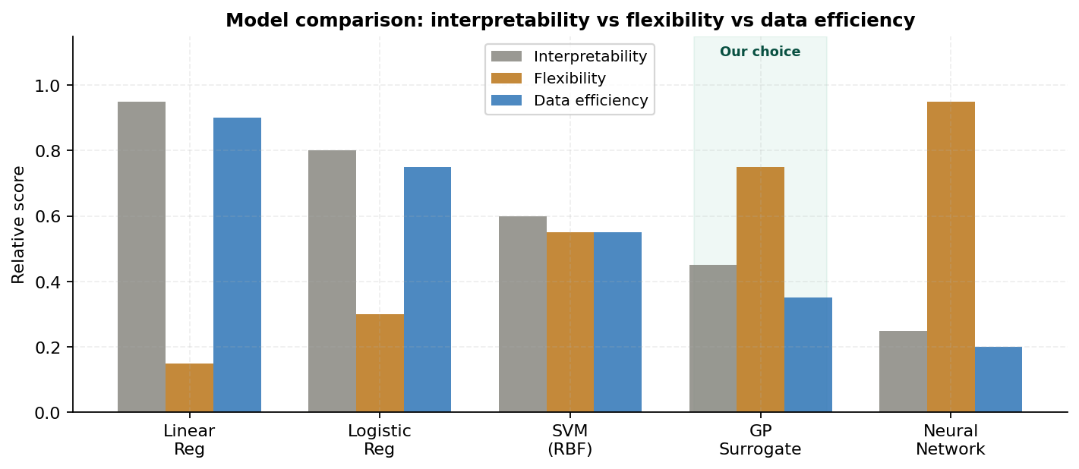
Figure 4: Model comparison. GP highlighted as the best fit for this data scale.
Model | Interpret. | Flexibility | Data eff. | Best suited to
Linear regression | Very high | Very low | High | Locally flat surfaces only
SVM (RBF) | Moderate | Moderate | Moderate | Non-linear boundaries, limited data
GP surrogate | Moderate | High | Very high | BBO with uncertainty quantification
Neural network | Low | Very high | Low | High-data, complex approximation

The GP was chosen because it balances flexibility with data efficiency and provides the uncertainty estimates that EI and UCB require. A neural network would offer more flexibility but demands data volumes far beyond what is available here. A linear model would fail immediately on functions like F5 whose output spans 0.11 to 3511.

5 to 7. Neural Network Gradients, Boundaries, and Complexity
Feature importance from GP length scales (proxy for neural network gradients). For F5, dims 2, 3, and 4 consistently received short RBF length scales, indicating steep gradients and high influence. Dim 1 received a long scale, indicating low influence. A neural network trained on the same data would produce a similar result through backpropagation — the input-layer weights connected to dims 2 to 4 would dominate. That signal was directly applied as the asymmetric search bounds in W4.
Decision boundary approximation. For a neural network trained on the F5 classification task, backpropagation would update weights to separate the low-dim-1, high-dims-2-to-4 corner from the rest. The resulting boundary would be interpretable through the first-layer weights. However, with only 22 observations across 4 dimensions, cross-validation would be unstable and the boundary poorly generalised beyond the training data.
Neural network vs simpler models. For functions like F3 (18 obs, 3D) and F4 (33 obs, 4D) in their locally well-behaved neighbourhoods, logistic regression or a linear model would capture the boundary reliably with less risk of overfitting. For F5 and F6 with extreme non-linearity, a neural network would theoretically perform better but would require at least 200 observations to generalise well — far more than the current budget provides. The GP captures the non-linearity through its kernel and does so from small data, making the added complexity of a neural network unjustifiable at this stage.

Week 4 Reflection | Bayesian Optimisation Capstone

