MOSES STUDIO
Website Back End Guide
How to manage your website content, projects, images and enquiries without touching any code.
Prepared for the owner and administrators of Moses Studio
Powered by Fodan Softnet Inc (08067578112)

What this guide covers
1. Signing in and finding your way around 2. Editing website text, colours and images 3. Managing projects and categories
4. Images and the media library 5. Enquiries 6. Users, passwords and security 7. Quick how-to recipes 8. Troubleshooting 9. Launch checklist

1. Welcome
Your website has two parts. The public website is what visitors see. The back end is a private dashboard where you control it. Almost everything on the public website, including headings, text, images, colours, projects, services, contact details and the footer, is stored in a database and edited from the dashboard. You never need to edit code.

How changes work
- You edit a section in the dashboard and press Save changes.
- The website updates straight away. If you do not see a change, refresh the public page once (Ctrl + F5 on Windows, Cmd + Shift + R on Mac).
- Nothing is published by accident: projects marked as drafts stay hidden from visitors until you tick Published.
- You can leave an optional field empty to hide that item. For example, an empty Years of experience field is not shown on the website.

What you need
- The website address, for example https://your-site.vercel.app
- Your back end email address and password, created when the site was set up.
- Any modern browser (Chrome, Edge, Safari or Firefox) on a computer, tablet or phone.

Keep it private
Never share your password. Anyone who signs in can change your website. Give each person who needs access their own account (see Section 6).

2. Signing in and finding your way around

2.1 Signing in
- Open your website and scroll to the bottom. Click the small BackEnd link under the line Powered by Fodan Softnet Inc. You can also type your website address followed by /admin/login.
- Enter your email address and password, then click Sign in.
- You arrive on the Dashboard. You stay signed in for 8 hours, then you are asked to sign in again.
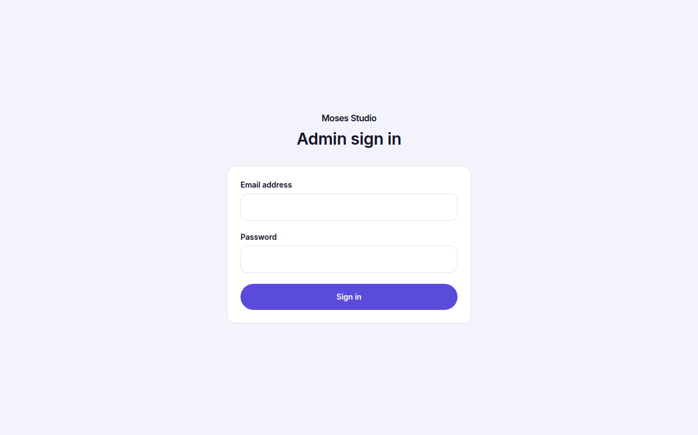
The sign in page
If sign in fails
Check your email address and password carefully. After several wrong attempts the system pauses sign in for about 15 minutes to protect your account. Wait, then try again.
If you have forgotten your password, ask a Super Admin to reset it for you (Users page), or contact the person who manages your hosting.

2.2 The dashboard
The Dashboard shows live numbers from your website: total projects, how many are Previous, Ongoing and Ready works, how many are published or drafts, and how many contact enquiries you have received. Below that you see your latest enquiries. All numbers are real, nothing is estimated.
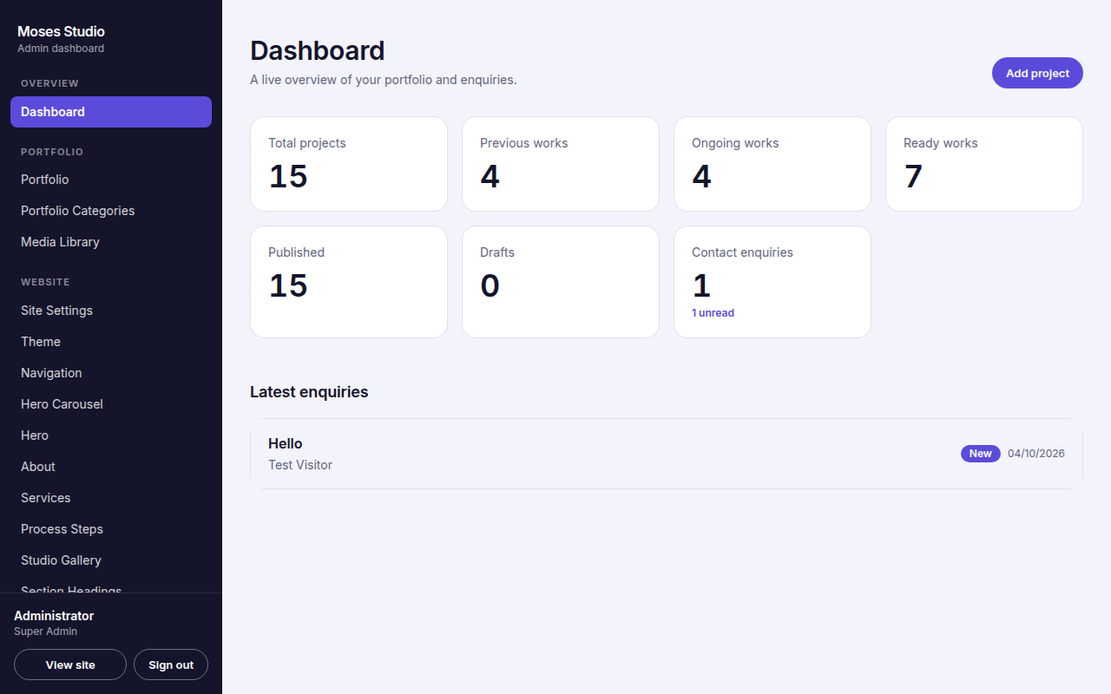
The dashboard overview

2.3 The menu (left side)
On a phone or tablet, tap the menu button at the top to open the same list.
Menu item | What it controls
Dashboard | Overview numbers and latest enquiries.
Portfolio | All projects: create, edit, publish, order, delete.
Portfolio Categories | The groups used to filter projects (for example Avatars).
Media Library | Every image you have uploaded.
Site Settings | Website name, tagline, logo and favicon.
Theme | Colours, light or dark look, heading style.
Navigation | The links in the top menu.
Hero Carousel | The large images that slide behind the main heading.
Hero | The main heading, subtitle, description and buttons at the top.
About | Your story, profile image, capabilities, years of experience, location.
Services | Service cards with image, description and icon.
Process Steps | The numbered Our process section with an image per step.
Studio Gallery | The mosaic of images in the Studio gallery section.
Section Headings | Titles and introductions of every section, plus the Why choose us list.
Testimonials | Client quotes (add only real, approved quotes).
Call To Action | The colourful banner inviting visitors to get in touch.
Contact | Phone, WhatsApp, email, address, opening hours.
Social Links | Facebook, Instagram, YouTube and other links.
Footer | Footer text, credit line and the BackEnd link label.
SEO | How your site appears in Google and when shared.
Enquiries | Messages sent through the contact form.
Users | Add or remove administrators (Super Admin only).
Security | Change your own password.
Activity Log | Who changed what, and when.

Tip
The coloured notice at the bottom of the screen confirms each action, for example Changes saved. If something is wrong, the notice turns red and explains what to fix.

3. Editing website text, colours and images
Every page under the Website group of the menu works the same way: change the fields, then press Save changes at the bottom. You can leave a page without saving and nothing changes.

3.1 How the fields work
Field type | How to use it
Text box | Type your text. Some boxes show a maximum length to keep the design tidy.
Large text box | For paragraphs. In the About biography, leave a blank line to start a new paragraph.
Image | Click Upload image to choose a file from your computer, or Choose from library to reuse an earlier upload. Click Remove to clear it.
Link | Type a full web address starting with https:// or use a section anchor such as #contact, #works, #services, #about.
Colour | Click the colour square and pick a colour, or enter a hex code such as #5B4BDB.
List (one per line) | Used for About capabilities. Write one item per line.
Repeating items | Used for the Why choose us reasons. Click Add another for more, Remove to delete one.
Drop-down | Choose from the options shown.

3.2 Website pages and what they change

Site Settings
Website title, tagline (shown beside the name), logo and favicon. If you upload a logo it replaces the text name in the top left. Use a transparent PNG or SVG at least 320 pixels wide for a sharp result. The favicon is the small icon in the browser tab; use a square image.

Theme
Controls the whole look of the site. Primary, Secondary and Third colours drive buttons, icons, gradients and highlights. The Precious/Previous, Ongoing and Ready colours control the status badges on project cards. Footer colour sets the dark band at the bottom. Appearance can be Light or Dark. Heading style switches between an elegant serif and a modern sans-serif.
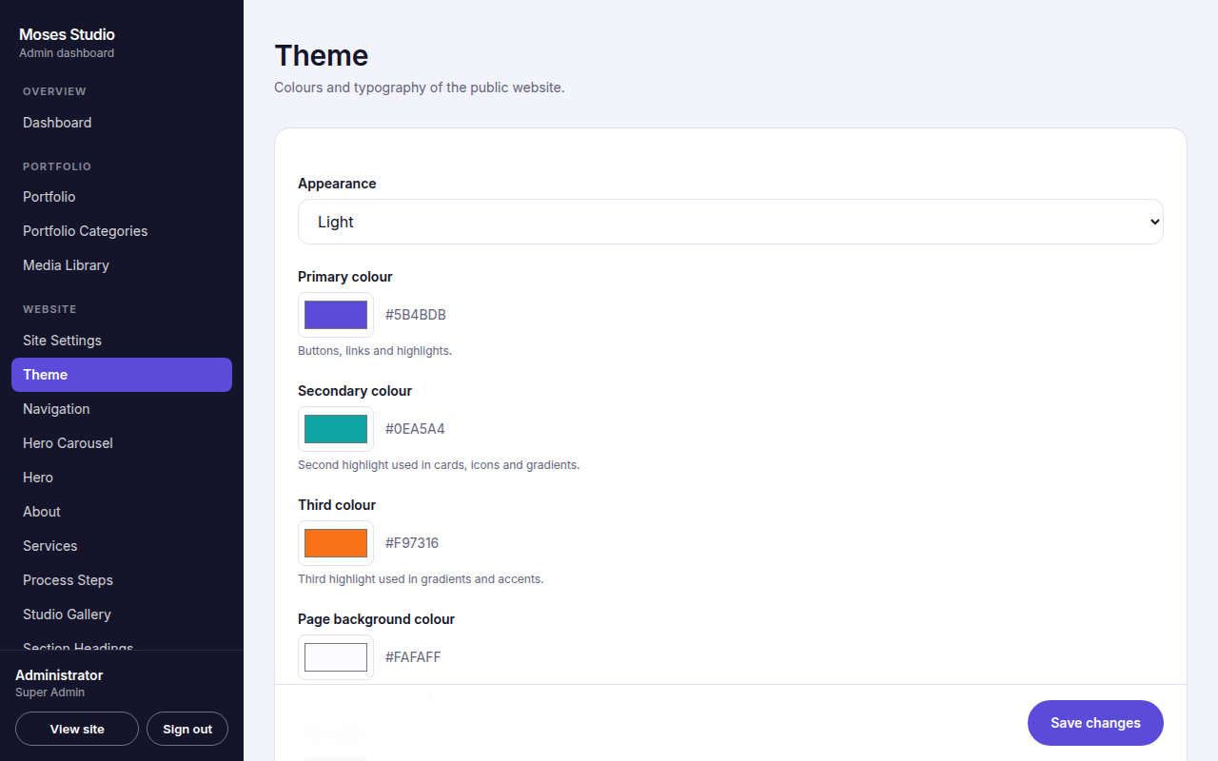
The Theme page
Choosing colours
Keep strong contrast between text and background so the site stays easy to read. Pick three colours that work together, one calm and two bright. After saving, open the public site and check the hero, buttons and footer.

Navigation
The links in the top menu. Each has a label, a link and a Show in menu switch. Use the up and down arrows to reorder. Links starting with # scroll to that section (#about, #services, #works, #contact). You can also link to another website using a full address.

Hero Carousel
The full screen images behind the main heading. Add several images: each has an image, a description for visually impaired visitors (alt text), a caption and an optional link. Use wide, high quality images, at least 1920 pixels wide, with the subject away from the left side where the heading sits. Hide a slide with Hide instead of deleting it if you may want it again.

Hero
Small label above the heading, the main heading, subtitle, description, and the two buttons with their links. Keep the heading short and clear. This is the first thing visitors read.
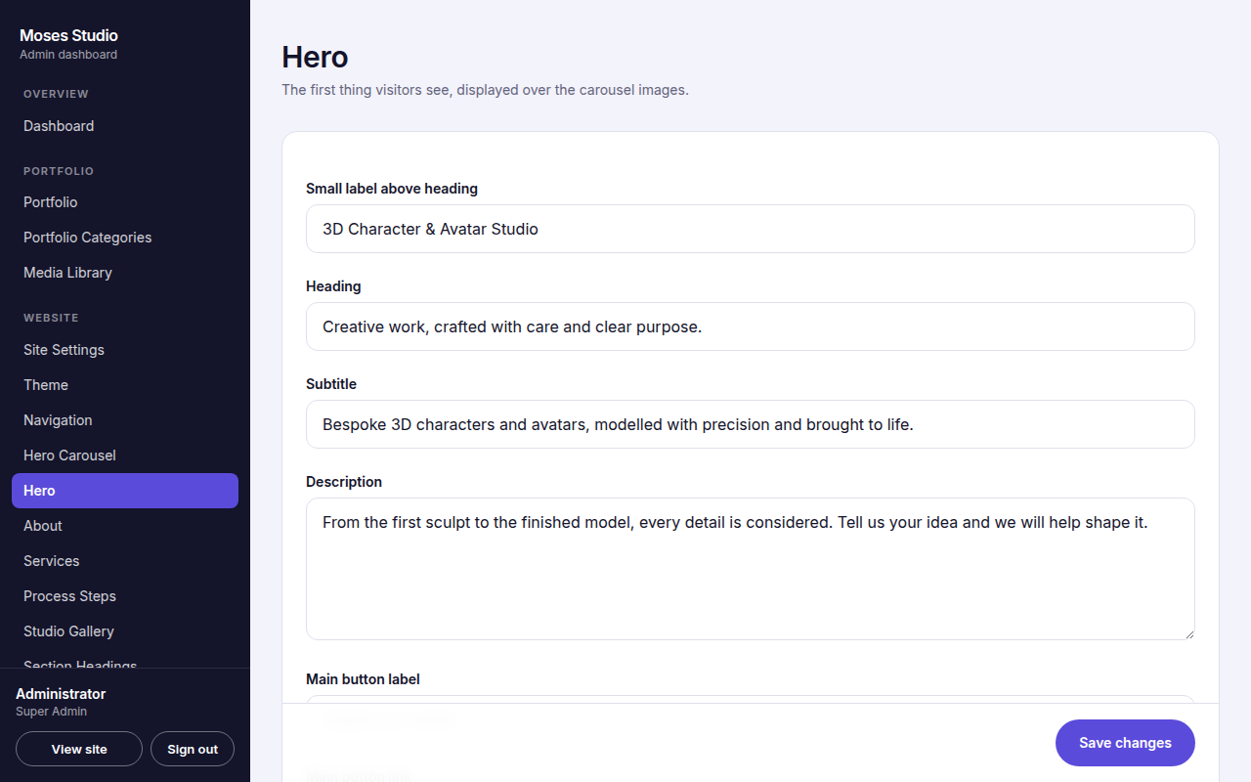
The Hero page

About
Profile image, introduction, biography, professional statement, key capabilities (one per line), years of experience, location, and the button. Only publish facts that are true. Leave Years of experience and Location empty if you prefer not to show them.

Services
Each service is a card. Fill in the title, short description and optional detailed description (visitors can open it with Learn more). Add an image, or leave it empty to show an icon; choose the icon from the list. Use Hide to remove a service from the website without deleting it.
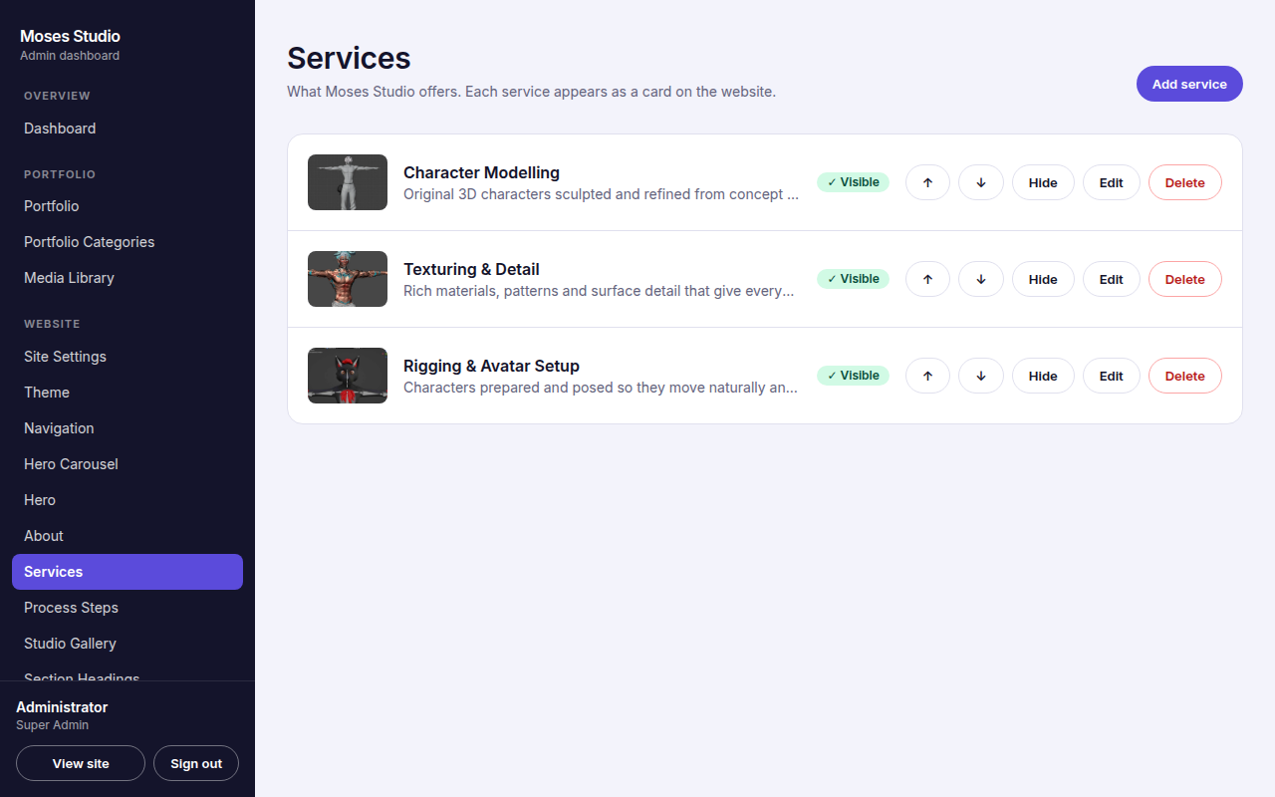
The Services list with reorder, hide, edit and delete buttons

Process Steps and Studio Gallery
Process Steps are the numbered boxes in Our process: title, description and image each. Studio Gallery is the image mosaic: image, caption (shown on hover) and a description. Both lists can have any number of items. Use the up and down arrows to change the order, and Hide or Delete to remove items.

Section Headings
The small label, title and introduction of each section (Services, Process, Works, Gallery and more), the Previous, Ongoing and Ready section titles, and the Why choose us reasons. Change wording here without touching the sections themselves.

Testimonials
Only real testimonials
Add testimonials only from real clients who have agreed to be quoted. The section disappears automatically when there are none.
Each testimonial has the client name, role or company, the quote, and an optional photo.

Call To Action
The colourful banner near the bottom: heading, description and button with its link.

Contact
Your phone number and WhatsApp number (enter them in international format, for example +234 813 419 8744), the message that is pre-filled when someone opens WhatsApp, an optional public email, an optional address and opening hours. The phone button calls the number. The WhatsApp button opens a chat with the pre-filled message. Enquiry notification email is where form messages are emailed, if email sending has been set up (see Section 5).

Social Links
Choose a network (Facebook, Instagram, YouTube, TikTok, LinkedIn, X, Behance, Dribbble or Other), paste the full profile address and save. Only networks you add appear in the footer, so no empty or fake links are shown.

Footer
The footer text (the current year is added automatically), the credit line and the small BackEnd link. The credit line currently reads Powered by Fodan Softnet Inc (08067578112). To hide the BackEnd link, empty its label; you can still sign in by typing /admin/login after the website address.

SEO
Controls how your site looks in Google and when shared on social media. Write a clear SEO title (about 50 to 60 characters) and description (about 150 to 160 characters). Upload a sharing image about 1200 by 630 pixels. Set Website address to your real domain once you have one. Set Search engines to Hide only while building the site.

4. Managing projects
Projects are the heart of the website. Each project is a full record with its own page on your site, at the address /work/ followed by the project slug.

4.1 The three work statuses
Status | Meaning and where it appears
Previous works | Finished projects that you are proud of. They appear in the Previous Works group. The first featured project here is shown larger.
Ongoing works | Projects currently in progress. They appear in the Ongoing Works group.
Ready works | Completed work that is ready to deliver or view. They appear in the Ready Works group.
Changing a status moves the project to the matching group on the website immediately.

4.2 The Portfolio list
Open Portfolio. Each project row shows its image, name, category and badges (status, Published or Draft, Featured). The buttons on each row:
Button | What it does
Status drop-down + Set | Changes the project status.
Publish / Unpublish | Shows or hides the project on the website. Drafts are never visible to visitors.
Feature / Unfeature | Featured projects are shown larger, and the first featured project appears in the Project in focus spotlight section.
Up and down arrows | Change the display order. Available when no filter is active.
Edit | Opens the full project form.
Duplicate | Makes an unpublished copy to reuse as a starting point.
Delete | Permanently removes the project after you confirm.
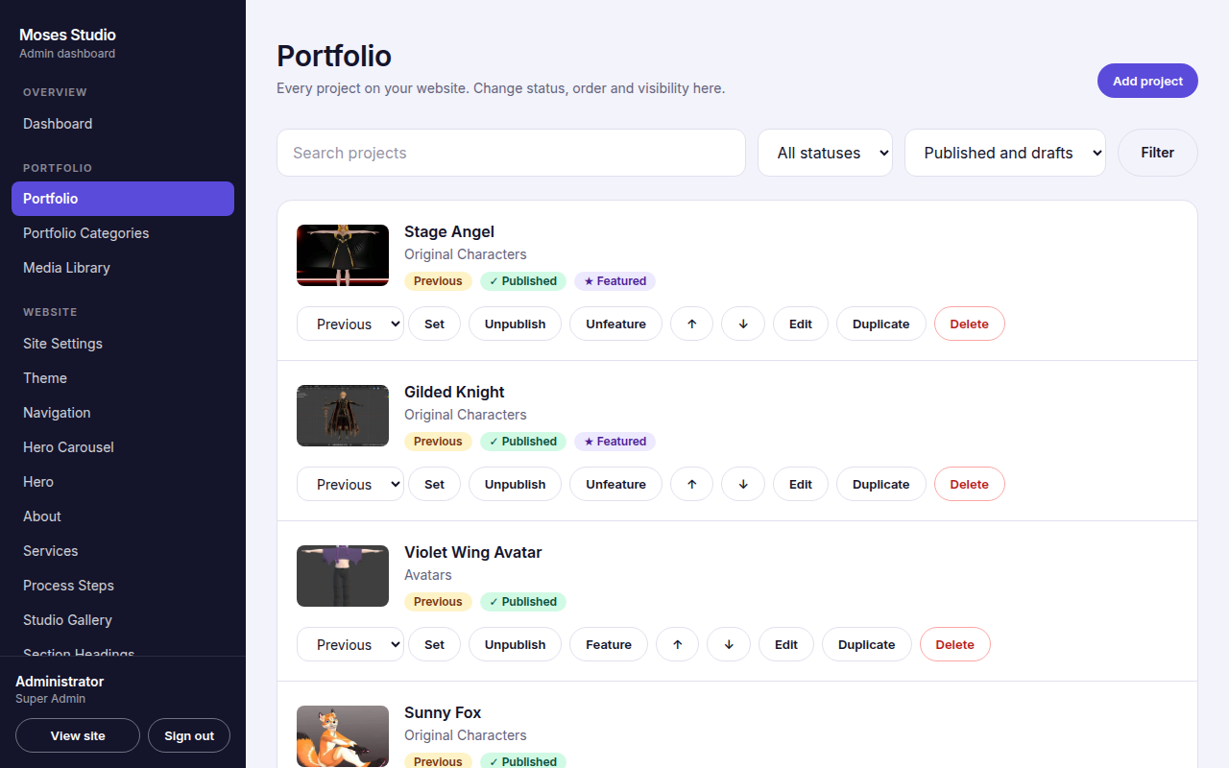
The Portfolio list
Use the search box and the status and visibility filters at the top to find a project quickly. The list works well with hundreds of projects.

4.3 Adding a project
- Go to Portfolio and click Add project.
- Fill in Basics: project title, status, category, short description (shown on cards) and full description.
- Upload the Featured image. This is the main picture on the card and at the top of the project page.
- Optionally add a video link (YouTube or Vimeo) and gallery images using Add gallery image. Use Move up or Move down to arrange the gallery.
- Add details if you want them shown: client name, location, dates, services provided, tools, external link.
- Tick Published when you are ready for visitors to see it, then click Save project.
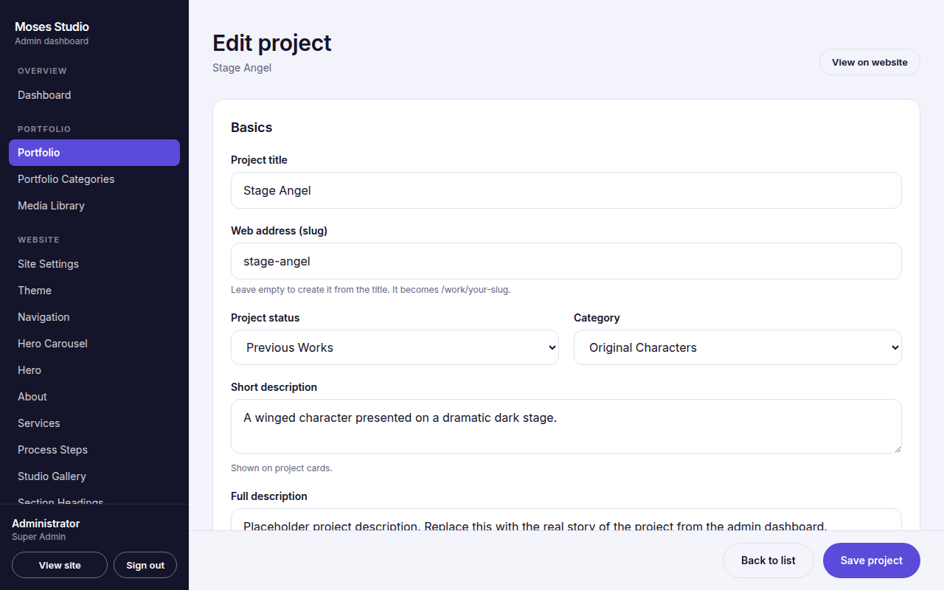
The project form

4.4 Project form fields explained
Field | Notes
Project title | Required. Used for the card, the page heading and the web address.
Web address (slug) | Optional. Leave empty and it is made from the title, for example gilded-knight becomes /work/gilded-knight. Each slug must be unique.
Project status | Previous, Ongoing or Ready (see 4.1).
Category | Choose one of your categories. Visitors can filter by it.
Short description | One or two sentences shown on the project card.
Full description | The full story. Leave a blank line between paragraphs.
Featured image | Main image. Use a clear image at least 1600 pixels wide.
Video link | Optional YouTube or Vimeo address. It appears on the project page.
Gallery | Extra images for the project page. Add as many as you need and write a short description for each.
Client name, Location | Optional. Only add a client name with the client's permission.
Project date, Completion date | Optional dates shown on the project page.
Services provided, Tools | Separate items with commas. They appear as coloured tags.
External project link | Optional link to the live work elsewhere (must start with https://).
Display order | Lower numbers appear first. You can also reorder with the arrows in the list.
Featured | Shows the project larger and in the spotlight section.
Published | Tick to show on the website. Untick to keep it as a draft.
SEO title and description | Optional wording for Google. If empty, the project title and short description are used.

4.5 Categories
Go to Portfolio Categories. Add, rename, reorder or delete categories. A category only appears as a filter button on the website once at least one published project uses it. Deleting a category does not delete its projects; they simply become uncategorised.

5. Images, enquiries and email

5.1 Uploading images
- Accepted files: JPG, PNG, WebP, AVIF and GIF. Maximum 8 MB each.
- Every upload is checked, resized to a maximum of 2400 pixels, and converted to the efficient WebP format automatically. You do not need to compress images yourself.
- Upload from any image field, or in bulk from the Media Library using Upload images.
- To replace an image, open the item and click Replace image. To remove one, click Remove.
- Write helpful image descriptions (alt text). They help visitors who use screen readers and also help search engines.

5.2 The Media Library
Every uploaded image appears here with its size. You can reuse an image in any image field with Choose from library. Deleting an image from the library removes the file, and any page still using it will show a missing image until you replace it, so check first.
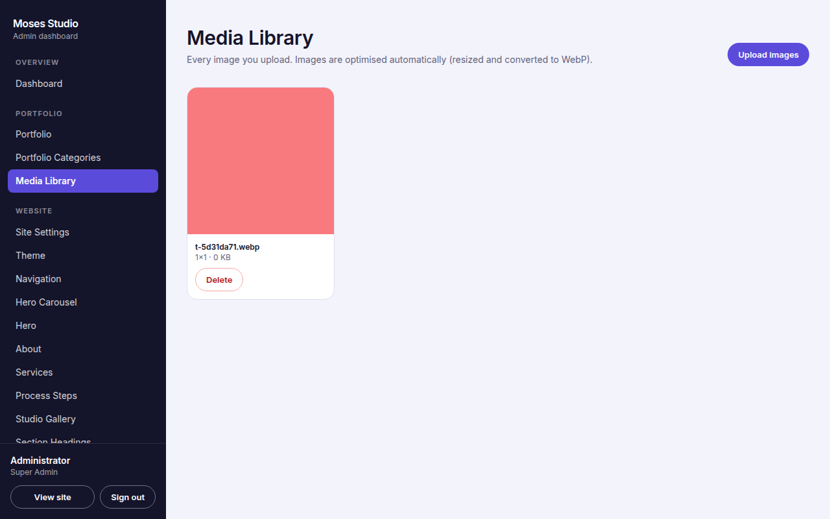
The Media Library
Image advice
Use real, well lit, high resolution images. Avoid screenshots with software menus or taskbars. Remove any text or watermarks you do not want shown. Do not upload images you do not have the right to use, or content that is inappropriate for a professional audience.

5.3 Enquiries
When a visitor uses the contact form, the message is saved in Enquiries. Each message shows the name, email, phone, subject, message and date. New messages are highlighted and counted in the menu. Click Mark read when handled, or Delete to remove. Click the email or phone shown to reply directly.
The contact form protects you from spam automatically: hidden checks, a limit on repeated submissions from one connection, and full validation of every field.

5.4 Email notifications (optional)
Messages are always saved in the dashboard. To also receive an email for every enquiry, your website host must have an email service key configured (Resend). Enter the address that should receive them in Contact, then Enquiry notification email. If emails are not arriving, enquiries are still safe in the Enquiries page.
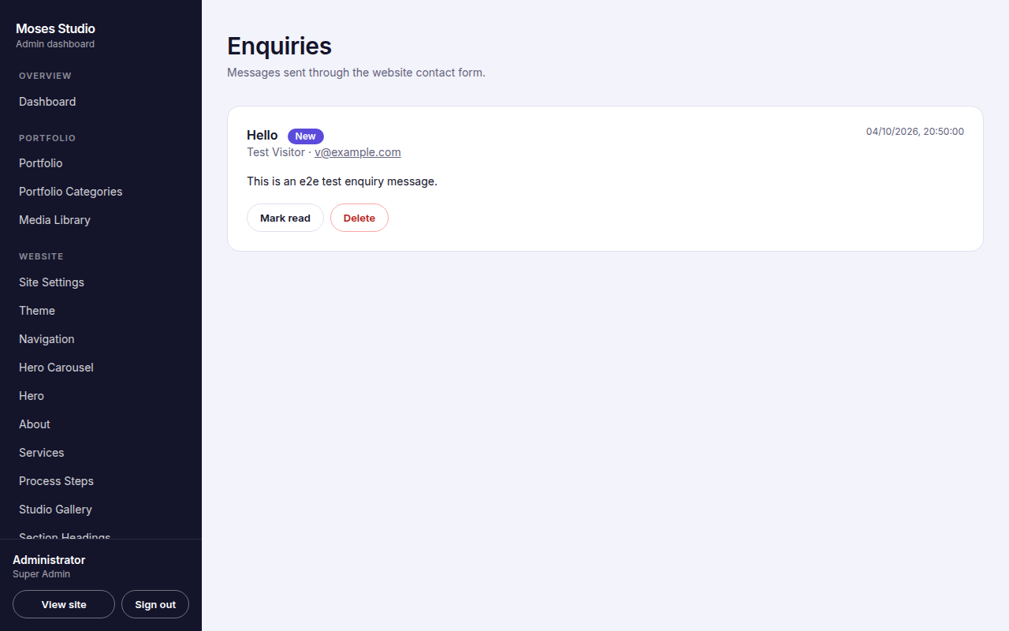
The Enquiries page

6. Users, passwords and security

6.1 Roles
Role | What they can do
Super Admin | Everything an Admin can do, plus add, deactivate, reset and delete users.
Admin | Edit all website content, projects, images and enquiries. Cannot manage users.

6.2 Changing your own password
- Open Security in the menu.
- Enter your current password, then the new password twice.
- Click Update password. You are signed out of other devices automatically.
A good password has at least 10 characters with upper case letters, lower case letters and a number. Use something unique that you do not use anywhere else.

6.3 Adding an administrator (Super Admin only)
- Open Users and scroll to Add an administrator.
- Enter their full name, email and a temporary password. Choose the role.
- Click Create account and send them the details privately. Ask them to change the password in Security after signing in.
On the same page you can reset a password, deactivate an account (blocks sign in but keeps the record), reactivate it, or delete it. You cannot delete or deactivate your own account, and at least one active Super Admin must always remain.
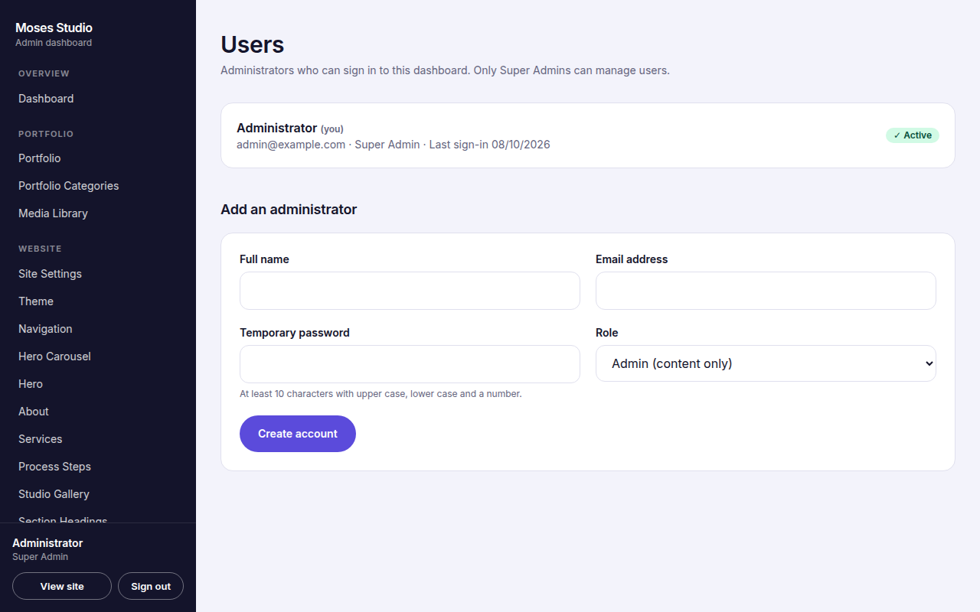
The Users page

6.4 Activity Log
Activity Log lists the most recent 200 actions: sign ins, saved content, project changes, uploads, deletions and more, with the person and time. Use it to see who changed something.

6.5 Staying safe
- Sign out (bottom of the menu) when using a shared or public computer.
- Never share your password in chat or email. Create separate accounts for each person.
- Deactivate accounts of people who no longer work with you.
- Back end pages are hidden from search engines and protected; visitors who are not signed in cannot reach them.

7. Quick how-to recipes
I want to... | Do this
Change my phone or WhatsApp number | Contact, edit Phone number and WhatsApp number (international format), Save changes.
Change the WhatsApp opening message | Contact, WhatsApp opening message, Save changes.
Replace the main hero pictures | Hero Carousel, open a slide, Replace image, Save. Add or hide slides as needed.
Change the main headline | Hero, edit Heading, Save changes.
Add a new project | Portfolio, Add project, fill the form, tick Published, Save project (see Section 4.3).
Move a project to Ongoing or Ready | Portfolio, choose the status in the drop-down on its row, click Set.
Hide a project without deleting it | Portfolio, click Unpublish on its row.
Show a project larger | Portfolio, click Feature on its row.
Put a project first | Portfolio, use the up arrow until it is first in its group (or set Display order to 0).
Add a service | Services, Add service, fill in, Save.
Add a testimonial | Testimonials, Add testimonial, only with the client's permission.
Add a social link | Social Links, Add social link, choose network, paste the address, Save.
Change the colours of the site | Theme, choose colours, Save changes.
Upload my logo | Site Settings, Logo, Upload image, Save changes.
Change the menu names | Navigation, edit the label of each item.
Change the footer wording | Footer, edit the text, Save changes.
Hide the small BackEnd link | Footer, empty the Back end link label, Save changes.
Update how I appear in Google | SEO, edit title and description, Save changes.
Add a new Gallery image | Studio Gallery, Add gallery image, upload, add caption, Save.
See who changed something | Activity Log.

8. Troubleshooting
Problem | What to try
I changed something but the website looks the same | Refresh the public page (Ctrl + F5, or Cmd + Shift + R on Mac). Check you pressed Save changes and saw the green confirmation.
My project does not appear on the website | Open Portfolio and check it says Published (not Draft). Check it has a status and, for category filters, a category.
The project page says not found | The project is a draft, or the web address (slug) was changed. Publish it, and use the View on website button on its edit page.
An image will not upload | Use JPG, PNG, WebP, AVIF or GIF under 8 MB. If every upload fails, the image storage connection on your hosting needs attention; contact your hosting administrator.
An image shows as broken | The file was deleted from the Media Library. Upload it again and select it in the item.
I cannot sign in | Check email and password. After repeated failures wait 15 minutes. Ask a Super Admin to reset your password.
Enquiry emails do not arrive | Messages are still stored in Enquiries. Email sending needs a service key on the host and a correct notification email in Contact.
A section has disappeared | Sections with no content hide themselves (for example Testimonials with no entries, Gallery with no images). Add items or unhide them.
The site shows an error page | Open your website address followed by /api/health. It lists the database and tables. Send what it shows to your technical contact, together with the time it happened.
Colours look wrong or text is hard to read | Open Theme and choose colours with strong contrast between text and background.

Who to contact
For hosting, domain or technical faults, contact Fodan Softnet Inc (08067578112). Keep your website address and the time of the problem ready.

9. Launch checklist
The website was delivered with clearly marked placeholder text, sample projects and sample images so it looks complete from day one. Before you promote the site, replace the placeholders with your real content.
- Site Settings: confirm the website title, tagline, logo and favicon.
- Theme: confirm colours and appearance.
- Hero Carousel and Hero: replace images and wording with your own.
- About: write your real story, upload a profile image, remove any capability that is not true.
- Services: enter the real services you offer with accurate descriptions and images.
- Process Steps and Studio Gallery: replace or confirm the images and wording.
- Portfolio: edit or delete each sample project. Add your real projects and choose their status.
- Portfolio Categories: rename the categories to match your work.
- Testimonials: add real, approved quotes only.
- Why choose us (Section Headings): make sure every reason is true for you.
- Contact: confirm phone, WhatsApp, email, address and hours. Send a test message through the contact form.
- Social Links: add your real profiles.
- Footer: confirm the wording.
- SEO: write your SEO title and description, upload a sharing image, set the Website address to your real domain.
- Security: change your password. Create separate accounts for other people.
- Open the public site on a phone and a computer and read every section once.

Glossary
Term | Meaning
Back end | The private dashboard used to manage the website.
Publish / Draft | Published content is visible to visitors; a draft is saved but hidden.
Slug | The part of a project's web address, for example gilded-knight in /work/gilded-knight.
Alt text | A short description of an image for visitors who cannot see it and for search engines.
SEO | Search engine optimisation: helping Google understand and show your site.
Hero | The large opening area at the top of the home page.
Featured | A project highlighted at larger size and in the spotlight section.
Hex code | A colour written like #5B4BDB.

Thank you for choosing Moses Studio. Your website is yours to shape.

