The TrackR SWD Connection
(c) Robin Callender, March 4, 2016
This document shows how to connect and use the Segger “JLink.Exe” utility to connect to the TrackR device. Below is an overview photo of how I established a SWD connection to the TrackR. Much of the components on the left side of the photo may be substituted for your own equipment: Standard JLink or other SWD compatible adapter could be used. The important concern is to get the SWD related lines mapped into the connector cable. Details on these SWD mappings are shown in the following photo.

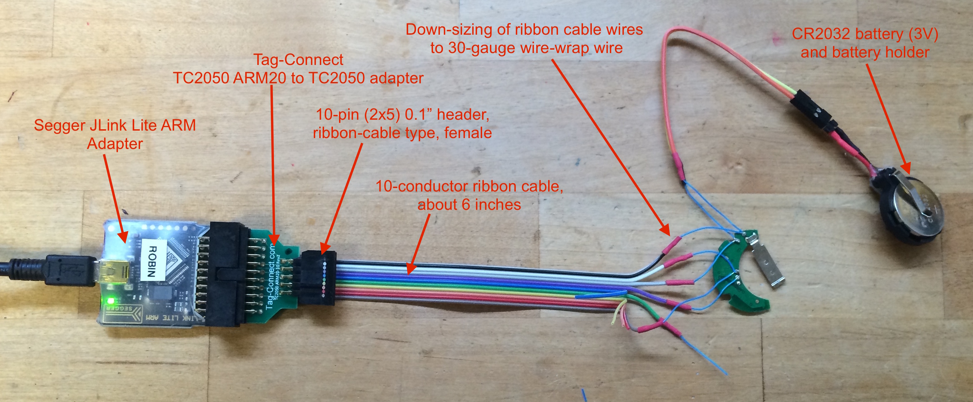
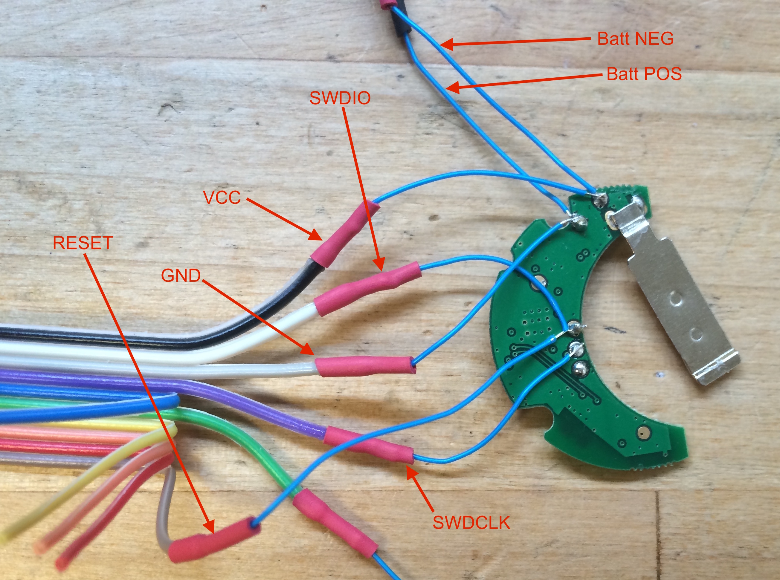

After you have physically connected the SWD adapter to to the TrackR, start the JLink program on the system connected to the SWD (JLink) adapter. Using a command line shell, you should be able to connect to the TrackR by following the red hi-lited sequence in the listing below.

knots:~ robin$ JLinkExe -if SWD -device nrf51822_xxab -speed 1000
SEGGER J-Link Commander V5.10f (Compiled Dec 22 2015 14:25:20)
DLL version V5.10f, compiled Dec 22 2015 14:25:14

Connecting to J-Link via USB...O.K.
Firmware: J-Link ARM Lite V8 compiled Oct 29 2014 09:03:16
Hardware version: V8.00
S/N: xxxxxxxxx
License(s): GDB
Emulator has Trace capability
VTref = 2.957V

Type "connect" to establish a target connection, '?' for help

J-Link>connect
Device "NRF51822_XXAB" selected.

Found SWD-DP with ID 0x0BB11477
Found Cortex-M0 r0p0, Little endian.
FPUnit: 4 code (BP) slots and 0 literal slots
CoreSight components:
ROMTbl 0 @ F0000000
ROMTbl 0 [0]: F00FF000, CID: B105100D, PID: 000BB471 ROM Table
ROMTbl 1 @ E00FF000
ROMTbl 1 [0]: FFF0F000, CID: B105E00D, PID: 000BB008 SCS
ROMTbl 1 [1]: FFF02000, CID: B105E00D, PID: 000BB00A DWT
ROMTbl 1 [2]: FFF03000, CID: B105E00D, PID: 000BB00B FPB
ROMTbl 0 [1]: 00002000, CID: B105900D, PID: 000BB9A3 ???
Cortex-M0 identified.

J-Link>h
PC = 000119CE, CycleCnt = 00000000
R0 = 20000103, R1 = 00000032, R2 = E000E200, R3 = 00000032
R4 = 00000000, R5 = 20002AB4, R6 = 00000000, R7 = 00000000
R8 = FFFFFFFF, R9 = FFFFFFFF, R10= 0001CFF0, R11= 0001CFF0
R12= FFFFFFFF
SP(R13)= 20003AF0, MSP= 20003AF0, PSP= FFFFFFFC, R14(LR) = 0000116B
XPSR = 61000000: APSR = nZCvq, EPSR = 01000000, IPSR = 000 (NoException)
CFBP = 00000000, CONTROL = 00, FAULTMASK = 00, BASEPRI = 00, PRIMASK = 00

J-Link>s
000119CE: 40 BF SEV
J-Link>s
000119D0: 20 BF WFE
J-Link>s
000119D2: 41 78 LDRB R1, [R0, #+0x01]
J-Link>s
000119D4: 03 78 LDRB R3, [R0]
J-Link>s
000119D6: 43 70 STRB R3, [R0, #+0x01]

The JLink.exe, is the Windows name for the utility. It is named “JLinkExe” for Linux and OSX.

