Clean up gating

Anja Bråthen Kristoffersen

08 March 2022

This document describes the different lines of the file “example clean up gating alle filer.R”. To perform your own gating save the file “example clean up gating alle filer.R” from github <https://github.com/folkehelseinstituttet/cytof> give it a new name and change the necessary paths and values throughout the document to use it on your own data.

You start with defining a variable data_path that contains the path of the folder where all your uncleaned files are saved. I prefer using the function path from the library fs. When using a function from a given library the way to get the function is by library_name::function_name so in this case fs::path

data_path <- fs::path("C:", "CyToF data", "immun_aga", "panel1 RAA")

which gives the path

data_path

## C:/CyToF data/immun_aga/panel1 RAA

Now define the paths to the folder where you want to save

* the new files that are clean up gated and
* figures of the gating performance.

Do also define the path where the files script used are saved.

outDataPath <- fs::path("C:", "CyToF data", "immun_aga", "panel 1 cleaned data")  
out_result <- fs::path("C:", "CyToF data", "immun_aga", "figures panel 1 cleaning")  
scriptPath <- fs::path("C:", "CyToF data", "fra github")

I have already made many functions that can be used for reading, transforming, gating and plotting in R. These functions can be found on github <https://github.com/folkehelseinstituttet/cytof>. Save the files gating_functions.R, ploting_functions, read_data_function.R, analysis_functions.R and transformation_functions.R into your script folder and source them into R so that you might use them later

source(fs::path(scriptPath, "gating_functions.R"))  
source(fs::path(scriptPath, "ploting_functions.R"))  
source(fs::path(scriptPath, "read_data_functions.R"))  
source(fs::path(scriptPath, "transformation_functions.R"))  
source(fs::path(scriptPath, "analysis_functions.R"))

file.info() and list.files() are functions in R that can be used to find the name of all files in one folder

fcs_files <- fs::path(data_path, rownames(file.info(list.files(data_path))))

to see which files that is included in the variable fcs_files:

fcs_files

## C:/CyToF data/immun_aga/panel1 RAA/Ko_Ma_A_70_578K1_Panel1.fcs  
## C:/CyToF data/immun_aga/panel1 RAA/Ko_Ma_A_72_582K1_Panel1.fcs  
## C:/CyToF data/immun_aga/panel1 RAA/M_Fe_B_20_T1_FHI155_Panel1.fcs  
## C:/CyToF data/immun_aga/panel1 RAA/M_Fe_B_43_T1_FHI004_Panel1.fcs  
## C:/CyToF data/immun_aga/panel1 RAA/Ref1_Panel1_230621.fcs  
## C:/CyToF data/immun_aga/panel1 RAA/S_ Fe_B_22_T1_FHI111T1_Panel1.fcs

basename() is a function that give you the name of the file without the path. By using the function grepl() we choose only the files that contains .fcs.

files_to_open <- basename(fcs_files)  
files_to_open <- files_to_open[grepl(".fcs", files_to_open)]

setwd() is a function who set the working directory. Here we want the working directory to be where the uncleaned cytof files are. dirname() gives the directory/folder of one file, and fcs_files[1] gives the first file in the vector fcs_files.

setwd(dirname(fcs_files[1]))

The variable file_names are made as a shorter version of the variable files_to_open (without “.fcs”) by using the function gsub(), the function gsub() first takes the pattern that you want to substitute and then the pattern you want to replace it with in the vector which is the last variable in the function call. This is done to have shorter unique names on each dataset/file for later use.

file_names <- gsub(".fcs", "", files_to_open)

The number of .fcs files in the variable vector file_names are found by the function length()

n_files <- length(file_names)

Here a vector filenumbers containing 1, 2, 3, …. to n_files are made for later use

filenumbers <- 1:n_files  
filenumbers

## [1] 1 2 3 4 5 6

Two empty matrixes to take care of how many percentages of each file that are lost by each gating and in total of all previous gating are defined as percent_lost_each_gating and percent_lost_from_full_dataset, respectively. These data.frames are given the column name of the gating and the rownames of the files that are gated.

percent_lost_each_gating <- as.data.frame(matrix(NA, ncol = 9, nrow = n_files))  
percent_lost_from_full_dataset <- as.data.frame(matrix(NA, ncol = 9, nrow = n_files))  
  
colnames(percent_lost_each_gating) <- c("Ce140Di", "Residual", "Center", "Offset", "Width",  
 "Event_length", "Pt194Di", "Ir191Di", "Ir193Di")  
  
colnames(percent_lost_from_full_dataset) <- colnames(percent_lost_each_gating)  
  
rownames(percent_lost_each_gating) <- file_names  
rownames(percent_lost_from_full_dataset) <- rownames(percent_lost_each_gating)

plotSignal() is a function that has to be made to the dataset that are used. It tells how to plot the files you use. Here I have 6 files and I want to plot them with 2 rows and 3 columns. The variable plot_list is a list that I will produce later that contain a plot per file. To write comments into an R code you use # in the beginning of the line. I have here written a version of this function that plots 66 plots in 6 rows and 11 columns.

plotSignal <- function(plot_list){  
 g <- gridExtra::grid.arrange(plot_list[[1]], plot_list[[2]], plot_list[[3]], plot_list[[4]], plot_list[[5]],  
 plot_list[[6]], ncol = 3, nrow = 2)  
 return(g)  
}  
  
# plotSignal <- function(plot_list){  
# g <- gridExtra::grid.arrange(plot_list[[1]], plot_list[[2]],   
# plot_list[[3]], plot_list[[4]], plot_list[[5]],  
# plot_list[[6]], plot_list[[7]], plot_list[[8]],   
# plot_list[[9]], plot_list[[10]], plot_list[[11]],   
# plot_list[[12]], plot_list[[13]], plot_list[[14]],   
# plot_list[[15]], plot_list[[16]], plot_list[[17]],   
# plot_list[[18]], plot_list[[19]], plot_list[[20]],  
# plot_list[[21]], plot_list[[22]], plot_list[[23]],   
# plot_list[[24]], plot_list[[25]], plot_list[[26]],  
# plot_list[[27]], plot_list[[28]], plot_list[[29]],  
# plot_list[[30]], plot_list[[31]], plot_list[[32]],   
# plot_list[[33]], plot_list[[34]], plot_list[[35]],  
# plot_list[[36]], plot_list[[37]], plot_list[[38]],   
# plot_list[[39]], plot_list[[40]], plot_list[[41]],   
# plot_list[[42]], plot_list[[43]], plot_list[[44]],   
# plot_list[[45]], plot_list[[46]], plot_list[[47]],   
# plot_list[[48]], plot_list[[49]], plot_list[[50]],  
# plot_list[[51]], plot_list[[52]], plot_list[[53]],   
# plot_list[[54]], plot_list[[55]], plot_list[[56]],   
# plot_list[[57]], plot_list[[58]], plot_list[[59]],   
# plot_list[[60]], plot_list[[61]], plot_list[[62]],   
# plot_list[[63]], plot_list[[64]], plot_list[[65]],  
# plot_list[[66]], ncol = 11, nrow = 6)  
# return(g)  
# }

You could either look at all files at the same time or divide it into blocks of files. Here is an example with all files. If memory problems, it is possible to divide the files to clean into groups using a loop.

Read all files in data_path into a list object fcs_data by using the function read_some_data_from_folder(). This function returns two elements the dataset and the file_name in the same order as the data is read. I choose to store this in two separate variables and remove the variable with both objects by using the function rm().

fcs_data_with_info <- read_some_data_from_folder(data_path, file_number = filenumbers)  
fcs_data <- fcs_data_with_info$fcs_data  
file_names <- factor(fcs_data_with_info$file_names, levels = fcs_data_with_info$file_names)  
rm(fcs_data_with_info)

By using the function get_params_fcs_data() the parameters of the first element of the list fcs_data are obtained. By writing the variable name params we get to see what this variable contains.

params <- get_params_fcs_data(fcs_data[[1]])  
params

## name desc range minRange maxRange  
## $P1 Time <NA> 2097152 0 2097151  
## $P2 Event_length <NA> 4096 0 4095  
## $P3 Y89Di 89Y_CD45 16384 0 16383  
## $P4 Pd102Di 102Pd 4096 0 4095  
## $P5 Pd104Di 104Pd 4096 0 4095  
## $P6 Pd105Di 105Pd 4096 0 4095  
## $P7 Cd106Di 106Cd_CD57 65536 0 65535  
## $P8 Pd108Di 108Pd 32768 0 32767  
## $P9 Cd110Di 110Cd 4096 0 4095  
## $P10 Cd111Di 111Cd_CD19 32768 0 32767  
## $P11 Cd112Di 112Cd_CD5 32768 0 32767  
## $P12 Cd113Di 113Cd_CD8 16384 0 16383  
## $P13 Cd114Di 114Cd_HLADR 65536 0 65535  
## $P14 Cd116Di 116Cd_CD3 65536 0 65535  
## $P15 Sn120Di 120Sn 32768 0 32767  
## $P16 I127Di 127I 16384 0 16383  
## $P17 Xe131Di 131Xe 4096 0 4095  
## $P18 Cs133Di 133Cs 4096 0 4095  
## $P19 Ba138Di 138Ba 32768 0 32767  
## $P20 Ce140Di 140Ce 8192 0 8191  
## $P21 Pr141Di 141Pr_CCR6 32768 0 32767  
## $P22 Nd142Di 142Nd_KLRG1 32768 0 32767  
## $P23 Nd143Di 143Nd_CD127 65536 0 65535  
## $P24 Nd144Di 144Nd_CD15 8192 0 8191  
## $P25 Nd145Di 145Nd_CD4 65536 0 65535  
## $P26 Nd146Di 146Nd_IgD 65536 0 65535  
## $P27 Sm147Di 147Sm_CD11c 4096 0 4095  
## $P28 Nd148Di 148Nd_CD16 65536 0 65535  
## $P29 Sm149Di 149Sm_CD25 4096 0 4095  
## $P30 Nd150Di 150Nd_CD134_OX40 16384 0 16383  
## $P31 Eu151Di 151Eu_CD123 8192 0 8191  
## $P32 Sm152Di 152Sm_TCRgd 4096 0 4095  
## $P33 Eu153Di 153Eu_CCR4 8192 0 8191  
## $P34 Sm154Di 154Sm_TIGIT 4096 0 4095  
## $P35 Gd155Di 155Gd_CD45RA 4096 0 4095  
## $P36 Gd156Di 156Gd_CXCR3 32768 0 32767  
## $P37 Gd158Di 158Gd_CD27 8192 0 8191  
## $P38 Tb159Di 159Tb_IgG 65536 0 65535  
## $P39 Gd160Di 160Gd_CD28 4096 0 4095  
## $P40 Dy161Di 161Dy_CD160 16384 0 16383  
## $P41 Dy162Di 162Dy_CD95 8192 0 8191  
## $P42 Dy163Di 163Dy_CRTH2 4096 0 4095  
## $P43 Dy164Di 164Dy_CD161 16384 0 16383  
## $P44 Ho165Di 165Ho_CD85j 65536 0 65535  
## $P45 Er166Di 166Er_TCRVa7.2 4096 0 4095  
## $P46 Er167Di 167Er_CCR7 4096 0 4095  
## $P47 Er168Di 168Er_ICOS 65536 0 65535  
## $P48 Tm169Di 169Tm_NKG2A 4096 0 4095  
## $P49 Er170Di 170Er_CD169 16384 0 16383  
## $P50 Yb171Di 171Yb_CXCR5 4096 0 4095  
## $P51 Yb172Di 172Yb_CD38 4096 0 4095  
## $P52 Yb173Di 173Yb_CD141 32768 0 32767  
## $P53 Yb174Di 174Yb_CD279_PD-1 4096 0 4095  
## $P54 Lu175Di 175Lu_CD14 8192 0 8191  
## $P55 Yb176Di 176Yb_CD56 4096 0 4095  
## $P56 BCKG190Di 190BCKG 4096 0 4095  
## $P57 Ir191Di 191Ir_DNA1 32768 0 32767  
## $P58 Ir193Di 193Ir_DNA2 65536 0 65535  
## $P59 Pt194Di 194Pt_Cisplatin 131072 0 131071  
## $P60 Pt195Di 195Pt_Cisplatin 32768 0 32767  
## $P61 Pt198Di 198Pt 4096 0 4095  
## $P62 Pb208Di 208Pb 65536 0 65535  
## $P63 Bi209Di 209Bi_CD11b 32768 0 32767  
## $P64 Center <NA> 16384 0 16383  
## $P65 Offset <NA> 4096 0 4095  
## $P66 Width <NA> 4096 0 4095  
## $P67 Residual <NA> 4096 0 4095

Now that we have read all the data into R we are ready for gating so that we are left with only live cells.

## Beads gating

Beads channels can be “Ce140Di”, “Eu151Di”, “Eu153Di”, “Ho165Di” or “Lu175Di” or maybe something else in your dataset. Here we use the function grepl() to get the correct name used in params. the string “140|151|153|165|175” tells grepl() to look for 140, 151, 153, 165 or 175 in the column name of the data.frame params. R is case sensitive, so it is important to write the name correctly.

#***************************************************  
#gating on Beads ----  
#***************************************************  
bead_channels <- as.character(params$name[grepl("140|151|153|165|175", params$name)])  
bead_channels

## [1] "Ce140Di" "Eu151Di" "Eu153Di" "Ho165Di" "Lu175Di"

here we choose to do the beads gating on Ce140Di, first making the list beads_data where I have arc_sinh transformed the signal data.

x <- "Ce140Di"  
beads_data <- arc_sinh_transform_selected_channels(fcs_data = fcs_data, channels = bead_channels)

The variable beads_data is a list that contain as many elements as fcs file used

length(beads_data)

## [1] 6

where each element in the list contains a matrix with the observation of that file. By using the function head() we can look at the six first rows in the first element ([[1]]) in the list beads_data

head(beads_data[[1]])

## Ce140Di Eu151Di Eu153Di Ho165Di Lu175Di Time  
## 1 0.00000000 0.0000000 0.000000 0.4203946 0.08786318 0.039  
## 2 0.00000000 0.2816456 0.000000 0.4150252 0.00000000 2.331  
## 3 6.95949234 6.7431394 6.953601 6.9163646 6.92496600 2.969  
## 4 0.16807481 0.0000000 1.556992 0.0000000 0.07307996 3.945  
## 5 0.08145197 0.0000000 0.000000 2.3374715 0.05895377 6.198  
## 6 0.00000000 0.4823033 3.496447 0.2487503 0.15427276 6.979

by using the function number_of_events_raw_data() we get a vector with number of events in the dataset

number_of_events_raw_data <- number_of_events(data = fcs_data, file_names = file_names)  
number_of_events_raw_data

## Ko_Ma_A_70_578K1_Panel1 Ko_Ma_A_72_582K1_Panel1   
## 299020 300000   
## M_Fe_B_20_T1_FHI155_Panel1 M_Fe_B_43_T1_FHI004_Panel1   
## 298690 300000   
## Ref1_Panel1_230621 S_ Fe_B_22_T1_FHI111T1_Panel1   
## 300000 300000

since it takes time and memory to plot many events, we here choose to randomly plot 10000 events per file. This events are found by the function random_events() which gives a list of as many elements that you have files. Each element of the list contains a vector with 10000 numbers representing the events to plot.

random_events_for_plotting <- random_events(number_of_events_raw_data, n = 10000)

When performing beads gating the purpose is to exclude events with high signal.

Here the function find_gate_perc_height_upper_noise() takes the dataset that you want to make the gates based on, here beads_data in column channel x, and a value upper_perc_height, here 0.001, the proportion height of the max of the density curve. The max of the density curve is here shown with the red line. while 0.001 times this height is shown with the green line. The gate should be placed where the green horizontal line crosses the density curve. Here shown by the green vertical line. The function find_gate_perc_height_upper_noise() take a list of matrices and return a vector in the same length as the list, i.e. one gate per file.

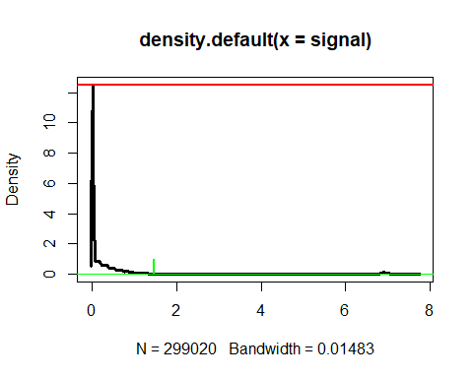

Here we use the function find_gate_perc_height_upper_noise() to find upper_gate for noise gating based on the channel Ce140Di. The upper_gate values are stored in the variable upper_gate_Ce140Di.

upper_gate_Ce140Di <- find_gate_perc_height_upper_noise(data = beads_data, channel = x, upper_perc_height = 0.001)

Then we make a time signal plot where the signal is plotted against time and the gate is shown. Even though we here only make the plot for those events we want to plot, saved in random_events_for_plotting, the gate is made on all datapoints.

time_signal_plots <- time_signal_plot(data = beads_data, random_events = random_events_for_plotting,   
 channel = x, plot_title = file_names, upper_gate = upper_gate_Ce140Di)  
   
time_signal_plots[1] # to see first plot

## [[1]]

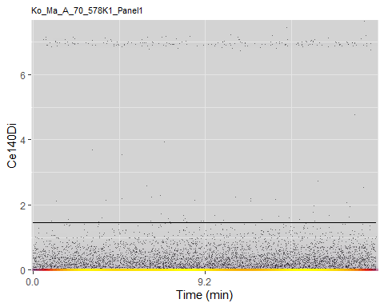

All the plots can be plotted together by using the function plotSignal(). I prefer to save this plot to a tiff file instead of plotting it in R. In that way you have saved it to later evaluations.

plotSignal(plot_list = time_signal_plots)

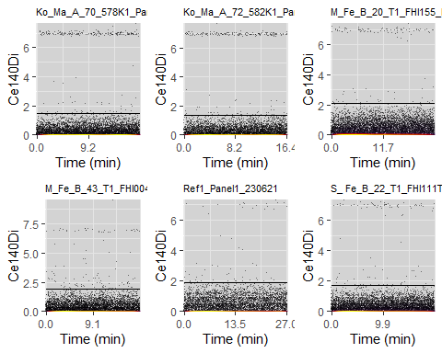

## TableGrob (2 x 3) "arrange": 6 grobs  
## z cells name grob  
## 1 1 (1-1,1-1) arrange gtable[layout]  
## 2 2 (1-1,2-2) arrange gtable[layout]  
## 3 3 (1-1,3-3) arrange gtable[layout]  
## 4 4 (2-2,1-1) arrange gtable[layout]  
## 5 5 (2-2,2-2) arrange gtable[layout]  
## 6 6 (2-2,3-3) arrange gtable[layout]

I prefer to save this plot to a tiff file instead of plotting it in R. In that way you have saved it to later evaluations. To run the lines remove “#”.

# tiff(fs::path(outFigPath, paste0("Signal_fig1_bead_gating.tiff")))  
# plotSignal(plot_list = time_signal_plots)  
# dev.off()

The gate could also be plotted in a density plot made by the function density_plot(). Again you could either see it directly in the RStudio or save it to a tiff file. If saving it, you do not have to run the script again to see what you did.

density_plots <- density_plot(data = beads_data, channel = x, plot_title = file_names, upper_gate = upper_gate_Ce140Di)  
density_plots # to see the plots

## Picking joint bandwidth of 0.0181

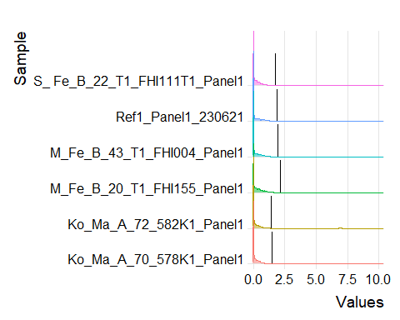

# tiff(fs::path(outFigPath, paste0("fig1_bead_gating.tiff")))  
# density_plots  
# dev.off()

Before continuing with the script, it should be decided if the gate is ok or something should be adjusted. If ok, proceed using the gate and adjust the dataset by excluding the events with signal above upper_gate_Ce140Di.

* The function events_to_keep_after_gating() find which events to keep per dataset.
* The function update_data_based_on_events_to_keep() update the fcs_data
* The number of events per file after gating are found by number_of_events()
* The percentages lost by this gating and for full dataset is calculated and saved in the matrices percent_lost_from_full_dataset and percent_lost_from_full_dataset
* A new vector of random_events_for_plotting is made by the function random_events()

events_to_keep_after_gating <- events_to_keep(data = beads_data, channel = "Ce140Di", upper_gate = upper_gate_Ce140Di)  
   
 #overwrite the raw dataset (will take lot of space if we make one new each time, and do not need it)  
 fcs_data <- update_data_based_on_events_to_keep(data = fcs_data, kept_events = events_to_keep_after_gating)  
 number_of_events_after_gating <- number_of_events(data = fcs_data, file_names = file_names)  
 percent_lost_each_gating[as.character(file_names),"Ce140Di"] <- number_of_events_after_gating/number_of_events_raw_data * 100   
 percent_lost_from_full_dataset[as.character(file_names),"Ce140Di"] <- number_of_events_after_gating/number_of_events_raw_data * 100   
 random_events_for_plotting <- random_events(number_of_events_after_gating)  
   
   
 number_of_events_after_beads_gating <- number_of_events_after_gating

The percent of events lost for this gating is saved in the matrix percent_lost_each_gating, and can be printed here as

percent_lost_each_gating[as.character(file_names),"Ce140Di"]

## [1] 97.64029 97.96200 98.92430 99.04367 99.41833 99.05067

Since we are finished working with beads_data, remove them to save space in memory

rm(beads_data)

# clean_up_data

* the clean up channel names can be found by using grep of the string “Center|Offset|Width|Residual|Event|Ir191|Ir193|Pt195Di|Pt194Di”
* a arc_sinh transformed dataset with this channels are made using the function arc_sinh_transform_selected_channels()

#************************************************  
 #clean_up_data  
 #************************************************  
 clean_up_channels <- as.character(params$name[grep("Center|Offset|Width|Residual|Event|Ir191|Ir193|Pt195Di|Pt194Di", params$name)]) #Pt194Di og 195 tilsvarer Cis  
 clean_up_data <- arc_sinh_transform_selected_channels(fcs_data = fcs_data, channels = clean_up_channels)

to be able to calculate the number of events lost by this gating we make the variable number_of_events_before_clean_up_gating using the function number_of_events()

number_of_events_before_clean_up_gating <- number_of_events(data = fcs_data, file_names = file_names)

# Gating on Residual

The first clean up gating is on residuals.

First the number of events left before this gating are found and a new set random cells for plotting made.

#************************************************  
 #gating on Residual+ ----  
 #************************************************  
 number_of_events_before_residual_gating <- number_of_events(data = fcs_data, file_names = file_names)  
 random_events_for_plotting <- random_events(number_of_events_before_residual_gating)

Here the function find_gaussian_gates_second_top() takes the dataset that you want to make the gates based on, here clean_up_data in column channel “Residual”, and two values lower_perc_height and upper_perc_height, here 10 and 10, the percentage height of the max of the density curve. The maximum and minimum of the density curve is here shown with the red line, while the height between these lines are shown in blue. 0.1 times this height is shown with the green line. The gate should be placed where the green horizontal line crosses the density curve. Here shown by the green vertical lines. The function find_gaussian_gates_second_top() take a list of matrices and return two vectors which both has the same length as the list, i.e. two gates per file.

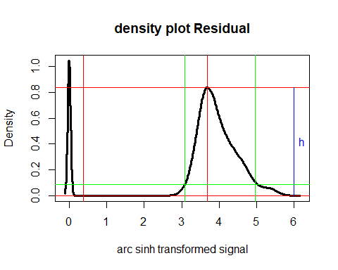

The function find_gaussian_gates_second_top() are used to find lower and upper gate for the positiv signal of the residuals. It takes the variables

* data: here the arc sinh transformed clean_up_data are used
* channel: which marker/channel you want to gate, here “Residual”.
* lower_gate_percent: tells where the lower gate is placed. See figure and explanation above, here 10 %
* upper_gate_percent: tells where the upper gate is placed. See figure and explanation above, here 10 %

R code to fine the lower and upper residual gates:

residual_gates <- find_gaussian_gates_second_top(data = clean_up_data, channel = "Residual", lower_gate_percent = 10, upper_gate_percent = 10)

make a time signal plot where the signal is plotted against time and the gate is shown.

time_signal_plots <- time_signal_plot(data = clean_up_data, random_events = random_events_for_plotting, channel = "Residual", plot_title = file_names, lower_gate = residual_gates$lower_gate, upper_gate = residual_gates$upper_gate)  
   
time_signal_plots[1] # to see first plot

## [[1]]

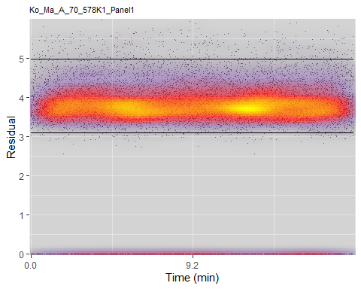

All the plots can be plotted together by using the function plotSignal().

plotSignal(plot_list = time_signal_plots)

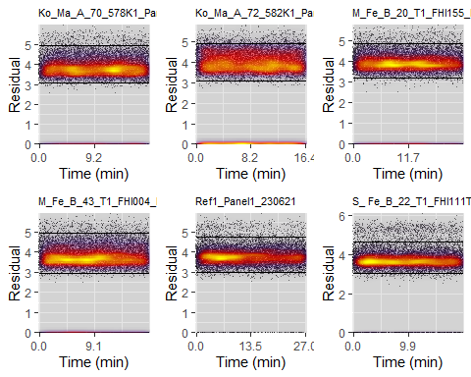

## TableGrob (2 x 3) "arrange": 6 grobs  
## z cells name grob  
## 1 1 (1-1,1-1) arrange gtable[layout]  
## 2 2 (1-1,2-2) arrange gtable[layout]  
## 3 3 (1-1,3-3) arrange gtable[layout]  
## 4 4 (2-2,1-1) arrange gtable[layout]  
## 5 5 (2-2,2-2) arrange gtable[layout]  
## 6 6 (2-2,3-3) arrange gtable[layout]

I prefer to save this plot to a tiff file instead of plotting it in R. In that way you have saved it to later evaluations.

# tiff(fs::path(outFigPath, paste0("Signal_fig2_residal_gating.tiff")))  
# plotSignal(plot_list = time_signal_plots)  
# dev.off()

The gate could also be plotted in a density plot made by the function density_plot(). Again, you could either see it directly in the RStudio or save it to a tiff file. If saving it, you do not have to run the script again to see what you did.

density_plots <- density_plot(data = clean_up_data, "Residual", plot_title = file_names, lower_gate = residual_gates$lower_gate, upper_gate = residual_gates$upper_gate)  
density_plots # to see the plots

## Picking joint bandwidth of 0.0369

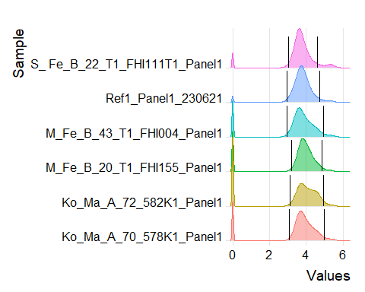

# tiff(fs::path(outFigPath, paste0("fig1_bead_gating.tiff")))  
# density_plots  
# dev.off()

Before continuing with the script, it should be decided if the gate is ok or something should be adjusted. If ok, proceed using the gate and adjust the dataset by excluding the events that do not have a signal between lower and upper residual gates.

* The function events_to_keep_after_gating() find which events to keep per dataset.
* The function update_data_based_on_events_to_keep() update the fcs_data and the clean_up_data
* The number of events per file after gating are found by number_of_events()
* The percentages lost by this gating and for full dataset is calculated and saved in the matrices percent_lost_from_full_dataset and percent_lost_from_full_dataset
* A new vector of random_events_for_plotting is made by the function random_events()

events_to_keep_after_gating <- events_to_keep(data = clean_up_data, channel = "Residual", lower_gate = residual_gates$lower_gates,  
 upper_gate = residual_gates$upper_gate)  
  
 fcs_data <- update_data_based_on_events_to_keep(data = fcs_data, kept_events = events_to_keep_after_gating)  
 clean_up_data <- update_data_based_on_events_to_keep(data = clean_up_data, kept_events = events_to_keep_after_gating)  
 number_of_events_after_residual_gating <- number_of_events(data = fcs_data, file_names = file_names)  
 percent_lost_from_full_dataset[as.character(file_names),"Residual"] <- number_of_events_after_residual_gating/number_of_events_raw_data * 100 #percent remaining from total  
 percent_lost_each_gating[as.character(file_names),"Residual"] <- number_of_events_after_residual_gating/number_of_events_before_residual_gating * 100 #percent remaining from bead gating

The percent of events lost for this gating is

percent_lost_each_gating[as.character(file_names),"Residual"]

## [1] 84.19908 76.51028 83.83834 85.21528 92.03366 86.20066

# Gating on Center

The second clean up gating is on center.

First the number of events left before this gating are found and a new set random cells for plotting made.

#************************************************  
 #gating on Center+ ----  
 #************************************************  
 number_of_events_before_center_gating <- number_of_events_after_residual_gating  
 random_events_for_plotting <- random_events(number_of_events_before_center_gating)

Center is gated in the same way as Residuals by using the function find_gaussian_gates_second_top(). Also, here we have chosen to use 10% gaussian gates for both lower and upper gate. This must be adjusted to what level you want to use for your data. Plots are made and if wanted saved in the same way as for Residuals.

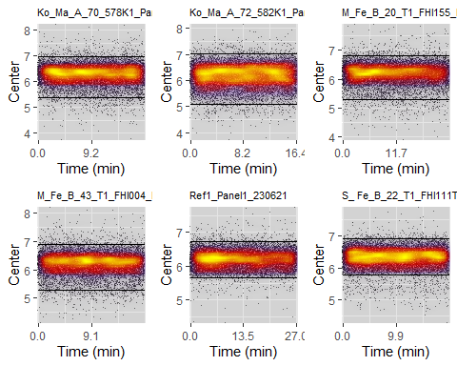

FALSE TableGrob (2 x 3) "arrange": 6 grobs  
FALSE z cells name grob  
FALSE 1 1 (1-1,1-1) arrange gtable[layout]  
FALSE 2 2 (1-1,2-2) arrange gtable[layout]  
FALSE 3 3 (1-1,3-3) arrange gtable[layout]  
FALSE 4 4 (2-2,1-1) arrange gtable[layout]  
FALSE 5 5 (2-2,2-2) arrange gtable[layout]  
FALSE 6 6 (2-2,3-3) arrange gtable[layout]

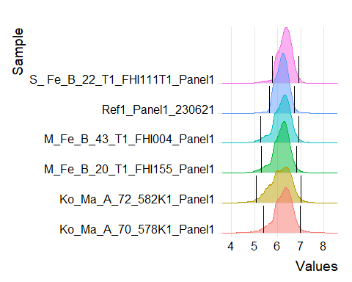

and the number of events to keep based on the center gating are updated together with the datasets fcs_data and clean_up_data. Also, the number_of_events_after_center_gating and percent lost with this gating is updated similar to the Residual gating.

The percent of events lost for this gating is

percent_lost_each_gating[as.character(file_names), "Center"]

## [1] 93.97960 95.73499 94.05182 94.40642 95.84000 93.99095

# Gating on Offset

The third clean up gating is on offset.

First the number of events left before this gating are found and a new set of random cells for plotting made.

#************************************************  
#gating on Offset+ ----  
#************************************************  
number_of_events_before_offset_gating <- number_of_events_after_center_gating  
random_events_for_plotting <- random_events(number_of_events_before_offset_gating)

Also offset is gated in the same way as Residuals and Center by using the function find_gaussian_gates_second_top(). But here we have chosen to include more of the data using 7 % gaussian gates for both lower and upper gate. This must be adjusted to what level you want to use for your data. Plots are made and if wanted saved in the same way as for Residuals.

#update lower_gate_percent, upper_gate_percent  
offset_gates <- find_gaussian_gates_second_top(data = clean_up_data, channel = "Offset", lower_gate_percent = 7, upper_gate_percent = 7)  
  
time_signal_plots <- time_signal_plot(data = clean_up_data, random_events = random_events_for_plotting, channel = "Offset", plot_title = file_names, lower_gate = offset_gates$lower_gate, upper_gate = offset_gates$upper_gate)  
plotSignal(plot_list = time_signal_plots)

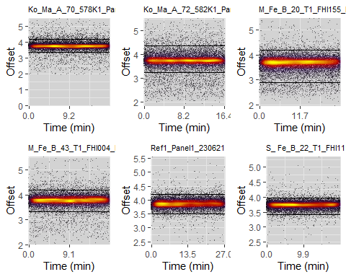

## TableGrob (2 x 3) "arrange": 6 grobs  
## z cells name grob  
## 1 1 (1-1,1-1) arrange gtable[layout]  
## 2 2 (1-1,2-2) arrange gtable[layout]  
## 3 3 (1-1,3-3) arrange gtable[layout]  
## 4 4 (2-2,1-1) arrange gtable[layout]  
## 5 5 (2-2,2-2) arrange gtable[layout]  
## 6 6 (2-2,3-3) arrange gtable[layout]

# tiff(fs::path(outFigPath, paste0("Signal_fig4_offset_gating.tiff")))  
# plotSignal(plot_list = time_signal_plots)  
# dev.off()  
  
density_plots <- density_plot(data = clean_up_data, "Offset", plot_title = file_names, lower_gate = offset_gates$lower_gate, upper_gate = offset_gates$upper_gate)  
density_plots

## Picking joint bandwidth of 0.0133

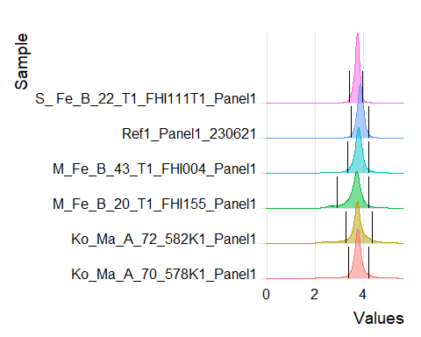

# tiff(fs::path(outFigPath, paste0("fig4_offset_gating.tiff")))  
# print(density_plots)  
# dev.off()

The number of events to keep based on the offset gating are updated together with the datasets fcs_data and clean_up_data, number_of_events_after_offset_gating and percent lost with this gating is updated similar to the previous gatings.

events_to_keep_after_offset_gating <- events_to_keep(data = clean_up_data, channel = "Offset", lower_gate = offset_gates$lower_gate, upper_gate = offset_gates$upper_gate)  
  
fcs_data <- update_data_based_on_events_to_keep(data = fcs_data, kept_events = events_to_keep_after_offset_gating)  
clean_up_data <- update_data_based_on_events_to_keep(data = clean_up_data, kept_events = events_to_keep_after_offset_gating)  
number_of_events_after_offset_gating <- number_of_events(data = fcs_data, file_names = file_names)  
percent_lost_from_full_dataset[as.character(file_names),"Offset"] <- number_of_events_after_offset_gating/number_of_events_raw_data * 100 #percent remaining from total  
percent_lost_each_gating[as.character(file_names),"Offset"] <- number_of_events_after_offset_gating/number_of_events_before_offset_gating * 100 #percent remaining from center gating

The percent of events lost for this gating is

percent_lost_each_gating[as.character(file_names), "Offset"]

## [1] 88.16176 84.09016 90.47548 88.65620 94.19027 93.78788

# Gating on Width

The fourth clean up gating is on Width

First the number of events left before this gating are found and a new set random cells for plotting made.

#************************************************  
#gating on Width+ ----  
#************************************************  
number_of_events_before_width_gating <- number_of_events(data = fcs_data, file_names = file_names)  
random_events_for_plotting <- random_events(number_of_events_before_width_gating)

Here the function find_gaussian_gates_highest_top() takes the dataset that you want to make the gates based on, here clean_up_data in column channel “Width”, and two values lower_perc_height and upper_perc_height, here 0.025 and 0.04, the proportion height of the max of the density curve. The max of the density curve is here shown with the red line. while 0.025 times this height is shown with the green line, and 0.4 times the height is shown with a dark green line. The gate should be placed where the green horizontal line crosses the density curve. Here shown by the green vertical line. The function function find_gaussian_gates_highest_top() take a list of matrices and return two vector in the same length as the list, i.e. two gate per file.

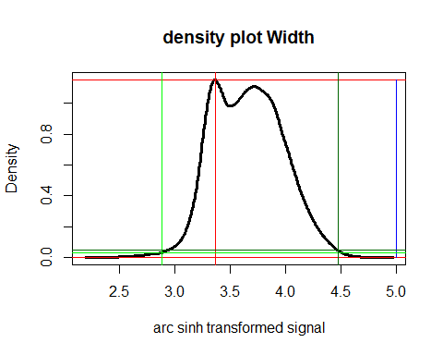

The find_gaussian_gates_highest_top() are used to find lower gate for the positiv signal of the width. It takes the variables

* data: here the arc sinh transformed clean_up_data are used
* channel: which marker/channel you want to gate, here “Width”.
* lower_gate_percent: tells where the lower gate is placed. See figure and explanation above, here 2.5 %
* upper_gate_percent: tells where the upper gate is placed. See figure and explanation above, here 4 %

R code to fine the lower and upper residual gates:

#update lower_gate_percent, upper_gate_percent  
 width_gates <- find_gaussian_gates_highest_top(data = clean_up_data, channel = "Width", lower_gate_percent = 2.5, upper_gate_percent = 4)  
  
 density_plots <- density_plot(data = clean_up_data, "Width", plot_title = file_names, lower_gate = width_gates$lower_gate, upper_gate = width_gates$upper_gate)  
 density_plots

## Picking joint bandwidth of 0.0256

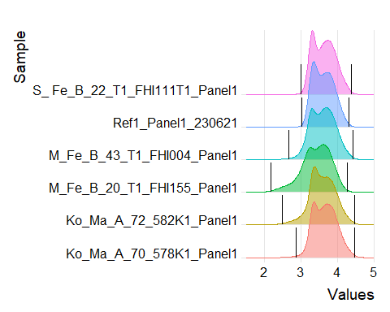

# tiff(fs::path(outFigPath, paste0("fig5_width_gating.tiff")))  
 # print(density_plots)  
 # dev.off()  
 #time_signal_plots <- time_signal_plot(data = clean_up_data, random_events = random_events_for_plotting, channel = "Width", plot_title = file_names, lower_gate = width_gates$lower_gate, upper_gate = width_gates$upper_gate)  
 #time_signal_plots # to see all plots  
 #time_signal_plots[1] # to see first plot  
 plotSignal(plot_list = time_signal_plots)



## TableGrob (2 x 3) "arrange": 6 grobs  
## z cells name grob  
## 1 1 (1-1,1-1) arrange gtable[layout]  
## 2 2 (1-1,2-2) arrange gtable[layout]  
## 3 3 (1-1,3-3) arrange gtable[layout]  
## 4 4 (2-2,1-1) arrange gtable[layout]  
## 5 5 (2-2,2-2) arrange gtable[layout]  
## 6 6 (2-2,3-3) arrange gtable[layout]

# tiff(fs::path(outFigPath, paste0("Signal_fig5_width_gating.tiff")))  
# plotSignal(plot_list = time_signal_plots)  
# dev.off()

The number of events to keep based on the width gating are updated together with the datasets fcs_data and clean_up_data, number_of_events_after_offset_gating and percent lost with this gating is updated similar to the previous gatings.

events_to_keep_after_width_gating <- events_to_keep(data = clean_up_data, channel = "Width", lower_gate = width_gates$lower_gate, upper_gate = width_gates$upper_gate)  
#   
 fcs_data <- update_data_based_on_events_to_keep(data = fcs_data, kept_events = events_to_keep_after_width_gating)  
 clean_up_data <- update_data_based_on_events_to_keep(data = clean_up_data, kept_events = events_to_keep_after_width_gating)  
 number_of_events_after_width_gating <- number_of_events(data = fcs_data, file_names = file_names)  
 percent_lost_from_full_dataset[as.character(file_names),"Width"] <- number_of_events_after_width_gating/number_of_events_raw_data * 100 #percent remaining from total  
 percent_lost_each_gating[as.character(file_names),"Width"] <- number_of_events_after_width_gating/number_of_events_before_width_gating * 100 #percent remaining from offset gating

The percent of events lost for this gating is

percent_lost_each_gating[as.character(file_names), "Width"]

## [1] 99.11921 99.14537 99.25568 99.22188 99.54155 99.61027

# Gating on Event

The fifth clean up gating is on event.

First the number of events left before this gating are found and a new set random cells for plotting made.

#************************************************  
 #gating on Event+ ----  
 #************************************************  
 number_of_events_before_event_gating <- number_of_events(data = fcs_data, file_names = file_names)  
 random_events_for_plotting <- random_events(number_of_events_before_event_gating)

Also event is gated by using the function find_gaussian_gates_second_top(). But here we have chosen to include less of the data using 20 % gaussian gates for both lower and upper gate. This must be adjusted to what level you want to use for your data. Plots are made and if wanted saved in the same way as for Residuals.

#update lower_gate_percent, upper_gate_percent  
 EventGates <- find_gaussian_gates_second_top(data = clean_up_data, channel = "Event_length", lower_gate_percent = 20, upper_gate_percent = 20)  
 density_plots <- density_plot(data = clean_up_data, "Event_length", plot_title = file_names, lower_gate = EventGates$lower_gate, upper_gate = EventGates$upper_gate)  
 density_plots

## Picking joint bandwidth of 0.022

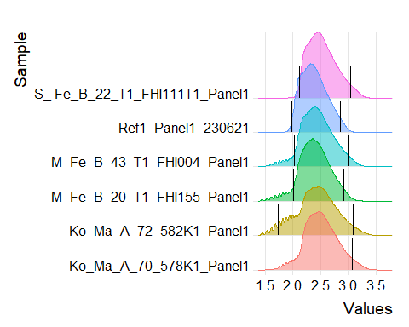

# tiff(fs::path(outFigPath, paste0("fig6_event_gating.tiff")))  
 # print(density_plots)  
 # dev.off()  
 time_signal_plots <- time_signal_plot(data = clean_up_data, random_events = random_events_for_plotting, channel = "Event_length", plot_title = file_names, lower_gate = EventGates$lower_gate, upper_gate = EventGates$upper_gate)  
 #time_signal_plots # to see all plots  
 #time_signal_plots[1] # to see first plot  
   
 plotSignal(plot_list = time_signal_plots)

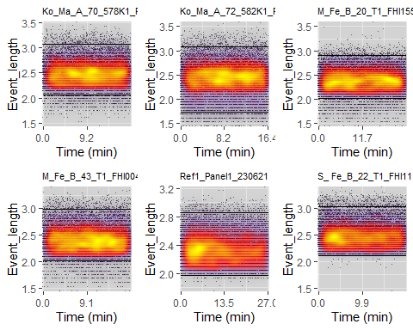

## TableGrob (2 x 3) "arrange": 6 grobs  
## z cells name grob  
## 1 1 (1-1,1-1) arrange gtable[layout]  
## 2 2 (1-1,2-2) arrange gtable[layout]  
## 3 3 (1-1,3-3) arrange gtable[layout]  
## 4 4 (2-2,1-1) arrange gtable[layout]  
## 5 5 (2-2,2-2) arrange gtable[layout]  
## 6 6 (2-2,3-3) arrange gtable[layout]

# tiff(fs::path(outFigPath, paste0("Signal_fig6_event_gating.tiff")))  
 # plotSignal(plot_list = time_signal_plots)  
 # dev.off()

The number of events to keep based on the event gating are updated together with the datasets fcs_data and clean_up_data, number_of_events_after_offset_gating and percent lost with this gating is updated similar to the previous gatings.

events_to_keep_after_event_gating <- events_to_keep(data = clean_up_data, channel = "Event_length", upper_gate = EventGates$upper_gate)  
 #percent_to_keep_this_gating(kept_events = events_to_keep_after_event_gating, file_names = file_names)  
  
fcs_data <- update_data_based_on_events_to_keep(data = fcs_data, kept_events = events_to_keep_after_event_gating)  
 clean_up_data <- update_data_based_on_events_to_keep(data = clean_up_data, kept_events = events_to_keep_after_event_gating)  
 number_of_events_after_event_gating <- number_of_events(data = fcs_data, file_names = file_names)  
 percent_lost_from_full_dataset[as.character(file_names),"Event_length"] <- number_of_events_after_event_gating/number_of_events_raw_data * 100 #percent remaining from total  
 percent_lost_each_gating[as.character(file_names),"Event_length"] <- number_of_events_after_event_gating/number_of_events_before_event_gating * 100 #percent remaining from width gating

The percent of events lost for this gating is

percent_lost_each_gating[as.character(file_names), "Event_length"]

## [1] 95.79171 96.33974 96.58029 96.20826 96.96987 95.34054

# Gating on CIS

The sixth clean up gating is on CIS, live cells.

First the number of events left before this gating are found and a new set random cells for plotting made.

#************************************************  
 #gating on Live Dead---- Cis,  
 #************************************************  
 number_of_events_before_cis_gating <- number_of_events(data = fcs_data, file_names = file_names)  
 random_events_for_plotting <- random_events(number_of_events_before_cis_gating)

Also CIS is gated by using the function find_gaussian_gates_second_top(). But here we have chosen to use 5 % gaussian gates for the lower gate and 20 % for the upper gate. This must be adjusted to what level you want to use for your data. Plots are made and if wanted saved in the same way as for Residuals.

#update lower_gate_percent, upper_gate_percent  
 cis_gates <- find_gaussian_gates_second_top(data = clean_up_data, channel = "Pt194Di", lower_gate_percent = 5, upper_gate_percent = 30)  
# if you want to overwrite the gate found this could be done like this:  
 # tvungetLavereCISgate <- 0.5 #sett inn NA hvis du heller vil bruke gaussian gate for CIS. evt annet tall..  
 # if(!is.na(tvungetLavereCISgate)){  
# cis_gates$lower_gates <- rep(tvungetLavereCISgate, length(cis_gates$lower_gates))  
# }  
  
 density_plots <- density_plot(data = clean_up_data, "Pt194Di", plot_title = file_names, lower_gate = cis_gates$lower_gate, upper_gate = cis_gates$upper_gate)  
 density_plots

## Picking joint bandwidth of 0.0582

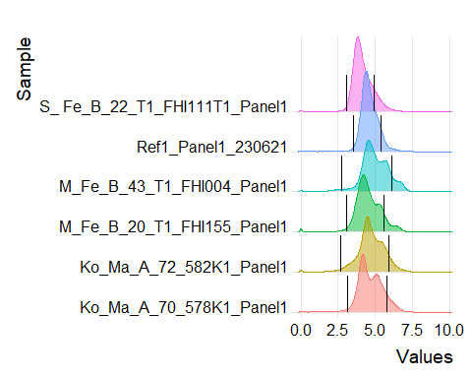

# tiff(fs::path(outFigPath, paste0("fig7_cis_gating.tiff")))  
 # print(density_plots)  
 # dev.off()  
 time_signal_plots <- time_signal_plot(data = clean_up_data, random_events = random_events_for_plotting, channel = "Pt194Di", plot_title = file_names, lower_gate = cis_gates$lower_gate, upper_gate = cis_gates$upper_gate)  
 #time_signal_plots # to see all plots  
 #time_signal_plots[1] # to see first plot  
 #time_signal_plots <- time_signal_plot(data = clean_up_data, random_events = random_events_for_plotting, channel = "Pt194Di", plot_title = file_names, lower_gate = NA, upper_gate = NA)  
 #time_signal_plots # to see all plots  
   
 plotSignal(plot_list = time_signal_plots)

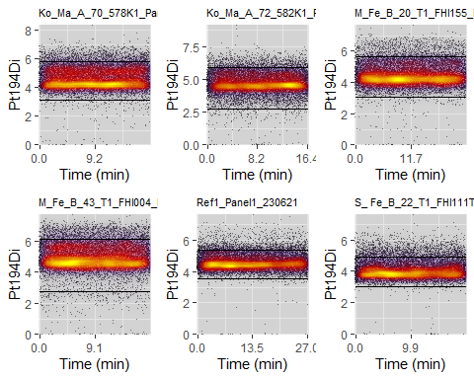

## TableGrob (2 x 3) "arrange": 6 grobs  
## z cells name grob  
## 1 1 (1-1,1-1) arrange gtable[layout]  
## 2 2 (1-1,2-2) arrange gtable[layout]  
## 3 3 (1-1,3-3) arrange gtable[layout]  
## 4 4 (2-2,1-1) arrange gtable[layout]  
## 5 5 (2-2,2-2) arrange gtable[layout]  
## 6 6 (2-2,3-3) arrange gtable[layout]

# tiff(fs::path(outFigPath, paste0("Signal_fig7_cis_gating.tiff")))  
 # plotSignal(plot_list = time_signal_plots)  
 # dev.off()

The number of events to keep based on the cis gating are updated together with the datasets fcs_data and clean_up_data, number_of_events_after_offset_gating and percent lost with this gating is updated similar to the previous gatings.

events_to_keep_after_cis_gating <- events_to_keep(data = clean_up_data, channel = "Pt194Di", lower_gate = cis_gates$lower_gate, upper_gate = cis_gates$upper_gate)  
  
  
 fcs_data <- update_data_based_on_events_to_keep(data = fcs_data, kept_events = events_to_keep_after_cis_gating)  
 clean_up_data <- update_data_based_on_events_to_keep(data = clean_up_data, kept_events = events_to_keep_after_cis_gating)  
 number_of_events_after_cis_gating <- number_of_events(data = fcs_data, file_names = file_names)  
 percent_lost_from_full_dataset[as.character(file_names),"Pt194Di"] <- number_of_events_after_cis_gating/number_of_events_raw_data * 100 #percent remaining from total  
 percent_lost_each_gating[as.character(file_names),"Pt194Di"] <- number_of_events_after_cis_gating/number_of_events_before_cis_gating * 100 #percent remaining from event gating

The percent of events lost for this gating is

percent_lost_each_gating[as.character(file_names), "Pt194Di"]

## [1] 88.36916 89.78884 88.24484 87.34849 89.18104 85.48538

# gating on DNA1, Ir 191

This is the last and seventh clean up gating.

First the number of events left before this gating are found and a new set random cells for plotting made.

#************************************************  
 #gating on DNA1, Ir191Di+ ----  
 #************************************************  
 number_of_events_before_Ir191Di_gating <- number_of_events(fcs_data, file_names = file_names)  
 random_events_for_plotting <- random_events(number_of_events_before_Ir191Di_gating)

Also, here gaussian gate for the second top is found, but instead of using the variables lower_gate_percent and upper_gate_percent another variable is used. This is perc_include. In this version of the function, we assume the signals to come from two normal distribution and that we want to find the gate that include 99 % of the normal distribution with the highest top. This way of finding the gates involves some computation and will take some time. The best approach is to test on some files and then run it for all files later.

Ir191di_gates <- find_gaussian_gates_second_top(data = clean_up_data, channel = "Ir191Di", lower_gate_percent = NA, upper_gate_percent = NA, perc_included = 0.99, main_top_to_left = F)

FALSE VGLM linear loop 1 : loglikelihood = -7995.823  
FALSE VGLM linear loop 2 : loglikelihood = -7442.573  
FALSE VGLM linear loop 3 : loglikelihood = -7370.461  
FALSE VGLM linear loop 4 : loglikelihood = -7357.152  
FALSE VGLM linear loop 5 : loglikelihood = -7352.573  
FALSE VGLM linear loop 6 : loglikelihood = -7350.897  
FALSE VGLM linear loop 7 : loglikelihood = -7350.259  
FALSE VGLM linear loop 8 : loglikelihood = -7350.013  
FALSE VGLM linear loop 9 : loglikelihood = -7349.917  
FALSE VGLM linear loop 10 : loglikelihood = -7349.88  
FALSE VGLM linear loop 11 : loglikelihood = -7349.865  
FALSE VGLM linear loop 12 : loglikelihood = -7349.859  
FALSE VGLM linear loop 13 : loglikelihood = -7349.857  
FALSE VGLM linear loop 14 : loglikelihood = -7349.856  
FALSE VGLM linear loop 15 : loglikelihood = -7349.856  
FALSE VGLM linear loop 1 : loglikelihood = -11242.68  
FALSE VGLM linear loop 2 : loglikelihood = -11155.96  
FALSE VGLM linear loop 3 : loglikelihood = -11143.28  
FALSE VGLM linear loop 4 : loglikelihood = -11140.32  
FALSE VGLM linear loop 5 : loglikelihood = -11139.54  
FALSE VGLM linear loop 6 : loglikelihood = -11139.34  
FALSE VGLM linear loop 7 : loglikelihood = -11139.29  
FALSE VGLM linear loop 8 : loglikelihood = -11139.28  
FALSE VGLM linear loop 9 : loglikelihood = -11139.27  
FALSE VGLM linear loop 10 : loglikelihood = -11139.27  
FALSE VGLM linear loop 1 : loglikelihood = -6456.714  
FALSE VGLM linear loop 2 : loglikelihood = -5498.344  
FALSE VGLM linear loop 3 : loglikelihood = -5388.993  
FALSE VGLM linear loop 4 : loglikelihood = -5378.259  
FALSE VGLM linear loop 5 : loglikelihood = -5375.42  
FALSE VGLM linear loop 6 : loglikelihood = -5374.668  
FALSE VGLM linear loop 7 : loglikelihood = -5374.478  
FALSE VGLM linear loop 8 : loglikelihood = -5374.431  
FALSE VGLM linear loop 9 : loglikelihood = -5374.42  
FALSE VGLM linear loop 10 : loglikelihood = -5374.417  
FALSE VGLM linear loop 11 : loglikelihood = -5374.416  
FALSE VGLM linear loop 12 : loglikelihood = -5374.416  
FALSE VGLM linear loop 1 : loglikelihood = -5254.295  
FALSE VGLM linear loop 2 : loglikelihood = -4959.776  
FALSE VGLM linear loop 3 : loglikelihood = -4942.553  
FALSE VGLM linear loop 4 : loglikelihood = -4939.944  
FALSE VGLM linear loop 5 : loglikelihood = -4939.456  
FALSE VGLM linear loop 6 : loglikelihood = -4939.366  
FALSE VGLM linear loop 7 : loglikelihood = -4939.35  
FALSE VGLM linear loop 8 : loglikelihood = -4939.347  
FALSE VGLM linear loop 9 : loglikelihood = -4939.347  
FALSE VGLM linear loop 10 : loglikelihood = -4939.346  
FALSE VGLM linear loop 1 : loglikelihood = -45937.12  
FALSE Applying Greenstadt modification to 10000 matrices  
FALSE VGLM linear loop 2 : loglikelihood = -1445858  
FALSE Taking a modified step.....  
FALSE VGLM linear loop 2 : loglikelihood = -45750.5  
FALSE Applying Greenstadt modification to 10000 matrices  
FALSE VGLM linear loop 3 : loglikelihood = -39445.66  
FALSE Taking a modified step.......  
FALSE VGLM linear loop 3 : loglikelihood = -45730.61  
FALSE VGLM linear loop 4 : loglikelihood = -40732.52  
FALSE VGLM linear loop 5 : loglikelihood = -35728.82  
FALSE VGLM linear loop 6 : loglikelihood = -30729.66  
FALSE VGLM linear loop 7 : loglikelihood = -25727.16  
FALSE VGLM linear loop 8 : loglikelihood = -20764.67  
FALSE VGLM linear loop 9 : loglikelihood = -15861.01  
FALSE VGLM linear loop 10 : loglikelihood = -11128.58  
FALSE VGLM linear loop 11 : loglikelihood = -6806.858  
FALSE VGLM linear loop 12 : loglikelihood = -3381.716  
FALSE VGLM linear loop 13 : loglikelihood = -1509.868  
FALSE VGLM linear loop 14 : loglikelihood = -1054.556  
FALSE VGLM linear loop 15 : loglikelihood = -1032.61  
FALSE VGLM linear loop 16 : loglikelihood = -1032.563  
FALSE VGLM linear loop 17 : loglikelihood = -1032.563  
FALSE VGLM linear loop 1 : loglikelihood = -841.9967  
FALSE VGLM linear loop 2 : loglikelihood = 2045.32  
FALSE VGLM linear loop 3 : loglikelihood = 3533.864  
FALSE VGLM linear loop 4 : loglikelihood = 4457.501  
FALSE VGLM linear loop 5 : loglikelihood = 4763.386  
FALSE VGLM linear loop 6 : loglikelihood = 4824.827  
FALSE VGLM linear loop 7 : loglikelihood = 4835.939  
FALSE VGLM linear loop 8 : loglikelihood = 4836.305  
FALSE VGLM linear loop 9 : loglikelihood = 4836.308  
FALSE VGLM linear loop 10 : loglikelihood = 4836.308

density_plots <- density_plot(data = clean_up_data, "Ir191Di", plot_title = file_names, lower_gate = Ir191di_gates$lower_gate, upper_gate = Ir191di_gates$upper_gate)  
  
density_plots

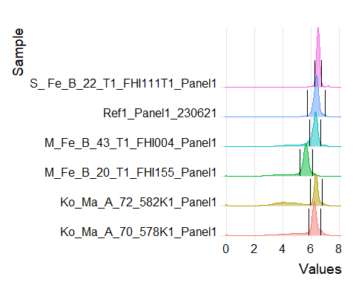

# tiff(fs::path(outFigPath, paste0("fig8_Ir191_gating.tiff")))  
# print(density_plots)  
# dev.off()  
time_signal_plots <- time_signal_plot(data = clean_up_data, random_events = random_events_for_plotting, channel = "Ir191Di", plot_title = file_names, lower_gate = Ir191di_gates$lower_gate, upper_gate = Ir191di_gates$upper_gate)  
#time_signal_plots # to see all plots  
#time_signal_plots[1] # to see first plot  
  
  
plotSignal(plot_list = time_signal_plots)

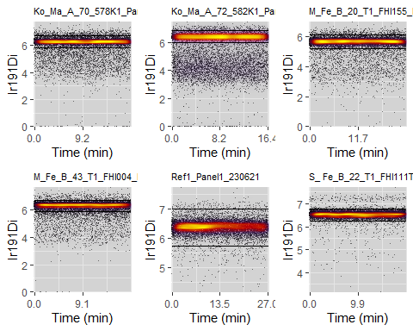

FALSE TableGrob (2 x 3) "arrange": 6 grobs  
FALSE z cells name grob  
FALSE 1 1 (1-1,1-1) arrange gtable[layout]  
FALSE 2 2 (1-1,2-2) arrange gtable[layout]  
FALSE 3 3 (1-1,3-3) arrange gtable[layout]  
FALSE 4 4 (2-2,1-1) arrange gtable[layout]  
FALSE 5 5 (2-2,2-2) arrange gtable[layout]  
FALSE 6 6 (2-2,3-3) arrange gtable[layout]

# tiff(fs::path(outFigPath, paste0("Signal_fig8_Ir191_gating.tiff")))  
# plotSignal(plot_list = time_signal_plots)  
# dev.off()

events_to_keep_after_Ir191Di_gating <- events_to_keep(data = clean_up_data, channel = "Ir191Di", lower_gate = Ir191di_gates$lower_gate, upper_gate = Ir191di_gates$upper_gate)  
 #percent_to_keep_this_gating(kept_events = events_to_keep_after_Ir191Di_gating, file_names = file_names)  
  
  
fcs_data <- update_data_based_on_events_to_keep(data = fcs_data, kept_events = events_to_keep_after_Ir191Di_gating)  
clean_up_data <- update_data_based_on_events_to_keep(data = clean_up_data, kept_events = events_to_keep_after_Ir191Di_gating)  
number_of_events_after_Ir191Di_gating <- number_of_events(data = fcs_data, file_names = file_names)  
percent_lost_from_full_dataset[as.character(file_names),"Ir191Di"] <- number_of_events_after_Ir191Di_gating/number_of_events_raw_data * 100 #percent remaining from total  
percent_lost_each_gating[as.character(file_names),"Ir191Di"] <- number_of_events_after_Ir191Di_gating/number_of_events_before_Ir191Di_gating * 100 #percent remaining from cis gating

The percent of events lost for this gating is

percent_lost_each_gating[as.character(file_names), "Ir191Di"]

## [1] 72.24777 57.64281 78.87213 76.80667 96.30529 92.68086

# gating on DNA1, Ir 193

It is optional to also gate on the second DNA1 channel. First the number of events left before this gating are found and a new set random cells for plotting made.

#************************************************  
 #gating on DNA1, Ir193Di+ ----  
 #************************************************  
 number_of_events_before_Ir193Di_gating <- number_of_events(fcs_data, file_names = file_names)  
 random_events_for_plotting <- random_events(number_of_events_before_Ir193Di_gating)

Here we use another function called find_gaussian_gates_highest_top() which again take the variables lower_gate_percent and upper_gate_percent.

#update lower_gate_percent, upper_gate_percent  
 Ir193di_gates <- find_gaussian_gates_highest_top(data = clean_up_data, channel = "Ir193Di", lower_gate_percent = 15, upper_gate_percent = 5)  
  
  
density_plots <- density_plot(data = clean_up_data, "Ir193Di", plot_title = file_names, lower_gate = Ir193di_gates$lower_gate, upper_gate = Ir193di_gates$upper_gate)  
  
density_plots

## Picking joint bandwidth of 0.0122

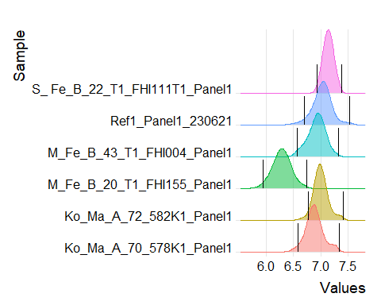

# tiff(fs::path(outFigPath, paste0("fig9_Ir193_gating.tiff")))  
# print(density_plots)  
# dev.off()#density_plots  
  
time_signal_plots <- time_signal_plot(data = clean_up_data, random_events = random_events_for_plotting, channel = "Ir193Di", plot_title = file_names, lower_gate = Ir193di_gates$lower_gate, upper_gate = Ir193di_gates$upper_gate)  
#time_signal_plots # to see all plots  
#time_signal_plots[1] # to see first plot  
  
  
  
plotSignal(plot_list = time_signal_plots)

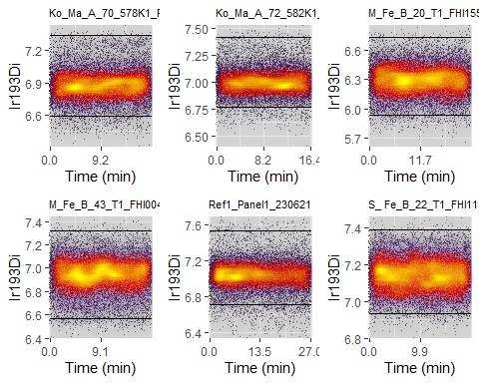

## TableGrob (2 x 3) "arrange": 6 grobs  
## z cells name grob  
## 1 1 (1-1,1-1) arrange gtable[layout]  
## 2 2 (1-1,2-2) arrange gtable[layout]  
## 3 3 (1-1,3-3) arrange gtable[layout]  
## 4 4 (2-2,1-1) arrange gtable[layout]  
## 5 5 (2-2,2-2) arrange gtable[layout]  
## 6 6 (2-2,3-3) arrange gtable[layout]

# tiff(fs::path(outFigPath, paste0("Signal_fig9_Ir193_gating.tiff")))  
# plotSignal(plot_list = time_signal_plots)  
# dev.off()

events_to_keep_after_Ir193Di_gating <- events_to_keep(data = clean_up_data, channel = "Ir193Di", lower_gate = Ir193di_gates$lower_gate, upper_gate = Ir193di_gates$upper_gate)  
 #percent_to_keep_this_gating(kept_events = events_to_keep_after_Ir193Di_gating, file_names = file_names)  
  
  
 fcs_data <- update_data_based_on_events_to_keep(data = fcs_data, kept_events = events_to_keep_after_Ir193Di_gating)  
 clean_up_data <- update_data_based_on_events_to_keep(data = clean_up_data, kept_events = events_to_keep_after_Ir193Di_gating)  
 number_of_events_after_Ir193Di_gating <- number_of_events(data = fcs_data, file_names = file_names)  
 percent_lost_from_full_dataset[as.character(file_names),"Ir193Di"] <- number_of_events_after_Ir193Di_gating/number_of_events_raw_data * 100 #percent remaining from total  
 percent_lost_each_gating[as.character(file_names),"Ir193Di"] <- number_of_events_after_Ir193Di_gating/number_of_events_before_Ir193Di_gating * 100 #percent remaining from cis gating

The percent of events lost for this gating is

percent_lost_each_gating[as.character(file_names), "Ir193Di"]

## [1] 95.86377 95.71781 96.71938 97.03659 94.01092 97.31072

The last ting to do is to save the clean files.

#************************************************  
 #save fcs_data ----  
 #************************************************  
  
 flowCore::write.flowSet(fcs_data, outdir = outDataPath, filename = as.character(file_names))

## C:/CyToF data/immun_aga/panel 1 cleaned data

and the amount of the files lost during gating.

write.csv2(percent_lost_each_gating, fs::path(out_result, "percent_kept_each_gatingnr2.csv"))  
 write.csv2(percent_lost_from_full_dataset, fs::path(out_result, "percent_kept_from_full_datasetnr2.csv"))