Survival analysis to calculate length of stay, season and place

Anja Bråthen Kristoffersen

22 April 2021

# Symptom start to hospitalization

## mu size N  
## before_june_2020_Norway 9.017 4.476 860  
## from_june_2020_to_jan_2021_Norway 7.383 5.019 809  
## from_jan_2021_to_march_2021_Oslo 6.137 4.514 31  
## from_jan_2021_to_march_2021_not_Oslo 8.342 9.078 248  
## from_march_2021_Oslo 6.823 3.010 100  
## from_march_2021_not_Oslo 8.465 19.350 607

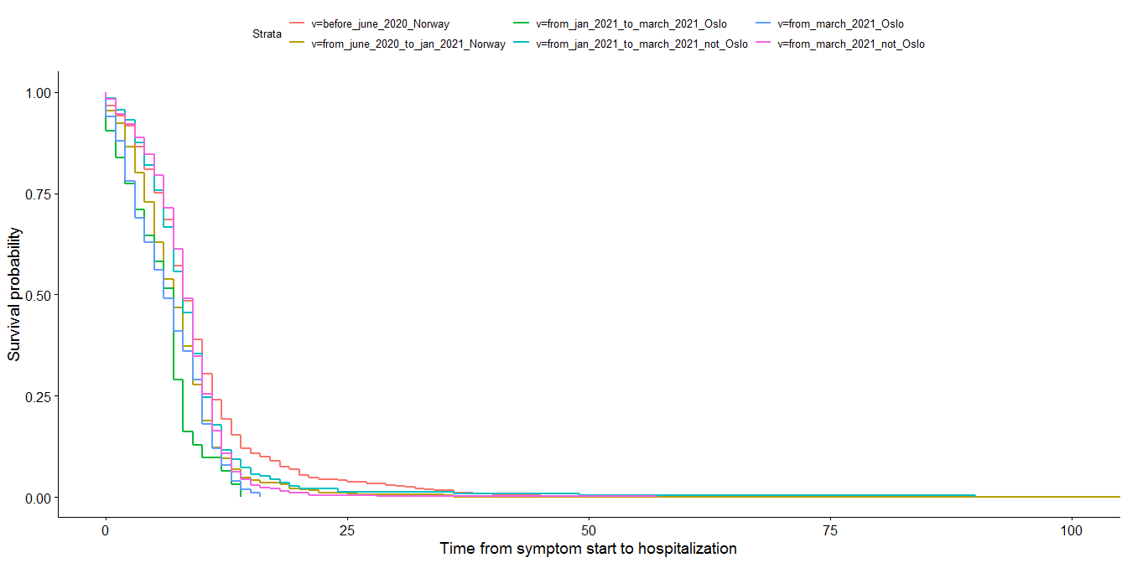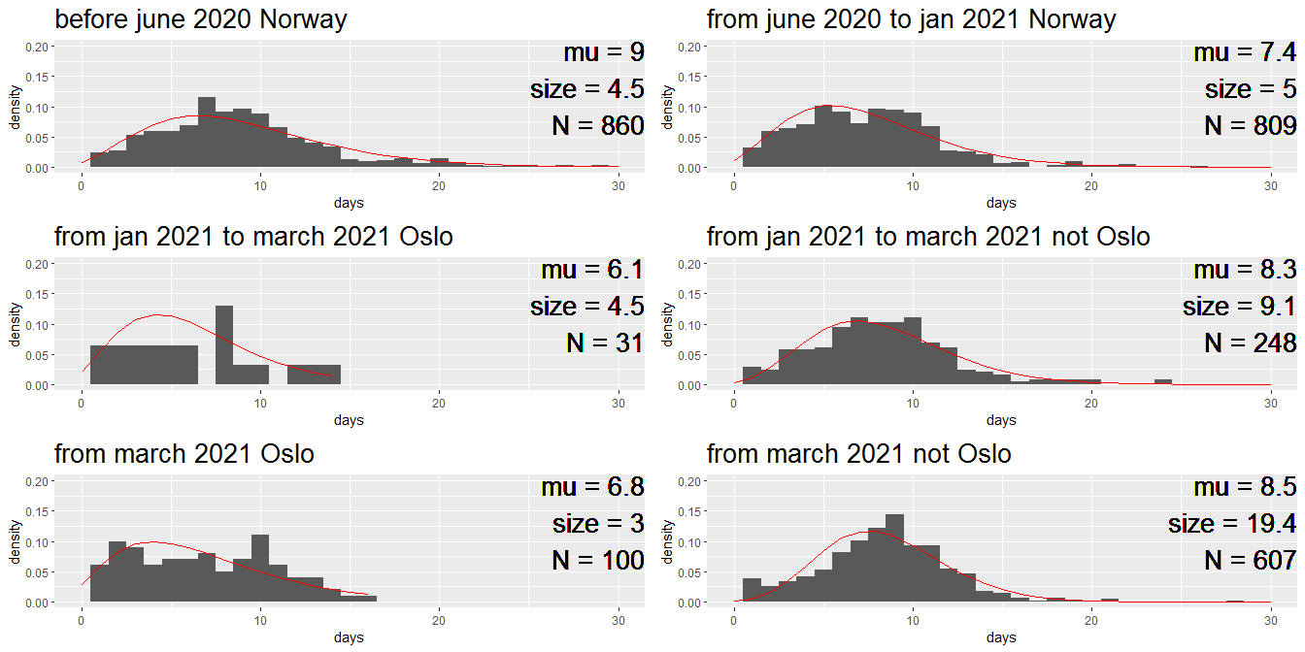

## png   
## 2

# admittion to discharge, not ICU

## mu size N  
## before_june_2020_Norway 6.003 2.215 803  
## from_june_2020_to_jan_2021_Norway 5.421 1.970 1033  
## from_jan_2021_to_march_2021_Oslo 5.473 1.993 150  
## from_jan_2021_to_march_2021_not_Oslo 5.099 1.939 335  
## from_march_2021_Oslo 5.080 2.458 413  
## from_march_2021_not_Oslo 5.216 2.463 852

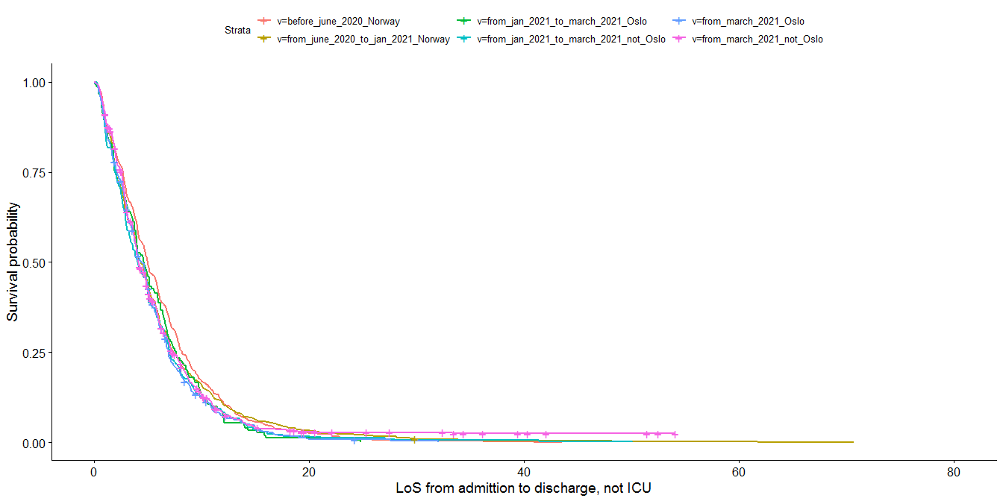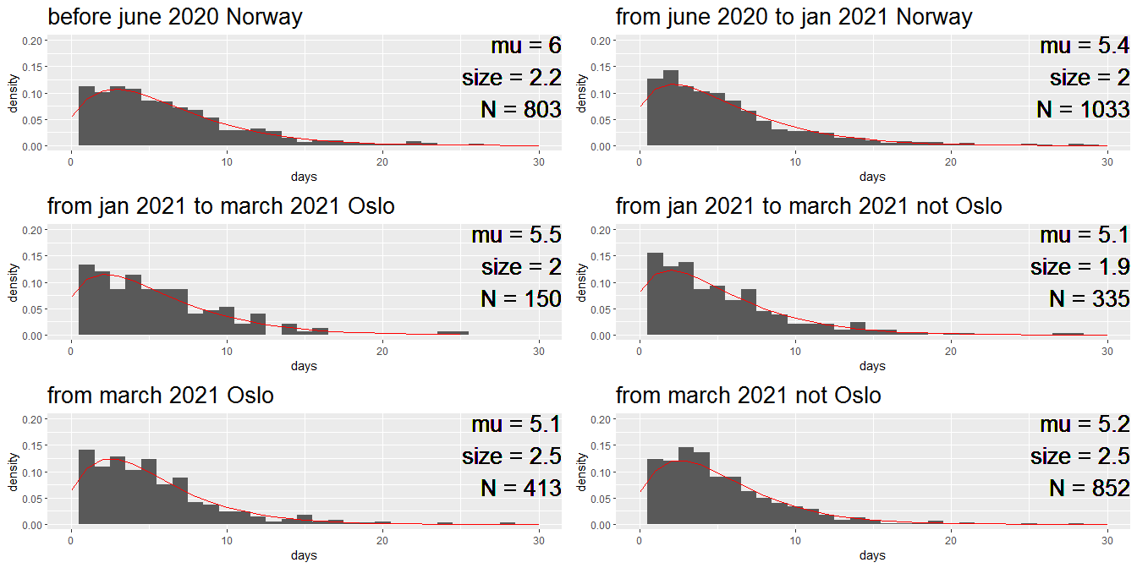

## png   
## 2

# admittion hospital to ICU

## mu size N  
## before_june_2020_Norway 2.206 1.082 168  
## from_june_2020_to_jan_2021_Norway 2.748 1.200 128  
## from_jan_2021_Oslo 2.607 1.157 131  
## from_jan_2021_not_Oslo 2.594 1.383 205

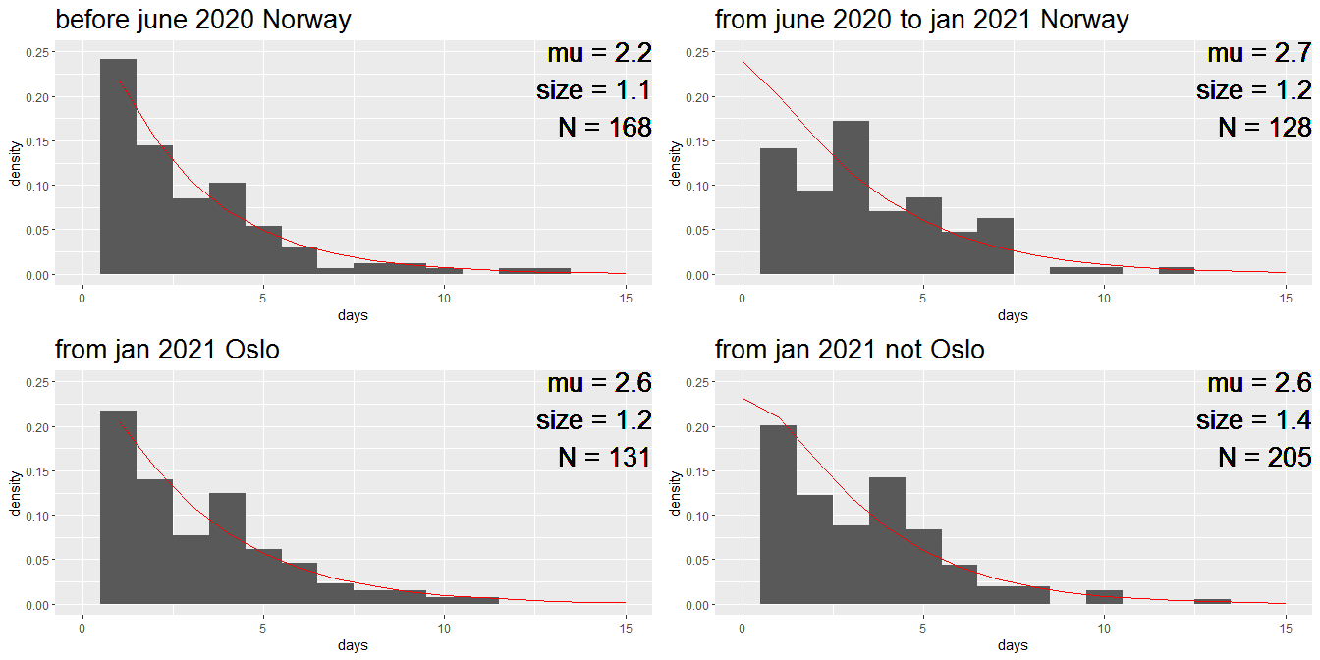

## png   
## 2

# time in ICU

## mu size N  
## before_june_2020_Norway 16.181 2.030 168  
## from_june_2020_to_jan_2021_Norway 13.069 1.116 128  
## from_jan_2021_Oslo 11.932 1.165 131  
## from_jan_2021_not_Oslo 14.051 1.441 205

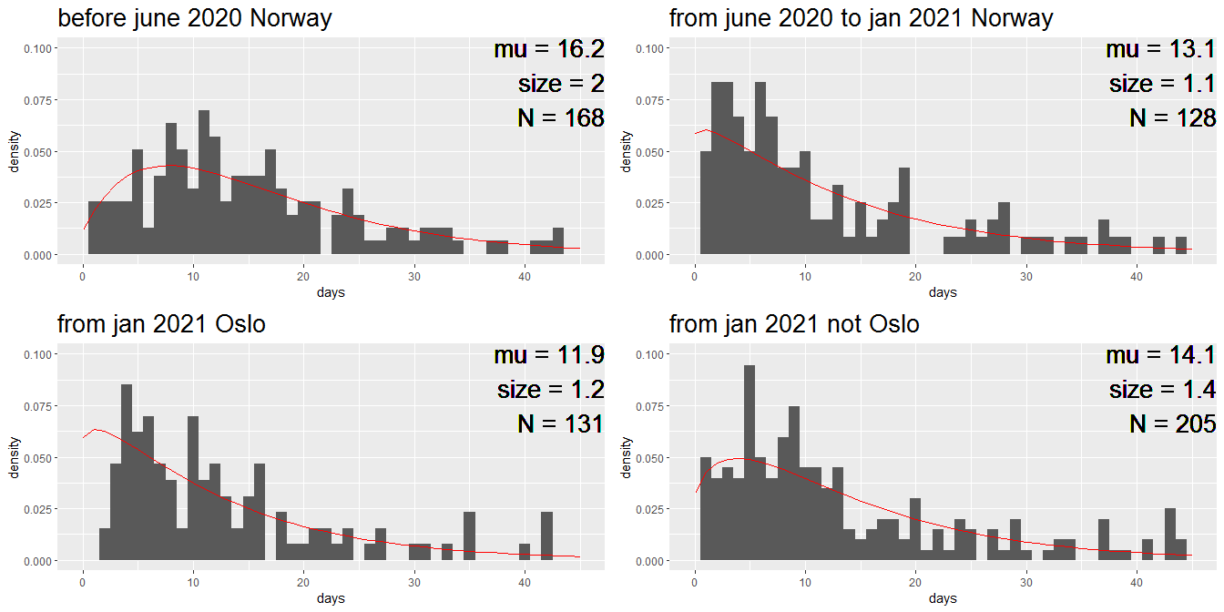

## png   
## 2

# LoS after ICU

## mu size N  
## before_june_2020_Norway 14.501 1.932 155  
## from_june_2020_to_jan_2021_Norway 12.300 1.644 111  
## from_jan_2021_Oslo 9.480 2.655 119  
## from_jan_2021_not_Oslo 11.838 1.537 169

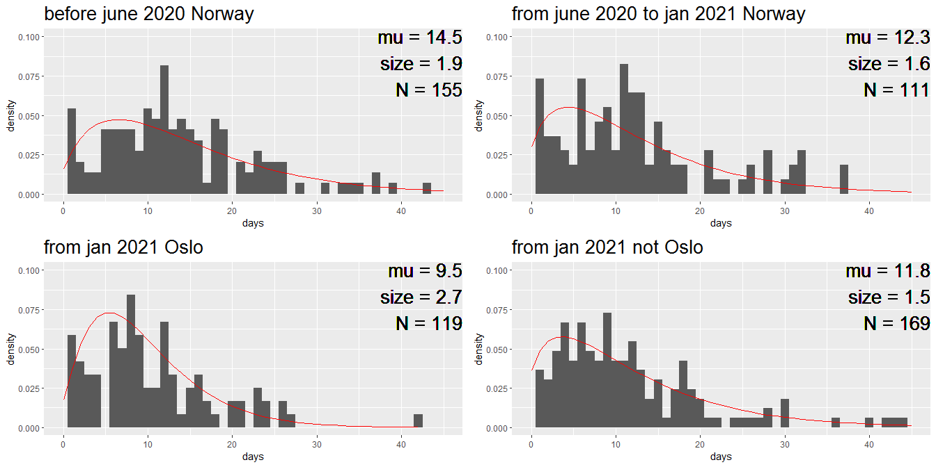

## png   
## 2

# Propotion hospitalized that need ICU treatment

## ICU hospitalized proportion_ICU  
## before_june_2020_Norway 168 971 0.173  
## from_june_2020_to_jan_2021_Norway 134 1167 0.115  
## from_jan_2021_Oslo 131 694 0.189  
## from_jan_2021_not_Oslo 199 1386 0.144