**SHORT LED PLAYER USER MANUAL**

**Content**

1. Installation of QL LED Player 5.0
2. Configuring of Display Controller
3. Setting Display areas and Changing Text
4. **Installation of QL LED Player 5.0**

***Note! You must be logged-in as Administrator to your Windows operating system***

* 1. Insert CD with LED player software to CD-reader of your computer
  2. Open folder “**Led Player 5.0**“

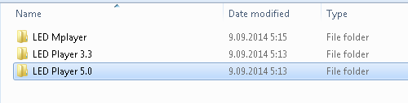

* 1. Click on file “**Led Player 5.x.x.x.exe**“ file



* 1. Click “**Allow**“ if your anti-virus prompts you.
  2. Choose language when prompted and click “**OK**“

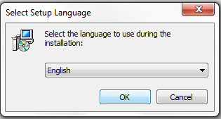

* 1. Click “**Next**“ when setup wizard opens:

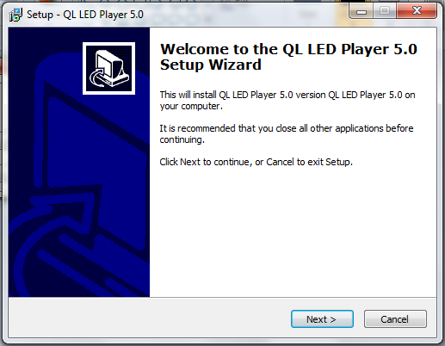

* 1. Choose folder of installation (you need to have Administrator privileges of that folder) and click “**Next**“:

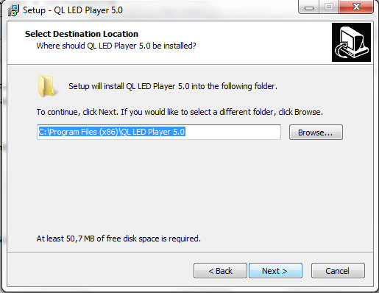

* 1. Modify Shortcut name if needed and click “**Next**“:

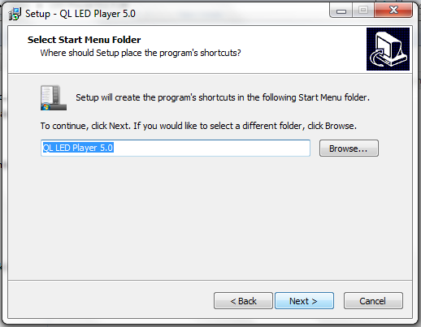

* 1. Accept desktop icon by clicking “**Next**“:

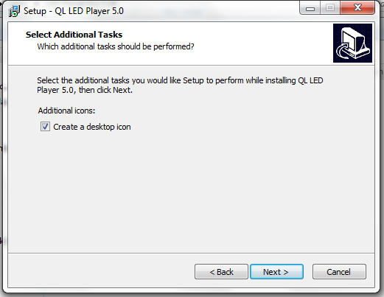

* 1. Click “**Install**“ to start installation:

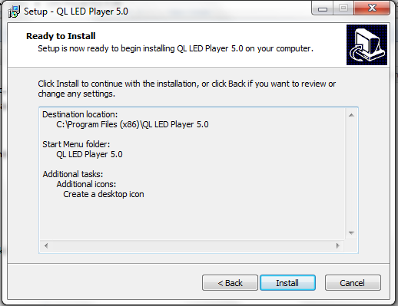

* 1. After installation is completed click “**Finish**“ to restart the computer

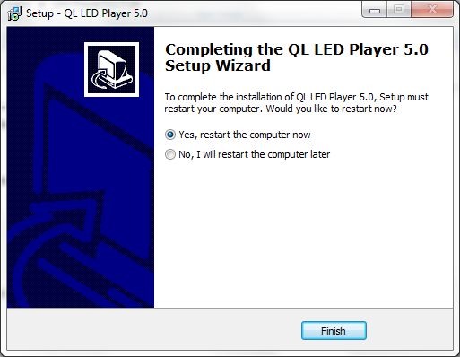

1. **Configuring of Display Controller**

Led Player must be configured upon first startup to communicate with the controller.

2.1 Click on desktop **icon QL Led Player.exe** to start the software

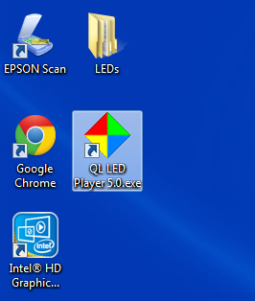

2.2 Startup screen will open,

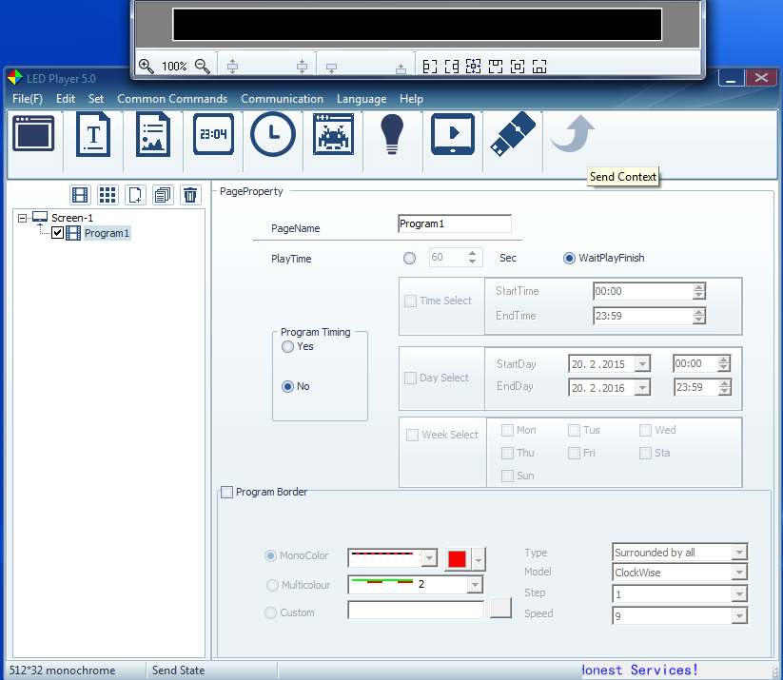

2.3. From the upper toolbar select “**Set**“ and from dropdown menu “**ScreenSet**“

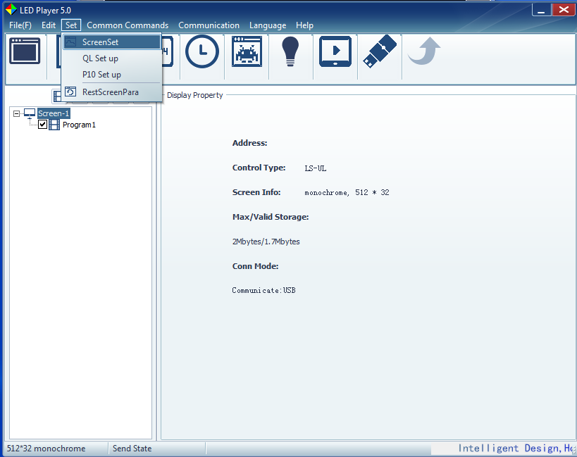

2.4. Enter password “**888**“ and click “**OK**“

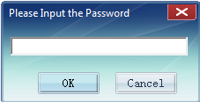

2.5. Select Controller typel from the dropdown menu “ **LS-2013 Serial**“

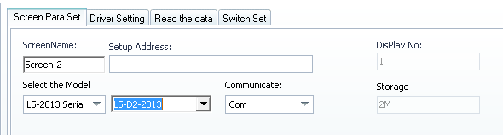

2.6. Select Controller module from the dropdown menu “ **LS-D3NET-2013**“

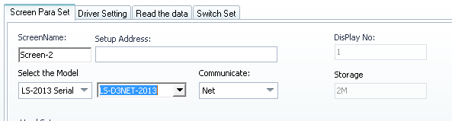

2.7. Set Screen Width and height to “**4 modules**“

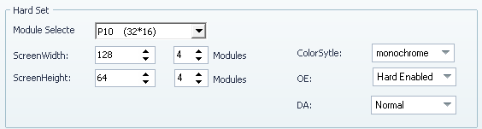

2.8. Click on “**SetScreenPara**“ button:

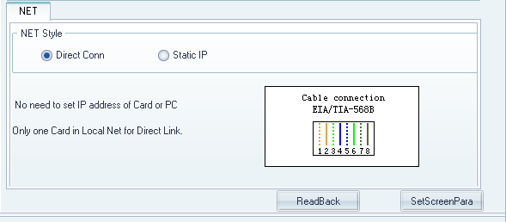

2.9. “**Allow“** connection if Anti-virus prompts:

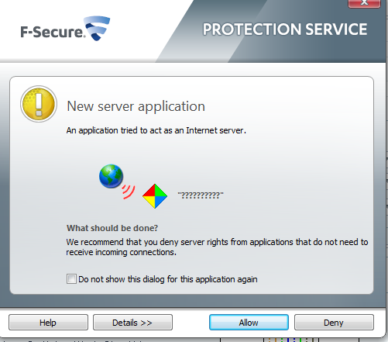

2.10. Wait for the program to send data, data is successfully sent if the status bar below shows “**Send Screenpara Success**“:

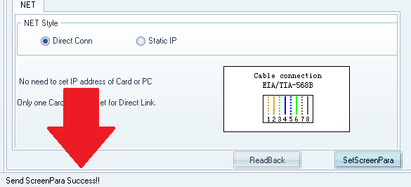

2.11. If the status bar shows “**Communicate fail!**“, Repeat pushing the button “**SetScreenPara**“

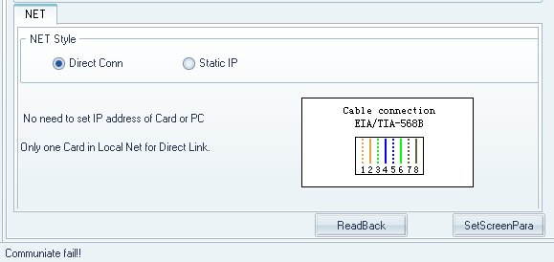

If the problem persists after repeating pushing the button for 5 times, check the communication cable and try again. And If this does not help, reboot the computer and repeat the whole process.

2.12. Close the parameters setting page after “**Send Screenpara Success“** response.

1. **Setting Display areas and Changing Text**

Led Player must be configured after configuring controller for the first time.

* 1. Click on desctop **icon QL Led Player.exe** to start the software



* 1. Click on “**T**“ icon to add text line area

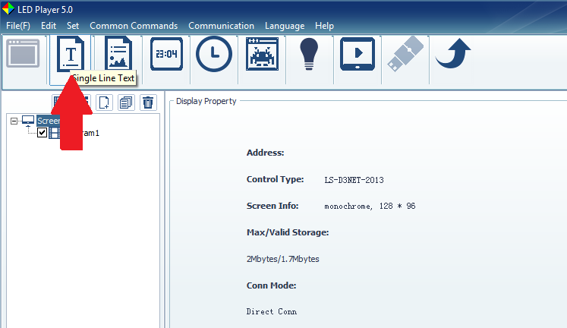

* 1. Drag area from the corner to the desired size (Please note that LED Player software displays all rows as one screen)

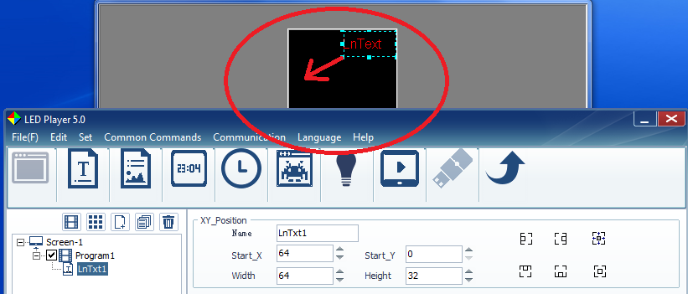

* 1. Insert and modify text in the field below as you prefer. Note that in the higher part live preview is available:

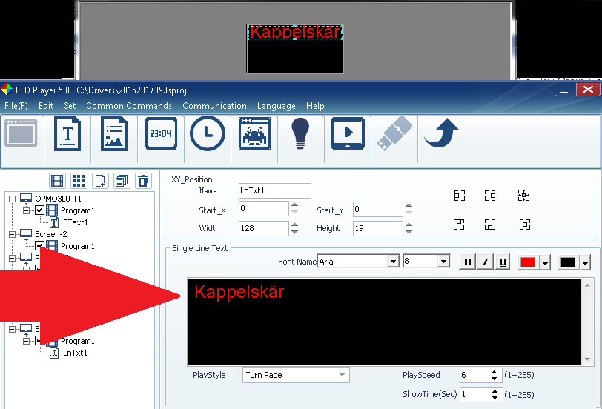

Add as many text areas as you need, by pressing the “T“ icon.

You can modify also different Playstyles and their speed.

* 1. Preview area can be zoomed in and out:

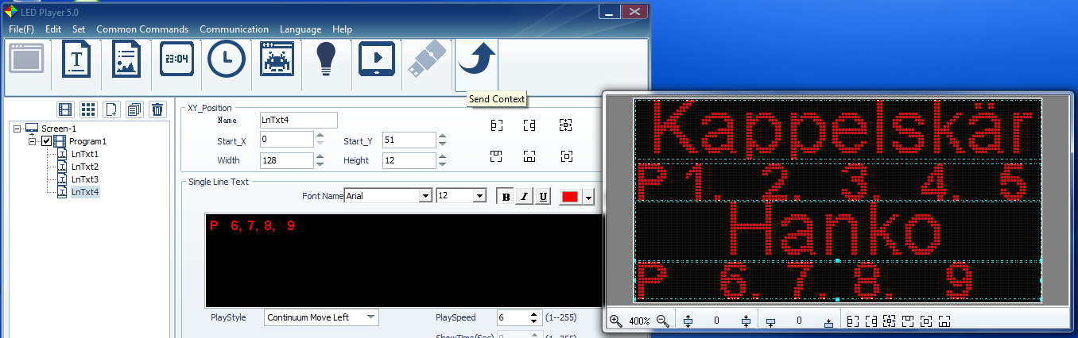

* 1. Press “**Send** “ icon to upload the data to the screen:

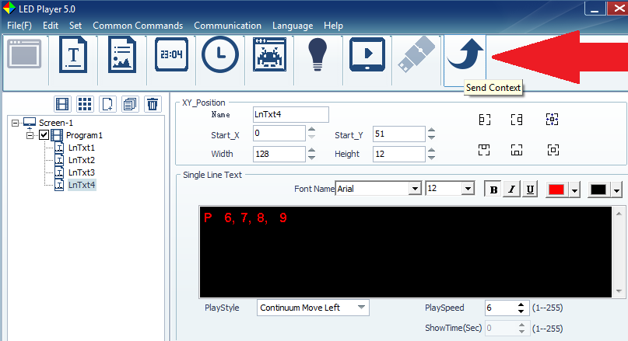

* 1. Check the status bar below for successful upload:

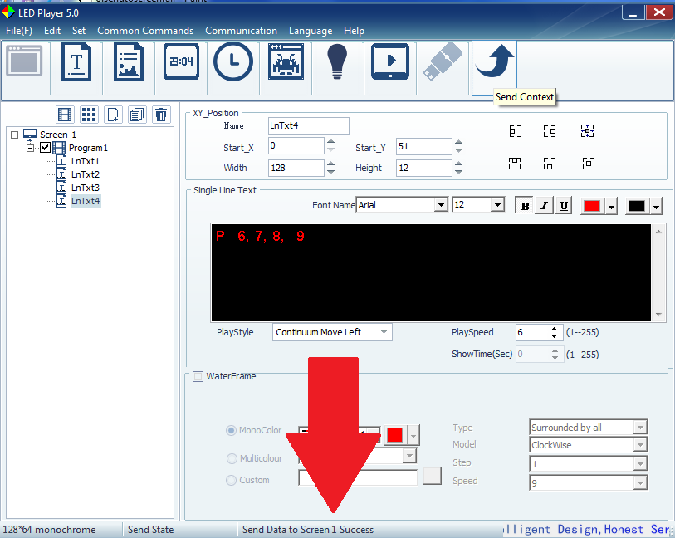

If the status bar shows “**Communicate fail!**“, Repeat pushing the “**Send**“ icon.

If the problem persists after repeating pushing the button for 5 times, check the communication cable and try again. And If this does not help, reboot the computer and repeat the whole process.

* 1. NB! Upon successful upload of the message, please be sure to save the configuration by pushing “YES“ when asked to confirm “Are You sure to save screenlist file?“ This allows you to use all your pre-saved data about the display after you open LED Player next time. If you do not save the settings on exit, you will need to reconfigure areas again next time when you open the software.