**A REPORT ON**

**PORTFOLIO HEDGING USING STOCK AND INDEX FUTURES AND THEIR ANALYSIS**

**By**

**Ishaan Singh (2021B3A33043H)**

**Under Supervision of Dr. ACV Subrahmanyam**

**Course Code: ECON F354 Course**

**Title: Derivatives and Management**

**Time of Submission – 19/11/2024, 23:50 hours**



**BIRLA INSTITUTE OF TECHNOLOGY AND SCIENCE, PILANI HYDERABAD CAMPUS (17-11-2024)**

**Note:**

**1. All the prices used are in Indian Rupee (INR)**

**2. Data is collected from June 30th 2022 to June 30th 2024 and analysis is done for the dates July 1st 2024 to September 25th 2024.**

**3. All the data has been taken for the NSE Website.**

**ACKNOWLEDGEMENT**

**I would like to thank Prof. ACV Subrahmanyam for providing me this opportunity and letting me work under him. I got a great learning experience by working on real data and analyzing it. I would like to thank him for providing me with such a wonderful opportunity to apply our course knowledge on real-life data and get hands-on experience.**

**Table of Contents**

**Part 1: Portfolio Construction, Descriptive Statistics, Returns5**

Returns5

Correlation Plots6

**Part 2: Hedging Using Stock Futures7**

Choice of Individual Futures7

Calculating OHRs8

Time-Frame Analysis9

Hedging Strategy10

**Part 3: Hedging Using Stock Index Futures for the Entire Portfolio12**

Portfolio and Market Return and Analysis12

Hedging Strategy12

Hedging Returns (Results)13

**Part 4: Conclusion14**

**Part 1: Portfolio Construction, Descriptive Statistics, Returns**

**Portfolio Overview –**

|  |  |  |  |  |
| --- | --- | --- | --- | --- |
| Company | Weight | Investment Amount | Company Sector | Market Capitalization |
| IDBI | 0.2 | 20,000,000 | Banking | 827.40 billion INR |
| ENDURANCE | 0.3 | 30,000,000 | Automobiles | 334.78 billion INR |
| SRF | 0.1 | 10,000,000 | Chemicals | 662.57 billion INR |
| EXIDE | 0.4 | 40,000,000 | Battery Manufacturing | 355.51 billion INR |

Our portfolio comprises of four companies which are all in different industries, each of them having a market cap of at least 300 billion INR. This allows the portfolio holder to diversify their risk as an economical to a particular industry would not adversely affect our portfolio. We have taken the size of our portfolio to 100 million INR.

We have given weight to the stocks in accordance to their past performance. Exide Industries should the most consistent growth in stock price over the past two years and hence has been given the highest weightage. On the other hand, SRF limited has had highly fluctuating stock price in this time frame and hence has been given the lowest weightage. These trends are clearer and more evident from the graphs provided below.

**Returns –**

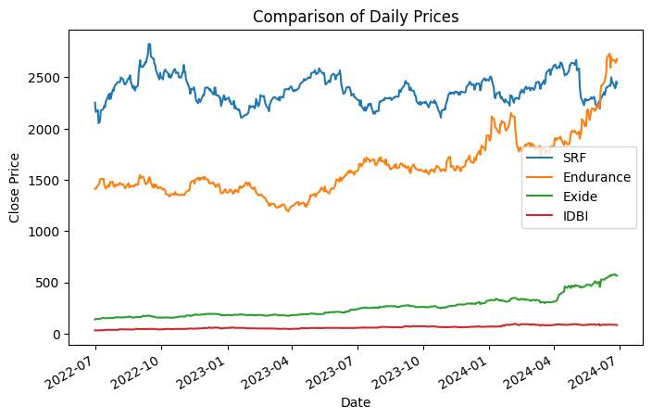

The above graph shows the closing prices of our stocks over a two-year span. We can see that Endurance and Exide show a constant growth throughout this period; hence we chose to give them the highest weightage in our portfolio. On the other hand, SRF’s stock value has been continuously fluctuating and almost has a seasonal quality to it. Due to the risk associated with this stock, we gave it the lowest weightage.

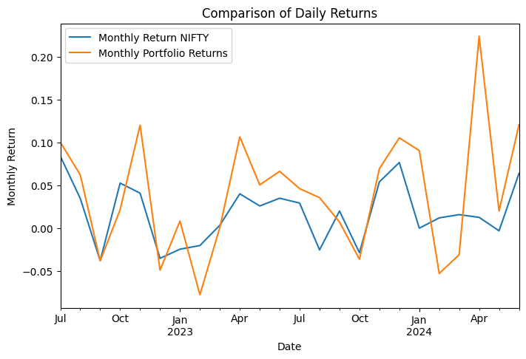

This graph shows us the monthly returns of portfolio along side with returns of from the NIFTY 50 index. We can see that for most of the graph, there is a significant correlation between the returns of the two. This shows that our portfolio tends to give us good returns whenever the general market is doing well. We can take the help of correlation plots to see a more objective relation between the index and our portfolio.

**Correlation Plots -**

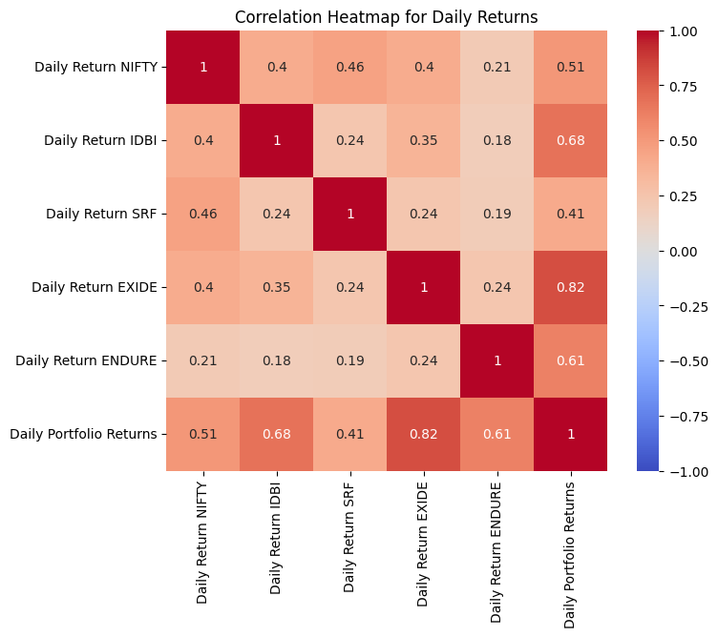

This graph shows the correlation between the daily returns of each stock with each other, as well as their correlation with the overall portfolio and the NIFTY 50 Index. We can see that all the stock returns have a positive correlation with the returns from the NIFTY index and our portfolio return has a correlation of 0.51 with the daily return from the index which is quite significant.

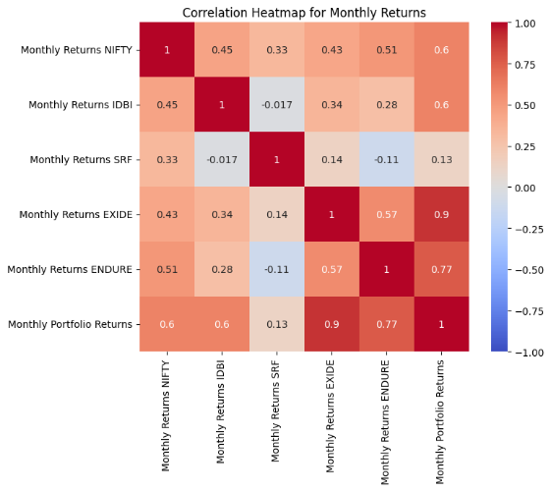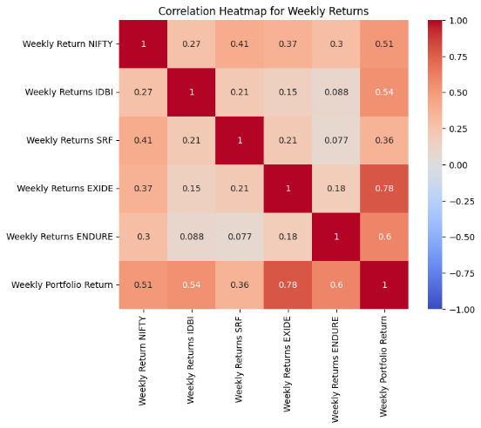

The above diagrams are weekly and monthly return correlation plots respectively, similar to what we saw with our daily returns above. The correlation between weekly portfolio returns and weekly index returns (0.51) is still the same as the daily time frame but the correlation between the two is even higher at 0.6 in the monthly time-frame.

Moreover, we can see that there is a positive correlation between each stock and the index; regardless of the time frame we have considered. We have also seen a significantly positive correlation between our overall portfolio and the NIFTY 50 index.

**Part 2: Hedging and Stock Futures**

None of our given companies had their own stock futures, hence appropriate futures for cross hedging our stocks had to be used.

**Futures Choices for Each Stock: -**

1. **For IDBI – Bank NIFTY Index Futures**

Bank NIFTY Index is made up of the largest bank stocks in India and hence provides a good baseline for the trends in the banking sector. IDBI’s stock price (being a part the banking sector) moves in correlation with the general trends of the banking sector. This is confirmed by a correlation of 0.48 between the returns of IDBI and Bank NIFTY Index, showing that there is moderate to strong correlation between the two. For these reasons, BANK Nifty Index Futures are used to cross hedge IDBI Stocks.

1. **For ENDURANCE – Nifty Midcap Futures**

Endurance Technologies is involved in the production of automobile parts and software. A suitable hedge for this stock would have been NIFTY Auto Index Futures, but the data for this index was unavailable. Due to this, we used NIFTY Midcap Index Futures to cross hedge this stock. As we saw in our graphs, Endurance Technologies showed decent correlation with general market trends and it being a midcap company, midcap futures seemed appropriate for cross hedging. Correlation between the two is 0.25 which is on the weaker side.

1. **For SRF – Nifty Midcap Futures**

Similar to Endurance technology, Nifty Midcap Futures were used as data for Nifty Commodity Index Futures were unavailable. SRF being a chemicals company which is dependent on raw materials, commodity futures would’ve ideal for cross hedging. SRF being a midcap company shows similar trends to the overall market and hence Nifty Midcap Futures were used as an alternative. Correlation between the stock returns and the futures returns is 0.45.

1. **For Exide – Nifty 50 Index Futures**

Exide Industries’ primary revenue comes from supplying car batteries and other deliverable battery sources and hence NIFTY Auto Index Futures would have been idea, but the data for the index futures was unavailable. As seen in the graphs provided above, Exide showed high correlation with general market trends and it being a large cap company, NIFTY 50 Index futures was seen as a suitable substitute. Correlation between the stock returns and the futures returns is 0.45.

**Calculating OHRs: -**

Using appropriate futures for each individual stock, we have calculated the optimum hedge ratio for each stock based on daily, weekly, and monthly returns. The values have been calculated for both 1-year data and 2-year data.

|  |  |  |  |
| --- | --- | --- | --- |
| Using 1 - year data | | | |
| OHR | Day Returns | Weekly Returns | Monthly Returns |
| IDBI | 0.183 | 0.052 | -0.016 |
| ENDURANCE | 0.143 | 0.154 | 0.254 |
| SRF | 0.373 | 0.352 | 0.194 |
| EXIDE | 0.23 | 0.135 | 0.124 |
| Using 2 - years data | | | |
| OHR | Day Returns | Weekly Returns | Monthly Returns |
| IDBI | 0.154 | 0.103 | 0.107 |
| ENDURANCE | 0.112 | 0.184 | 0.304 |
| SRF | 0.134 | 0.142 | 0.042 |
| EXIDE | 0.176 | 0.097 | 0.181 |

**Time Frame Analysis: -**

Because of variations in volatility, correlation, and the sensitivity of the asset and hedging instrument over various time periods, the optimal hedge ratio usually depends on the time frame of analysis.  
  
**Daily Time Frame**: Because short-term price fluctuations are more volatile and noisier, OHRs are typically higher. To properly balance risks, a higher hedge ratio is necessary because daily returns capture rapid market fluctuations.  
  
**Weekly Time Frame**: As weekly returns reduce some of the daily volatility, OHRs tend to stabilize. OHRs are marginally reduced because of the more stable correlation between the asset and the hedging tool.  
  
**Monthly Time Frame**: Because long-term patterns predominate and short-term changes have less of an impact, OHRs are often the lowest. The lesser frequency, meanwhile, might understate the necessity of careful hedging in volatile markets.

**Calculating Optimal Contracts: -**

Now, using the above calculated OHRs, the values of our stocks in our portfolio and the values of our individual future contracts, we calculate optimal number of contracts to by for each time frame for each stock. We use both one-year and two-year data.

|  |  |  |  |
| --- | --- | --- | --- |
| Using 1 year data | | | |
| Optimal Contracts | Day Returns | Weekly Returns | Monthly Returns |
| IDBI | 4.59 | 1.29 | -0.402 |
| ENDURANCE | 13.91 | 14.97 | 24.70 |
| SRF | 12.09 | 11.41 | 6.28 |
| EXIDE | 15.06 | 8.84 | 8.12 |
| Using 2- years data | | | |
| Optimal Contracts | Day Returns | Weekly Returns | Monthly Returns |
| IDBI | 3.86 | 2.59 | 2.69 |
| ENDURANCE | 10.89 | 17.82 | 29.56 |
| SRF | 4.34 | 4.60 | 1.36 |
| EXIDE | 11.52 | 6.37 | 11.85 |

Based on daily returns from the past two years, the optimal number of futures contracts to be bought for IDBI, ENDURANCE, SRF, and EXIDE are 3.86, 10.89, 4.34 and 11.52 respectfully.

**Hedging Strategy: -**

Now that we know the optimum number of future contracts to buy, we can establish an appropriate hedging strategy. The table below details our strategy.

|  |  |  |  |  |  |  |
| --- | --- | --- | --- | --- | --- | --- |
| Stock/Index | Hedge Position | Entry Date | Entry Price | Exit Date | Close Out Price | Number of Contracts |
| Bank NIFTY  (for IDBI) | Long | 01-Jul-24 | 52,574 | 25-Sep-24 | 54,101 | 4 |
| NIFTY Midcap  (for Endurance) | Long | 01-Jul-24 | 15,840 | 25-Sep-24 | 16,913 | 11 |
| NIFTY Midcap  (for SRF) | Long | 01-Jul-24 | 15,840 | 25-Sep-24 | 16,913 | 4 |
| NIFTY 50  (for Exide) | Long | 01-Jul-24 | 24,141 | 25-Sep-24 | 26,004 | 12 |

1. **For hedging IDBI Stocks**, we entered a Bank NIFTY Futures contracts on 01-Jul-24 and took a long position with a strike price of 52,574 INR with expiry on 25-Sep-24. Closed out our position by going short in Bank NIFTY Futures on 01-Aug-24 at a strike price of 54,101 INR with expiry on 25-Sep-24.
2. **For hedging ENDURANCE Stocks**, we entered a NIFTY Midcap Index Futures contracts on 01-Jul-24 and took a long position with a strike price of 15,840 INR with expiry on 25-Sep-24. Closed out our position by going short in NIFTY Midcap Index Futures on 31-Jul-24 at a strike price of 16,913 INR with expiry on 25-Sep-24.
3. **For hedging SRF Stocks**, we entered a NIFTY Midcap Index Futures contracts on 01-Jul-24 and took a long position with a strike price of 15,840 INR with expiry on 25-Sep-24. Closed out our position by going short in NIFTY Midcap Index Futures on 31-Jul-24 at a strike price of 16,913 INR with expiry on 25-Sep-24.
4. **For hedging EXIDE Stocks**, we entered a NIFTY 50 Index Futures contracts on 01-Jul-24 and took a long position with a strike price of 24,141 INR with expiry on 25-Sep-24. Closed out our position by going short in NIFTY Midcap Index Futures on 31-Aug-24 at a strike price of 26,004 INR with expiry on 25-Sep-24.

**Portfolio Hedging Returns: -**

|  |  |  |  |
| --- | --- | --- | --- |
| Stock | Stock Returns (INR) | Hedging Profit/Loss (INR) | Net Return (INR) |
| IDBI | 1,104,396 | 3,715,416 | 4,819,812 |
| ENDURANCE | -3,255,517 | 53,310 | -3,202,206 |
| SRF | -43,250 | 23,356 | -19,894 |
| EXIDE | -6,722,866 | 921,357 | -5,801,508 |
| Total | -8,917,237 | 4,713,440 | -4,203,796 |

**Profit from hedging – 4,713,440 INR**

**Overall Portfolio Return - -4,203,796 INR**

**Part 3: Hedging Using Stock Index Futures for the Entire Portfolio-**

**Portfolio and Market Return Analysis: -**

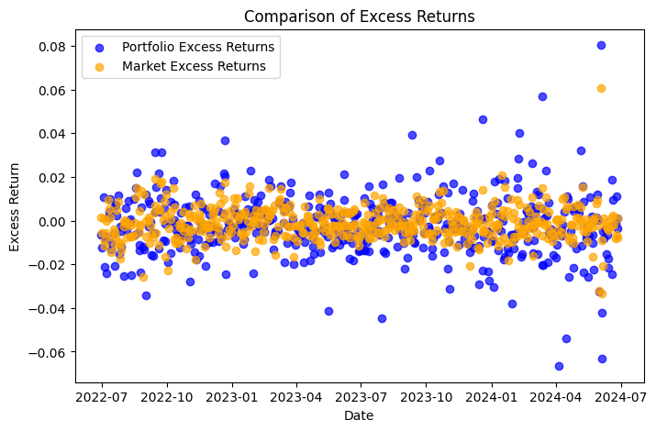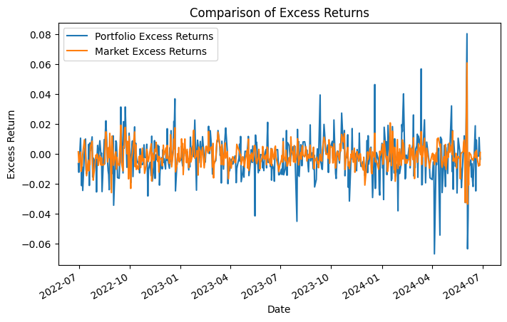

These graphs show the trend in excess returns for our portfolio and the excess returns from the market index. We can see that even though our portfolio returns fluctuate a lot more compared to market, they both follow very similar trends, our portfolio follows the market trend quite consistently.

**Hedging Strategy: -**

1. By using the Capital Asset Pricing Model, we have calculated the optimal hedging ratio and optimal number of contracts to buy to hedge our entire portfolio with the help of NIFTY 50 Index Futures.
2. CAPM gives us a beta value for our portfolio which tells using about the portfolio’s sensitivity to market movements. By our calculations, we got a beta value of 0.915, which indicates that our portfolio returns are highly correlated with the market. This evident from the graphs shown above as well.
3. Using this beta value, we calculated the optimal number of index futures contracts to hedge our entire portfolio, which came out to be 152 contracts.
4. To complete our hedging strategy, we entered 152 NIFTY 50 Index Futures contract in a long position on 1st July 2024 at a strike price of 24141.95 INR with an expiry date of 25th September 2024. The position was closed out by shorting 152 NIFTY 50 Index Futures on 31st August with an expiry date of 25th September 2024 with a strike price of 26004.15 INR.
5. By applying this hedging strategy, we had a futures profit of 7,029,805 INR but it was insufficient in protecting the portfolio values as we ended up with an overall loss of 4,035,802 INR.

**Hedging Returns Using Index Futures (Results): -**

|  |  |  |  |
| --- | --- | --- | --- |
| Using Stock Index Futures | Portfolio Profits (INR) | Hedge Profits (INR) | Overall Profits (INR) |
| Overall Return | -11,065,607 | 7,029,805 | -4,35,802 |

**Part 4: Conclusion**

The following table shows are overall returns from both individual stock hedging as well as hedging for the entire portfolio.

|  |  |  |  |
| --- | --- | --- | --- |
| Using Individual Stock Futures | Stock Profits | Hedge Profits | Overall Profits |
| IDBI | 1,104,396 | 3,715,416 | 4,819,812 |
| ENDURANCE | -3,255,517 | 53,310 | -3,202,206 |
| SRF | -43,250 | 23,356 | -19,894 |
| EXIDE | -6,722,866 | 921,357 | -5,801,508 |
| Overall Return | -8,917,237 | 4,713,440 | -4,203,796 |
|  |  |  |  |
| Using Index Futures  (Entire Portfolio) | Portfolio Profits | Hedge Profits | Overall Profits |
| Overall Returns | -11,065,607 | 7,029,805 | -4,035,802 |

**Analysing our overall returns from both approaches: -**

1. **Stock Futures Hedging: -**
2. IDBI stock performed the best on its own but the hedging profits outperformed the stocks and hence gave us a significant profit.
3. In the case if ENDURACE, SRF and EXIDE, major losses in the stock market were incurred which were not sufficiently protected by our hedging strategy. This is especially true for the EXIDE stock which suffered the largest amongst the four.
4. The total overall return from stock hedging is negative, indicating limited effectiveness.
5. **Index Futures Hedging: -**
6. The portfolio on its own suffered a huge loss of 11,065,607 INR.
7. Yet the hedge was able to recuperate much of that loss by giving us a profit of 7,029,805 INR.
8. We end with a negative profit which could suggest that the hedge was ineffective but the profits it made to offset the initial lose should not be ignored.

**3. Comparison and Conclusion**: - Index futures hedging provided us with higher hedge profits and overall were more adept at hedging our portfolio risk as we end with lower losses in the case of index futures hedging. It is often more ideal to perform individual stock hedges because it allows us to mitigate risks specific to each stock and is hence more granular but is also more time consuming. But in this case the ease of implementation and higher returns of index hedging makes it the clear choice.