Libvirt管理的虚拟机迁移到convirt平台

- 下载工具包converter.tar
http://www.convirture.org/forums/viewtopic.php?f=35&t=1846&p=2871
使用winscp 复制到 linux的/root
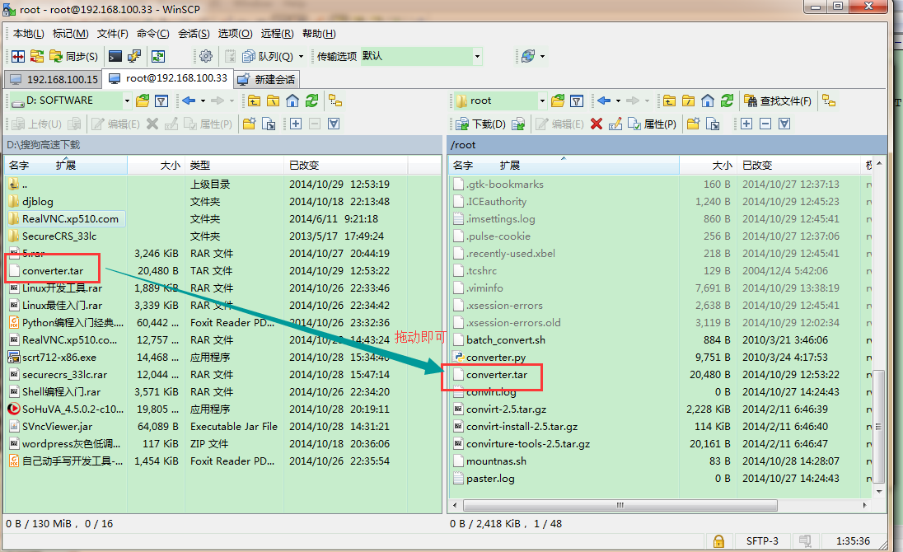
- 解压converter.tar
#tar -xvf converter.tar
- 获取libvirt管理的虚拟机的配置文件
#cd /etc/libvirt/qemu
#cp win7.xml(我自己的配置文件名) ~/
- 执行#./batch_convert 获取到转换后的文件win7.cfg
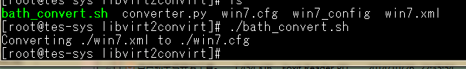
- 转换后的源文件(win7.cfg)内容：
# Automtically generated by ConVirt
kernel = '/usr/lib/xen/boot/hvmloader'
vif = ['mac=52:54:00:75:b2:7f,bridge=br1']
on_shutdown = 'destroy'
disk=['qemu:raw:/var/lib/libvirt/images/win7.img,hda,w','qemu:raw:None,hdc:cdrom,r'] → 修改将浅红字体部分删掉，红字前的qemu:raw: 修改为：file: !

vncunused = 1
apci = 0
uuid = 'eae70d55-dd1b-6a4c-6075-dc4b6164c589'
os_version = '1.0'
on_reboot = 'restart'
boot = 'c'
platform = 'kvm'
pae = 1
memory = 3072
acpi = 1
os_name = 'Linux'
vnc = 1
on_crash = 'restart'
network_mode = 'tap'
os_flavor = 'Linux'
bootloader = ''
arch = 'x86_64'
soundhw = 'ich6' →删除掉，会报错找不到
name = 'win7' → name = 'win7-lib'(如果有重名需要修改)
usbdevice = 'tablet'
device_model = '/usr/libexec/qemu-kvm'
builder = 'hvm'
template_version = '1.0'
vfb = ['type=vnc,vncunused=1']
vcpus = 2
usb = 1
- 复制的convirt的配置文件目录
#cp win7.cfg /var/cache/convirt/vm_configs/ win7.cfg
- 在convirt web界面导入配置文件
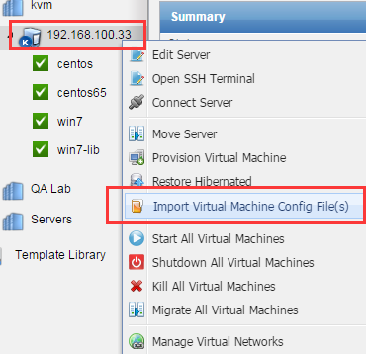
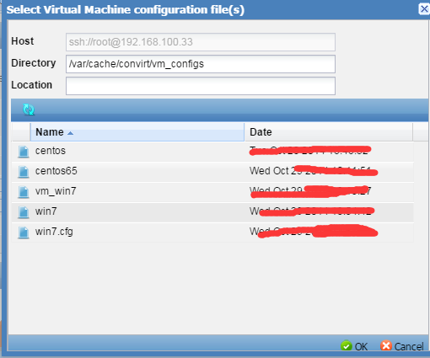
启动该虚拟机，如果没有成功继续按照提示修改；
如果正常启动并运行，配置文件会如下所示：
灰色文字部分是系统自动添加的

修改后的源文件内容：
kernel = '/usr/lib/xen/boot/hvmloader'
vif = ['mac=52:54:00:75:b2:7f,bridge=br1']
on_shutdown = 'destroy'
STORAGE_STATS = {'DISK_STATS': {'raw:/var/lib/libvirt/images/win7.img': {'DEV_TYPE': 'UKNOWN', 'IS_LOCAL': True, 'DISK_SIZE': None, 'DISK_NAME': 'raw:/var/lib/libvirt/images/win7.img', 'STORAGE_DISK_ID': None}, 'raw:None': {'DEV_TYPE': 'UKNOWN', 'IS_LOCAL': True, 'DISK_SIZE': None, 'DISK_NAME': 'raw:None', 'STORAGE_DISK_ID': None}}, 'LOCAL_ALLOCATION': 0, 'SHARED_ALLOCATION': 0} →这是在web页面修改时自己添加的
disk = ['file:/var/lib/libvirt/images/win7.img,hda,w']
vncunused = 1
apci = 0
uuid = '5c69eeef-2b1e-fcc5-0cfc-0aab01908782'
platform = 'kvm'
on_reboot = 'restart'
boot = 'c'
os_version = '1.0'
pae = 1
memory = 3072
acpi = 1
os_name = 'Linux'
vnc = 1
on_crash = 'restart'
network_mode = 'tap'
os_flavor = 'Linux'
config_filename = '/var/cache/convirt/vm_configs/win7.cfg'
bootloader = ''
arch = 'x86_64'
name = 'win7-lib'
usbdevice = 'tablet'
device_model = '/usr/libexec/qemu-kvm'
builder = 'hvm'
template_version = '1.0'
vfb = ['type=vnc,vncunused=1']
vcpus = 2
usb = 1
- 启动成功的界面
