若客户自行去解析这条RSDR指令
RSDR 688 TDI (ff000000000000000000000000000000000000000000000000000000000000000000f00000f00000000000000000000000000000000000000000000000000000000000000000000000000000000000000000000000ff) TDO (ff000000000000000000000000000000000000000000000000000000000000000000f00000f00000000000000000000000000000000000000000000000000000000000000000000000000000000000000000000000ff) MASK (ffffffffffffffffffffffffffffffffffffffffffffffffffffffffffffffffffffffffffffffffffffffffffffffffffffffffffffffffffffffffffffffffffffffffffffffffffffffffffffffffffffffffffff) ;

第一步
SDR 688 TDI (ff000000000000000000000000000000000000000000000000000000000000000000f00000f00000000000000000000000000000000000000000000000000000000000000000000000000000000000000000000000ff) RMASK (ffffffffffffffffffffffffffffffffffffffffffffffffffffffffffffffffffffffffffffffffffffffffffffffffffffffffffffffffffffffffffffffffffffffffffffffffffffffffffffffffffffffffffff) ;
其中RMASK表征的是，TDO Shift出来的值，进行保存

第二部
再执行
SDR 688 TDI (XXXXXXXXXXXXXXXXXXXXXXXXXXXXXXXXXXXXXXXXXXXXXXXXXXXXXXXXXXXXXXXXXXXXXXXXXXXXXXXXXXXXXXXXXXXXXXXXXXXXXXXX)
其中XX值由第一条指令保存的值决定。
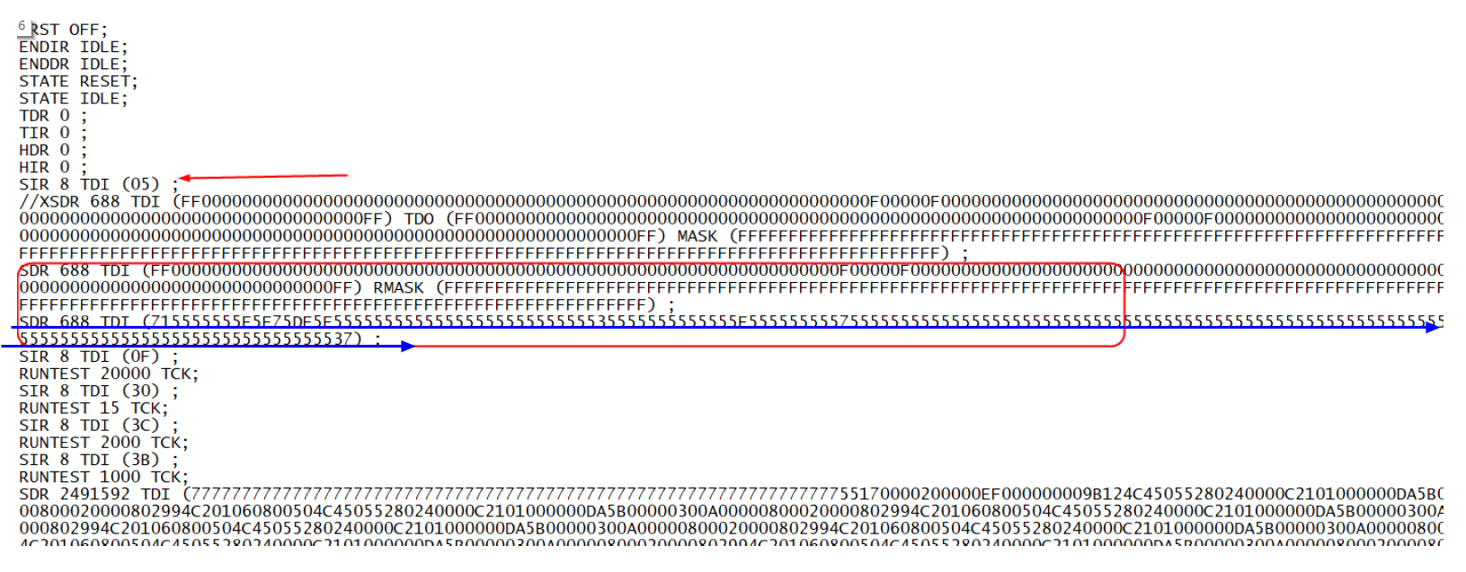

对于BIN转SRAM，和研发确认，SRAM的数据中途未做其他填充，格式和FLASH烧录下载类似。
FFDD66BB->>>>DD66BBFF,=
22FCBE04->>>>207D3F44
