Image Ruler

by Joost de Folter

Multi-purpose image measurement tool, which allows obtaining data from published graphs accurately.

Requirements: Windows / .NET

Instructions

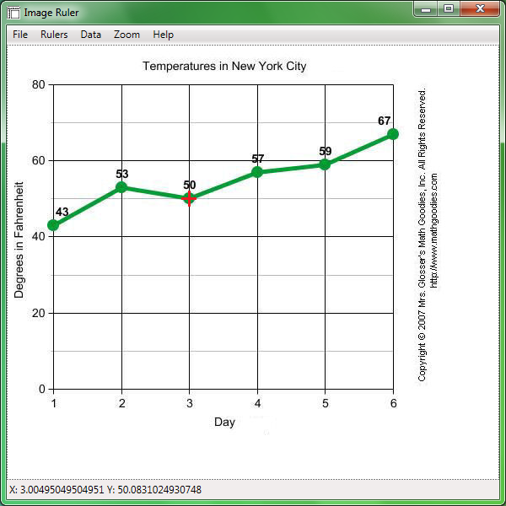
Selecting a source image

Select an input image by selecting from the main menu: File → Open Image, and navigating to a desired source image.
Alternatively, an image may be copied (i.e. obtained by Print Screen), by selecting from the main menu: File ->Image from Clipboard.

Setting up the rulers

After opening an image, the ruler selection mode is automatically started. The status bar displays current coordinates, or the current mode. At this stage the status bar will show 'Setting X ruler start', indicating that the start point for the axis in horizontal direction is activated. Clicking on the image will set the start point, and activate a dialog asking for the corresponding numerical value. After setting a ruler point, the next selection mode is automatically activated. The next mode is 'Setting X ruler end', where the end point for the horizontal axis can be set. After setting this, the process is repeated for the axis in the vertical direction, which is indicated by 'Y ruler'. Note that these options can also be manually activated via the Rulers menu. It is also possible to only set the axis in a single direction, and directly switching to the Mark mode manually.

Obtaining data points

When both rulers are set, the application will switch to the marking mode, where selections on the graph can be made. In this mode, the status bar will show the numerical values corresponding to the position of the cursor. Clicking on the image will mark a point, shown by a small grey dot on the image. After a point is marked, in addition to the current coordinates, the difference from the last marked point is also displayed (preceded by the delta symbol Δ). These points are stored in a list that can be displayed by selecting from the main menu: Data → Show. All marked data can be cleared by selecting Data → Clear, or by selecting the Clear button in the Data window. Data can be exported to CSV file format which is compatible with MS Excel or other spreadsheet software.

Zooming

The size of the image display can be adjusted by zooming in or out, either using the menu options from the Zoom menu, or by scrolling the middle mouse button. The size can be reset by selecting Zoom 100% from the Zoom menu.

