Ultimate Time Gadgets

Introduction

Ultimate Time Gadgets is a desktop gadget style Windows extension, and is developed by Joost de Folter.

Installation

- Execute the installation file, and follow its instructions
- This software requires .NET framework version 4 which will automatically be downloaded by the installation wizard (this needs to be done only once)

Tray icon

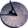

Right clicking the tray icon brings up the menu.

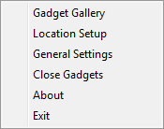
The available menu options are as follows:

- Gadget Gallery Shows the Gadget Gallery
- Location Setup Opens the Location Setup window
- General Settings Opens the General Settings window
- Close Gadgets Closes all current gadgets
- About Shows the about dialogue
- Exit Exit the application

Double clicking the tray icon opens the Gadget Gallery as well.

Gadgets gallery

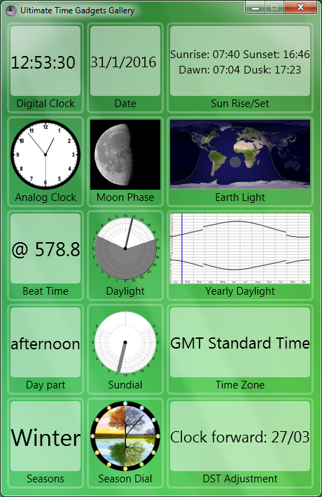

Gadgets can be placed on the desktop by dragging and positioning them from the gallery window.

Gadgets

Each gadget positioned on the desktop reveals a number of buttons when the mouse is hovered over it.

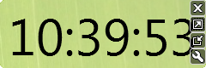
These can close the gadget, enlarge it, shrink it and bring up specific gadget settings.

Gadget Settings

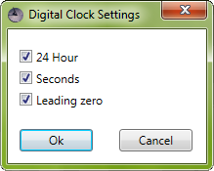
Each gadget has specific settings. Any changes to the settings can subsequently be confirmed or cancelled.

General Settings

The General Settings can be accessed from the tray icon menu.

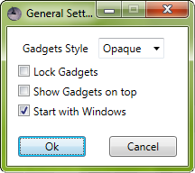
The General Settings has a number of settings that affect all the gadgets:
- Gadget Style Select the gadget display style
- Lock Gadgets Locks position, size and settings of gadgets
- Show Gadgets on top Shows gadgets on top of any other windows
- Start with Windows Start Ultimate Time Gadgets when Windows starts

These general settings can then be confirmed or cancelled.
Location Setup

The Location Setup can be accessed from the tray icon menu.

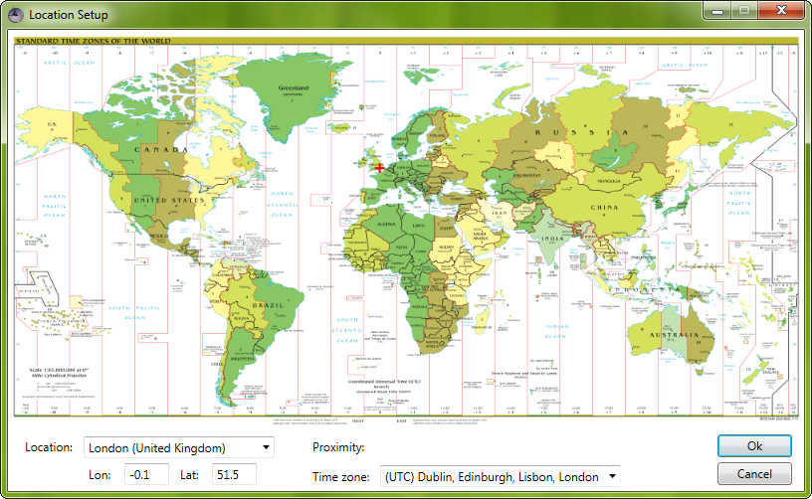
Specific locations can be found by manually entering text in the bottom left control labelled Location. As text is entered any location matches will be displayed in the same control, which can subsequently be selected. The current location is highlighted by a red cross (+) on the map.

Alternatively, a location can be selected with the mouse on the map. The map zoom can be controlled with the mouse wheel. Additionally the time zone can be selected using the Time Zone control in the bottom right.

A new selection can finally be confirmed or cancelled.

