Formiva Database Plan and Schema Specification
PostgreSQL 16 design for a multi-tenant, audit-grade intake and approval platform
Version 2.1
Prepared 20 September 2026
Replaces: Formiva Database Planning, Architecture and Schema (2.0)
Companion package: Formiva_DB_v2.1 (migrations 001-008, tests, README)
Revision 2: government-document policy added (migration 007)
Status: schema written and tested on PostgreSQL 16.15 (107 automated checks and a 12-session concurrency race pass); not yet deployed

Contents
1. Purpose and status
2. Design principles
3. Tenant isolation model
4. Roles and privileges
5. Table catalog
5.1 Identity, tenancy and access (7 tables)
5.2 Forms and public access (4 tables)
5.3 Workflow definitions (6 tables)
5.4 Cases, documents and evidence (9 tables)
5.5 AI control plane (11 tables)
5.6 Review, approval and SLA (6 tables)
5.7 Execution, integrations, billing (18 tables)
5.8 Governance, audit and recovery (5 tables)
6. State machines
6.1 Cases
6.2 AI jobs, workflow steps, integration interactions, review tasks
7. Transaction patterns
7.1 Submission
7.2 Claiming work (worker)
7.3 Recording an AI result
7.4 Integration call (exactly-once guard)
7.5 Human correction
7.6 Approval and action
7.7 Audit
7.8 Creating a workspace
8. Sensitive data and encryption
8.1 Government documents in the database (migration 007)
8.2 Generic connectors (migration 008, ADR-16)
9. Retention, deletion and legal hold
10. Performance and capacity
11. Backup, restore and migration rules
12. What the test suites prove
13. Useful analytics queries (for Phase 11)
14. Known limitations and open decisions

1. Purpose and status
This document specifies the database that holds every Formiva case, document record, AI result, routing decision, review, approval, integration attempt and audit event. It is written for three readers: you (to understand what is protected and why), the AI coding tool (to write correct data-access code), and the technical reviewer (to check the controls).
Item | Value
Engine | PostgreSQL 16, running on VM1 with the API and workers (ADR-01)
Tables | 66 in schema public; 59 are tenant-owned with forced row-level security; 7 are global catalogs (permissions, billing plans, model registry, benchmark runs, document subtypes, connector categories, connector templates)
Support objects | 66 triggers, 6 privileged (SECURITY DEFINER) functions, 1 metrics view, 4 helper procedures, a state-transition table with 109 rows
Migrations | 001_foundation to 008_generic_connectors (SQL-first, ADR-10)
Tests | 107 assertions in four SQL suites plus a shell concurrency race (12 sessions, 10 jobs, each claimed once). Every claim in this document that says "enforced" is backed by one of them
What is not yet proven | Performance at pilot scale, backup and restore on VM1, behaviour behind a connection pooler, and the API layer that calls all this. Those are POC gates

Decision: the database is the last line of defence. Application code must be correct, but when it is wrong, the database must still refuse to leak a tenant's data, overwrite evidence, skip an approval or run a state change that the state machine does not allow.

2. Design principles
- Tenant isolation is enforced three ways at once: composite foreign keys (a child row cannot point at another tenant's parent), forced row-level security on every tenant table, and an authorization layer in the API. A bug in one layer does not open the others.
- Deny by default. With no tenant context set, tenant tables return zero rows.
- Append-only evidence. AI results, source evidence, extractions, validation results, routing decisions, human corrections, consent records, file scans, integration attempts and audit events cannot be updated or deleted, by trigger and by privilege.
- Immutable once published. Form versions, workflow versions, their child rows and active routing policies freeze. Rollback moves a pointer; history is never rewritten.
- State machines live in the database. A transition table lists every legal change for cases, AI jobs, workflow steps, integration interactions and review tasks. Illegal changes are rejected.
- Safety invariants are constraints, not conventions. Government documents need an opt-in policy with a stated purpose; Aadhaar policies must require a masked copy; highly sensitive values must be ciphertext; a sensitive case cannot execute an action without a complete approval; sensitive or irreversible thresholds cannot allow auto-proceed; an unknown external outcome cannot go straight back to the queue.
- The database is the queue. Workers claim jobs with FOR UPDATE SKIP LOCKED under leases (ADR-04). There is no second copy of job state to reconcile.
- Idempotency is a unique index. One business effect per (workspace, idempotency key).
- Time-ordered facts, plain types. timestamptz everywhere, UUID primary keys, text with CHECK constraints instead of enum types (easier to evolve), JSONB only for genuinely variable payloads.
- Secrets are never stored, only referenced. Credential fields hold references; API keys and respondent tokens hold hashes only.

3. Tenant isolation model
Layer | Mechanism | Proven by test
L1 Application authorization | Membership and permission checks in the API; workspace taken from the token, never from the body | API suite (Phase 2)
L2 Session context | Every transaction runs select app.set_context(workspace, user); app.current_workspace() reads it | T01a-d
L3 Row-level security | tenant_isolation policy on 59 tables: workspace_id = app.current_workspace() for both reads and writes; FORCE ROW LEVEL SECURITY so even table owners obey | T01, T02
L4 Composite foreign keys | Each parent has UNIQUE (id, workspace_id); each child references (parent_id, workspace_id) | T03
L5 Privilege separation | The app role has no BYPASSRLS; only the NOLOGIN formiva_definer role does, and only inside six reviewed functions | T13d, T15

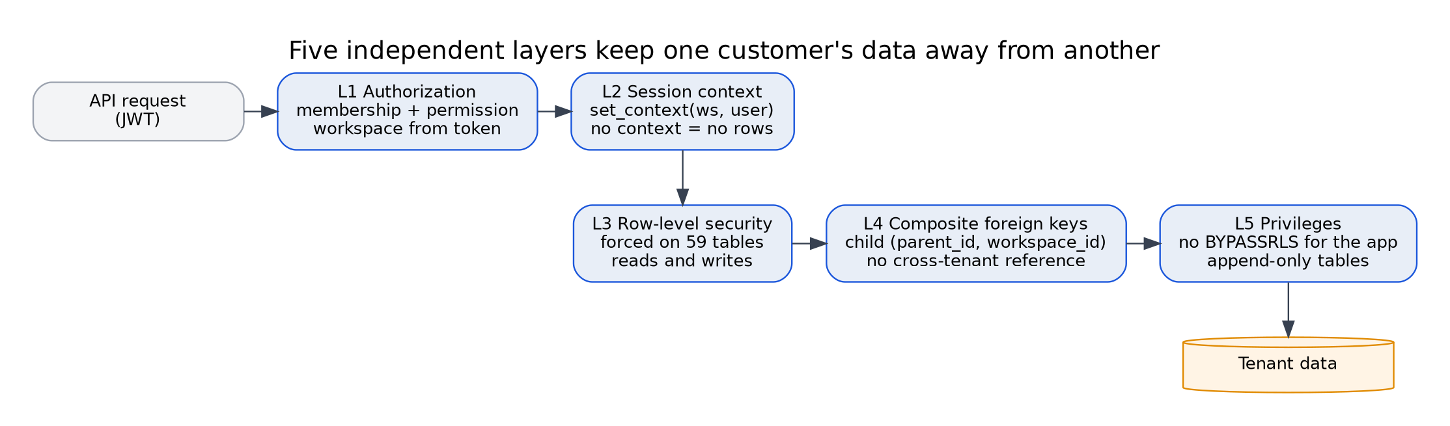
Figure 1: The five isolation layers
Usage contract for code:
-- every request / job, inside ONE transaction
begin;
select app.set_context('<workspace uuid>', '<user uuid>'); -- transaction-local
-- ... all reads and writes ...
commit;

Warning: the context is transaction-local (set_config(..., true)). If a connection pooler in transaction mode is ever added, keep withTenant() as the only way to run queries so the context and the statements share one transaction. Do not use session-level settings.

4. Roles and privileges
Role | Login | Purpose | Can do | Cannot do
formiva_app (group) | via API login role | API runtime | SELECT, INSERT, UPDATE on tenant tables (RLS-limited); DELETE only on draft-editable tables (respondent_tokens, case_values while draft, form_fields and workflow nodes/edges while draft, role_permissions, delegations, webhook endpoints); call ops.workspaces_for_user, ops.resolve_respondent_token | Update or delete append-only tables; write global catalogs; bypass RLS; call queue-claim functions
formiva_worker (group) | via worker login role | Workers and scheduler | Same as app minus all DELETE; execute the claim and reaper functions; read ops.queue_health | Delete anything; write global catalogs
formiva_readonly | analyst login | Reporting | SELECT under RLS | Any write
formiva_ops | operator login | Model registry, plans, incidents, platform credentials, metrics | Write global catalogs and platform-level rows; read ops.queue_health | Read tenant data without setting a context
formiva_definer | never | Owns the privileged functions | Bypass RLS (BYPASSRLS) for six functions only | Log in
Migration admin | You, occasionally | Applies migrations | Everything | Must not be used by the application

Production creates LOGIN roles that inherit from these groups, with passwords from the secret store. Never connect the application as the migration admin or a superuser.

5. Table catalog
Mutability classes. M = mutable. A = append-only (trigger and privilege block update, delete and truncate). P = immutable once published. F = free to edit while the parent is a draft, frozen afterwards. S = state-machine controlled.

5.1 Identity, tenancy and access (7 tables)
Table | Purpose | Key constraints and indexes | Class
users | Projection of the Clerk identity (authentication only) | auth_subject unique, email unique (citext); RLS: self or co-member | M
workspaces | The tenant boundary; safe_mode default review_sensitive_actions | slug unique; status check; RLS: own row | M
roles | Per-workspace roles (seven system roles created by app.bootstrap_workspace) | (workspace_id, name) unique; (id, workspace_id) unique | M
permissions | Global catalog of 26 permission keys | Primary key key | M (ops only)
role_permissions | Role to permission mapping | PK (role_id, permission_key); composite FK to roles | M
workspace_members | Membership, status, role | PK (workspace_id, user_id); index (user_id, status) | M
workspace_counters | Race-free per-workspace counters (case numbers) via app.next_counter | PK (workspace_id, name) | M

System roles: owner (all), admin, reviewer, approver, integration_operator, auditor, viewer. A reviewer cannot approve; an approver cannot review or export audit; an auditor can read and export audit but cannot change anything (test T18).

5.2 Forms and public access (4 tables)
Table | Purpose | Key constraints and indexes | Class
form_templates | A named form | (workspace_id, key) unique | M
form_template_versions | Versioned compiled schema, privacy-notice version, SHA-256 | (template_id, version_number) unique; published requires published_at and hash; trigger blocks edits to published or retired versions | P
form_fields | Field definitions with sensitivity label | (version_id, field_key) unique; frozen when parent is published (T08f) | F
respondent_tokens | Public-link and resume tokens, hash only (32 bytes), expiry, revocation | token_hash unique with length check (T17d); partial index on expiry | M

5.3 Workflow definitions (6 tables)
Table | Purpose | Key constraints and indexes | Class
workflow_definitions | A named workflow with an active_version_id pointer | Trigger: pointer may only reference a published version (T08a) | M
workflow_versions | Versioned definition (config_json, SHA-256) | Published versions immutable and undeletable; only published to retired allowed (T08c-h) | P
workflow_nodes | 12 node types (used by the future visual editor) | (version_id, node_key) unique; frozen with parent | F
workflow_edges | Directed edges with conditions | FKs to nodes by (version_id, node_key); frozen with parent | F
workflow_dry_runs | Result of dry-run against fixtures | Never creates an interaction | A
workflow_publish_events | Publish, rollback, retire history | Actor, prior and new status, validation report | A

5.4 Cases, documents and evidence (9 tables)
Table | Purpose | Key constraints and indexes | Class
cases | The unit of business work; 16 states; sensitivity default sensitive | (workspace_id, case_number) unique; partial unique index on business_key; composite FKs to form and workflow versions; state-transition and approval-guard triggers | S
consent_records | Notice version, purpose, granted, IP hash (DPDP evidence) | Composite FK to case | A
case_participants | Respondent, reviewer, approver, owner; external contact encrypted | Composite FK | M
case_values | Submitted and corrected values as revisions; highly sensitive values ciphertext only | (case_id, field_key, revision) unique; CHECK: highly sensitive requires ciphertext and key id and no plaintext (T09a-b); frozen after submission, corrections insert a new revision (T10c-d) | F
retention_policies | Named retention rules per data kind | (workspace_id, name) unique; delete mode hard_delete, crypto_erase or anonymize | M
case_documents | File metadata: tenant-scoped object key, hash, class, subtype, status, sensitivity, retention, legal-hold flag. A trigger enforces the government-document policy (section 8.1) | (bucket, object_key) unique; SHA-256 length check; quarantined requires a reason; partial retention index | M
document_subtypes | Global catalog of 22 document subtypes (10 government-issued) with class, default sensitivity and description | Primary key key; read-only to runtime roles (T29c) | M (ops only)
document_type_policies | Per-workspace collection policy: mode (not collected, optional, required), require-masked, store-file, retain days, reveal permission, purpose | (workspace_id, doc_subtype) unique; CHECK Aadhaar requires masked; CHECK a collected type needs a purpose (T23, T24) | M
document_scans | Evidence of every file-safety check (ClamAV, magic sniff, PDF sanitizer, image limits, archive limits) | Composite FK | A

5.5 AI control plane (11 tables)
Table | Purpose | Key constraints and indexes | Class
ai_model_registry | Global list of candidate, approved, rejected and retired models with licence, digest, runtime, languages | (model_key, version) unique; approved requires approver and time (T15f) | M (ops only)
ai_benchmark_runs | Pre-registered thresholds plus measured p50, p95, peak memory, queue age, accuracy, calibration, failure rate, mixed-load flag, pass/fail | FK to registry | M (ops only)
routing_policies | Workspace policy versions (onboarding-v3) | (workspace_id, policy_version) unique | M
routing_policy_thresholds | Per class, language and action risk minimum confidence | CHECK: sensitive or irreversible risk can never allow auto-proceed (T12b); frozen when the policy is active (T12c) | P
ai_jobs | Durable AI work item with lease, attempts, backoff | (workspace_id, idempotency_key) unique (T07a); CHECK lease present exactly when claimed or running (T12d); partial indexes for ready and leased rows; state-transition trigger | S
ai_executions | One row per attempt, including failures: model, engine and OCR versions, timings, memory, error class | (ai_job_id, attempt_no) unique | M
ai_results | Structured model output: class, subtype, language, calibrated confidence, components, sensitivity, recommendation | One per execution; range check 0 to 1 | A
source_evidence | Page, region, text hash, optional redacted excerpt per result | Composite FKs | A
document_extractions | Extracted fields with confidence and evidence IDs; highly sensitive as ciphertext | Same CHECK as case values | A
document_validation_results | Deterministic rule outcomes with rule versions | Partial index on needs-review | A
routing_decisions | The backend's routing decision, reasons, thresholds applied, superseding link | (workspace_id, decision_key) unique | A

5.6 Review, approval and SLA (6 tables)
Table | Purpose | Key constraints and indexes | Class
review_tasks | Exception queue with lease, priority, due time, resolution and optimistic row_version | Partial queue index; resolved requires resolution, resolver and time; transition trigger | S
human_corrections | Previous and corrected value, reason (3 or more characters), approval context | Composite FKs | A
approvals | Decision per approver per step per round | Unique (case, step, approver, round); decided approvals are final (T11d); rejection requires a reason (T11e) | S
approval_delegations | Time-boxed delegation | Exclusion constraint: no overlapping windows per delegator (T12a) | M
sla_policies | Targets and escalation rules | (workspace_id, key) unique | M
sla_instances | Running SLA timers | Partial index on due time | M

5.7 Execution, integrations, billing (18 tables)
Table | Purpose | Key constraints and indexes | Class
workflow_executions | Runtime instance of a workflow version for a case | (workspace_id, business_key) unique | M
workflow_execution_steps | Durable step state with lease and retry counters | Lease CHECK; partial indexes; transition trigger | S
integration_connections | Provider connection with credential reference, scopes, health, safe-mode override, category | CHECK rejects values that look like pasted secrets (T09c); provider is free-form (lowercase key), not a fixed list (T31-T33) | M
connector_categories | Global catalog of 12 integration categories: ticketing, crm, hrms, lms, sis_university, spreadsheet, payments, messaging, webhook, identity, storage, other | Primary key key; read-only to runtime roles (T34b) | M (ops only)
connector_templates | Documented examples of free or open-source tools per category (Zammad, EspoCRM, Moodle, and more) — reference data only, never credentials | (category, name) unique | M (ops only)
integration_field_mappings | Versioned mapping per workflow version | Unique per connection, workflow version, version | M
integration_interactions | One row per intended business effect; safe-mode flag; lease | (workspace_id, idempotency_key) unique (T07b); statuses include in_flight, unknown, review; transition trigger | S
integration_executions | Every provider attempt: outcome, HTTP status, provider reference, redacted result | (interaction_id, attempt_no) unique; unique provider reference per workspace and provider | A
external_action_attempts | Effect ledger for every side effect (integration or internal); replay link | (workspace_id, idempotency_key) unique | M
notifications | Delivery history (queued, sent, delivered, bounced, complained, failed). Never proof that a business action succeeded | Partial queue index | M
webhook_endpoints | Customer outbound endpoints; HTTPS only; secret by reference | (workspace_id, name) unique | M
inbound_webhook_events | Clerk, Resend, Razorpay callbacks: replay protection and signature result | (provider, provider_event_id) unique | M
api_keys | Hash of key, prefix, scopes, expiry, revocation | key_hash unique, 32 bytes | M
service_credentials | Inventory of secrets for rotation (references only) | name unique; rotation due date | M
billing_plans | Free, Starter (INR 999), Vertical Pro (INR 2,999), Governance (INR 7,999); limits are placeholders | key unique | M (ops only)
subscriptions | Plan state including manual provider for early pilots | One live subscription per workspace (partial unique) | M
usage_events | Idempotent metering source of truth | (workspace_id, event_key) unique | M
usage_counters | Monthly aggregates | PK (workspace_id, period_start, metric) | M

app.record_usage() inserts the event and increments the counter once; a replay returns false and changes nothing (T07c-e).

5.8 Governance, audit and recovery (5 tables)
Table | Purpose | Key constraints and indexes | Class
legal_holds | Case, document or workspace hold with reason and release | Partial index on active holds | M
deletion_requests | Request, approval, execution, proof-of-deletion evidence, SLA due | Completed requires a completion time | M
incident_records | Severity, scope, actions, notifications, evidence references | Closed requires a closing time | M
dead_letter_items | Every exhausted or abandoned item, diagnosis, replay authorization | Replay states require an authorizing user and time | M
audit_events | Tamper-evident log, per-workspace hash chain | (workspace_id, chain_seq) unique; append-only (T05c-e); chain verified by function (T06) | A

6. State machines
Enforced by app.state_transitions and the enforce_transition trigger. Statuses listed with their permitted next states. Terminal states have none.

6.1 Cases
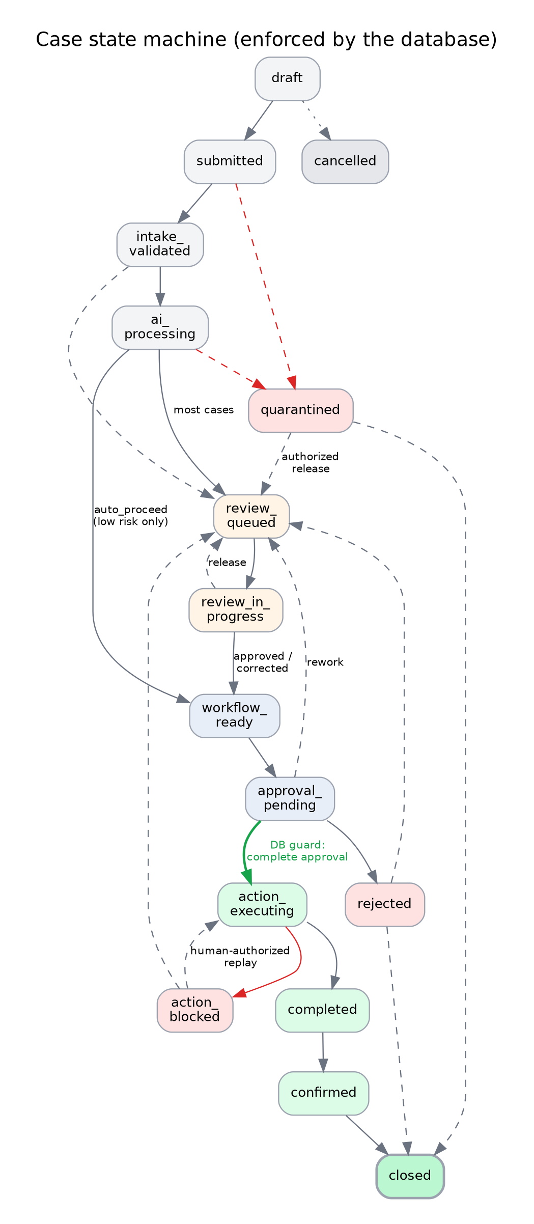
Figure 2: Case state machine as enforced by the database
From | To
draft | submitted, cancelled
submitted | intake_validated, quarantined, rejected, cancelled
intake_validated | ai_processing, review_queued, workflow_ready, quarantined, cancelled
ai_processing | review_queued, workflow_ready, quarantined, cancelled
review_queued | review_in_progress, quarantined, cancelled
review_in_progress | workflow_ready, review_queued, rejected, quarantined
workflow_ready | approval_pending, action_executing, cancelled
approval_pending | action_executing, rejected, review_queued, cancelled
action_executing | completed, action_blocked
action_blocked | action_executing (authorized replay), review_queued, cancelled
completed | confirmed
confirmed | closed
rejected | review_queued, closed
quarantined | review_queued (authorized release), closed, cancelled
closed, cancelled | none

Guard on entering `action_executing`: if the case sensitivity is sensitive or highly_sensitive (the default is sensitive), the latest approval round must contain at least one approved decision and no pending, rejected or rework-requested decisions (tests T11a-c).

6.2 AI jobs, workflow steps, integration interactions, review tasks
Entity | Transitions
AI job | created to queued; queued to claimed or cancelled; retrying to claimed or cancelled; claimed to running, queued, retrying or dead_letter; running to completed, review, retrying, failed or dead_letter; failed to review or dead_letter; dead_letter to queued (authorized replay); review to completed
Workflow step | pending to claimed or skipped; retrying to claimed; claimed to running, pending, retrying or dead_letter; running to succeeded, failed, retrying, waiting_approval, waiting_review or dead_letter; waiting states to succeeded, failed or skipped; failed to dead_letter; dead_letter to pending
Integration interaction | created to queued; queued to claimed or cancelled; claimed to in_flight, queued or failed_permanent; in_flight to succeeded, failed_transient, failed_permanent or unknown; failed_transient to queued or failed_permanent; unknown to succeeded or review only; review to queued, succeeded, failed_permanent or cancelled; failed_permanent to review or cancelled
Review task | open to claimed, cancelled or escalated; claimed to open, resolved, rejected, escalated or cancelled; escalated to open

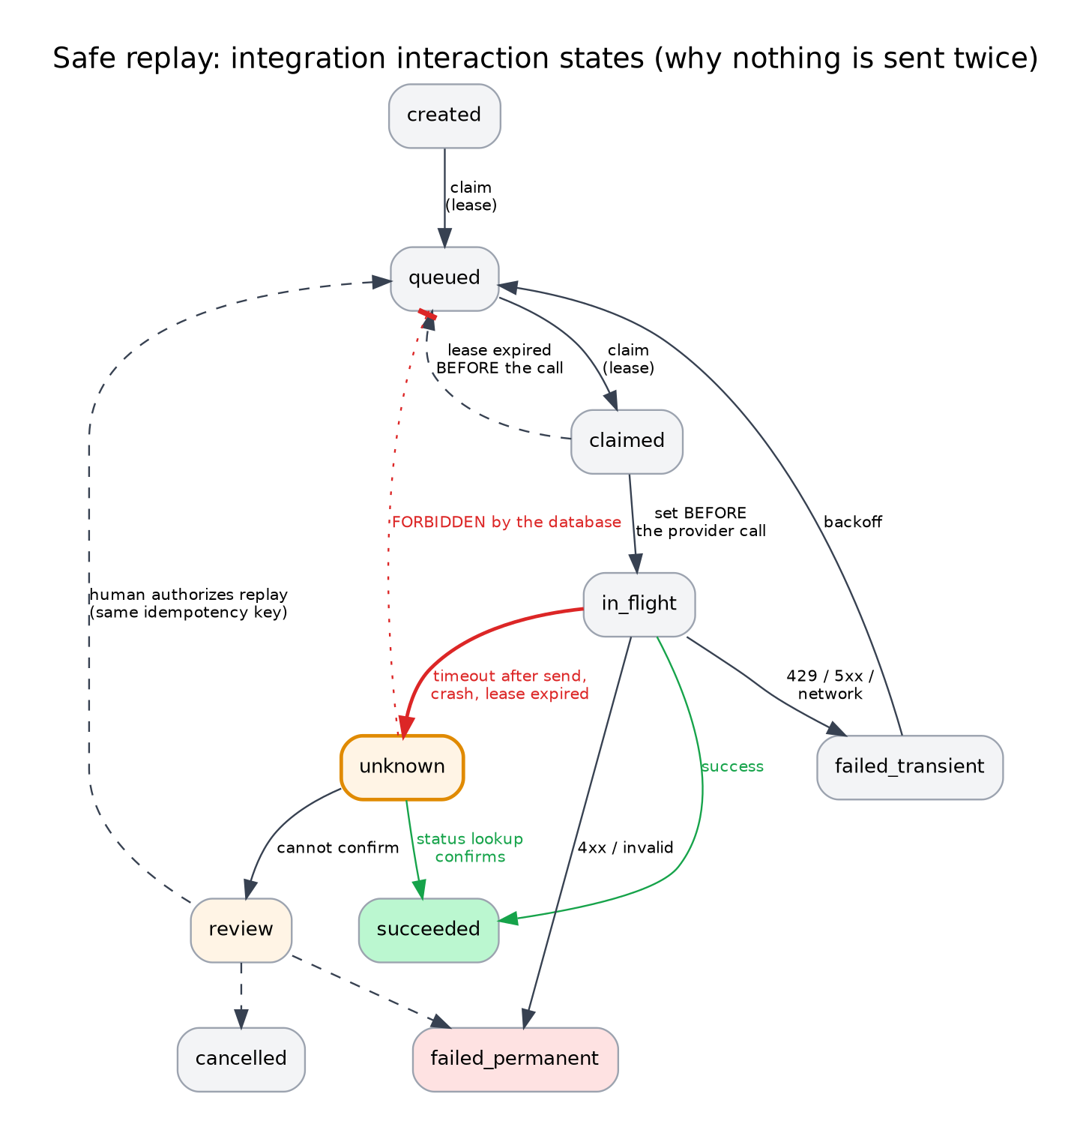
Figure 3: Integration interaction states
Decision: unknown can never move directly back to queued. An unknown outcome means a provider call may have been sent. The only paths out are a status lookup that confirms success, or a human review that authorizes a replay under the same idempotency key (tests T14g-i).

7. Transaction patterns
These are the patterns the API and workers must follow. Each is a single transaction unless noted.

7.1 Submission
withTenant(workspace, user) {
insert cases (status draft) -> update status submitted -- legal transition
insert case_values (revisions; highly sensitive = ciphertext + key_id + masked_preview)
insert case_documents (already scanned clean)
insert ai_jobs (status queued, idempotency_key = ws:case:doc:sha256:policy)
select app.audit('case.submitted', 'case', case_id, ...)
} -- nothing is published to any external queue; workers poll

7.2 Claiming work (worker)
-- no tenant context; runs as formiva_worker
select * from ops.claim_next_ai_job('worker-1', 300); -- returns (job_id, ws_id, case_id, ...)
-- then process inside withTenant(ws_id, null) and heartbeat by updating lease_until

The claim function selects one ready row with FOR UPDATE SKIP LOCKED, sets status claimed, lease owner, lease expiry and increments the attempt counter. Twelve concurrent sessions claimed ten jobs exactly once each (concurrency test).

7.3 Recording an AI result
withTenant(ws) {
insert ai_executions (attempt, model, versions, timings)
insert ai_results, source_evidence, document_extractions, document_validation_results
insert routing_decisions (decision_key unique) -- backend decision
insert review_tasks OR advance case + workflow step
update ai_jobs (running -> completed | review) -- lease cleared automatically
select app.audit('ai.result.recorded', ...)
}

7.4 Integration call (exactly-once guard)
1. insert integration_interactions (idempotency_key = caseId:notify:policyVersion) -- unique
2. claim (queued -> claimed), then set in_flight BEFORE calling the provider
3. call provider with the SAME idempotency key and a timeout
4. insert integration_executions (outcome), update interaction:
success -> succeeded | transient -> failed_transient -> queued (backoff)
permanent -> failed_permanent | unclear -> unknown -> lookup or review
5. if the process dies while in_flight, ops.requeue_expired_leases() marks it UNKNOWN

7.5 Human correction
withTenant(ws, reviewer) {
select review_tasks ... where id = $1 and row_version = $2 -- optimistic lock
insert human_corrections (previous, corrected, reason)
insert case_values (revision + 1, source human_correction)
insert routing_decisions (supersedes_id = previous)
update review_tasks (claimed -> resolved) ; audit
} -- the original ai_results / source_evidence rows are untouched

7.6 Approval and action
Insert approvals for the round, record decisions (final once decided; rejection needs a reason), then update the case to action_executing. The guard trigger refuses the update if approval is incomplete.

7.7 Audit
select app.audit(action, object_type, object_id, reason, payload, actor_type, actor_id, correlation_id) inserts an event. A trigger takes a per-workspace advisory lock, assigns the next chain_seq, links prev_hash and computes event_hash (SHA-256 over the previous hash and all event fields with a fixed UTC time format). app.verify_audit_chain(workspace) recomputes the chain and returns the first broken sequence number. Payloads must contain redacted metadata only.
Decision: anchor the chain: once a day the scheduler writes each workspace's latest hash to a write-once object in a different bucket (or emails it to the founder). Without an external anchor a database administrator could rewrite the whole chain consistently.

7.8 Creating a workspace
withTenant(newWorkspaceId, ownerUser) {
insert workspaces (id = newWorkspaceId, ...)
select app.bootstrap_workspace(newWorkspaceId, ownerUser); -- 7 roles, owner membership, audit
select app.seed_document_policies(newWorkspaceId); -- default government-document policy (employer edits it)
}

8. Sensitive data and encryption
Data class | Examples | Storage rule
Highly sensitive | ID numbers (Aadhaar, PAN, passport), bank account numbers | Ciphertext only (AES-256-GCM envelope), key_id, masked_preview (Aadhaar XXXX-XXXX-1234); enforced by CHECK; never logged; never in AI prompts beyond the engine's own scrubbed output
Sensitive | Names, dates of birth, addresses, employment and education details, document files | Access-controlled, masked in UI by default, may be encrypted per policy; file object keys are tenant-scoped
Confidential | Workflow definitions, integration mappings | Access-controlled
Internal / public | Form labels, published form structure | Standard

Envelope encryption (ADR-11). A master key stays outside the database (OCI Vault or a SOPS-encrypted key file, decision D-4). Each workspace has a data key, itself encrypted by the master key and stored with a key_id. Values are encrypted in the application with AES-256-GCM (random 96-bit nonce, workspace and field bound as associated data). Rotating the master key re-wraps data keys without touching values. Destroying a workspace data key (crypto-erase) makes every ciphertext for that scope unreadable.

8.1 Government documents in the database (migration 007)
Formiva reads government documents and extracts a few fields; it does not verify authenticity (Technical Documentation section 7.11). The database enforces the policy so that application mistakes cannot break it.
Rule | Where it is enforced | Test
A catalog of 22 document subtypes says which are government-issued (aadhaar, pan, passport, driving_licence, voter_id, uan_epf, esic, itr_ack, caste_community_certificate, police_verification) and their default sensitivity | document_subtypes | T20
A government document cannot be stored unless the workspace has a policy that allows it (fail closed) | Trigger on case_documents | T21, T26, T29d
An Aadhaar policy must require a masked copy | CHECK on document_type_policies | T23
Collecting any type requires a stated purpose (ten characters or more) | CHECK on document_type_policies | T24
Identity documents must be classified highly sensitive, and the class must match the subtype | Trigger | T25
Retention date is set automatically from the policy | Trigger | T27
AI results can only name a subtype that exists in the catalog | Foreign key | T28
Highly sensitive values are ciphertext only; Aadhaar is never stored in full, even as ciphertext (application rule; the AI Engine scrubs it) | CHECK plus AI Engine | T09
Policies are per tenant; the catalog cannot be edited by runtime roles | Row-level security and privileges | T29

Default policies are seeded by app.seed_document_policies(workspace): PAN required; Aadhaar, passport, driving licence, voter ID, UAN and ESIC optional; return-acknowledgement, caste or community certificate and police verification not collected. The employer edits them.

8.2 Generic connectors (migration 008, ADR-16)
The original schema listed six fixed providers. Since integrations must now reach "any other API" (ticket tools, CRM, HRMS, LMS, university/student-information systems, and more), migration 008 replaces the fixed list with:
- connector_categories — 12 categories (ticketing, crm, hrms, lms, sis_university, spreadsheet, payments, messaging, webhook, identity, storage, other), a global read-only catalog.
- connector_templates — documented, free or open-source examples per category (for instance Zammad or Freescout for ticketing, EspoCRM for CRM, Moodle for an LMS), so a non-developer has a starting point without a code search. This is reference data, not credentials, and not a guarantee that a tool's terms have not changed.
- integration_connections.provider is now a free-form lowercase key (CHECK ^[a-z][a-z0-9_]{1,39}$) instead of a fixed enum, with a new category column pointing at the catalog.
Every other rule for integrations is unchanged: one row per business effect, idempotency keys, safe mode, credential references only, and success/transient/permanent/unknown outcome classification (Section 7). A university or student-information system rarely exposes one standard API, so its default path is the generic signed-webhook or REST adapter (already built in Phase 9) rather than a named integration.

9. Retention, deletion and legal hold
Retention periods are legal and contractual decisions; the columns below are ready but the numbers are not set by this document. Record them in the decision log after counsel review.
Data | Where | Mechanism
Uploaded documents | case_documents.retain_until, retention_policies | Daily sweeper deletes the object and marks the row deleted unless legal_hold is true
Government identity documents | document_type_policies.retain_days, store_file | Retention date set automatically on insert (T27); store_file = false means extract, review, then delete the file; periods are decision D-6
Extracted evidence excerpts | source_evidence.redacted_excerpt | Deleted or nulled on the same schedule (excerpts are optional)
Case values, extractions | Cascade with case deletion or anonymization | Deletion request workflow
Audit events | Never deleted while the workspace exists | Contain hashes and metadata only, so they can survive personal-data deletion
Backups | R2 backups bucket | Lifecycle rules; deleted data ages out of backups; document this to customers

Deletion procedure: request (deletion.request), approval (deletion.approve), block if a legal hold exists, delete R2 objects, delete or anonymize rows, crypto-erase where designed, record proof (object keys, hashes, timestamps) in deletion_requests.evidence, audit the action. Deletion must not break the audit chain because audit payloads hold no personal data.

10. Performance and capacity
Volumes below are planning hypotheses for the pilots; measure and replace them.
Table | Pilot estimate (12 months) | Growth driver
cases | 1,000-10,000 | Hires per customer
case_documents | 8-12 per case | Document slots
ai_jobs, ai_executions, ai_results | About one per document, plus retries | Documents
audit_events | 30-60 per case | Every state change
integration_executions | 2-5 per case | Notifications

- Indexes: partial indexes serve the hot paths (ready jobs, leased jobs, open review tasks, running SLAs, unknown interactions, active legal holds). Add new indexes only from measured slow queries.
- Queue tables churn. Set aggressive autovacuum on ai_jobs, workflow_execution_steps and integration_interactions (for example autovacuum_vacuum_scale_factor = 0.02, fillfactor = 85); measure bloat monthly.
- Connections: a pool of 10-20 per service is plenty at pilot scale. max_connections = 60.
- Timeouts: statement_timeout = 15s, lock_timeout = 3s, idle_in_transaction_session_timeout = 30s for application roles; longer only for named maintenance jobs.
- Partitioning: not needed for the pilots. Revisit audit_events and ai_executions when either passes about 10 million rows or backups slow down. Partitioning by month and workspace hash is the likely design; the hash chain is per workspace so it partitions cleanly.
- Audit chain contention: the advisory lock serializes audit writes per workspace only. At pilot rates this is negligible; measure p95 audit insert time in Phase 7.
- Memory: PostgreSQL on VM1 with shared_buffers = 1 GB, effective_cache_size = 4 GB, work_mem = 16 MB as starting points on a 12 GB VM shared with the web app, API, workers and ClamAV. Tune from measurements.

11. Backup, restore and migration rules
Backups (Phase 10). Nightly logical backups (custom format), encrypted with age to a public key whose private half is offline, uploaded to the backups bucket with a manifest and checksum; every 6 hours during pilots. Point-in-time recovery with WAL archiving (pgBackRest or WAL-G) is a later option if the recovery point objective must be under 6 hours. Targets are hypotheses until drilled: RPO 6-24 hours, RTO 4-8 hours. A restore into an isolated database, followed by the SQL suites and the tenant negative tests, is a release gate.
Migration rules.
- Never edit an applied migration; add the next numbered file. The runner stores a checksum and refuses changed files.
- Prefer additive changes (expand, migrate data, contract in a later release).
- SET lock_timeout in every migration; create indexes with CONCURRENTLY in separate non-transactional files for large tables.
- Every new tenant table gets: workspace_id, UNIQUE (id, workspace_id) if it has children, composite FKs, call app.tenantize(...), and, if evidence, call app.append_only(...).
- Every new status column gets a transition set in app.state_transitions.
- Run both SQL suites in CI on every migration; add a test for every new invariant.

12. What the test suites prove
Test group | Assertions | Proves
T01-T04 | 9 | Cross-tenant reads are impossible, no context returns nothing, cross-tenant inserts and references are refused, user and workspace visibility is scoped
T05 | 7 | AI results, routing decisions and audit events cannot be updated, deleted or truncated, by trigger and by privilege
T06 | 4 | Audit chain verifies, tampering is detected, chains are independent per workspace
T07 | 5 | Idempotency for AI jobs and integration interactions; usage events count once
T08 | 8 | Published versions are immutable; active pointer only to published; rollback by pointer; retired cannot return to draft
T09-T10 | 8 | Highly sensitive plaintext refused; secret-looking references refused; illegal transitions refused; case values frozen after submission and corrected by revision
T11 | 5 | No sensitive action without approval; approvals are final; rejection needs a reason
T12 | 4 | Overlapping delegations refused; sensitive thresholds cannot auto-proceed; active policy frozen; lease consistency
T13 | 4 | Workers claim across tenants without context, each job once; API role cannot call claim functions
T14 | 9 | Expired leases retry, exhausted jobs dead-letter visibly, in-flight expiry becomes unknown, unknown never goes straight to queued
T20-T29 | 18 | Government documents: catalog of 22 subtypes with 10 government-issued; a government document without a workspace policy is refused; seeded defaults are idempotent; Aadhaar policy must require a masked copy; purpose is mandatory; identity documents must be highly sensitive and match their class; not-collected types are refused; retention date comes from the policy; unknown AI subtypes are refused; policies are isolated per tenant; runtime roles cannot edit the catalog
T15-T19 | 18 | Privilege matrix, model approval rule, login and token helpers, bootstrap roles, metrics view without tenant data
Race | 1 | 12 concurrent sessions claim 10 jobs exactly once each

13. Useful analytics queries (for Phase 11)
-- first-pass completeness and human-review rate per workspace (run as formiva_readonly with context)
select count(*) filter (where c.status in ('completed','confirmed','closed')) as finished,
count(*) filter (where exists (select 1 from review_tasks r where r.case_id = c.id)) as reviewed
from cases c where c.submitted_at >= now() - interval '30 days';

-- time from submission to workflow_ready (approximate, from audit)
select percentile_cont(0.5) within group (order by extract(epoch from (a2.occurred_at - a1.occurred_at))) as p50_s
from audit_events a1 join audit_events a2 on a2.object_id = a1.object_id
where a1.action = 'case.submitted' and a2.action = 'case.workflow_ready';

-- oldest ready job age per queue (operator, no tenant data)
select * from ops.queue_health;

14. Known limitations and open decisions
# | Item | Decision or action
DB-1 | PostgreSQL 16 has no built-in UUIDv7; IDs are random UUIDs, which spreads writes | Acceptable at pilot scale; revisit on upgrade
DB-2 | Payloads in audit_events, integration_executions.redacted_result and error_detail_redacted rely on the application to redact | Log-redaction tests in Phase 10; never put raw text in payloads
DB-3 | The six definer functions bypass row-level security by design | Reviewed and minimal; each has a fixed search_path; changes need reviewer approval
DB-4 | The audit chain is only tamper-evident if its head is anchored outside the database | Daily anchor job (section 7.7)
DB-5 | Retention periods, backup retention and deletion SLAs are not set | Counsel and founder decisions (D-6)
DB-6 | Row-level security adds planner overhead | Measure in Phase 7; the composite indexes lead with workspace_id where it matters
DB-7 | billing_plans.limits are placeholders | Set from pilot data
DB-9 | Policies are per document subtype, not per form slot; the web form must offer only the slots the policy allows | Enforced in the API and UI (Coding Plan Prompt 3.5)
DB-11 | connector_templates is reference data, not a guarantee that a listed tool's free tier or API has not changed | Verify each tool's current terms before connecting it (Technical Documentation Section 4.6.1)
DB-10 | Authenticity is not verified, by design | Format checks only; HR verifies through official portals (SOP)
DB-8 | No connection pooler | Not needed at this scale; if added, session-safety rules in section 3 apply

