Formiva CaseFlow Technical Documentation
Architecture, security, AI Engine, reliability and operations specification
Version 2.1
Prepared 20 September 2026
Replaces: Formiva Technical Documentation, CaseFlow Platform (2.0)
Companions: Database Plan v2.1, Coding Plan v2.1, Formiva_DB_v2.1 package
Revision 3: two separate OCI accounts, Netlify/Vercel frontend, generic connector framework, expanded use cases
Status: design specification; nothing in this document is deployed yet. Controls are labelled implemented in schema / planned / assessment-required

Contents
1. Purpose, scope and status
2. Decisions and what changed from 2.0
3. System architecture
3.1 Components and trust boundaries
3.2 Deployment topology and resource budgets
3.3 Network design
3.4 Submission-to-outcome data flow
4. Component specifications
4.1 Web application (Netlify free tier)
4.2 API (Fastify, VM1)
4.3 Worker and scheduler (VM1)
4.4 AI Engine (VM2)
4.5 File pipeline
4.6 Integrations
4.7 Visual workflow editor (Phase 8)
5. API surface (REST, OpenAPI 3.1)
6. Routing and state machines
7. Security architecture
7.1 Principles
7.2 Threat model
7.3 Authentication and authorization
7.4 Data classification and handling
7.5 Cryptography and key management
7.6 Secrets management
7.7 Host and network hardening checklist (VM1 and VM2)
7.8 Supply chain and CI/CD security
7.9 Logging and audit
7.10 Privacy: DPDP mapping (controls, not conclusions)
7.11 Government Documents Policy (ADR-14)
8. Reliability and operations
8.1 Failure analysis
8.2 Observability and alerts
8.3 Backup and disaster recovery
8.4 Capacity plan [Hypothesis]
8.5 Release and change control
8.6 Free-tier fit and fallback ladder (ADR-08)
9. Cost model [Verify every figure]
10. Test strategy
11. Assumption register
12. Open decisions
13. Appendices
Appendix A: port map
Appendix B: server directory layout
Appendix C: glossary

1. Purpose, scope and status
This document defines how Formiva CaseFlow is built, secured and operated: a multi-tenant service that takes an employee-onboarding submission and its documents through validation, AI-assisted reading, deterministic routing, human review, approval and one authorized action, leaving an audit trail that can be verified.
In scope: the proof of concept, the visual workflow editor (Phase 8), the integrations (Phase 9), hardening and the first paid pilots (Phases 0 to 11 of the PRD). Out of scope for launch: WhatsApp commerce, marketing sites, and education and other vertical packs as separate products. Baseline: free tiers and open-source software only, across two OCI accounts (ADR-08).
Use cases this design supports (Review document, Section 2.2):
- Employee onboarding — the launch wedge, built first end to end.
- Customer, client or vendor onboarding — opening an account for a new client, registering a supplier, light KYC-style intake; uses the same case/document/approval mechanism with new workflow definitions.
- Internal and external approvals — any sign-off (purchase, vendor onboarding, policy exception, budget, access request). "External" approvers reuse the respondent-token mechanism already built for public forms.
- Claims, applications and compliance intake (researched addition) — insurance claims, loan or credit applications, admissions or scholarship applications, audit evidence requests. Identical mechanism; documented reach, not a build target.
- Free integration with external systems — ticketing tools, CRMs, HRMS, LMS and university/student-information systems, and anything else reachable over HTTPS, through the generic connector framework (Section 4.6.1).
Status labels used throughout. [Schema] = enforced and tested in the delivered PostgreSQL schema. [Planned] = specified here, built in a named phase. [Assess] = needs a legal, security or vendor assessment before it can be claimed. [Verify] = a provider fact or number that must be checked at deployment. [Hypothesis] = a planning number to be replaced by a measurement.
Warning: this document does not claim compliance with any law or certification. It describes controls. Whether those controls satisfy your obligations as a data processor under the Digital Personal Data Protection Act, 2023 and its 2025 Rules is a question for counsel.

2. Decisions and what changed from 2.0
ADR | Decision | Effect on this document
ADR-01 | API, workers, PostgreSQL, ClamAV and optional Valkey on VM1 (2 OCPU / 12 GB / 200 GB, OCI account A); VM2 is AI-only (2 OCPU / 12 GB / 200 GB, OCI account B) | Topology, resource budgets, failure analysis
ADR-02 | REST with OpenAPI 3.1 | Section 5
ADR-03 | VM1 to VM2 over private VCN addresses with signed requests; Cloudflare Tunnel only for public ingress | Network design
ADR-04 | PostgreSQL job claiming with leases; Valkey optional | Worker design
ADR-05 | The visual workflow editor (Phase 8) and the integrations (Phase 9) are in scope; workflows are stored as versioned JSON | Sections 4.6, 4.7 and 5
ADR-08 | Free tier and open source only; free-tier fit check and fallback ladder | Cost model, section 8.6
ADR-09 | Customer document content only ever processed by the self-hosted AI Engine | AI section, privacy
ADR-11 | Envelope encryption for highly sensitive values | Crypto
ADR-12 | The AI Engine holds no cloud credentials and fetches nothing. The worker sends the verified document bytes over the private link | AI Engine contract v1.1, threat model
ADR-13 | The frontend is hosted on Netlify's free tier (commercial use is permitted on Netlify's free plan). Vercel Hobby is kept only as a non-commercial fallback, since its free plan excludes commercial use | Section 4.1, topology
ADR-15 | VM1 and VM2 sit in two separate OCI accounts and connect over two independent Cloudflare Tunnels rather than a private VCN; the AI Engine hostname requires a Cloudflare Access service token in addition to HMAC signing | Network design, threat model
ADR-16 | Generic connector framework (migration 008): providers are no longer a fixed list; a documented catalog covers ticketing, CRM, HRMS, LMS, university/SIS and other categories | Section 4.6.1
ADR-14 | Government Documents Policy. Formiva reads and extracts but does not verify authenticity; opt-in collection with a stated purpose; masked Aadhaar only | Section 7.11, threat model, database migration 007

3. System architecture

3.1 Components and trust boundaries
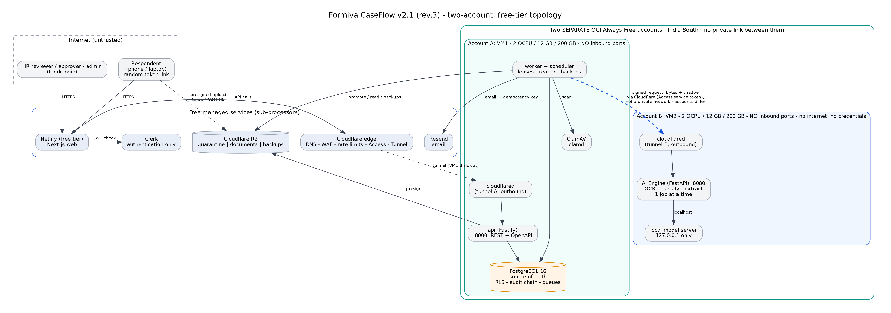
Figure 1: Deployment topology and trust boundaries (VM1 application and data, VM2 AI only, no inbound ports)

3.2 Deployment topology and resource budgets
Item | VM1 (application and data) — OCI account A | VM2 (AI) — OCI account B
Shape [Verify] | Ampere A1, 2 OCPU, 12 GB, 200 GB storage | Ampere A1, 2 OCPU, 12 GB, 200 GB storage
Public exposure | None. Outbound Cloudflare Tunnel. SSH only via Cloudflare Access or the OCI bastion service | None. Outbound Cloudflare Tunnel to its own private hostname, restricted by Cloudflare Access; SSH only via Access or bastion
Services | api, worker, scheduler, PostgreSQL, ClamAV, cloudflared, optional Valkey | ai-engine, local model server, cloudflared
Memory budget [Hypothesis] | PostgreSQL 2.8 GB, ClamAV 1.8 GB, worker 1.6 GB, api 1 GB, cloudflared 0.1 GB, OS and page cache 3.2 GB, headroom 1.5 GB | Small model 1-2.5 GB plus context 1 GB, OCR 1.5 GB, engine 0.5 GB, OS 1.5 GB, headroom at least 4 GB
Concurrency | Worker: AI jobs 2, steps 4, integrations 4 (env) | AI: 1 job at a time
Outbound internet | HTTPS to Cloudflare, R2, Resend, Clerk (JWKS) | None in normal operation; opened only in a maintenance window for OS updates and model files

Two VMs only. If measurements show VM1 or VM2 is short of memory, the answer is a smaller model, lower concurrency or more human review before it is a bigger VM, and any extra VM needs a recorded ADR.

3.3 Network design
Flow | From | To | Protocol and port | Control
Public web app | Internet | Netlify | HTTPS 443, Netlify's own edge | Netlify's free-tier CDN and TLS
Browser to API | Browser (page served from Netlify) | Cloudflare, then VM1 api | HTTPS | CORS allowlist of the Netlify production origin only; WAF and rate limits at Cloudflare
Admin SSH | Operator | VM1 or VM2 | Cloudflare Access SSH or OCI bastion (each account has its own) | Key only, no public port 22 on either VM
Database | api, worker | PostgreSQL | TCP 5432, compose network only | Not published on the host; role-based auth; TLS optional on the internal network
AI call | VM1 worker | VM2 ai-engine, via its own Cloudflare Tunnel hostname | HTTPS through Cloudflare (no private VCN available across accounts) | Cloudflare Access service token required (mTLS-equivalent) plus HMAC signature, timestamp and nonce; body size cap (ADR-15)
Model server | ai-engine | local model | 127.0.0.1:8081 | Not reachable from the network
Object storage | worker, api | R2 | HTTPS | Per-bucket tokens, least privilege, no public access
Email | worker | Resend | HTTPS | API key by reference; webhook signature verified

3.4 Submission-to-outcome data flow
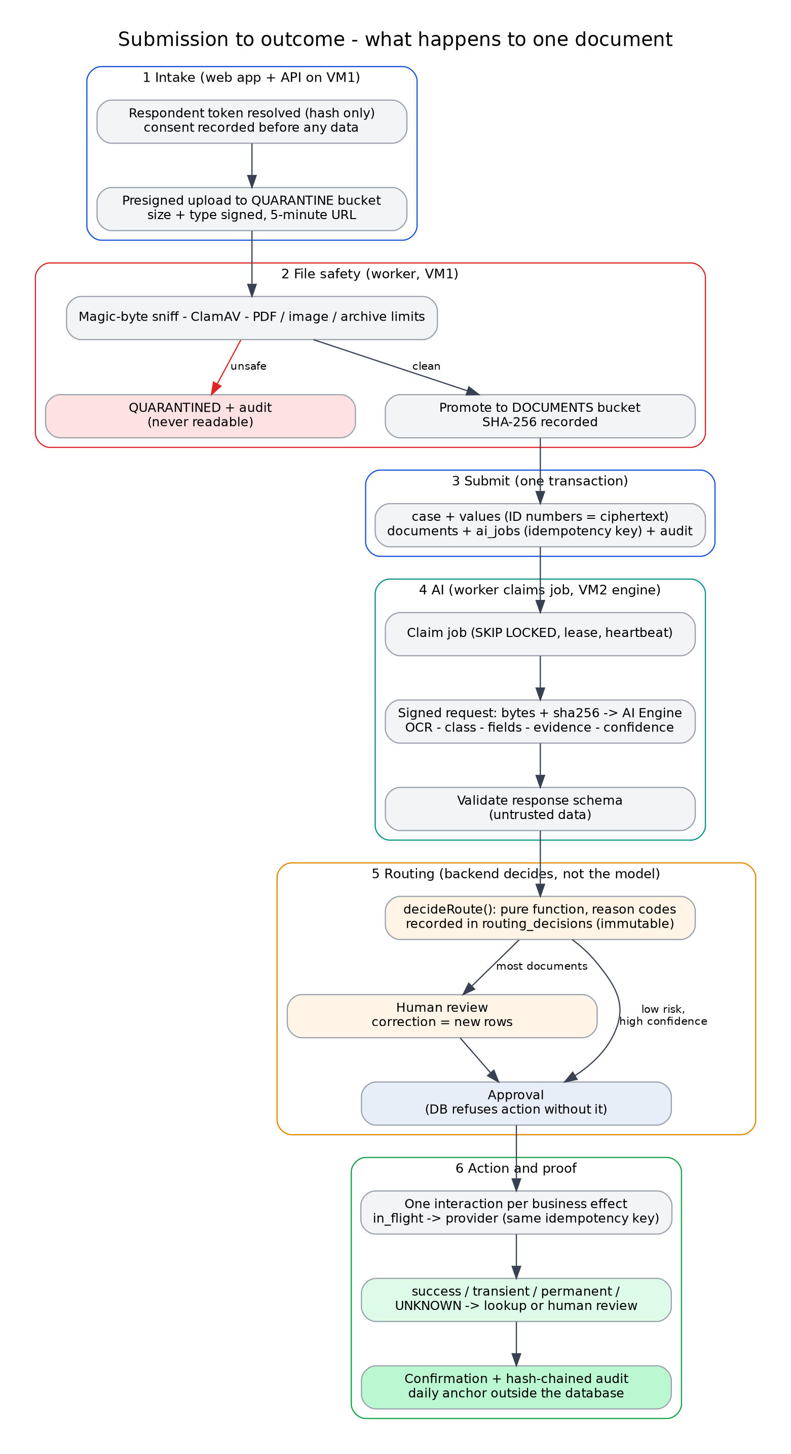
Figure 2: What happens to one document, from upload to audited outcome
- The respondent opens a link containing a random token, served by the Next.js frontend on Netlify. The API hashes it, resolves the workspace, form version and case through ops.resolve_respondent_token, and returns the published form. [Schema]
- Consent to the current privacy notice is recorded before any value is saved. [Schema: consent_records]
- For each document the API creates a case_documents row (pending; the database refuses any government document type that the workspace policy does not allow) and returns a short-lived presigned upload to the quarantine bucket with exact size and content type signed. [Planned Phase 3]
- The scanner worker downloads from quarantine, sniffs the type, runs ClamAV, applies PDF, image and archive limits, then promotes the file to the documents bucket or marks it quarantined. Every check writes document_scans. [Planned Phase 3]
- On submit, one transaction creates the case, values (highly sensitive values encrypted), documents and one ai_jobs row per document with a deterministic idempotency key, and writes the audit event. [Schema]
- A worker claims the AI job (ops.claim_next_ai_job), downloads the clean document, verifies its SHA-256 and sends bytes plus metadata to the AI Engine over its Cloudflare Tunnel hostname, with a Cloudflare Access service token and a signed request. [Schema for claiming; Planned Phase 5-6]
- The engine returns class, fields, language, confidence components, evidence references and reason codes. It never returns a full ID number. [Planned Phase 6]
- The worker validates the response schema, then in one transaction stores execution, result, evidence, extractions and validation results, calls the routing function, stores the decision, and either creates a review task or advances the case. [Schema for storage; Planned Phase 7 for routing]
- A reviewer resolves exceptions; a correction inserts new rows and a superseding routing decision, never overwriting the AI result. [Schema]
- An approver decides. The database refuses action_executing for a sensitive case without a complete approval. [Schema]
- The integration executor creates one interaction per business effect, marks it in flight, calls Resend with the same idempotency key, and records the outcome. An uncertain outcome becomes unknown and goes to lookup or human review. [Schema for states; Planned Phase 5]
- Delivery status is stored separately in notifications; the case moves to completed, confirmed and closed. [Schema]
- Every step appended to the hash-chained audit log; a daily job verifies chains and anchors the head hash outside the database. [Schema for chain; Planned anchor]

4. Component specifications

4.1 Web application (Netlify free tier)
Next.js App Router, deployed to Netlify's free tier (ADR-13: Netlify's free plan permits commercial use; Vercel's Hobby plan does not, so it is kept only as a non-commercial fallback for quick previews). Three surfaces: public respondent form (token in URL, no login), reviewer/approver console (Clerk login), and administration. Standards: mobile first; WCAG 2.1 AA target with automated axe checks; strict Content-Security-Policy (no inline scripts except hashed), frame-ancestors 'none', Referrer-Policy: no-referrer, X-Content-Type-Options: nosniff, HSTS; no personal data, document text or ID numbers in URLs, analytics or client logs; document viewing through a signed URL that expires in 60 seconds and is watermarked with the viewer's name; sensitive values masked by default with an audited reveal. Netlify's free tier gives separate deploy-preview and production contexts; preview never receives production secrets. Verify Netlify's current free-tier bandwidth and function-invocation limits before each major release (they can change).

4.2 API (Fastify, VM1)
Request pipeline (order matters): request ID and correlation ID, size limit, rate limit, authentication (Clerk JWT verified against JWKS: issuer, audience, expiry, authorized party), workspace selection (header is a selector validated against membership), permission check (fails closed), Zod validation of params, query and body, handler inside withTenant(), audit event, response validation (Zod) in test and staging.
Error model: RFC 9457 application/problem+json with type, title, status, a safe detail, correlation_id and field errors. 404 is returned for cross-tenant identifiers (no existence leak). 409 for state conflicts (for example incomplete approval). 429 with Retry-After. Internal diagnostics never appear in responses.
Idempotency: business keys (business_key, decision_key, integration idempotency_key) are the source of truth. POST endpoints that create work accept an Idempotency-Key header mapped to those keys.
Rate limits [Hypothesis]: public form endpoints per token and per IP; authenticated endpoints per user; stricter limits on upload requests and token resolution; Cloudflare rate-limit rules in front.

4.3 Worker and scheduler (VM1)
One binary, two roles. Worker: claims AI jobs, workflow steps and integration interactions; heartbeats leases; aborts work when a lease is lost; shuts down gracefully. Scheduler (exactly one instance):
Job | Cadence | Purpose
requeue_expired_leases | 60 s | Retry, dead-letter, or mark in-flight integrations unknown
Queue health snapshot | 5 min | Metrics and alerts
SLA breach check | 1 min | Escalations
Token and session cleanup | Daily | Expired respondent tokens
Retention sweeper | Daily | Delete documents past retention (no legal hold)
Audit-chain verification and anchor | Daily | Detect tampering; write head hash outside the database
Backup | Nightly, 6-hourly during pilots | Encrypted dump to R2
Backup age and restore-drill reminder | Daily / monthly | Alerts
Integration health checks | 15 min | Connection status
Usage rollup | Daily | Metering and billing
Credential rotation reminders | Daily | 14 days before due

4.4 AI Engine (VM2)
Purpose. Read one document and return structured, evidence-linked suggestions. It decides nothing.
Pipeline. (1) verify signature, size, hash and limits; (2) open the file safely; take the text layer per page if present; (3) for image-only pages, decode within pixel limits, deskew and denoise, run Tesseract (English, Hindi, Tamil); (4) detect language from script ratios; (5) classify with a constrained model output (class from an enumerated list or unknown); (6) extract per-class fields; drop any value that cannot be found in the OCR text; (7) compute confidence components; (8) scrub sensitive values; (9) return JSON and delete temporary files.
Limits (enforced before processing). [Hypothesis] max 10 MB, 20 pages, 25 megapixels, job timeout 240 s, one concurrent job, temp files on a size-limited tmpfs, memory limit through the container.
Prompt-injection and hallucination defences.
Risk | Defence
Document text tells the model to change behaviour | Text is passed as data inside delimiters; the system prompt states it is untrusted; output is grammar-constrained to a JSON schema with enumerated classes; the model has no tools and no network, so an injection can at most change a field value
Injection markers | Phrase heuristics set prompt_injection_suspected, which forces human review
Invented values | Each extracted value must be found (after normalisation) in the OCR text; ungrounded values are dropped and lower the evidence component
Over-confident scores | Confidence is the minimum of four components and is only trusted after per-class calibration; uncalibrated classes always route to review
Sensitive leakage | Values matching Aadhaar-like or account-like patterns are reduced to last-four before leaving the engine; nothing is logged except hashes and counts

Confidence. Components each 0 to 1: model (calibrated probability of the chosen class from token log-probabilities), ocr (evidence-weighted OCR quality), evidence (share of required fields grounded), rule_agreement (validators and keyword features agree). Overall = the minimum. Calibration: fit an isotonic or Platt mapping per class on the labelled corpus; store the calibration version and corpus hash; report reliability tables and expected calibration error. A class with too few labelled examples is uncalibrated. The 0.85 figure from the original design is a placeholder starting threshold for low-risk classes only; real thresholds come from the benchmark. [Hypothesis]
Model selection. One quantized model at a time, benchmarked on the pre-registered corpus on the real VM2 shape, under mixed load. Start with the smallest model that meets accuracy; record licence, digest, runtime and languages in the registry. Do not assume every size in a family shares a licence. Order-of-magnitude expectation only: a small quantized model (about 1.5 to 3 billion parameters) on two ARM cores generates a few to a dozen tokens per second, so a document may take one to several minutes end to end; that is acceptable for background processing and unacceptable for interactive use. Rules and OCR carry most of the work; the model is used only where rules are not enough. [Hypothesis] The benchmark decides.
Contract v1.1 (extends 2.0).
POST /v1/ai/jobs (multipart: "request" JSON + "document" bytes)
Headers: X-Formiva-Timestamp, X-Formiva-Nonce, X-Formiva-Signature
signature = HMAC-SHA256(secret, METHOD + PATH + timestamp + nonce + sha256(body))

request: { job_id, workspace_id, case_id, document_id, object_ref (label only), mime_type,
sha256, requested_tasks[ocr,language,classify,extract,route],
allowed_classes[identity,address,education,employment,bank,tax,photo,other],
allowed_subtypes[] (from the workspace document policy; never caste, community or police),
policy_version, safe_mode, trace_id }

response: { status, document_class, document_subtype, detected_language, confidence,
confidence_components{model,ocr,evidence,rule_agreement}, calibrated,
extractions[{field,value|null,sensitivity,confidence,evidence_refs[]}],
source_evidence_refs[{id,page,bbox,text_sha256}],
sensitivity, routing_recommendation, routing_reasons[],
prompt_injection_suspected, full_number_detected, format_checks[{name,result}],
model_id, model_version, model_digest,
ocr_runtime_version, engine_version, timings_ms, trace_id }

The backend validates every response (schema, class in the allowed list, confidence range, evidence present, ownership match, current policy version, duplicate job key) and recomputes the route itself. The engine's routing_recommendation is advisory.

4.5 File pipeline
Two buckets so that nothing unscanned is ever readable by the application flow: formiva-quarantine (write by presigned URL, read only by the scanner) and formiva-docs (written only by the scanner, read by workers and by signed viewing links). Object keys are tenant-scoped (ws/<workspace>/cases/<case>/<document>). Files are never served inline from the application domain; viewing uses short-lived signed links with Content-Disposition and a restrictive content type. Metadata (EXIF) is stripped by re-encoding images. Archives are always rejected.

4.6 Integrations
Every adapter implements: validateConfig, healthCheck, dryRun, execute, classifyError, lookupStatus, redact. Outcomes are success, transient, permanent or unknown. Adapters in scope: Resend (email, Phase 5), then signed outbound webhooks, Google Sheets and Razorpay (Phase 9). All use free tiers or free APIs.

4.6.1 Generic connector framework (ADR-16, migration 008)
The four launch adapters are examples of one interface, not a closed list. Migration 008 replaces the fixed provider list with a free-form key (lowercase letters, digits, underscore) plus a category (ticketing, crm, hrms, lms, sis_university, spreadsheet, payments, messaging, webhook, identity, storage, other) and a documented catalog (connector_templates) of specific free or open-source tools per category — for example Zammad or Freescout for ticketing, EspoCRM for CRM, Moodle for an LMS. A university or student-information system rarely has one standard API, so the default path for that category is the generic signed-webhook or REST adapter rather than a named integration.
Adding a new connector is: (1) add a row to connector_templates if it is a new named tool, (2) write one small adapter implementing the same interface as the existing adapters (validateConfig, healthCheck, dryRun, execute, classifyError, lookupStatus, redact), (3) map its fields in the visual workflow editor. No database migration is needed for a new adapter of an existing category. Every rule in Section 4.6 (idempotency, safe mode, credential references, outcome classification) applies to every connector, named or generic. Workspace safe mode overrides connectors: block_all_external, test_endpoints_only, review_sensitive_actions, off. Connection credentials are references to secrets. Provider callbacks (Clerk, Resend, Razorpay) are verified by signature and deduplicated by provider event ID [Schema: inbound_webhook_events].
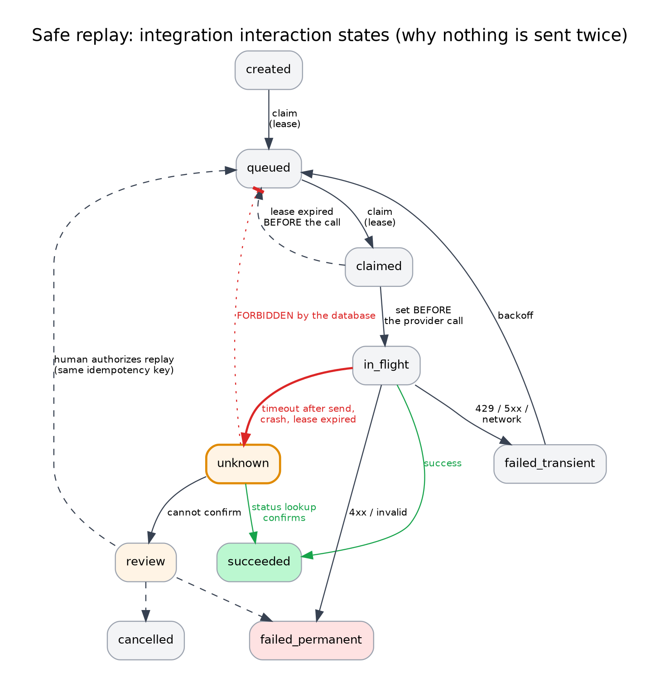
Figure 3: Integration interaction states. An unknown outcome can never return directly to the queue.

4.7 Visual workflow editor (Phase 8)
The editor is a graph editor in the web app (React Flow, MIT licence). It edits a draft and produces the same versioned JSON definition that the worker runs, so there is one format, not two. Limits that keep it safe and testable:
- Only the 12 node types (trigger, condition, deterministic check, AI-result check, human review, timer, approval, team route, notification, integration, record update, confirmation). No free-form code, scripts or expressions beyond a small validated condition language.
- A linter blocks publication when a definition has unreachable nodes, unbounded loops, a sensitive action without an approval, a missing error path, an unsupported connector scope, or a safe-mode conflict.
- A dry-run engine runs a draft against synthetic fixtures and records the matched conditions and intended actions. It can never create an executable integration interaction.
- Publishing creates an immutable version and a publish event. Rollback moves the active pointer to an earlier published version. Both need workflow.publish and are audited.
- Cases store the exact workflow version they ran on, so editing a workflow never changes a case in flight.

5. API surface (REST, OpenAPI 3.1)
All authenticated routes require a Clerk JWT and X-Workspace-Id (selector). Every route is listed in the OpenAPI document with its permission; CI fails if a route lacks security metadata.
Method and path | Auth | Permission | Notes
GET /public/v1/forms/{token} | Respondent token | none | Published form and notice version
POST /public/v1/cases/{token}/consent | Respondent token | none | Records consent before any data
PUT /public/v1/cases/{token}/values | Respondent token | none | Draft save (resume)
POST /public/v1/cases/{token}/uploads | Respondent token | none | Returns presigned quarantine upload
POST /public/v1/cases/{token}/submit | Respondent token | none | One transaction
GET /v1/me/workspaces | JWT | none | Uses ops.workspaces_for_user
POST /v1/workspaces | JWT | none | Bootstraps roles and owner
GET, POST, PATCH /v1/members | JWT | member.manage | Last owner protected
GET, POST /v1/forms; POST /v1/forms/{id}/versions; PUT .../fields; POST .../publish; POST /v1/forms/{id}/links | JWT | form.edit, form.publish | Published versions immutable
GET /v1/cases, /v1/cases/{id}, /v1/cases/{id}/timeline, /v1/cases/{id}/ai-results | JWT | case.read | Values masked by default
GET /v1/documents/{id}/view | JWT | case.read (document.read_sensitive to unmask) | Signed URL, audited
GET /v1/review-tasks; POST .../claim, .../release, .../resolve | JWT | case.review, case.correct | Optimistic lock
GET /v1/approvals; POST /v1/approvals/{id}/decide; POST /v1/delegations | JWT | case.approve | Rejection needs a reason
GET, POST /v1/integrations; POST .../health | JWT | integration.manage | Credential references only
POST /v1/interactions/{id}/replay; GET /v1/dead-letters; POST .../authorize-replay | JWT | integration.replay, deadletter.replay | Human-authorized only
GET, POST /v1/workflows; POST .../versions, .../lint, .../dry-run, .../publish, .../rollback | JWT | workflow.edit, workflow.publish | Published versions immutable; rollback moves the active pointer
GET, PUT /v1/document-policies; GET /v1/document-subtypes | JWT | workspace.manage (edit), case.read (read) | Government Documents Policy (section 7.11)
GET /v1/audit; POST /v1/audit/export | JWT | audit.read, audit.export | Includes chain verification result
POST /v1/deletion-requests; POST /v1/legal-holds; GET /v1/retention-policies | JWT | deletion.request, retention.manage | Proof recorded
GET, POST /v1/api-keys; PATCH /v1/workspace/safe-mode | JWT | apikey.manage, safe_mode.manage | Key shown once, hash stored
POST /webhooks/clerk, /webhooks/resend, /webhooks/razorpay, /webhooks/{connector} | Signature | none | Replay-protected; {connector} is any configured generic connector
GET /v1/connector-categories, /v1/connector-templates | JWT | integration.manage | Read-only catalog for the integrations screen
GET /healthz, /readyz, /metrics | Internal | none | Not exposed publicly
POST /v1/ai/jobs (VM2) | Signed request | none | Section 4.4

6. Routing and state machines
The routing decision is a pure backend function (Coding Plan, Prompt 7.1). It returns auto_proceed, human_review, quarantine, dead_letter or reject, with every applicable reason code. auto_proceed only means the case may enter the approval step. It requires: completed AI result, calibrated class within the allowed list, confidence at or above the class and language threshold, every component above the floor, sufficient evidence, all deterministic checks passed, no rule conflict, no injection flag, non-sensitive document and low-risk action, clean file, current policy, safe mode permitting, an idempotency key, and no duplicate or unknown outcome. Any single failure narrows the route to human review, quarantine or dead letter; a property test proves that no single failed condition can widen it.
Decision: expect most onboarding documents (identity, bank, tax) to route to human review. The product's value is fast, evidence-backed review with pre-filled fields and a complete audit trail, not blind automation. Price and sell it that way.

State machines for cases, AI jobs, workflow steps, integration interactions and review tasks are enforced by the database (Database Plan, section 6).

7. Security architecture

7.1 Principles
Least privilege; defence in depth; deny by default; fail closed; untrusted input everywhere (files, AI output, webhooks, the browser); evidence over trust; no secrets in code; reversibility; small blast radius (five isolation layers); every claim testable.

7.2 Threat model
ID | Threat | Mitigation | Verified by
T-01 | Cross-tenant access (IDOR) | Membership auth, tenant context, forced row-level security, composite FKs, no BYPASSRLS on app role | DB tests T01-T03; API suite generated from OpenAPI
T-02 | Forged or stolen JWT | JWKS verification with issuer, audience, expiry and azp; membership re-checked; short permission cache | Auth tests
T-03 | Guessing respondent tokens | 256-bit tokens, hash only, generic 404, rate limits, 7-day expiry, revocation | Token tests; T17
T-04 | Malware upload | Quarantine bucket, ClamAV, type sniffing, size and page limits, never served inline | Hostile corpus
T-05 | Decompression or pixel bombs | Limits before decode; archives rejected | Hostile corpus
T-06 | PDF active content | Reject JavaScript, embedded files, launch actions, XFA | Hostile corpus
T-07 | Polyglot or mislabelled files | Magic-byte sniffing, re-encode images, strip metadata | Hostile corpus
T-08 | Prompt injection through a document | Section 4.4 defences; human review on suspicion; model has no tools or network | Injection tests
T-09 | Hallucinated field values | Grounding check; evidence shown to reviewer | Grounding tests
T-10 | Model output causes approval | Backend recomputes route; database approval guard; sensitive thresholds cannot auto-proceed | Property tests; DB tests T11, T12
T-11 | SSRF via webhook URLs or file fetch | HTTPS only, block private and link-local ranges, no redirects, pinned DNS; AI Engine fetches nothing (ADR-12); applies to every generic connector, not only the named ones | SSRF tests
T-12 | Replay of signed requests | Timestamp window, nonce cache, HMAC over body hash | Contract tests
T-13 | Spoofed provider webhooks | Signature verification, event-ID dedupe | Webhook tests
T-14 | Duplicate business effects | Idempotency keys as unique indexes; effect ledger | DB tests T07; chaos tests
T-15 | Audit tampering or deletion | Append-only triggers and privileges; per-workspace hash chain; daily external anchor | DB tests T05, T06
T-16 | Database dump exposes ID numbers | Ciphertext for highly sensitive values; backups encrypted with an offline key | DB test T09; restore drill
T-17 | Secrets in repo, logs or AI tools | gitleaks, redacting logger, policy of never giving secrets to AI tools, .env blocked | CI; log redaction tests
T-18 | SSH brute force or credential theft | Key-only SSH, no public port 22, Access or bastion, fail2ban, MFA on all cloud accounts | Port scan; runbook
T-19 | Malicious dependency | Lockfiles, frozen installs, audit and osv scans, minimal dependencies, review of every new package | CI
T-20 | Privilege escalation | Permission catalog; last-owner guard; audit of role changes; separation of duties | API tests
T-21 | Denial of service on public paths | Cloudflare rate limits, size limits, per-token limits, bounded queues | Load tests
T-22 | AI resource exhaustion | One concurrent job, timeouts, container limits, queue age alerts | Benchmark
T-23 | Personal data in logs, URLs or analytics | Redacting logger, no PII in URLs, tests that search logs for fake IDs | Log tests
T-24 | XSS, CSRF, clickjacking | CSP, frame-ancestors 'none', framework output encoding, Clerk cookie protections, no inline document rendering | ZAP baseline
T-25 | CORS misconfiguration | Explicit origin allowlist | Header tests
T-26 | Backup theft or loss | age encryption, separate bucket credentials, off-VM copy, restore drill | Drill
T-27 | Unsafe connector action, including a newly added generic connector | Safe mode, approval guard, dry-run, human replay; the same rules apply regardless of category | Chaos tests
T-28 | Reviewer error or misuse | Masked by default, audited reveal, watermark, separation of duties, role-limited permissions | UI tests
T-29 | Exposure or misuse of government identity documents | Section 7.11: opt-in policy with purpose, masked Aadhaar, ciphertext ID numbers, restricted and audited reveal, no AI on special-category documents, Severity 1 incident | DB tests T20-T29; log-redaction tests

7.3 Authentication and authorization
Clerk authenticates; it never authorizes. Authorization is Formiva's: membership and role-permission rows in PostgreSQL, read through a definer function at login and cached for at most 30 seconds. Roles: owner, admin, reviewer, approver, integration_operator, auditor, viewer, with 26 permission keys. MFA is required for owners and admins (Clerk setting). API keys (later) are hashed and scoped.

7.4 Data classification and handling
Class | Examples | Handling
Highly sensitive | ID numbers, bank numbers | Ciphertext only, never logged, masked display, shortest retention
Sensitive | Names, dates of birth, addresses, employment and education records, uploaded documents | Access-controlled, masked by default, tenant-scoped storage, audited access
Confidential | Workflow definitions, mappings, credentials references | Role-limited
Internal | Metrics, queue counts | Operators
Public | Published form structure | None

7.5 Cryptography and key management
TLS 1.2+ everywhere externally. At rest: OCI block-volume encryption [Verify]; R2 encryption at rest [Verify]; application-level AES-256-GCM envelope encryption for highly sensitive values (per-workspace data keys wrapped by a master key kept outside the database, decision D-4); backups encrypted with age and an offline private key; HMAC-SHA256 for service-to-service and webhook signatures; SHA-256 for token and API-key storage and file hashes; constant-time comparisons. Rotation: data-key re-wrap on master rotation; HMAC keys with overlap; annual review of algorithms.

7.6 Secrets management
Secrets live in a secret store (OCI Vault or SOPS with age), are injected as files or environment variables at deploy time, are never in Git or logs, are inventoried in service_credentials with owner and rotation date, and are rotated on a schedule (Coding Plan, Prompt 10.2). The database holds references only. A pattern check rejects credential references that look like pasted keys. [Schema]

7.7 Host and network hardening checklist (VM1 and VM2)
# | Control | Status
1 | SSH key-only; PasswordAuthentication no; PermitRootLogin no; named operator; no NOPASSWD:ALL | [Planned P1-03] (current Server #1 uses password login and NOPASSWD:ALL and must be corrected first)
2 | No public inbound ports; access via Tunnel, Access or bastion | [Planned P1]
3 | firewalld default deny; NSG rules least privilege; VM2 reachable from VM1 only | [Planned P1]
4 | Automatic security updates; reboot window | [Planned P1]
5 | Containers: non-root, read-only root filesystem, dropped capabilities, no-new-privileges, resource limits, healthchecks | [Planned P1]
6 | SELinux left enforcing (Oracle Linux) with container policies | [Planned P1]
7 | auditd rules for SSH and sudoers changes; logs shipped off host | [Planned P10]
8 | Time synchronization; disk encryption confirmed | [Planned / Verify]
9 | MFA on both OCI accounts, Cloudflare, GitHub, Clerk, Resend, Netlify, Google, Razorpay, domain registrar | [Planned P1]
10 | Budget alert and a break-glass procedure for the founder account | [Planned P1]

7.8 Supply chain and CI/CD security
Pinned versions and lockfiles; --frozen-lockfile; Dependabot; pnpm audit, osv-scanner and pip-audit; semgrep; gitleaks; Trivy on images; SBOM generation per release; new dependencies require a stated reason and licence check; protected main with required checks and reviews; deployments only from tagged commits; production credentials never in CI; staging never receives production secrets.

7.9 Logging and audit
Application logs are JSON through a redacting logger (allowlist fields; never document text, ID numbers, tokens, cookies or credentials). Every request has a correlation ID that appears in the audit trail and the timeline. The audit log is the business record: append-only, hash-chained per workspace, with a verification function, exportable by the auditor role. Logs are rotated and kept for a documented period [Assess retention].

7.10 Privacy: DPDP mapping (controls, not conclusions)
Formiva will usually act as a data processor for its customers (employers are the data fiduciaries). Counsel must confirm roles, contract terms and obligations. Data-fiduciary obligations under the 2025 Rules are due to commence around 13 May 2027 [Verify with counsel].
Obligation area | Control in Formiva | Status
Notice and consent | Versioned privacy notice per form version; consent recorded before data capture | [Schema] tables; [Planned P3] UI
Purpose limitation and minimisation | Only onboarding fields; no typed ID numbers; identity via documents; retention per class | [Planned P3, P10]
Accuracy and correction | Human corrections with history | [Schema]
Security safeguards | Sections 7.1-7.9 | Partly [Schema], rest [Planned P1-P10]
Breach notification (72 hours per the Rules) | Incident record, SOP, contact list, evidence preservation | [Planned P10]; [Assess]
Erasure and retention | Retention policies, sweeper, deletion requests with proof, legal hold | [Schema] tables; [Planned P10]
Access and portability requests | Export by case and respondent | [Planned P10]
Children's data | Excluded at launch (no education vertical) | Scope decision
Cross-border transfer | Servers in India South; R2 location not India-only | [Assess] decision D-2
Processor agreement and sub-processors | Sub-processor list: Cloudflare, Clerk, Resend, Oracle, and (if enabled) Google and Razorpay | [Assess] counsel
Grievance redressal | Published contact and response process | [Planned]

Aadhaar and identity numbers. See section 7.11 (Government Documents Policy).

7.11 Government Documents Policy (ADR-14)
This section is the single, plain statement of how Formiva handles Aadhaar, PAN, passports and other government-issued documents. It is enforced by database migration 007 and by the AI Engine, not only by convention. [Schema] = enforced and tested.

7.11.1 What Formiva does, and what it does not do
Formiva does | Formiva does NOT do
Accept uploaded copies only if the employer's policy allows that document type and states why [Schema] | Verify that a document is genuine against any government source (UIDAI, income-tax PAN service, DigiLocker, Passport Seva, transport or election databases)
Scan the file, read it with OCR, classify the type, extract a few fields, and show the evidence to a human reviewer | Act as a KYC or eKYC provider, or run Aadhaar authentication (that needs a licence from the authority)
Run offline format checks (Aadhaar checksum, passport machine-readable-zone check digits, PAN and EPIC patterns) and report "format plausible" or "format invalid" | Decide that a person is who they say they are. A format check is not proof of authenticity
Route every government document to a human reviewer. It can never auto-proceed [Schema: highly sensitive documents never auto-proceed] | Say "verified" anywhere in the product. The wording is "received and read"
Keep an audit trail of every view, reveal, correction and deletion [Schema] | Use a paid verification service. Real verification is done by the employer's HR team through official free portals (checklist in the SOP), or by a licensed provider later (assessment-required, out of scope)

7.11.2 Document types and default handling
Defaults are starting templates seeded by app.seed_document_policies. The employer decides what to collect. Every collected type needs a stated purpose (minimum ten characters) [Schema].
Document type | Issued by | Default collection | What the AI Engine extracts | How it is stored and shown
Aadhaar | UIDAI | Optional. Masked copy only (first eight digits hidden) [Schema] | Name, date of birth, last four digits, "masked or not" | The full number is never stored, shown or logged. If a full number is visible in the image, the case goes to review with reason FULL_ID_NUMBER_VISIBLE and the person is asked for a masked copy. Last four digits displayed
PAN | Income-tax department | Required (payroll and tax deduction) | Name, date of birth, PAN | PAN stored as ciphertext (needed in full for payroll); last four displayed
Passport | Ministry of External Affairs | Optional | Name, date of birth, passport number, expiry, machine-readable-zone check result | Number as ciphertext; last four displayed
Driving licence | State transport authority | Optional | Name, date of birth, licence number, validity | Number as ciphertext; last four displayed
Voter ID (EPIC) | Election Commission | Optional | Name, EPIC number | Number as ciphertext; last four displayed
UAN / EPFO passbook | EPFO | Optional | UAN | UAN as ciphertext; last four displayed
ESIC card | ESIC | Optional | Insurance number | As ciphertext; last four displayed
Income-tax return acknowledgement | Income-tax department | Not collected by default | Assessment year, acknowledgement last four | Enable only with a documented need
Caste or community certificate | State authority | Not collected by default | No AI extraction at all | If enabled: stored as a restricted file; special-category data by our policy
Police verification certificate | Police | Not collected by default | No AI extraction at all | If enabled: restricted file, shortest retention
Education certificate, Form 16, bank documents, payslips, experience and relieving letters, offer letter, address proof, photo | Boards, universities, employers, banks | Employer's choice | Class-specific fields | Bank numbers as ciphertext; others sensitive

7.11.3 Handling rules
- Opt-in and purpose. No government document can be stored unless the workspace has a policy row that allows it and states a purpose. A missing policy refuses the upload (fail closed) [Schema].
- Highly sensitive by default. Identity documents are always classified highly sensitive; a lower classification is refused [Schema]. A document type must match its class (a PAN cannot be filed as an education document) [Schema].
- Aadhaar. The policy must require a masked copy [Schema]. The AI Engine reduces any 12-digit Aadhaar-like number to its last four digits before it leaves the engine. Full Aadhaar numbers are never held, even as ciphertext.
- Other ID numbers. Highly sensitive values are stored only as AES-256-GCM ciphertext with a key identifier, never as plaintext [Schema], and displayed as the last four digits.
- Viewing. Only roles with document.read_sensitive can reveal a value or open the file. Each reveal is audited, watermarked with the viewer's name and hides itself after 30 seconds.
- AI processing. The engine runs on VM2 with no internet access. OCR text is not stored (only hashes). Caste, community and police documents are never sent to AI extraction.
- Retention. Each policy has retain_days and a store_file switch (extract, review, then delete the file). The retention date is set automatically from the policy [Schema]. Periods are decisions for the employer and counsel (D-6); until set, nothing is deleted automatically, so set them before the first real pilot.
- Notice. The respondent notice lists each requested document, the purpose and the retention period. A document type that is not in the policy is not requested.
- Backups. Backups are encrypted; deleted documents age out of backups on the backup schedule, and customers are told so.
- Exposure. Loss or exposure of a government identity document is a Severity 1 incident (SOP), with the 72-hour breach-notification process.

7.11.4 What to confirm with counsel [Assess]
- Whether and how an employer may collect a masked Aadhaar for provident-fund and identity purposes, and how UIDAI's rules on storing and displaying Aadhaar numbers apply to a processor. The Supreme Court's 2018 Aadhaar judgment limited private-sector use of Aadhaar authentication, so treat any Aadhaar handling as a legal question, not only a technical one.
- The lawful basis and notice wording for each document type, and retention periods.
- Whether holding caste, community or police-verification documents is appropriate for a given customer.
- Formiva's role as data processor and the data-processing agreement.

7.11.5 Manual verification checklist for HR (free, outside Formiva)
Formiva never verifies authenticity. If an employer wants verification, its HR team can use the official government portals (Income Tax e-Filing portal for PAN, Parivahan for driving licences, the Election Commission voters' portal for EPIC, the EPFO member portal for UAN, Passport Seva for passports) or ask the employee to share verification through a government channel. Do not enter full ID numbers into Formiva, and do not collect an unmasked Aadhaar just to verify it. Record the outcome ("checked by HR, date, name") in the case notes; the record contains no ID number.

8. Reliability and operations

8.1 Failure analysis
Failure | Effect | Detection | Response | Target [Hypothesis]
Worker crashes mid-job | Lease expires; job retried once | Expired-lease metric | Reaper requeues; idempotency prevents a second effect | Automatic, under 5 min
Crash while an external call is in flight | Interaction unknown | Unknown-outcome metric | Status lookup, else human review; no blind retry | Same day
VM2 down or model too slow | AI jobs back up | Queue age, engine health | Cases route to human review after retries; documents remain collectable | Degrade, do not stop
VM1 down | API, workers, database offline | External uptime check | Restore VM from boot volume; else restore last backup to a new VM | RTO 4-8 h
Oracle stops, shrinks or reclaims a free-tier instance | Service down | Console, uptime alerts | Fallback ladder (section 8.6); restore the newest encrypted backup onto a new free instance | Hours
PostgreSQL corruption or accidental deletion | Data loss | Errors, drills | Restore from encrypted backup to isolated database, verify, cut over | RPO 6-24 h
Disk full | Writes fail | Disk alert at 80% | Clean logs, extend volume | Under 1 h
R2 outage | Uploads and viewing fail | Error rates | Retry; show respondent a friendly retry message | Provider-bound
Resend outage | Notifications delayed | Delivery metrics | Retries with backoff; unknown outcomes reviewed | Provider-bound
Clerk outage | Staff cannot log in; public forms still work | Auth errors | Wait; public intake unaffected | Provider-bound
Cloudflare Tunnel down | API unreachable | Uptime check | Restart cloudflared; alternate tunnel connector | Under 30 min
Bad release | Errors after deploy | Health gate, error rate | Roll back to previous image; forward-fix migrations | Under 30 min
Backup silently failing | No recovery point | Backup-age alert | Fix and re-run; drill | Under 26 h alert
Certificate or token expiry | Outage or auth failure | Expiry alerts | Rotate | Before due date
Runaway job or memory leak | Node starvation | Memory and queue alerts | Container limits restart; investigate | Automatic

8.2 Observability and alerts
Metrics from api, worker and engine plus ops.queue_health: oldest ready job age per queue, expired leases, dead letters, unknown outcomes, review backlog and oldest task, AI latency p50 and p95 and failure rate, backup age, disk and memory per VM, tunnel status, failed logins. Thresholds are set from the benchmark and the deployment decision record, not invented here. Alerts go by email with a runbook link; the founder is on call during pilots, with a stated response expectation to customers [Assess]. Every alert must be fired once in a test before the sensitive-pilot gate.

8.3 Backup and disaster recovery
Nightly and (during pilots) six-hourly encrypted logical backups to R2 plus a weekly copy to a second location (for example OCI Object Storage or a different R2 account); manifests with checksums and table row counts; offline private key with a documented custody plan; monthly restore drill into an isolated database with the SQL suites and tenant negative tests; documents-bucket inventory in each manifest. Because OCI can change or reclaim free-tier resources, treat the VM as disposable and the backup as the asset.

8.4 Capacity plan [Hypothesis]
Pilot volume is a few hundred to a few thousand cases and a few thousand documents. The bottleneck is AI throughput on two ARM cores: one document at a time. If the engine takes about two minutes per document, it processes about 30 per hour, so a customer submitting 20 cases of 8 documents at once creates a backlog of about five hours. Set customer expectations (results within hours, not seconds), throttle intake per workspace, let rules and OCR handle what they can, and measure the real number in Phase 6.

8.5 Release and change control
Trunk-based development; pull requests with required checks; staging (separate Compose project on VM1, synthetic data, own database and bucket prefix); tagged releases; migration first (expand-only), then API and worker images, then the web deployment; health gate after each step; rollback is the previous image tag; destructive schema changes only in a later release after the code stops using them; AI Engine and model promotion are separate releases recorded in the model registry with the benchmark run. Keep the three previous images on each VM.

8.6 Free-tier fit and fallback ladder (ADR-08)
Oracle's Always Free allowance was reported cut in June 2026 to 2 OCPU / 12 GB of Ampere compute in total, with 200 GB of block storage in total. The chosen baseline (two VMs of 2 OCPU / 12 GB) totals 4 OCPU / 24 GB, so it fits only if the tenancy still has the earlier allowance. Day-1 check: open the OCI console, note the compute limits, the storage limit and the state of Server #1, then choose the rung.
Rung | When | VM1 (account A) | VM2 (account B) | AI behaviour
1 (baseline) | Both accounts show 2 OCPU / 12 GB and 200 GB storage | 2 OCPU / 12 GB / 200 GB | 2 OCPU / 12 GB / 200 GB | Rules, OCR and a small model; results in minutes
2 (lite) | Either account is reduced below the baseline | Shrink proportionally (for example 1 OCPU / 6 GB) | Shrink proportionally | AI-lite: OCR and rules only, or a very small model in overnight batch; human review decides
3 (recover) | Oracle stops, shrinks, reclaims, or flags either account | Restore the newest encrypted backup onto a new free instance (same or a different account) | Rebuild from the container images and the model registry | Same as the rung that applies

Two Always Free accounts held by one person may fall outside Oracle's stated terms (commonly one Always Free account per person or verification method); that is worth checking directly with Oracle or your own reading of the terms — it is not something this design can confirm for you.
The two free AMD Micro instances (each a small fraction of a core with 1 GB) can run the uptime checker or a second tunnel connector; they are too small for anything else. The plan never adds a paid service silently: if none of the rungs is acceptable, the founder decides whether to pay.

9. Cost model [Verify every figure]
Item | Basis | Monthly
OCI compute and storage | Always Free Ampere A1 and 200 GB block storage (subject to the day-1 check) | INR 0
Web hosting | Netlify free tier (commercial use permitted) | INR 0
DNS, CDN, tunnels, access policies | Cloudflare free plan, two tunnels (one per OCI account) | INR 0
Authentication, email, file storage | Clerk, Resend and R2 free tiers at pilot volume | INR 0 (verify each limit)
Payments | Razorpay: no monthly fee; per-transaction fees are the customer's cost and are disclosed | INR 0 fixed
Google Sheets connector | Free API quota | INR 0
Monitoring and alert email | Free tiers | INR 0
Domain | vishyxtechie.in | about INR 1,000 per year

No paid infrastructure. The risk of this choice is not cost but continuity: free tiers can change and Oracle can reclaim capacity. Mitigations are encrypted off-server backups, the fallback ladder, a quarterly terms check for every provider and a restore drill. Variable cost per case (email, storage, reviewer minutes) is measured in Phase 11. Do not advertise zero-cost operation to customers.

10. Test strategy
Level | Tool | What it covers
Unit and property | Vitest, fast-check, pytest | Routing function (100% branch, invariants), crypto, parsers
Database | psql suites | 99 assertions plus concurrency race; extended with each migration
Integration | Vitest with real PostgreSQL | Transactions, claiming, integrations with fake providers
Contract | OpenAPI and AI contract validators | No drift between docs and code
End to end | Playwright | Respondent, reviewer, approver journeys; accessibility
Security | Generated IDOR suite, ZAP, hostile files, injection corpus, log redaction | Section 7.2
Chaos and reliability | Custom harness | Kills, duplicates, timeouts, 1,000 events
AI benchmark | Harness with pre-registered thresholds | Accuracy, calibration, latency, memory, mixed load
Recovery | Restore drill | Encrypted backup restored in isolation and verified

11. Assumption register
ID | Assumption | Evidence needed | Owner
A-1 | A small quantized model on VM2 can classify and extract onboarding documents accurately enough to save reviewer time | Phase 6 benchmark | Founder and reviewer
A-2 | Tesseract with English, Hindi and Tamil reads typical Indian onboarding documents adequately | Corpus results by language | Founder
A-3 | 2 OCPU and 12 GB suffice for VM1 at pilot volume | Load and memory measurements | Founder
A-4 | Oracle's Always Free allowance covers two VMs of 2 OCPU / 12 GB and 200 GB of storage | Day-1 console check (section 8.6) | Founder
A-8 | Two ARM cores give acceptable document turnaround in small-model or AI-lite mode | Phase 6 benchmark | Founder
A-5 | Customers accept results within hours | Pilot interviews | Founder
A-6 | Counsel confirms the processor model and controls are sufficient | Legal opinion | Counsel
A-7 | R2 or an alternative meets customers' data-location expectations | Decision D-2 | Founder

12. Open decisions
ID | Decision | Options | Needed by
D-8 | Free-tier fit: which rung of the fallback ladder applies | Day-1 console check | Week 1
D-1 | AI model and size | Benchmark candidates; smallest that passes | Week 7
D-2 | Document store location | Keep R2 (no India-only guarantee, so do not claim India residency) or use OCI Object Storage in the same India region through its S3-compatible API | Before first pilot
D-3 | Monitoring and alerting service | A free uptime and heartbeat service plus email; verify limits | Week 2
D-4 | Secrets and master-key custody | OCI Vault (verify free allowance) or SOPS with age | Week 2
D-5 | Counsel engagement | An Indian data-protection lawyer | By February 2027
D-6 | Retention periods, backup retention, deletion SLAs | Counsel and customer input | Phase 10
D-7 | Independent penetration test | Budget and provider | Phase 10

13. Appendices

Appendix A: port map
Host | Port | Service | Reachable from
VM1 | 8000 | api | cloudflared on the same host only
VM1 | 5432 | PostgreSQL | api and worker containers only
VM1 | 3310 | clamd | worker container only
VM2 | 8080 | ai-engine | Reachable only through VM2's own cloudflared, gated by Cloudflare Access (service token)
VM2 | 8081 | model server | 127.0.0.1 only

Appendix B: server directory layout
/opt/formiva/
compose/ docker-compose.yml, .env (from secret store), versions.lock
data/postgres/ named volume, owned by container user
backups/ staging area, encrypted before upload, cleaned after
logs/ rotated json logs
runbooks/ printed copies of the SOP procedures

Appendix C: glossary
Tenant: one customer workspace. Lease: a time-limited claim on a job. Idempotency key: a stable identifier that makes repeating an action safe. Dead letter: an item that exhausted retries and is kept visible. Unknown outcome: an external call that may or may not have happened. Safe mode: a workspace switch that limits connectors. Evidence: the page and region of a document that supports an extracted value.

