**Contact**

## Phone

+621248643810

## Email

[juliatheresiafonataba@gmail.com](mailto:juliatheresiafonataba@gmail.com)

## Linkedln

[juliafonataba](http://linkedin.com/in/julia-theresia-fonataba-763a152a0)

## Address

BSD, Tangerang Selatan, 15344

Julia Theresia Fonataba

Greetings, I’m an computer engineering major at Multimedia Nusantara University, Tangerang. I’m a self-motivated and responsible individual also eager to learn and grow.

# Education

**Multimedia Nusantara University, Tangerang *(2020 - Now)***

Faculty of engineering & informatics: Computer Engineering

**SMK NEGERI 1 KOTA SORONG, Sorong *(2018 - 2020)***

Faculty of engineering & informatics: Computer Engineering

Current GPA: 3.28

# Organizational Experience

**Skills**

## C Language MYSQL

**PHP Language Python Tableau**

## CSS

**Arduino**

## Computer Network

Association of Computer

**Engineering Students (ACES) *(January 2023 – December 2023)***

As the Secretary and Treasurer

**ACES *(January 2022 – December 2022)***

As a member of Public Relations Team.

**Pengenalan Prodi Teknik Komputer *(August, 2022)***

As a member of Documentation Team.

**GEAR *(March, 2021)***

As a member of LO & Registration Team

# Projects & Achievement

Final Project Deep Learning, Using Long-Short Term

## Linux

Memory and Gated Reccurent Unit to Predict Air Quality in Jakarta *(Grade: B+ )*

***(December, 2023)***

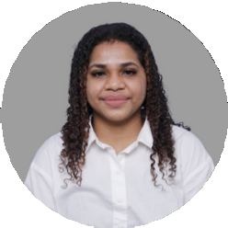

**Language**

Indonesia

English - Intermediate

Embedded System Design & Internet of Things: Developing Tools to Remotely Monitor Water Quality in Real-Time

ACES League (programming competencies) : Runner up

***( December, 2022)***

***( May, 2021)***