電通二甲微處理器實驗 實驗結報

實驗名稱 | Lab 06 – 音樂教室
組別 |  | 組員 | 06050464 朱峰志

- 實驗目的
如何使Arduino 發出特定旋律的聲音?
(1)Arduino接喇叭如何接線?
(2)如何使用 tone library?
(3)如何演奏一段音樂?
(4)如何使用4X4 鍵盤演奏音樂?
(5)如何發報摩斯密碼?
- 實驗步驟
- Arduino 演奏一段特定的音樂，旋律不得是小蜜蜂
- 使用 4X4 鍵盤演奏音樂
- 發報摩斯密碼
- 程式碼
(1)

#define MI 329
#define RE 294
#define DO 261
#define FA 349
#define WHOLE 1
#define HALF 0.5
#define QUARTER 0.25

int tune[] = {MI,RE,DO,RE,MI,MI,MI,RE,RE,RE,MI,MI,MI,MI,RE,DO,RE,MI,MI,MI,RE,RE,FA,RE,DO};

float duration[] = {QUARTER,QUARTER,QUARTER, QUARTER, QUARTER, QUARTER,HALF, QUARTER, QUARTER,HALF, QUARTER, QUARTER,HALF, QUARTER,QUARTER,QUARTER, QUARTER, QUARTER, QUARTER,HALF, QUARTER, QUARTER, QUARTER, QUARTER,WHOLE };
int length = sizeof(tune) / sizeof(tune[0]);
void setup() {
pinMode(8, OUTPUT);

}
void loop() {
for (int x=0; x<length; x++) {
tone(8, tune[x]);
delay(1300 *duration[x]);
noTone(8);
}
delay(5000);
}
(2)

#include <Keypad.h>
#define MI 329
#define RE 294
#define DO 261
#define FA 349
#define SO 392
#define LA 440
#define SI 493
#define DOH 523
#define REH 587
#define MIH 659
#define FAH 698
#define SOH 784
#define LAH 880
#define SIH 988
#define DOHH 1047
#define REHH 1175

int tune[] = {DO,RE,MI,FA,SO,LA,SI,DOH,REH,MIH,FAH,SOH,LAH,SIH,DOHH,REHH};
int n=0;
const byte ROWS = 4; // 4 Rows
const byte COLS = 4; // 4 Columns
char keys[ROWS][COLS] = {
{'7', '8', '9', 'C'}, {'4','5','6', 'D'},
{'1', '2', '3', 'E'}, {'0', 'A', 'B', 'F'}
};
byte rowPins[ROWS] = {2, 3, 4, 5};
byte colPins[COLS] = {9, 10, 11, 12};

Keypad keypad =Keypad( makeKeymap(keys), rowPins,colPins, ROWS, COLS );
void setup()
{
Serial.begin(9600);
}
void loop()
{
char key = keypad.getKey();
if (key != NO_KEY)
{
n = key - '0';
if(n>=0&&n<=9)
tone(8, tune[n],500);
else
{
if(key == 'A') tone(8, tune[10],500);
if(key == 'B') tone(8, tune[11],500);
if(key == 'C') tone(8, tune[12],500);
if(key == 'D') tone(8, tune[13],500);
if(key == 'E') tone(8, tune[14],500);
if(key == 'F') tone(8, tune[15],500);
}
}
}
(3)

char *morse[]={"01","1000","1010","100",
"0","0010","110","0000",
"00","0111","101","0100",
"11","10","111","0110",
"1101","010","000","1",
"001","0001","11","1001",
"1011","1100"};
char *ptr;
char index,chr;

void setup() {
pinMode(8,OUTPUT);
Serial.begin(9600);
}

void loop() {
if(Serial.available())
{
chr = Serial.read();
Serial.println(chr);
if((chr-'A')>=0 && (chr-'Z')<=0)
{
index = chr - 'A';
ptr = morse[index];

while(*ptr!='\0')
{
if(*ptr == '0')
{
tone(8,440,100);
delay(100);
}
else if(*ptr == '1')
{
tone(8,440,300);
delay(300);
}
ptr++;
delay(100);
}
delay(300);
}
}
}

- 實驗結果及分析
實驗一 : 順利地依照陣列設定好的頻率播出音樂
實驗二 : 鍵盤設定好之後也依照數字大小發出不同頻率的聲音
實驗三 : 利用指標來讀取要發長音或短音 然後用tone()函式設定發出的頻率跟持續時間
- 心得討論
第一個實驗找音樂找比較久，看不懂樂譜的我只好找同學來幫我
第二個實驗比較簡單一點所以很快就做完了

- 電路圖
(1)
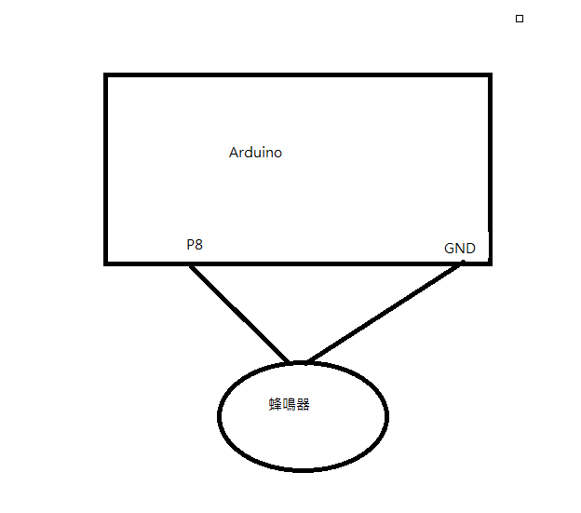

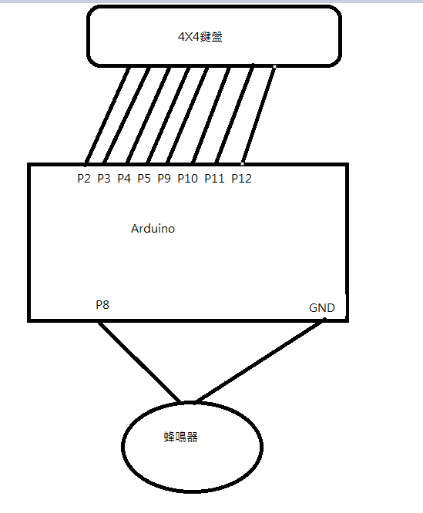
(2)

(3)

