電通二甲微處理器實驗 實驗結報

實驗名稱 | Lab 05 – 4X4鍵盤
組別 |  | 組員 | 06050464 朱峰志

- 實驗目的
  - 4X4鍵盤如何接線?
  - 如何使用Keyboard library?
  - 如何讀取鍵盤顯示數值?
  - 如何讓七段顯示器顯示鍵盤得輸入值?
- 實驗步驟
  - 4X4鍵盤之按鍵值經由串列傳輸，顯示在PC上
  - 4X4鍵盤之按鍵值顯示在七段顯示器上
- 程式碼
(1)
#include <Keypad.h>
#include "SevSeg.h"
SevSeg sevseg;
const byte ROWS = 4; // 4 Rows
const byte COLS = 4; // 4 Columns

char keys[ROWS][COLS] = {
{'C', '9', '8', '7'}, {'D','6','5', '4'},
{'E', '3', '2', '1'}, {'F', 'B', 'A', '0'}
};

byte rowPins[ROWS] = {5, 4, 3, 2};
byte colPins[COLS] = {12, 11, 10, 9};

Keypad keypad =Keypad( makeKeymap(keys), rowPins,colPins, ROWS, COLS );

void setup() {
Serial.begin(9600);
}

void loop() {
// put your main code here, to run repeatedly:
char key = keypad.getKey(); // Åª¨ú Keypad
if (key != NO_KEY)
Serial.println(key);

}
(2)
#include <Keypad.h>
#include "SevSeg.h"
SevSeg sevseg;
const byte ROWS = 4; // 4 Rows
const byte COLS = 4; // 4 Columns

char keys[ROWS][COLS] = {
{'C', '9', '8', '7'}, {'D','6','5', '4'},
{'E', '3', '2', '1'}, {'F', 'B', 'A', '0'}
};
byte rowPins[ROWS] = {5, 4, 3, 2};
byte colPins[COLS] = {12, 11, 10, 9};
Keypad keypad =Keypad( makeKeymap(keys), rowPins,colPins, ROWS, COLS );

void setup() {
// put your setup code here, to run once:
byte numDigits = 1;
byte digitPins[] = {6};
byte segmentPins[] = {13, 14, 15, 16, 17,8,7};

sevseg.begin(COMMON_CATHODE, numDigits, digitPins,segmentPins);
Serial.begin(9600);
}

void loop() {
// put your main code here, to run repeatedly:
char key = keypad.getKey();
if(key >='0'&& key <='9')
{
int n = key -'0';
sevseg.setNumber(n);
}
sevseg.refreshDisplay();
}

- 實驗結果及分析

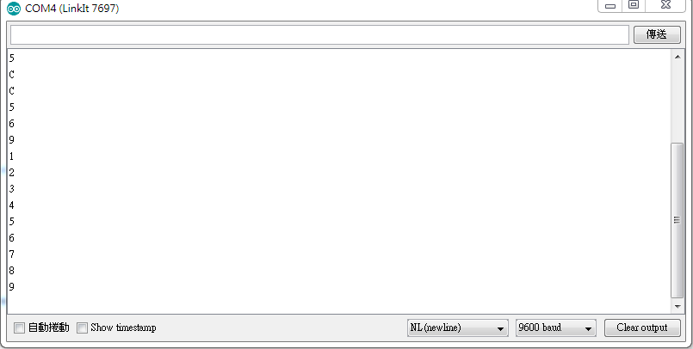
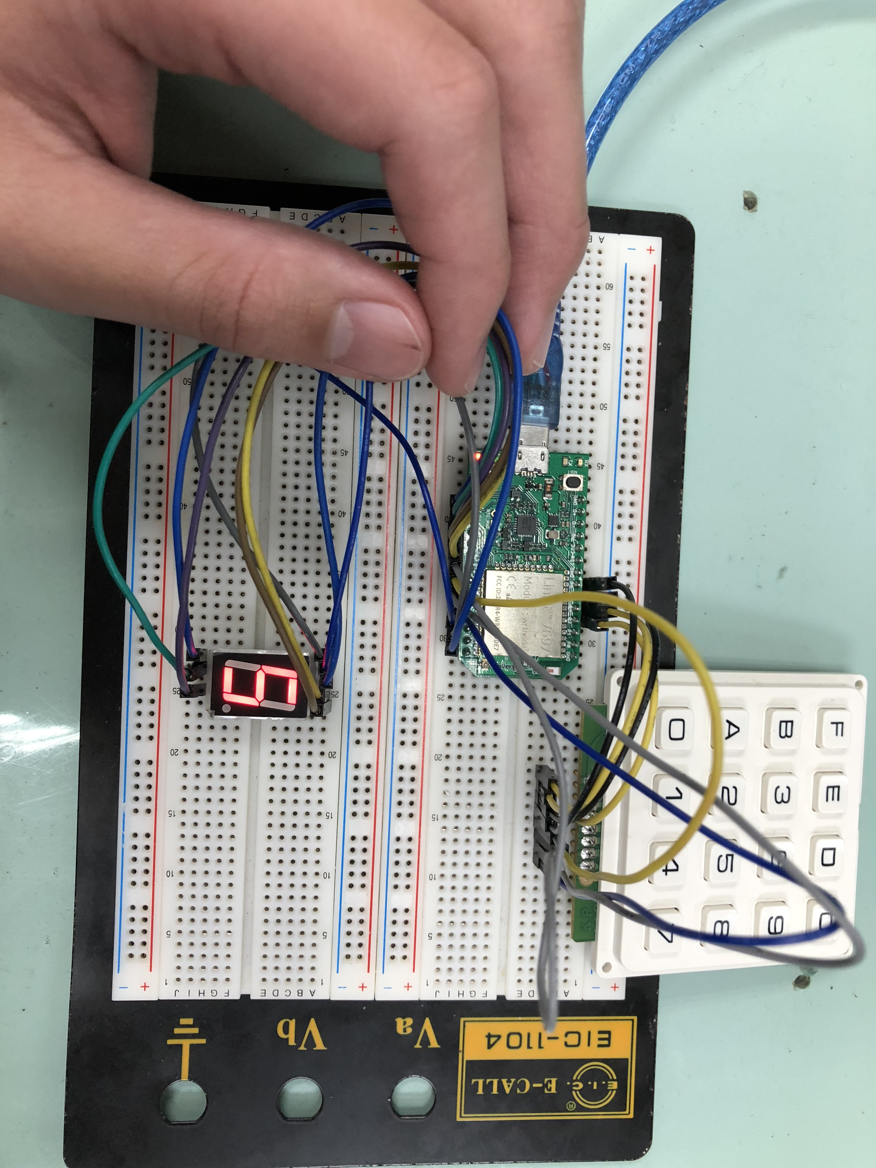
- 心得討論
這次的作業比較麻煩的地方就是要自己設定鍵盤按鈕 第二個實驗可以跟實驗四結合還蠻好玩的

6.電路圖
