電通二甲微處理器實驗 實驗結報

實驗名稱 | Lab 08 – 中斷控制與超音波測距
組別 |  | 組員 | 06050464 朱峰志

- 實驗目的
(1) 如何讀取超音波測距之值?
(2) 如何將超音波測距之值顯示於 LCD?
(3) Arduino 如何規劃外部中斷 INT0?
(4) 接一 SW, 當 SW 按下時暫停所有中斷, 實驗結果又如 何?
- 實驗步驟
- 讀取超音波測距之值並顯示在 LCD 上。
- 修改 int0() 程式碼, 於 int0 中執行超音波讀值，並將 結果顯示在 LCD 上。
- 觀察當 P6 按下時，按下 INT0 時之現象。
- 程式碼
(1)

#include <Ultrasonic.h>
#include <LiquidCrystal.h> // include the library code

LiquidCrystal lcd(12, 11, 5, 4, 3, 2); // initialize interface pins

#define TRIGGER_PIN 14
#define ECHO_PIN 13

Ultrasonic ultrasonic(TRIGGER_PIN, ECHO_PIN);
void setup()
{
lcd.begin(20, 2); // set up the LCD's number of columns and rows:
Serial.begin(9600);
}

void loop()
{
float cmMsec, inMsec;
long microsec = ultrasonic.timing();
cmMsec = ultrasonic.convert(microsec, Ultrasonic::CM); // 計算距離，
inMsec = ultrasonic.convert(microsec, Ultrasonic::IN); // 計算距離，單 Serial.print("MS: "); Serial.print(microsec);
Serial.print(", CM: "); Serial.print(cmMsec);
Serial.print(", IN: "); Serial.println(inMsec);
lcd.setCursor(0, 0);

lcd.print("CM: ");
lcd.print(cmMsec);
lcd.setCursor(0, 1);
lcd.print("IN: ");
lcd.print(inMsec);
delay(1000);

}

(2)
#include <Ultrasonic.h>
#include <LiquidCrystal.h> // include the library code

LiquidCrystal lcd(12, 11, 5, 4, 3, 2); // initialize interface pins

#define TRIGGER_PIN 14
#define ECHO_PIN 13

Ultrasonic ultrasonic(TRIGGER_PIN, ECHO_PIN);

volatile boolean state=LOW; //initial value of switch pin

void setup()
{

lcd.begin(20, 2); // set up the LCD's number of columns and rows:
Serial.begin(9600);
attachInterrupt(6, int0, RISING); //assign int0
}

void loop()
{

}
void int0()
{
float cmMsec, inMsec;

long microsec = ultrasonic.timing();
cmMsec = ultrasonic.convert(microsec, Ultrasonic::CM);
inMsec = ultrasonic.convert(microsec, Ultrasonic::IN);

Serial.print("MS: "); Serial.print(microsec);
Serial.print(", CM: "); Serial.print(cmMsec);
Serial.print(", IN: "); Serial.println(inMsec);

lcd.setCursor(0, 0);
lcd.print("CM: ");
lcd.print(cmMsec);
lcd.setCursor(0, 1);
lcd.print("IN: ");
lcd.print(inMsec);
delay(1000);
}

(3)
#include <Ultrasonic.h>
#include <LiquidCrystal.h> // include the library code

LiquidCrystal lcd(12, 11, 5, 4, 3, 2); // initialize interface pins

#define TRIGGER_PIN 14
#define ECHO_PIN 13

Ultrasonic ultrasonic(TRIGGER_PIN, ECHO_PIN);
volatile boolean state=LOW; //initial value of switch pin

void setup()
{

pinMode(15,INPUT);
lcd.begin(20, 2); // set up the LCD's number of columns and rows:
Serial.begin(9600);
attachInterrupt(6, int0, RISING); //assign int0
}
void loop()
{

state = digitalRead(15);
if(state)
interrupts();
else
noInterrupts();
}

void int0()
{
float cmMsec, inMsec;
long microsec = ultrasonic.timing();
cmMsec = ultrasonic.convert(microsec, Ultrasonic::CM);
inMsec = ultrasonic.convert(microsec, Ultrasonic::IN);

Serial.print("MS: "); Serial.print(microsec);
Serial.print(", CM: "); Serial.print(cmMsec);
Serial.print(", IN: "); Serial.println(inMsec);

lcd.setCursor(0, 0);
lcd.print("CM: ");
lcd.print(cmMsec);
lcd.setCursor(0, 1);
lcd.print("IN: ");
lcd.print(inMsec);
delay(1000);

}

- 實驗結果及分析
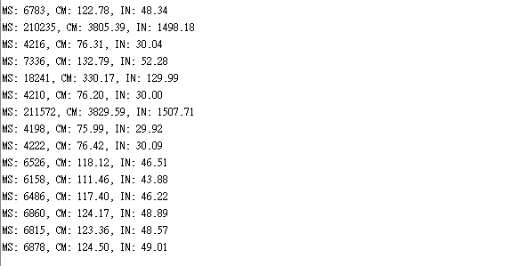
- 心得討論

中斷有點不懂

- 電路圖
