電通二甲微處理器實驗 實驗結報

實驗名稱 | Lab 12 - 溫濕度感應器
組別 |  | 組員 | 06050464 朱峰志

- 實驗目的
使用溫濕度感應器
- 實驗步驟
- 讓感測器一直量測溫度
- 用Timer讓感測器1秒測量一次
- 10秒量測一次溫濕度傳到MCS
- 程式碼
#include "DHT.h"

#define DHTPIN 2 // Digital pin connected to the DHT sensor
#define DHTTYPE DHT11 // DHT 22 (AM2302), AM2321
DHT dht(DHTPIN, DHTTYPE);

void setup() {
Serial.begin(9600);
Serial.println(F("DHTxx test!"));

dht.begin();
}

void loop() {
// Wait a few seconds between measurements.
delay(2000);
float h = dht.readHumidity();
float t = dht.readTemperature();
float f = dht.readTemperature(true);

// Check if any reads failed and exit early (to try again).
if (isnan(h) || isnan(t) || isnan(f)) {
Serial.println(F("Failed to read from DHT sensor!"));
return;
}

// Compute heat index in Fahrenheit (the default)
float hif = dht.computeHeatIndex(f, h);
// Compute heat index in Celsius (isFahreheit = false)
float hic = dht.computeHeatIndex(t, h, false);

Serial.print(F("Humidity: "));
Serial.print(h);
Serial.print(F("% Temperature: "));
Serial.print(t);
Serial.print(F("°C "));
Serial.print(f);
Serial.print(F("°F Heat index: "));
Serial.print(hic);
Serial.print(F("°C "));
Serial.print(hif);
Serial.println(F("°F"));
}
#include "Arduino.h"
#include "LTimer.h"
#include "DHT.h"

#define DHTPIN 2
#define DHTTYPE DHT11
DHT dht(DHTPIN, DHTTYPE);
int led0 = 7, led1 = 16, val0 = 0, val1 = 0;
float h, t, f;
LTimer timer1(LTIMER_1);
volatile int flag = 0;

void _callback1(void *usr_data)
{
flag = 1;
}
void setup()
{
dht.begin();
Serial.begin(9600);
timer1.begin();
timer1.start(1000, LTIMER_REPEAT_MODE, _callback1, NULL);
}
void loop()
{
if(flag)
{
float h = dht.readHumidity();
float t = dht.readTemperature();
float f = dht.readTemperature(true);
Serial.print(F("Humidity: "));
Serial.print(h);
Serial.print(F("% Temperature: "));
Serial.print(t);
Serial.print(F("°C "));
Serial.println(f);
flag = 0;
}
}
#include "DHT.h"
#include <LWiFi.h>
#include "LTimer.h"
#include "MCS.h"

#define DHTPIN 2
#define DHTTYPE DHT11

char _lwifi_ssid[] = "iPhone"; //wifi名稱
char _lwifi_pass[] = "19990718"; //wifi密碼

MCSDevice mcs("DRWIyesN", "sJWyFa0j9zaBwOHz"); // DeviceId , DeviceKey
MCSDisplayFloat Temperature("Temperature"); //設置資料型態 及 (MCS上的) 資料通道 Id: Temperature
MCSDisplayFloat Humidity("Humidity"); //設置資料型態 及 (MCS上的) 資料通道 Id: Humidity
LTimer timer1(LTIMER_1);
DHT dht(DHTPIN, DHTTYPE);
float h, t, f;
volatile int flag = 0;
void _callback1(void *usr_data)
{
flag = 1;
}
void setup()
{
Serial.begin(9600);
Serial.println("DHTxx test!");
dht.begin();

mcs.addChannel(Temperature); //設置到mcs上
mcs.addChannel(Humidity); //設置到mcs上
Serial.println("Wi-Fi 開始連線");
while (WiFi.begin(_lwifi_ssid, _lwifi_pass) != WL_CONNECTED) { delay(1000); }
Serial.println("Wi-Fi 連線成功");
while(!mcs.connected()) { mcs.connect(); }
Serial.println("MCS 連線成功");
timer1.begin();
timer1.start(10000, LTIMER_REPEAT_MODE, _callback1, NULL);
}

void loop()
{
while (!mcs.connected()) { //判斷是否還連線mcs
mcs.connect();
if (mcs.connected()) {
Serial.println("MCS 已重新連線");
}
}
mcs.process(1000);
if(flag)
{
float h = dht.readHumidity();
float t = dht.readTemperature();

if (isnan(t) || isnan(h)) {
Serial.println("Failed to read from DHT");
}
else {
Serial.print("Humidity: ");
Serial.print(h);
Serial.print(" %\t");
Serial.print("Temperature: ");
Serial.print(t);
Serial.println(" *C");
Temperature.set(t); //溫度上傳
Humidity.set(h); //濕度上傳
}
flag = 0;
}
}

- 實驗結果及分析
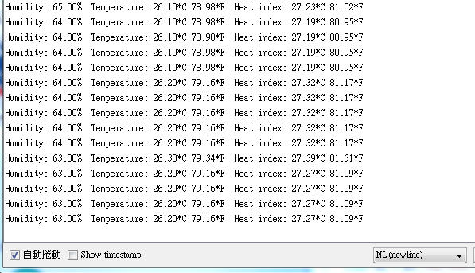
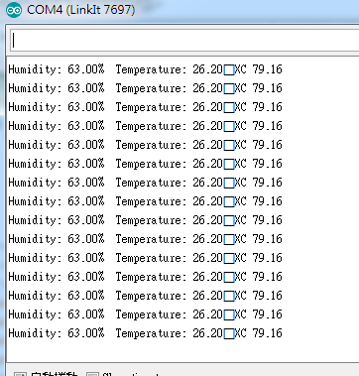
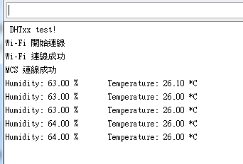
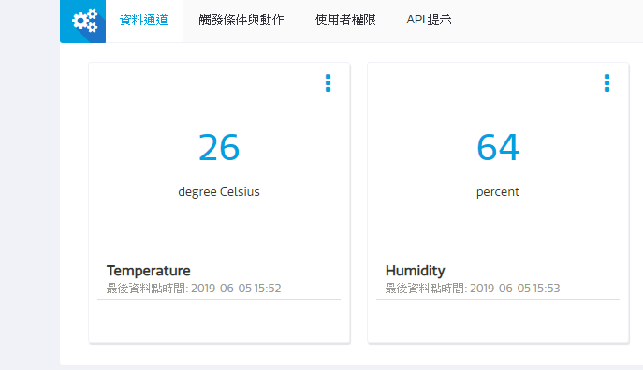

- 心得討論
這次實驗比較困難一點 快下課才做完

- 電路圖
