Navigator Portal Workshop — Day 3 Report & 3-Day Total Summary
Data Governance × Data Foundations Platform alignment · Seattle · July 21–23, 2026
Draft report · July 24,2026 ·
Prepared for workshop distribution

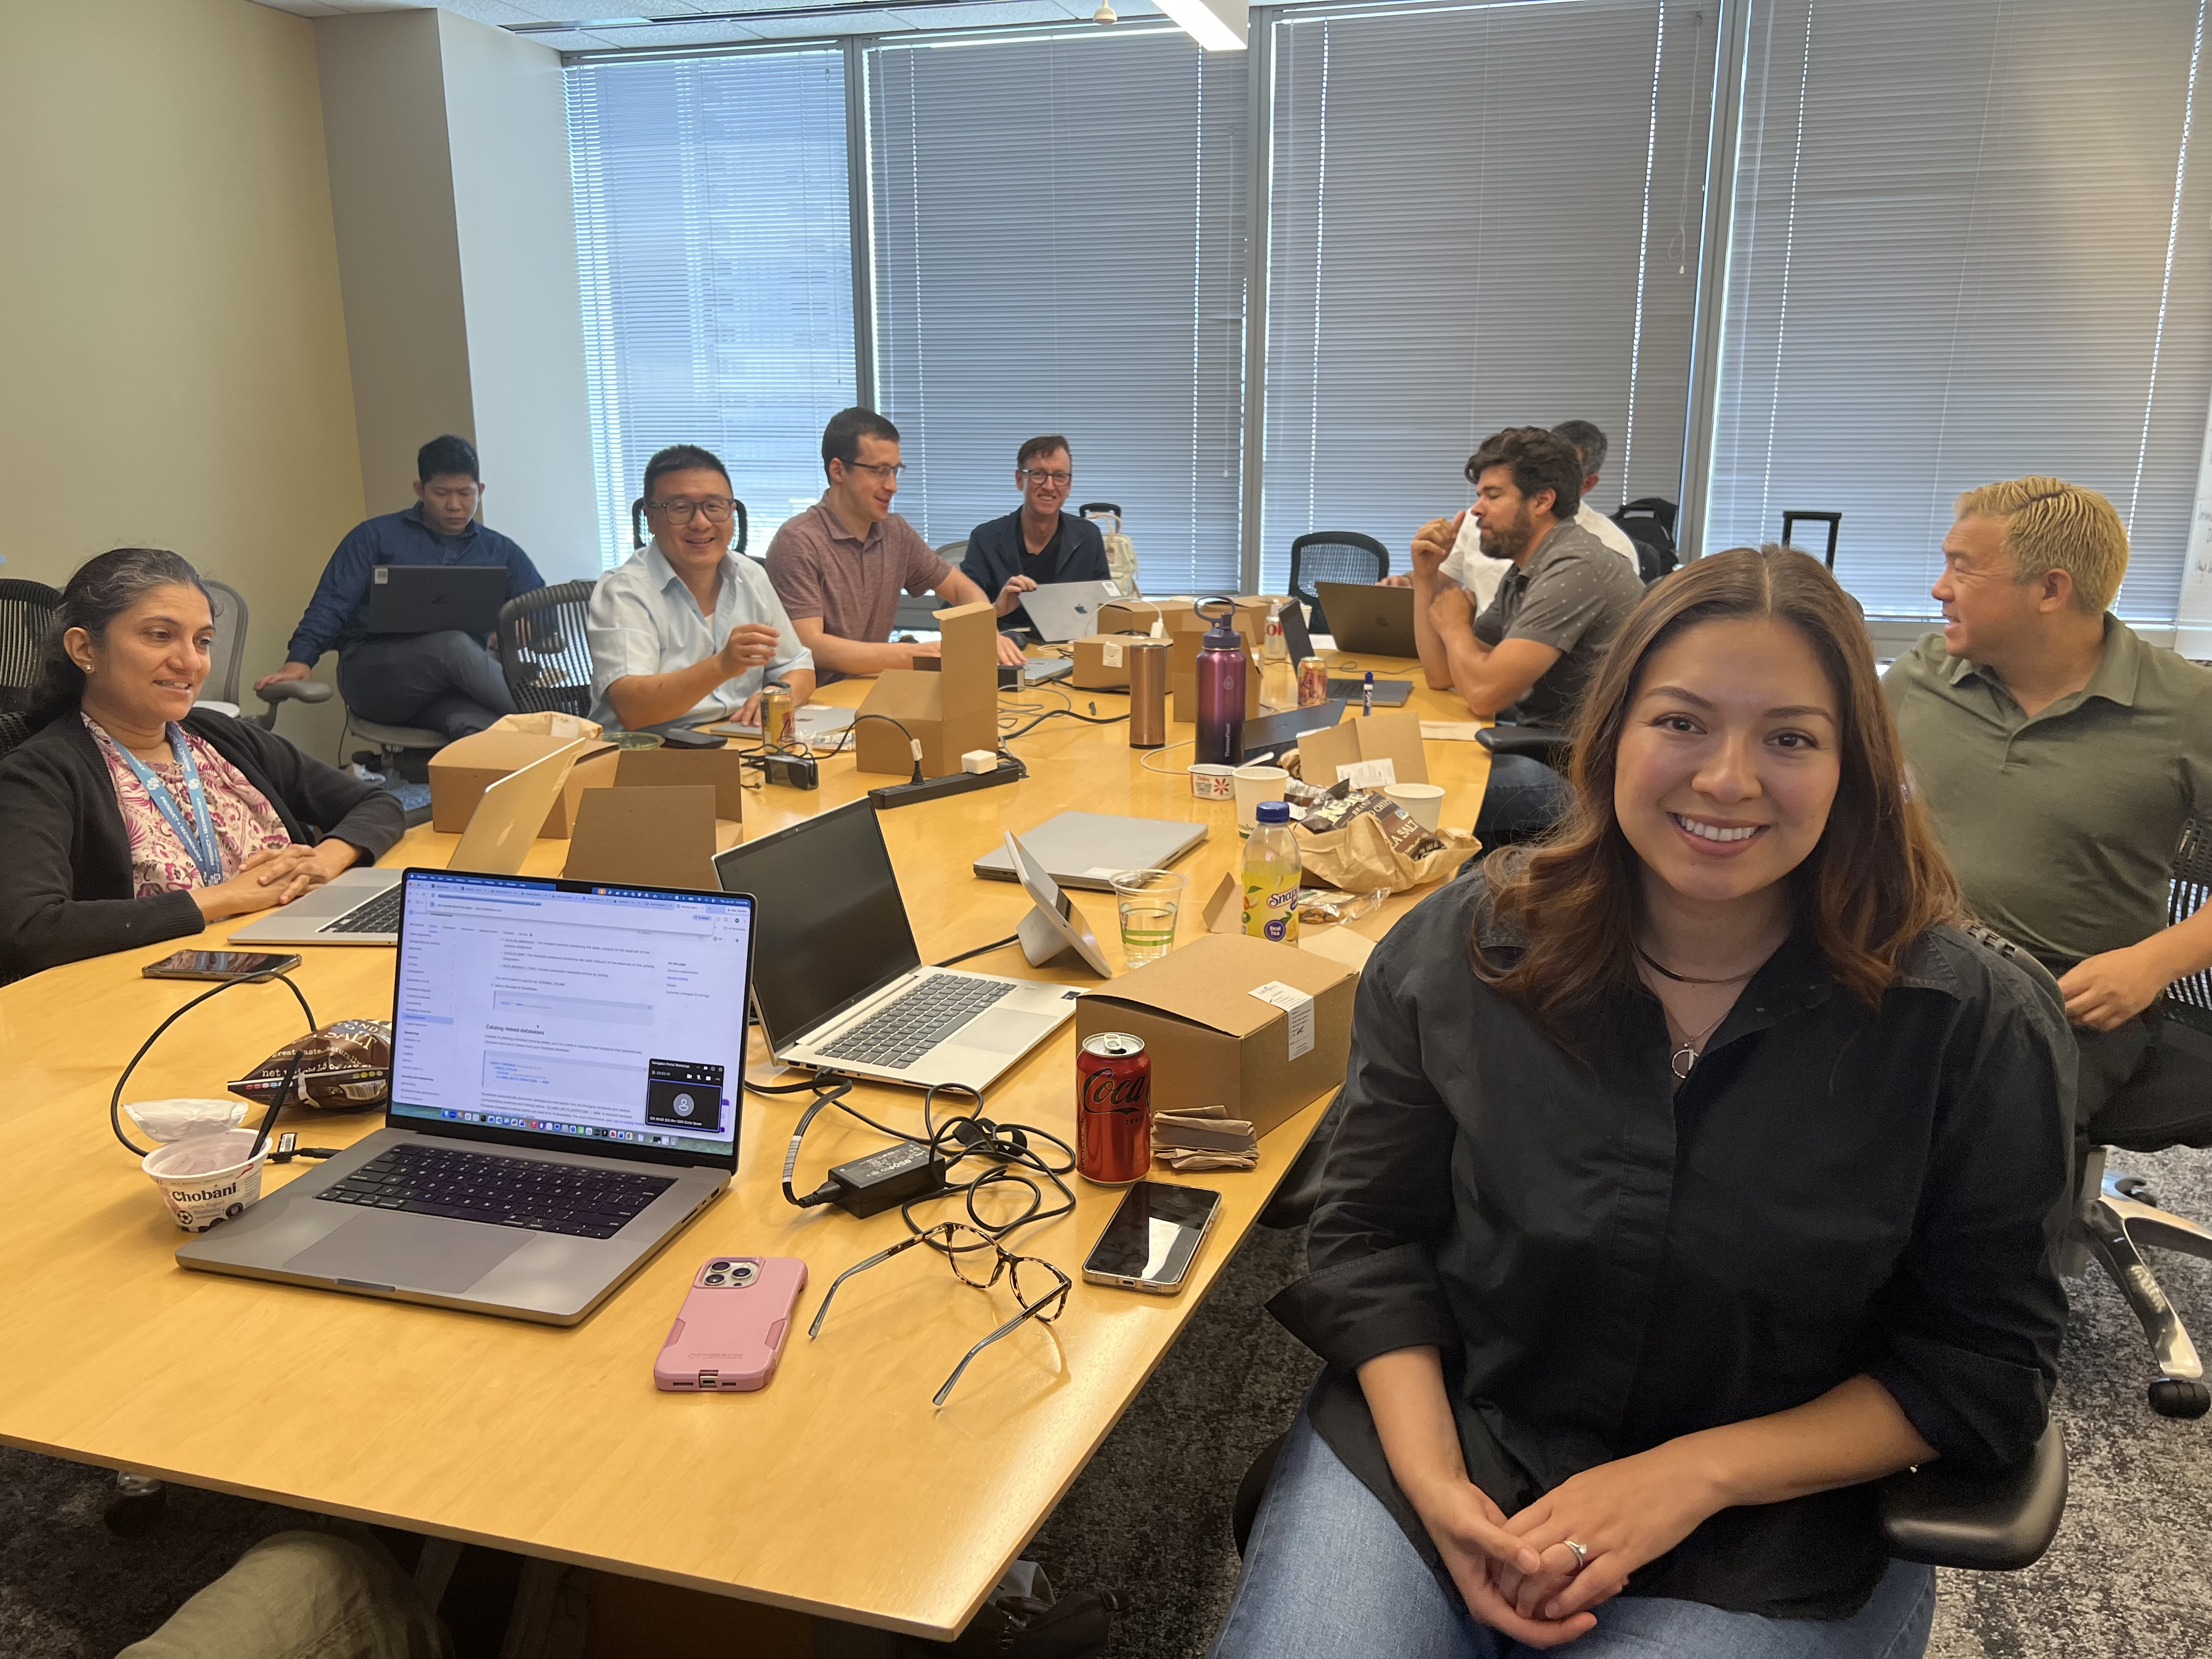
- 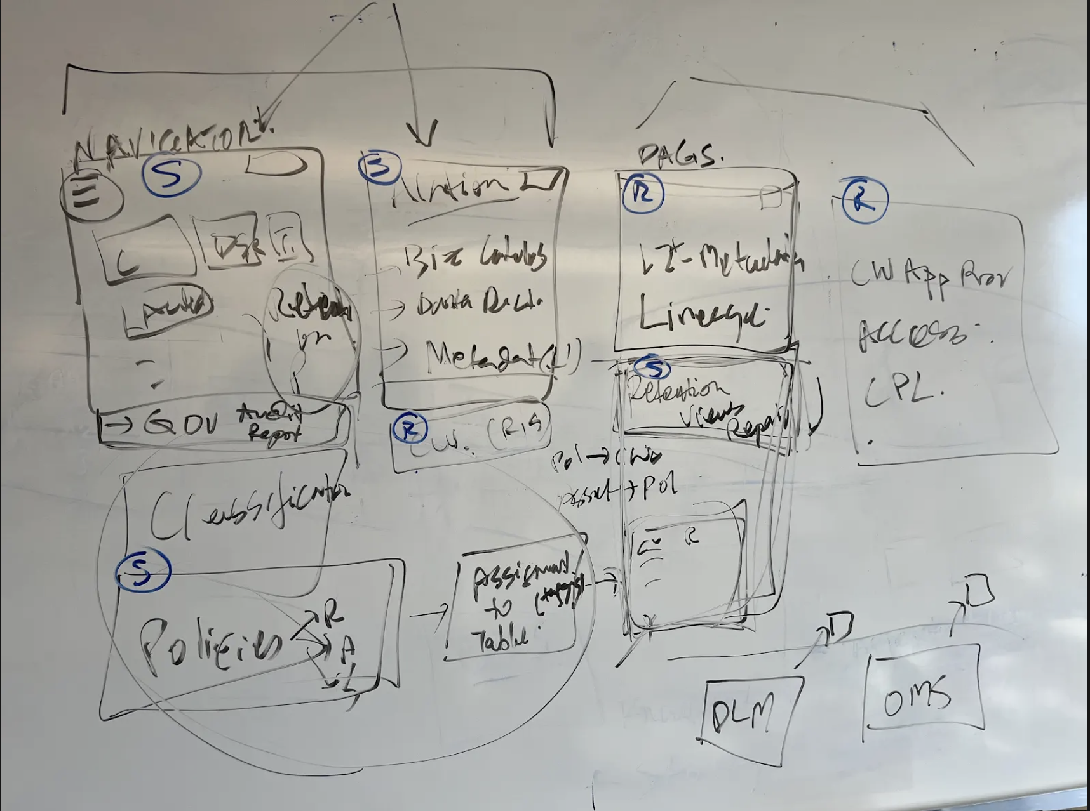
- Document purpose
- This report summarizes Day 3 (Thursday, July 23, 2026) of the Navigator Portal workshop and synthesizes outcomes across all three days. Format follows the Day 2 workshop report (Wilson Chaves) posted to the workshop Teams chat.
Sources:
- Teams meeting transcript — Navigator Portal Workshop, July 23, 2026 (recording segments; primary transcript reviewed via Teams MCP).
- Workshop Teams chat — Day 3 prep topics (Sarah Smurthwaite), facilitator wrap message, whiteboard photos.
- Day 1 summary — Wilson Chaves, workshop chat, July 21, 2026.
- Day 2 summary — Wilson Chaves, workshop chat and Word doc link, July 22, 2026.
- Facilitator notes — Brenda Villasenor SharePoint folder (linked from Facilitator bot at close of Day 3).
Note: Day 3 was recorded in multiple segments. The transcript reviewed for this report captures the metrics/semantic-layer deep dive, governance policy architecture whiteboard (Roopa Prabhu), and the closing reflection circle. Planned privacy/RIM/DSR agenda items may appear in earlier segments or facilitator notes not fully extracted here.

Day 3 — Executive summary
Day 3 shifted from persona and workflow framing (Days 1–2) toward concrete architecture for enterprise metrics, governance metadata, and policy enforcement. The group aligned on a Git-backed, OSI-standard metrics artifact model with DNA-led definition and Data Governance–led change control, OMS-backed drift detection, and phased enforcement for certified publishing. Roopa Prabhu walked through the Governance Metadata Repository (Postgres SoR for tags and policies), governance application services, and Iceberg-based metadata publication for platform consumption—including an end-to-end Access Manager / composable workspace policy-profile example. Engineering raised valid concerns about service boundaries, version sync between Postgres and Iceberg readers, and decision-service ownership; follow-up technical design sessions were agreed with Access Manager and platform engineering (Anne, Eric, Andrew). The day closed with strong cross-team sentiment that governance–platform collaboration had materially improved and that backend architecture plans mesh better than expected.

Day 3 session structure (as captured)
- Part 1 — Metrics creation, governance, and serving layers; OSI / GitHub YAML; unified semantic layer (leadership + product).
- Part 2 — Policy & governance architecture whiteboard; metadata repository, publication layer, access decision flow (Roopa + engineering).
- Part 3 — Workshop close; learnings, thank-yous, and commitment to follow-on working sessions.

Main decisions / emerging alignment (Day 3)

1. Three-layer metrics model (create → govern → serve)
- Creation layer: metric authors (often DNA / domain experts) record definitions in a centralized metrics knowledge base—not ad hoc in dashboards alone.
- Governance layer: review, conflict detection, steward approval, and enterprise naming conventions.
- Serving layer: discoverability and consumption via OMS / Navigator / semantic views; aligns with Discover–Govern–Monitor–Act–Consume from Day 2.
- Workshop gap called out: creators are not always in the room; product must explicitly support creation workflows, not only governance of existing metrics.

2. OSI + Git as the enterprise metric artifact
- YAML metric artifacts stored in Git (Open Semantic Interchange / OSI standard), PR-based change control, validation against OSI structure on merge.
- DNA owns metric definition negotiation with business leadership; Data Governance owns repository workflow, change control, and enforcement hooks.
- Approved metrics propagate to semantic layer implementations (Snowflake semantic views, Databricks metric views) for platform portability.
- OMS role evolves: from reverse-engineering scattered metrics to matching implementations against Git SoR and surfacing drift/conflicts.
- Rough scale cited: ~240 governed metrics today with backfill of P0 existing definitions; rate of change expected to stabilize after initial backfill.

3. Enforcement philosophy (pragmatic, phased)
- Exploration and personal analysis remain unconstrained; gates apply when publishing/sharing for enterprise consumption (360 / marketplace / certified dashboards).
- Near-term focus: Looker/DLN dashboards and DNA-controlled surfaces (~60–80% of drift problem); longer tail includes Tableau, Pixie, and other consumers.
- Certified vs uncertified reporting: executives may dismiss uncertified numbers in forums; culture + tooling combined.
- Metrics Council / stewardship review for conflicts; gated PR merge for net-new enterprise metrics.

4. Governance Metadata Repository architecture (directional)
- Postgres-backed Governance Metadata Repository as SoR for classifications, tags, and policy definitions (authored with legal/governance, effective dates, versioning).
- Governance application services expose policies to enforcement engines (API) and publish projections to platforms.
- Metadata published layer (Iceberg) for zero-ETL consumption inside Snowflake/Databricks catalogs—joint POC direction with Eric/Andrew/Sumanta.
- Platform asset tagging (table/CW tags) remains on platform; repository holds policy definitions and mappings—not necessarily every live tag instance.
- Access pattern: workspace policy profile + dataset/column tags → rules consumed by Access Manager decision logic (PII allow/mask/deny example validated conceptually).

5. Cross-org collaboration tone
- Ryan Malec: backend architecture across Gov and DFP “meshes together better than expected”; unified backend path feels achievable.
- Multiple participants noted improved Gov ↔ platform ↔ architecture relationship vs prior years.
- Pedro called out as leading Business Data Catalog on OMS; OMS team focused on technical metadata quality and lineage accuracy.

Key discussion topics (Day 3)

Part 1 — Metrics & semantic layer
- Industry pattern: “metric server” / single enterprise formula (Uber rides analogy); Disney attempting second major push after prior fragmentation.
- Nuanced metrics (e.g., watch hours): multiple valid flavors with explicit naming—not one overloaded definition.
- Context in OSI extensions: business dimensions, exclusions, column-level lineage for formulas; machines and agents need richer context than formula alone.
- Integration with Kyle / semantic layer POC and Metrics Console; alignment session planned with DNA leadership.
- Conflict workflow: detect duplicate/near-duplicate metrics at publish time; steward review and Metrics Council escalation.

Part 2 — Policy architecture & Access Manager integration
- Whiteboard: solid boxes = systems/boundaries; dotted groupings = logical functions (not separate monoliths).
- Flow: tag/policy workflows → update repository → policies ready for enforcement → governance services + Iceberg publication → platform engines (access, retention, classification).
- Chennah (Access Manager): decision service needs both policies and current tags; prefers clear single SoR and one owning service family per database to avoid drift between Iceberg and Postgres readers.
- Agreed next step: share written architecture doc; walk through concrete Access Manager request example; include Anne, Eric, Andrew in design follow-up.
- Versioning on policy change: impact analysis for affected datasets—not silent propagation.

Part 3 — Close & reflections
- Wireframes / governance portal vision cited as especially helpful for engineers (Tim Liu and others).
- Agent-first design repeated as success criterion: systems must answer how agents interact, not only human UI.
- Niru/Jon/Roopa/Richard/Wilson thanked for facilitation, documentation, and “polite aggression” in working sessions.
- Commitment to additional follow-up sessions rather than treating workshop as final spec.

Day 3 — Open questions
- Portal count & URL strategy: single vs multiple portals; landing experience (“Google vs ESPN”) — Sarah’s Day 3 prep list; still open.
- Where exactly does the policy decision service live, and which team owns reads/writes to the governance Postgres SoR?
- Iceberg vs API: which consumers must use which path to avoid version skew?
- Full privacy/RIM/DSR scope from original agenda: confirm coverage in earlier Day 3 segments or schedule dedicated follow-up with Norman/privacy leads.
- Sisu / external policy engine vs custom governance services — raised on Day 2; still unresolved.
- North Star one-liner for Navigator product definition — facilitator follow-up from late Day 2.

Day 3 — Action items
- Share governance metadata / policy architecture design doc with Access Manager and platform engineering (Roopa → Chennah, Anne, Eric, Andrew).
- Document end-to-end Access Manager example (registry CW request → policy profile → grant/deny/mask) as sequence diagram.
- Metrics: continue OSI/Git POC; schedule Kyle/DNA alignment; define backfill plan for P0 metrics.
- OMS: document drift-detection model once Git SoR is authoritative cutoff date.
- Wilson / TPM: capture whiteboard photos and AI summaries in workshop artifact folder (referenced in room).
- Product: portal strategy decision brief for leadership (single vs multiple; persona landing pages).
- Facilitator notes: incorporate Brenda Villasenor SharePoint folder content into master action tracker.

Day 3 — Leadership decisions needed
- Ratify metrics enforcement phased approach (what requires certification vs allowed exploratory use).
- Confirm Governance Metadata Repository as enterprise SoR for policy/tag definitions (vs distributing across platform catalogs).
- Portal strategy decision (carried from Days 1–2).
- Executive sponsorship for cross-team working sessions post-workshop (Gov + DFP + OMS + Access Manager).

3-Day workshop — total summary
The Navigator Portal workshop brought Data Governance, Data Foundations Platform, OMS, Access Manager, architecture, and domain partners together in Seattle for 2.5 days to align on post-Alation catalog/governance experience, shared backend architecture, and operating model across teams.

Arc across the three days
- Day 1 (Jul 21): Future-state framing — OMS as aggregation backbone, thin UI layers, single source of truth, portal strategy debate, metadata vs AI context (626), policy lifecycle vs discovery.
- Day 2 (Jul 22): Personas (~85% confidence), Discover/Govern/Monitor/Act/Consume workflows, classification/policy/access depth, governance portal expectations, policy translation pipeline.
- Day 3 (Jul 23): Metrics OSI/Git model, governance metadata & policy enforcement architecture, Access Manager integration concerns, collaborative close and follow-ups.

Cross-workshop themes (stable)
- Dual experience, shared spine: persona-specific portals/UI acceptable if backend and metadata SoR are unified.
- Governance is operational, not only reporting: enforcement, audit evidence, workspace-aware access, policy lifecycle.
- Human + agent consumers: metadata and context must be machine-readable and validated.
- Avoid duplicating OMS: rebuild Alation capabilities deliberately; don’t fork lineage/discovery.
- Relationship repair: Gov ↔ platform ↔ architecture collaboration explicitly improved during workshop.

Cross-workshop decisions & alignment (best current view)
- OMS remains central technical metadata / lineage / discovery backbone.
- Governance policy and tag definitions → Governance Metadata Repository (Postgres) with services + publication layer.
- Enterprise metrics → Git + OSI YAML, DNA defines, Gov operationalizes change control and enforcement hooks.
- Persona framework and DGMAC workflow categories are default IA for portal design pending leadership sign-off.
- Classification, policy, and access are tightly coupled; Access Manager is critical integration point.

Cross-workshop open questions (prioritized for leadership)
- 1. Portal strategy: one portal vs multiple vs shared shell with persona entry points.
- 2. Policy platform direction: extend existing stack, Sisu, or net-new governance services.
- 3. RACI: Gov vs DFP vs OMS vs Access Manager for build/support of each capability.
- 4. Metrics enforcement timeline and certification rules for enterprise publishing.
- 5. AI/context strategy (626): validation, canonical promotion, storage—post-workshop track.

Recommended immediate next steps (program)
- Publish alignment memo + RACI draft (workshop commitment; target late July 2026).
- Technical deep-dives: (a) policy repository ↔ Access Manager, (b) metrics Git/OSI POC, (c) portal IA decision.
- Leadership readout: portal strategy, policy SoR, metrics enforcement, and Gov/DFP operating model.
- Merge facilitator notes, Wilson Day 2 doc, and this Day 3/total summary into single workshop artifact repository.

References & links
- Workshop Teams chat: meeting thread 19:meeting_YzQ2MjIyOWUtNTQ1Yy00OGJiLWFiOTUtOWFhZTY1M2NiYjJi@thread.v2
- Day 2 report (Teams): Wilson Chaves message 1784759768700; Word doc on Wilson SharePoint (661115cf-fbed-421c-9f0e-e1ed03fdb352).
- Day 1 summary (Teams): Wilson Chaves message 1784676330255.
- Day 3 facilitator notes folder: Brenda Villasenor SharePoint (linked from Facilitator message 1784837423579).
- Day 3 recording/transcript: Navigator Portal Workshop-20260723 (Niru Sharma Recordings folder).
- OSI example (chat): github.com/apache/ossie (flights.yaml sample shared by Brenda).

Appendix — Whiteboard captures (Day 3)
In-room whiteboards (photos shared to workshop chat) illustrated:
- Navigator UI areas: site config, user profile, discover, search; Producer vs Consumer capabilities (catalog, lineage, search vs self-service, access).
- Classification and Policies feeding automated table/workspace controls; DFP and OMS called out as adjacent platform layers.
- Entry URLs discussed: datahq / data portal alignment; React + shared design system (“Shadow”) for thin UI.
- Governance hub: auth, domain groupings, metadata services, GraphQL/API backends.

