- if the customer already exist and user try to add the customer with same name, give message "Customer Already Exist - Select from Drop down menu) and same for the Project give messsage "Project Already Exist - Select from down menu).
- Once the drop down menu appears the scroll should appear on the main pages.
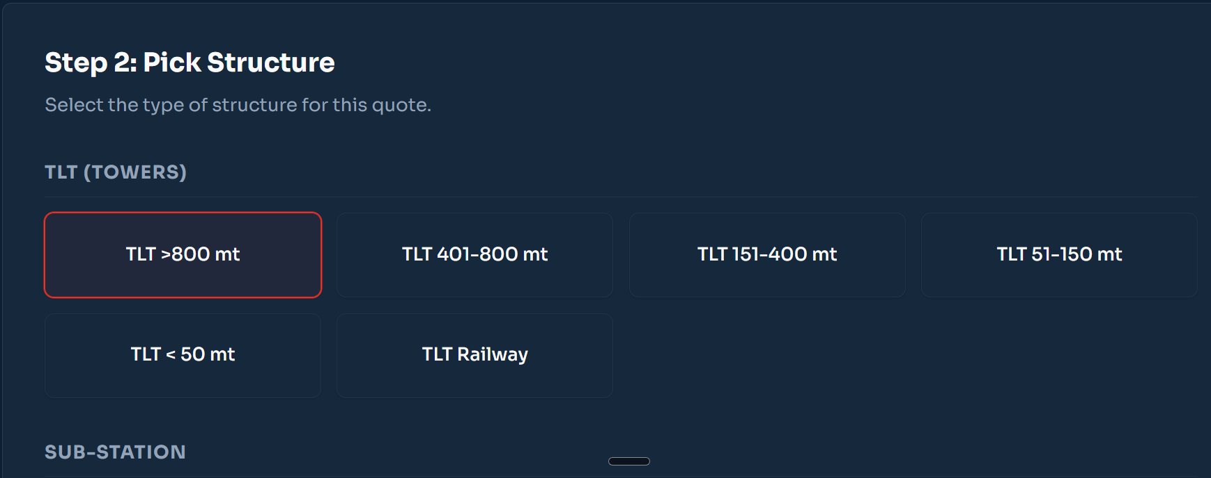

- If the customer name and project already existed one are chosen (that is new revision is being made), then all the options in the Pick structure should default to the rev 0 version only.
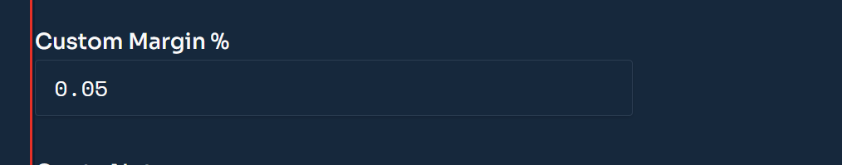
This field should come as percentage and not decimal.

