In general with dropdown menu, a search bar should be there to search the name directly
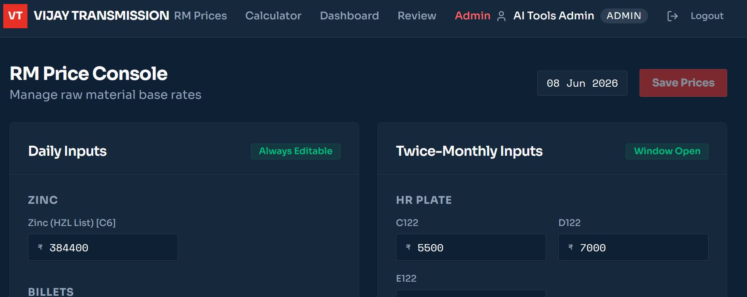
Save Prices option is disabled. Also The Import RM Prices should be also available if the user wants to import these rather than input, which will override the input. After input ask the user to verify and then give option to save prices.

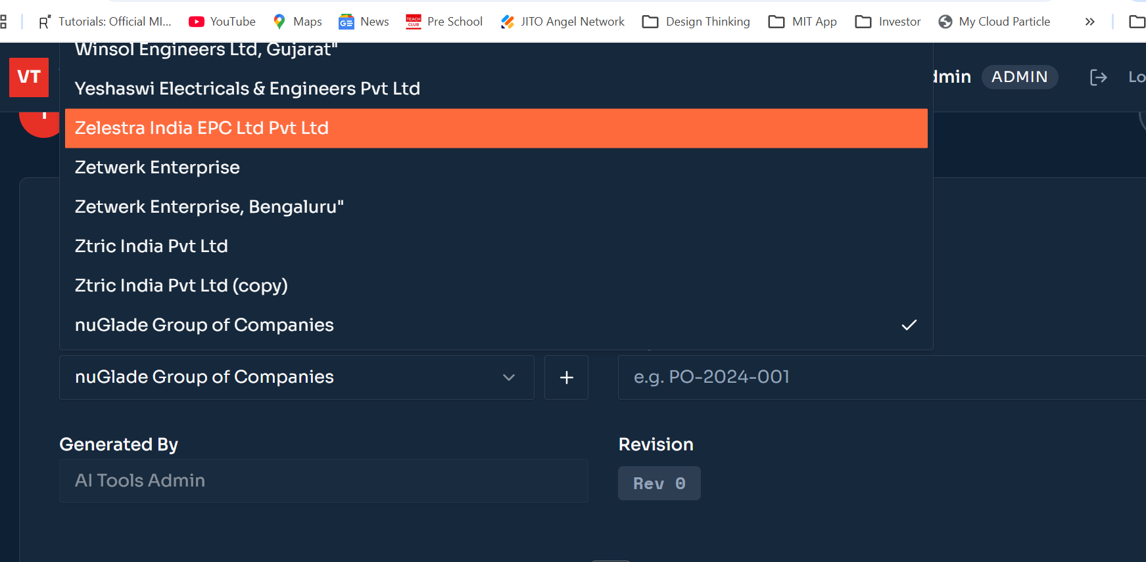
Drop down option should show in down side rather than upside wherever they are.

