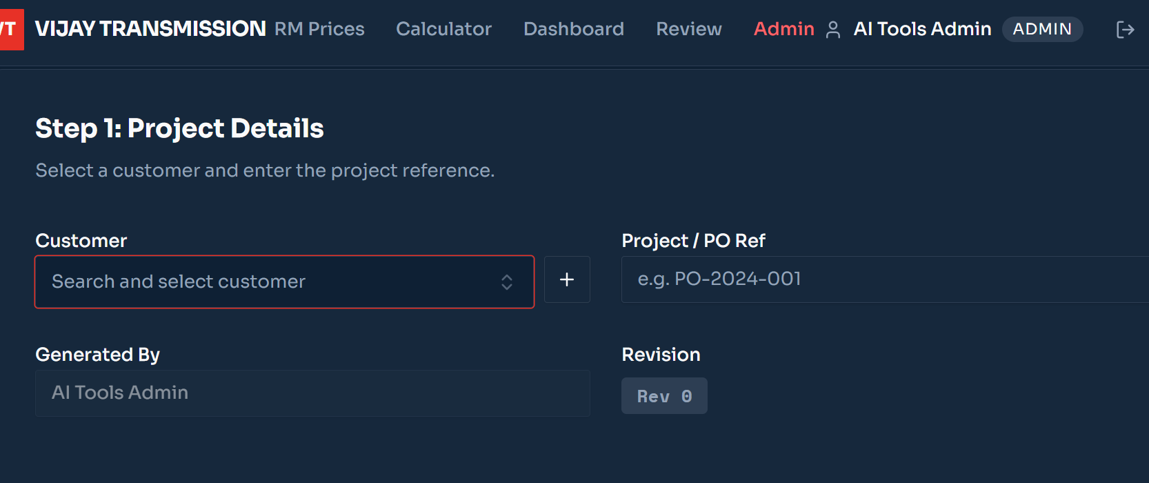
When new Customer is added in Project details, its not coming in dropdown menu. Also it should come as default selected in Customer if a new customer is added

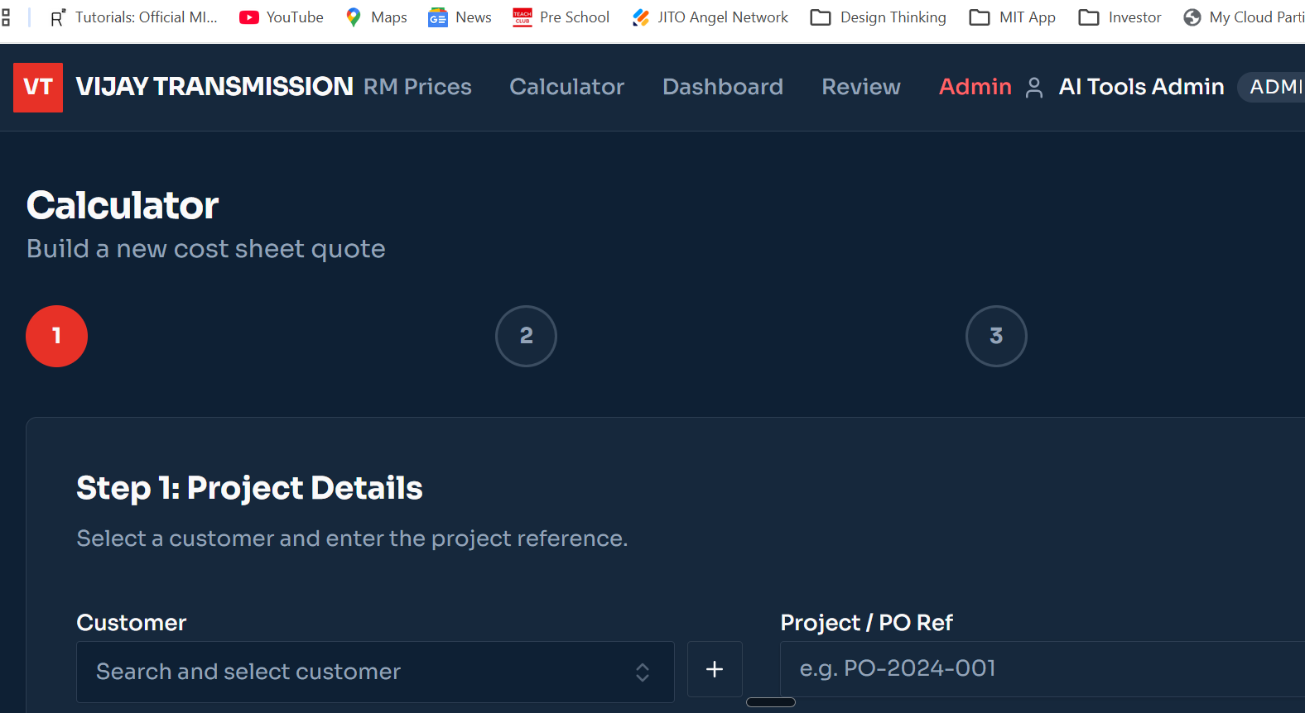

In the Calculator page if the customer is already existed is chosen and with respect to that customer already some projects are there, then they should come as drop down menu and if new project needs to be added then a plus sign to add.

