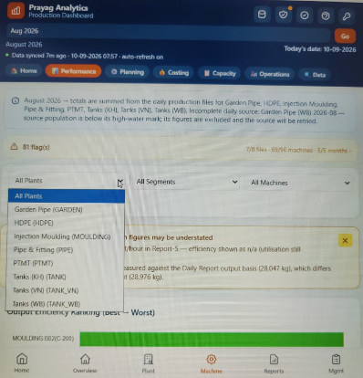
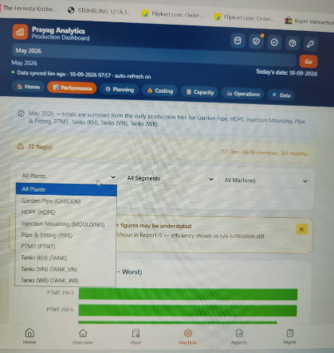

In May & August month under Machine View (in Machine Performance) – Data of Pipe & fitting (PIPE) & Injection Moulding (Moulding) are coming.
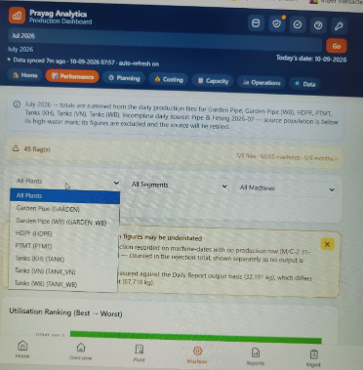
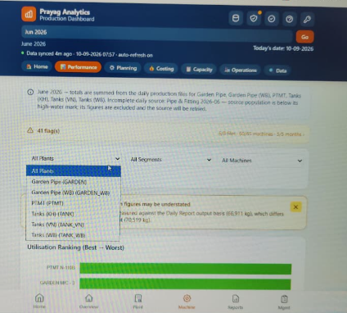
But in June & July month under Machine View (in Machine Performance) – Data of Pipe & fitting (PIPE) & Injection Moulding (Moulding) are not coming.

