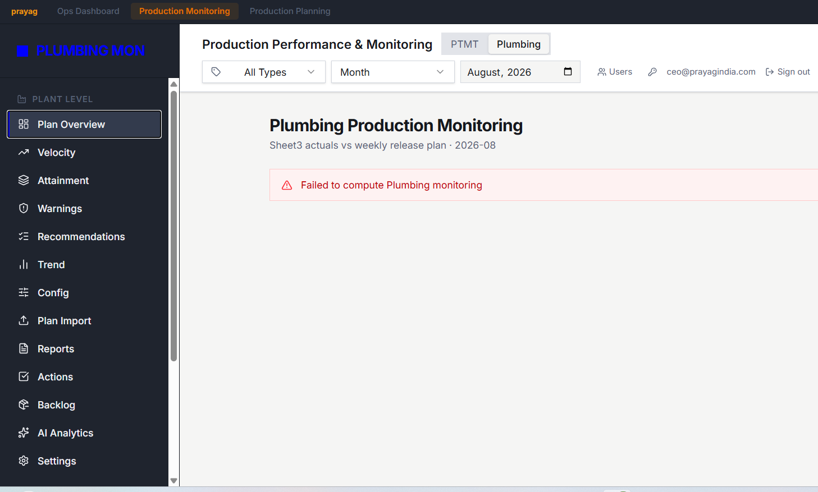
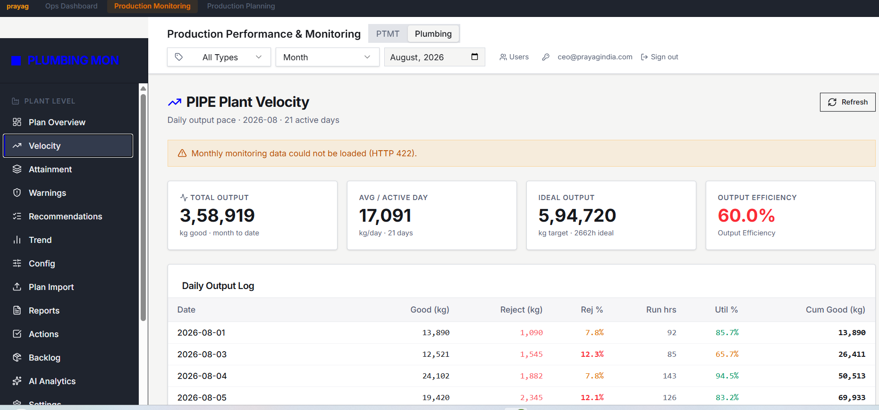

SOME MISMATCH IN FIGURES OR CALCULATION MISTAKES
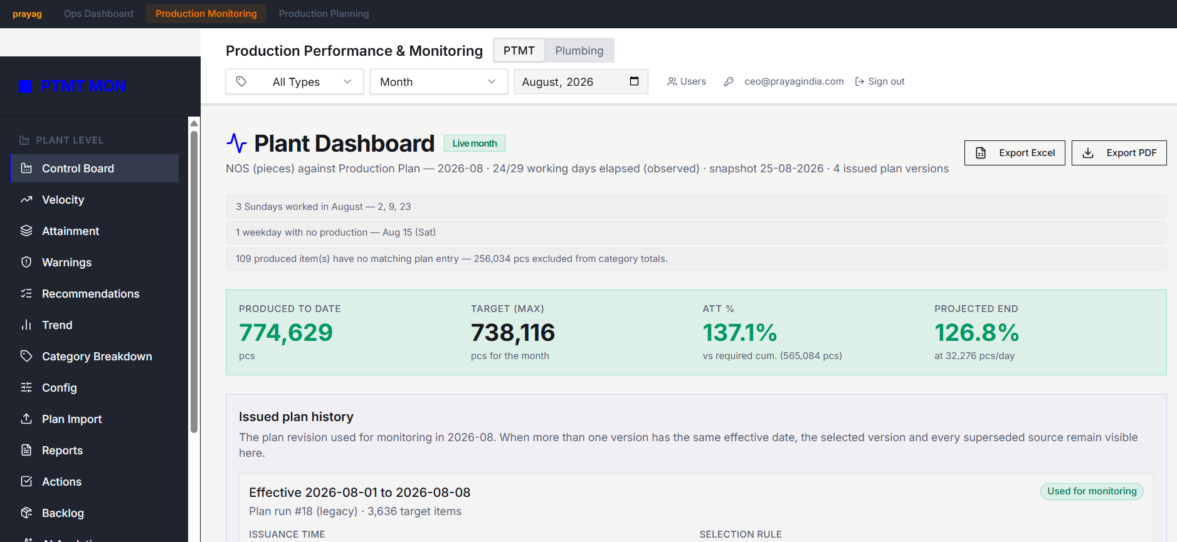
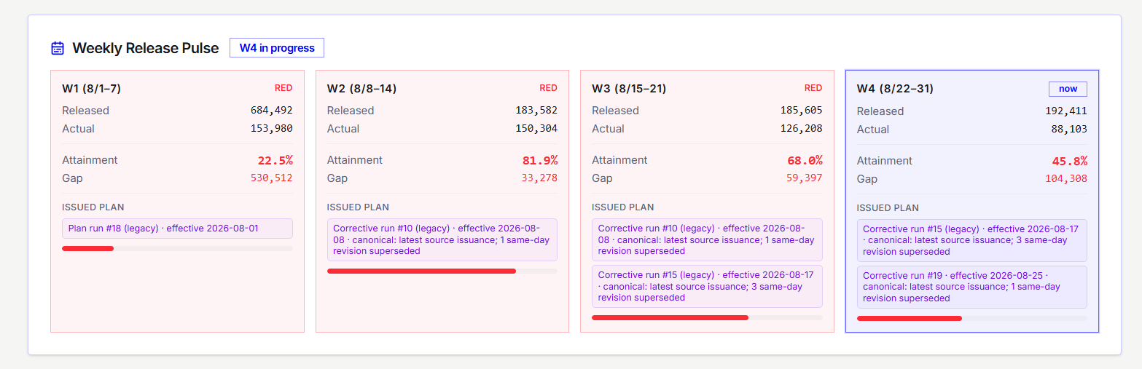

SOME MISMATCH IN FIGURES OR CALCULATION MISTAKES
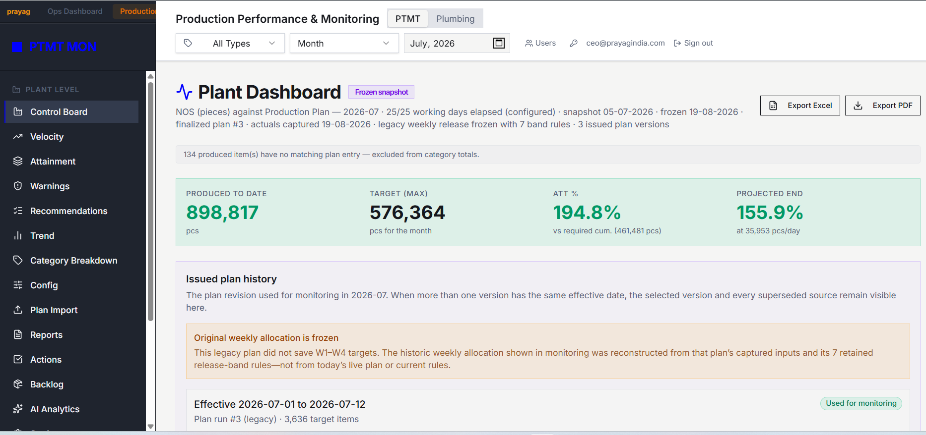
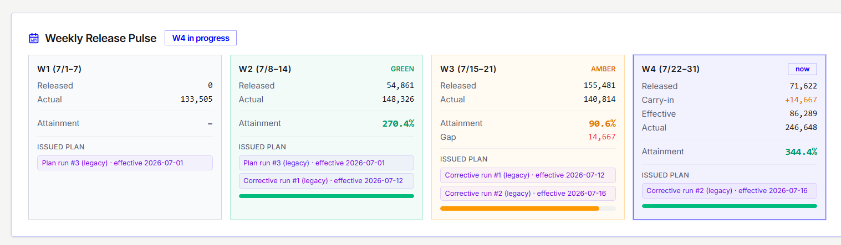
JUNE IS EMPTY
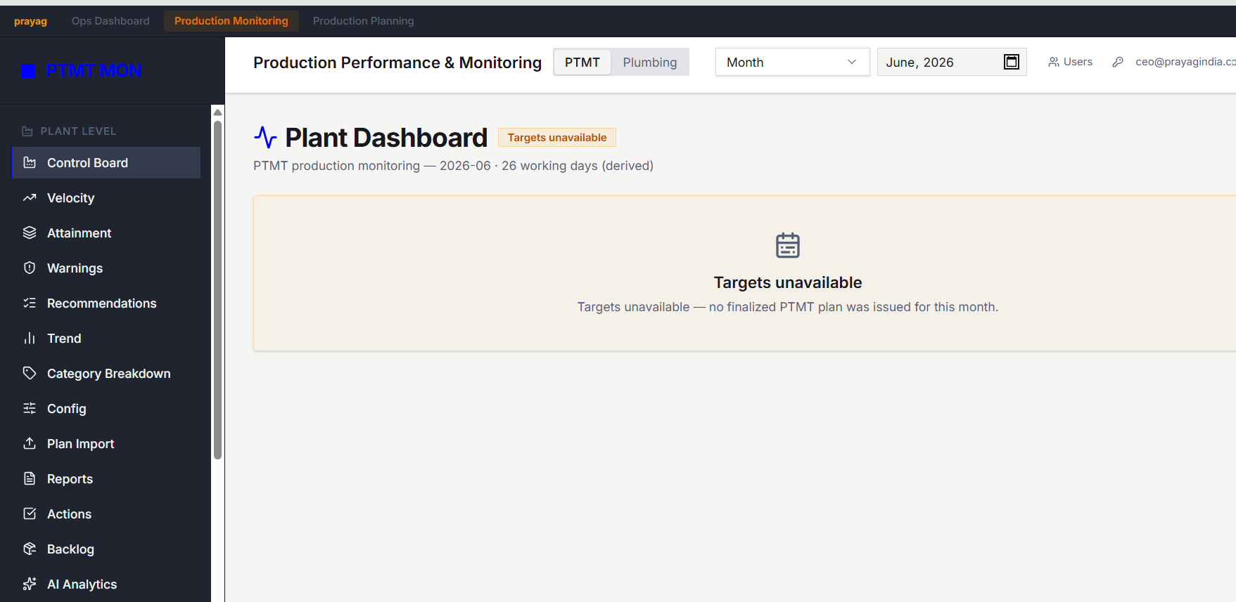
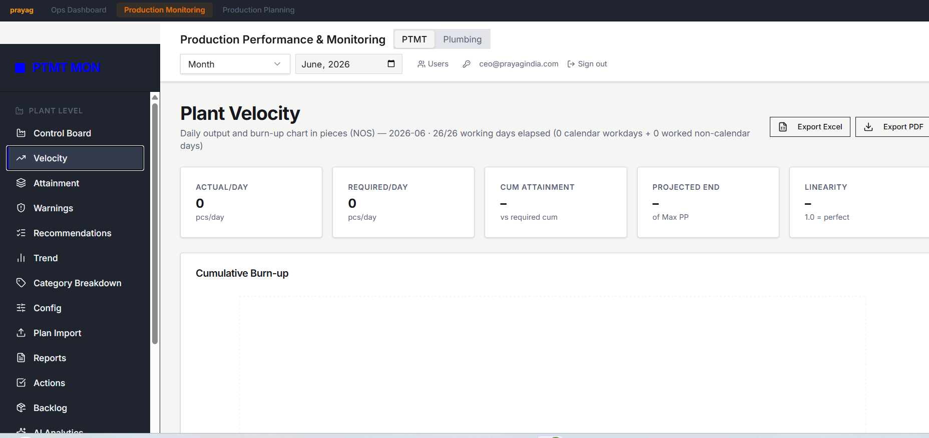

JULY DATA IS NOT COMING IN MONTHLY ORDER VALUE – F.Y. 2026-27
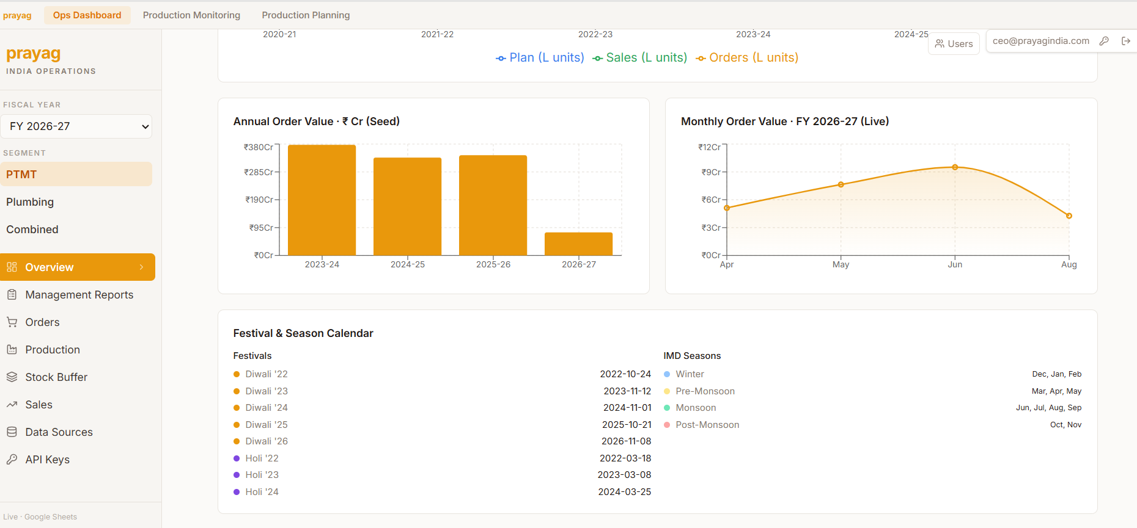
HERE ALSO JULY DATA IS NOT COMING
