

KYRGA ASMS
Automotive Sales Management Software
User Manual
Vehicle Sales Management System
Version 3.0 · Illustrated Manual

Contents
1. Introduction
2. Accessing the Application
3. Application Language (Portuguese / English)
4. User Types (Roles)
5. Dashboard
6. Vehicle Management
7. Vehicle Change History and Reversals
8. Investors
9. Reports
10. Panel
11. Personalising the Company (name, logo and colours)
12. Audit Log
13. Vehicle Import Simulator
14. Investor Portal
15. Frequently Asked Questions

1. Introduction
KYRGA ASMS is a vehicle sales management system that lets you record, track and analyse all of the dealership activity from any device with an Internet connection. Each client company has its own data, fully separated from that of the other companies.
Main features:
- Recording and editing vehicles with status control (In Stock, Sold, Reserved).
- Automatic calculation of margins and costs per vehicle.
- Management of investors and the capital invested in each vehicle.
- Detailed reports by salesperson, by investor and by date range.
- Dashboard with a chart of stock and margin evolution.
- Change history (audit) for each vehicle, including reversals.
- Central audit log, with the ability to undo movements.
- Vehicle import cost simulator for Portugal.
- Company personalisation: name, logo and colour palette.
- Bilingual application, in Portuguese and English.
- Team management by invitation, with different permission levels.

2. Accessing the Application
The application is available online and can be reached from any computer, tablet or mobile phone with an Internet connection.

Signing in
- Open the application address in your browser (Chrome, Safari, Edge).
- Enter your Email and your Password.
- Click the «Sign in» button.
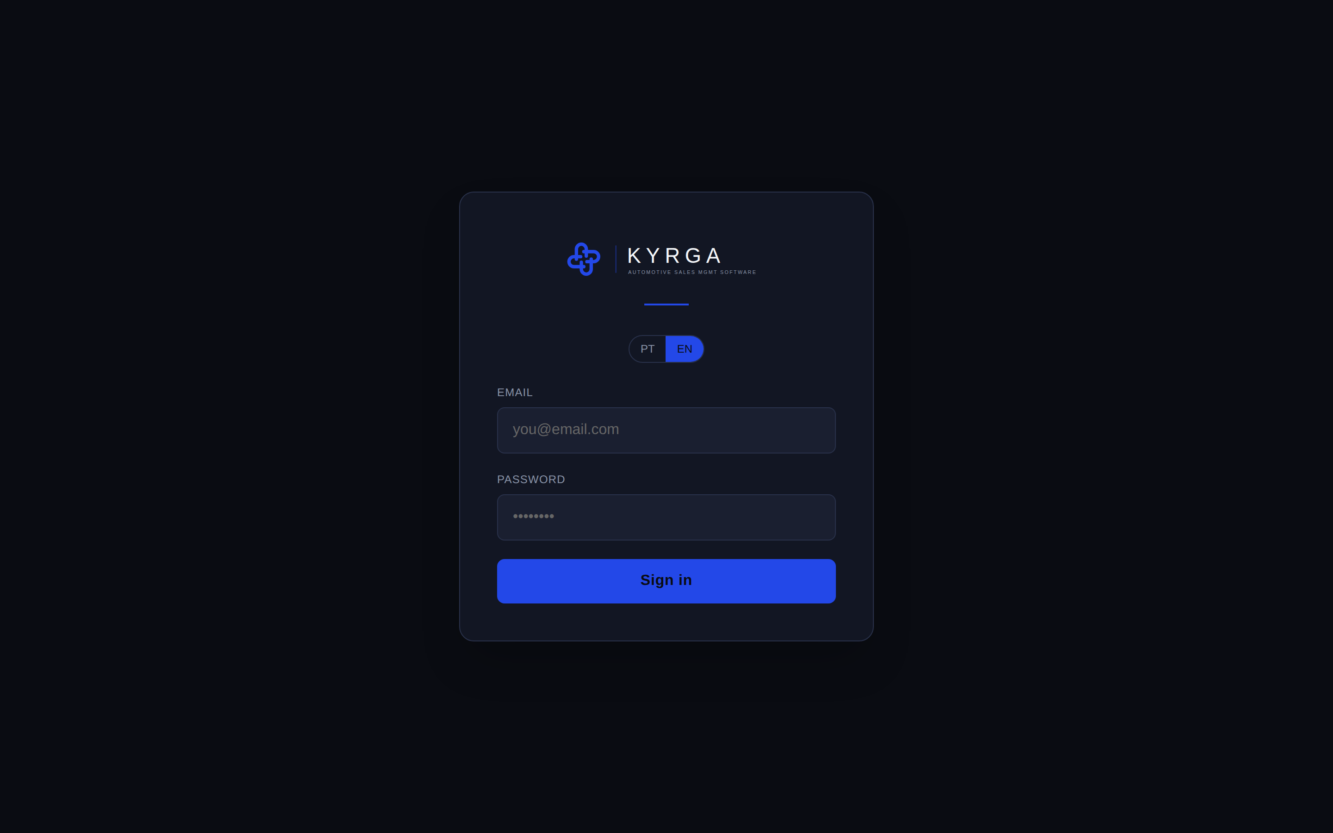
Figure 1: Sign-in screen.
Note: If your account has been suspended, you will see a message indicating this. In that case, contact your director to restore access.

Registration by invitation
Salespeople and investors access the application through an invitation. The director sends an invitation by email and, on opening the link received, the person sets their name and password to activate the account.

3. Application Language (Portuguese / English)
The application works in Portuguese and in English. On first entry, the language is chosen according to your system’s primary language; if it is not Portuguese, the application defaults to English.
You can switch at any time using the PT / EN selector, available in the top menu and on the sign-in screen. Your choice is saved for future visits.

4. User Types (Roles)
The application has three user types, each with different permissions:
- Director: manages all of the company activity, the team, the investors, the reports and the company settings.
- Salesperson: records and tracks their own vehicles and sales.
- Investor: accesses their personal portal to follow the invested capital and its results.

5. Dashboard
After signing in, the Dashboard is shown, the main page with an overview of the business.
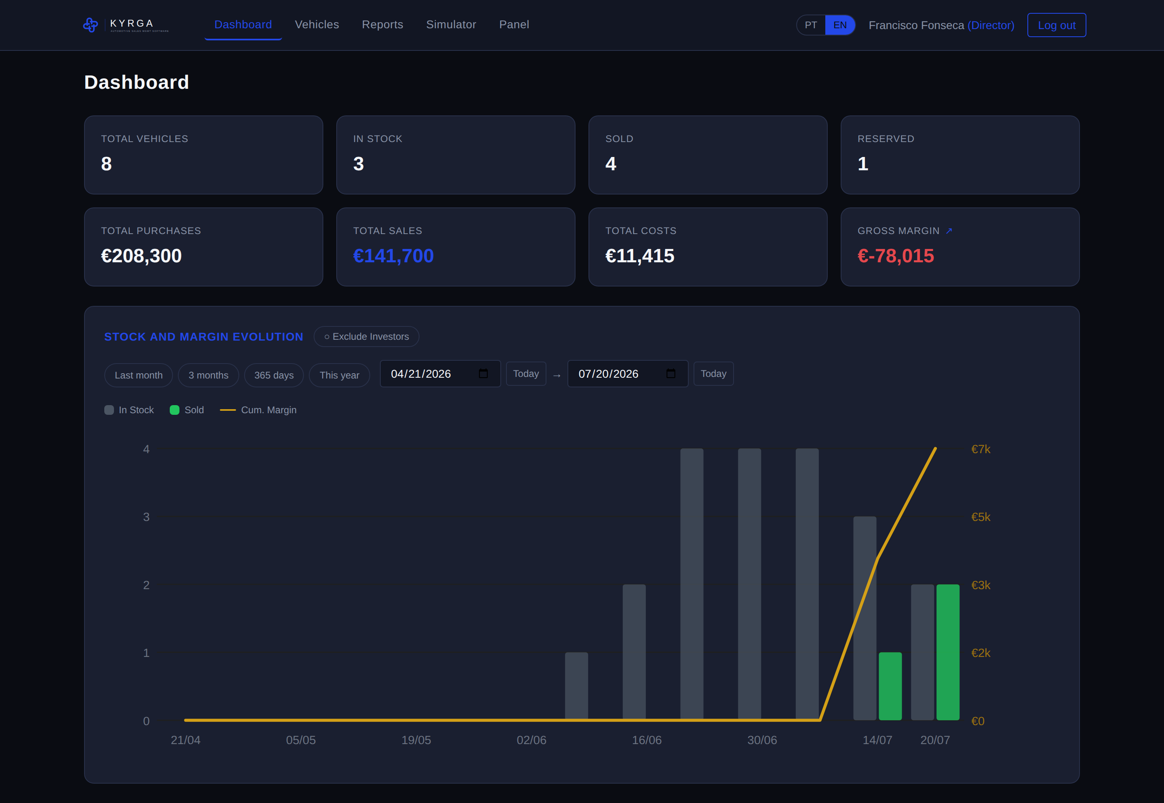
Figure 2: Dashboard with indicators and evolution chart.

Indicators (top cards)
- Total Vehicles, In Stock, Sold, Reserved: counts by status.
- Total Purchases, Total Sales, Total Costs: financial totals.
- Gross Margin: result (Sales minus Purchases minus Costs).

Excluding investor vehicles
The «Exclude Investors» button turns on and off the counting of investor-funded vehicles in the margin and in the chart. This way, those vehicles do not affect the margin when they have an associated investor.

Gross Margin breakdown
The «Gross Margin» card is clickable. Clicking it opens a window with the breakdown of all the vehicles that contributed to the value, so you can see exactly how it was calculated. The figures reconcile with the total shown on the Dashboard.

Evolution Chart
It shows the evolution over time: bars for vehicles in stock, bars for sold vehicles and a line with the accumulated margin.

6. Vehicle Management

Viewing vehicles
In the «Vehicles» menu you find the list of all the vehicles you have access to, organised into two tabs: «Stock» and «Investor Vehicles». You can filter by status in the top right corner.
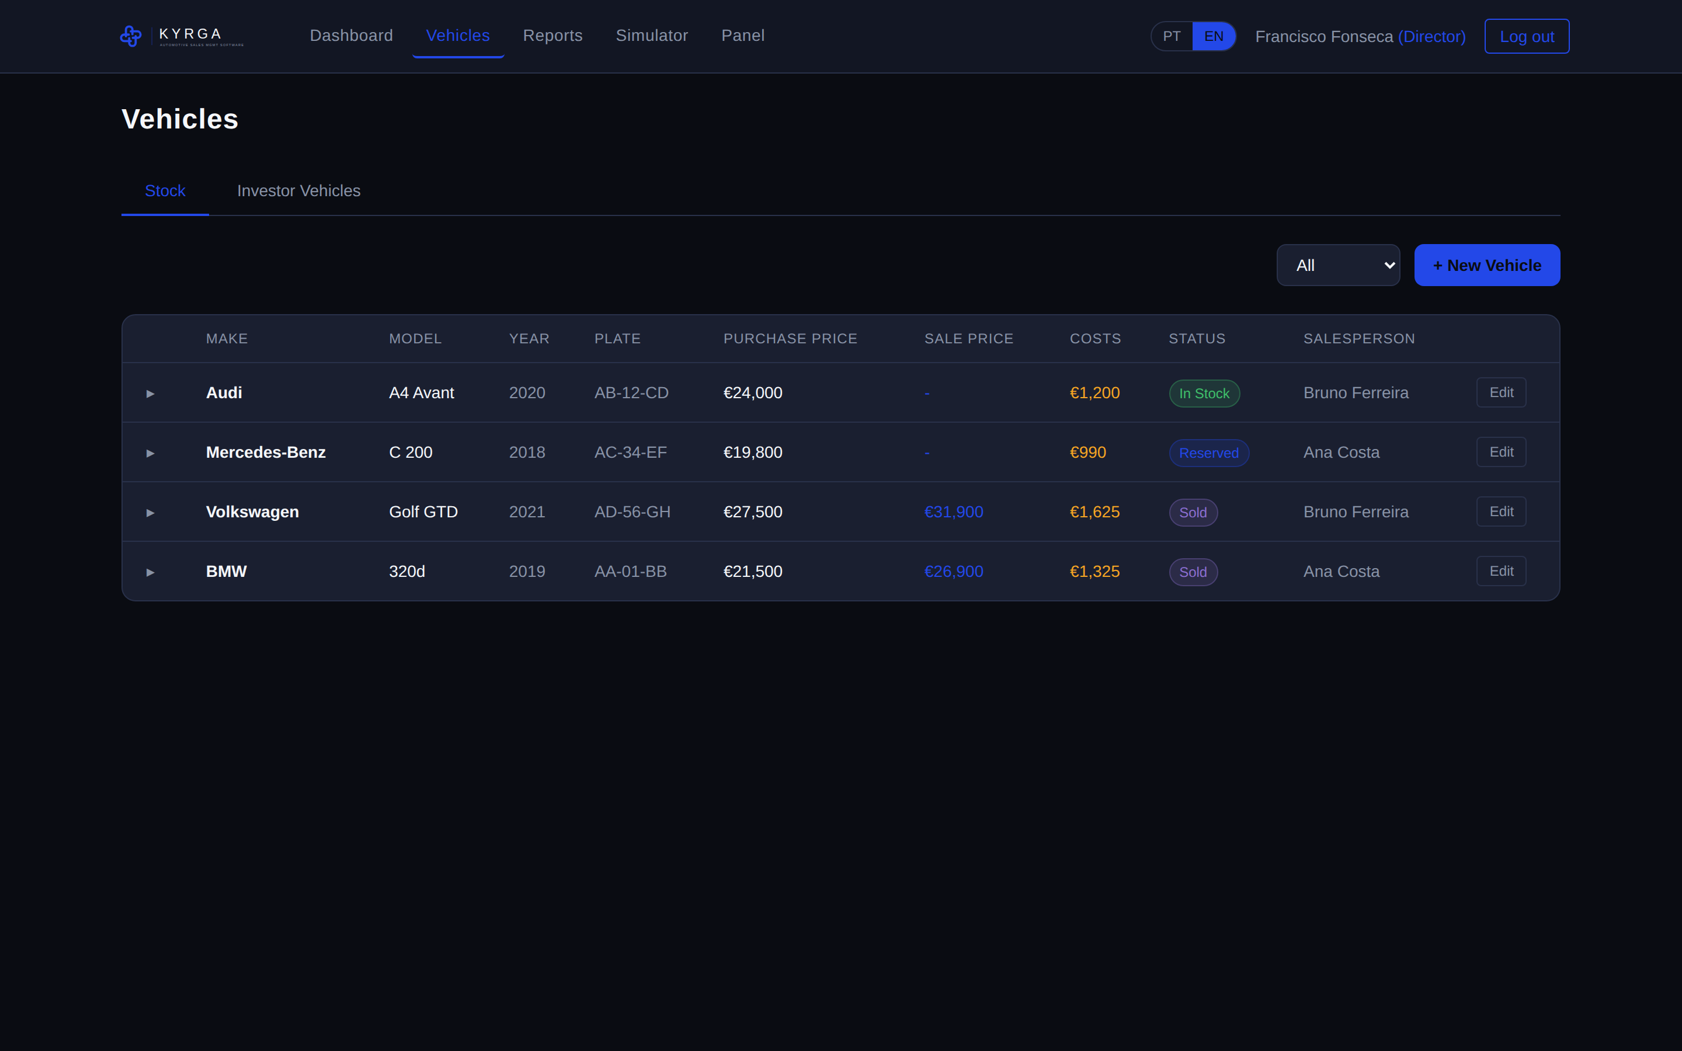
Figure 3: Vehicle list.

Registering a new vehicle
- Click the «+ New Vehicle» button.
- First fill in the Date (you can use the «Today» button).
- Fill in Make, Model, Year, Number Plate, VIN, Colour, Mileage and Fuel.
- Enter the Purchase Price (mandatory) and, if applicable, the Sale Price.
- The director can assign the vehicle to a salesperson and associate an investor.
- Click «Save».
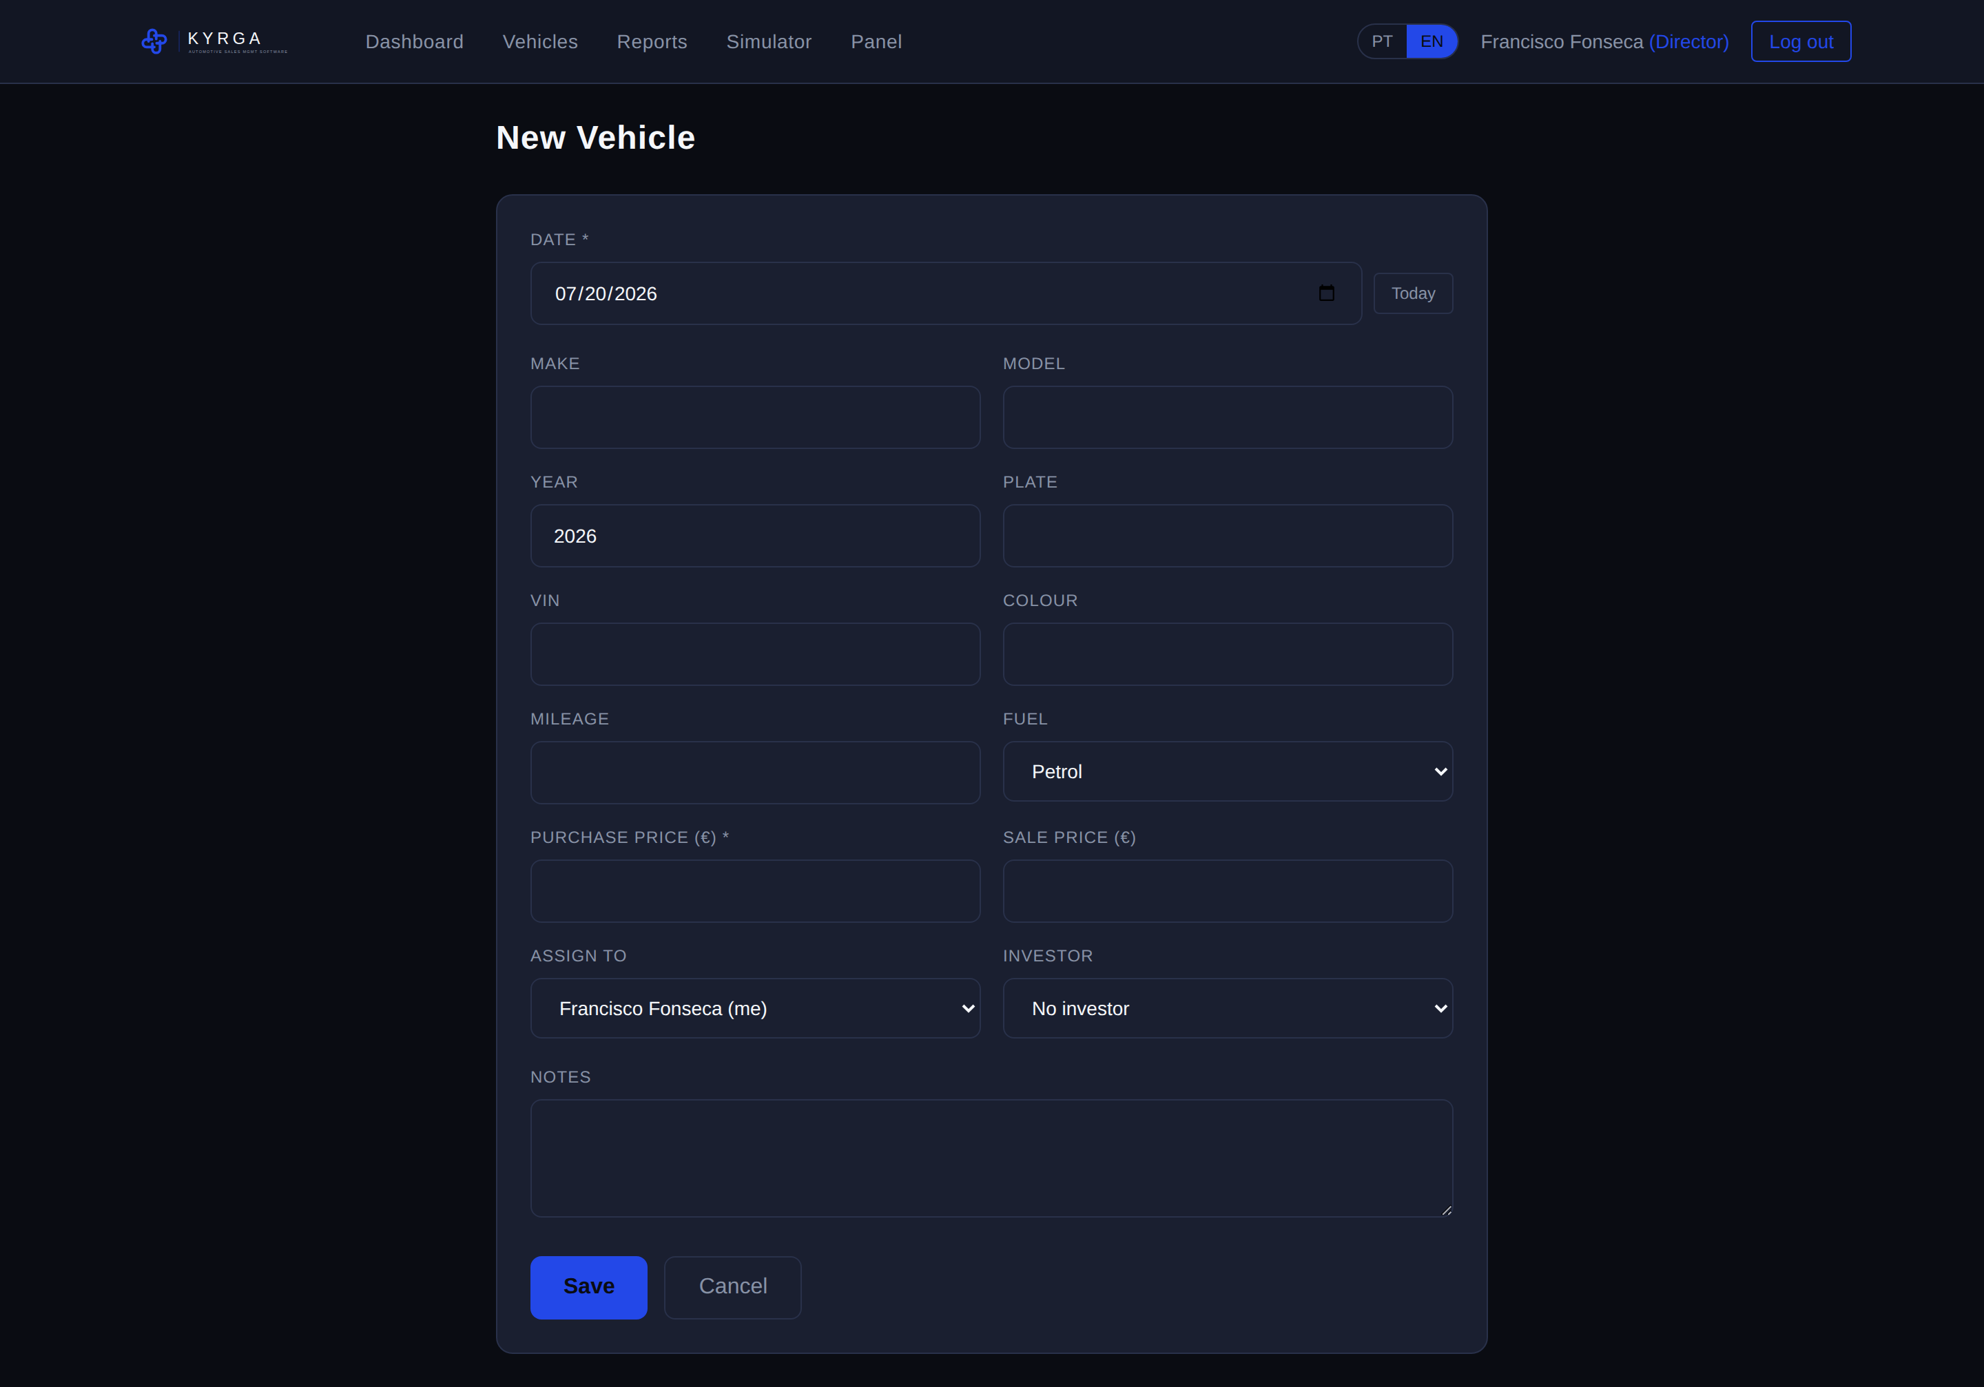
Figure 4: New vehicle form (Date field with «Today» button).
Note: When a salesperson registers a vehicle, it is automatically assigned to them. Assigning it to another salesperson and associating an investor are reserved for the director.

Editing or deleting costs
Within each vehicle you can add, edit or delete the associated costs (transport, maintenance, detailing, and others). The total cost is always recalculated and reflected in the margin.

Investor vehicles
In the «Investor Vehicles» tab you can edit or delete the vehicle, as well as manage its costs. On saving, the application returns to the corresponding list.

7. Vehicle Change History and Reversals
Each vehicle keeps a full record of all changes, acting as an audit trail.

How to consult it
- In the «Vehicles» menu, click the small arrow to the left of the vehicle row.
- The row expands and shows that vehicle’s change history.
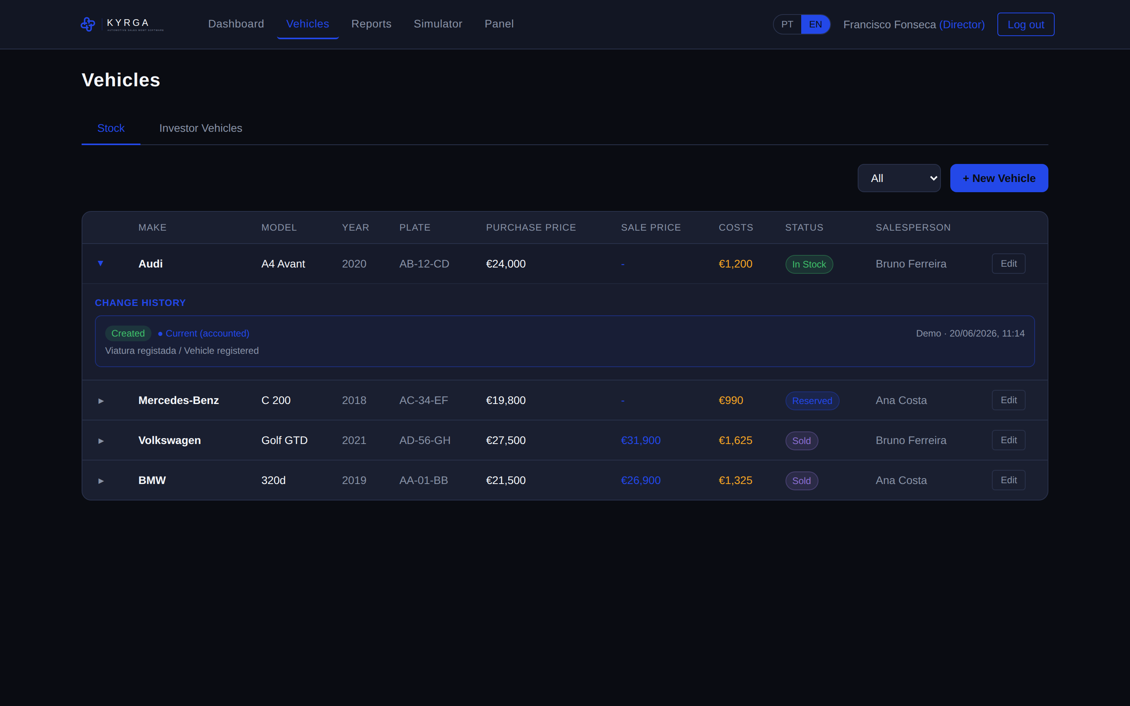
Figure 5: Change history expanded on a vehicle.
The history shows who made the change, the date and time, and what changed (field by field, with the previous and the new value). The most recent change is the one that counts for accounting purposes and is marked as «Current (accounted)».

Reversals
When a movement is undone from the audit log, that reversal also appears in the affected vehicle’s history, marked as «Reversal». This keeps a permanent record that the movement existed and was reverted.
Note: Only the current state of the vehicle counts for the reports and the Dashboard. The history serves as an audit trail and does not change the totals.

8. Investors
(Available to Directors)
An investor funds the purchase of vehicles. The vehicle stays in stock, but the capital belongs to the investor until it is sold.
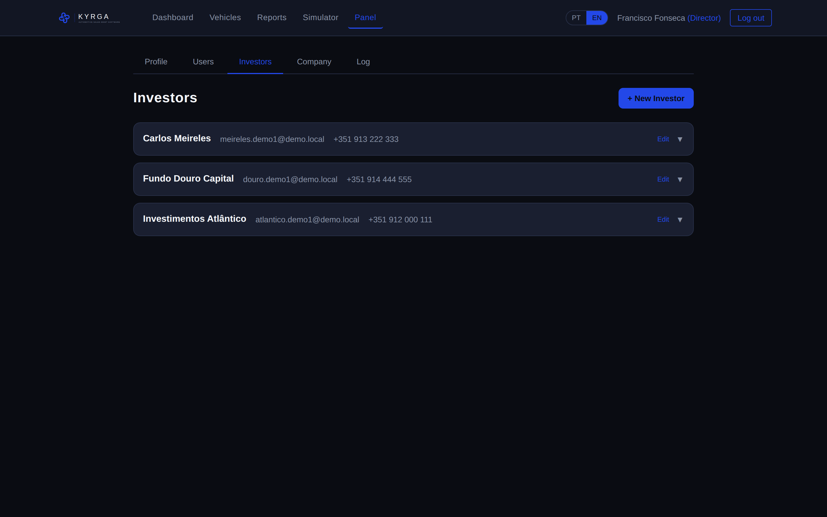
Figure 6: Investor management.

Managing investors
- In the «Panel», «Investors» tab, click «+ New Investor».
- Record each investor’s capital contributions (deposits).
- Associate vehicles with an investor when registering or editing the vehicle.
- You can invite the investor, by email, to access their own portal.

9. Reports
(Available to Directors)

Vehicles Report
Shows performance by salesperson and the sales breakdown, with margins and percentages.
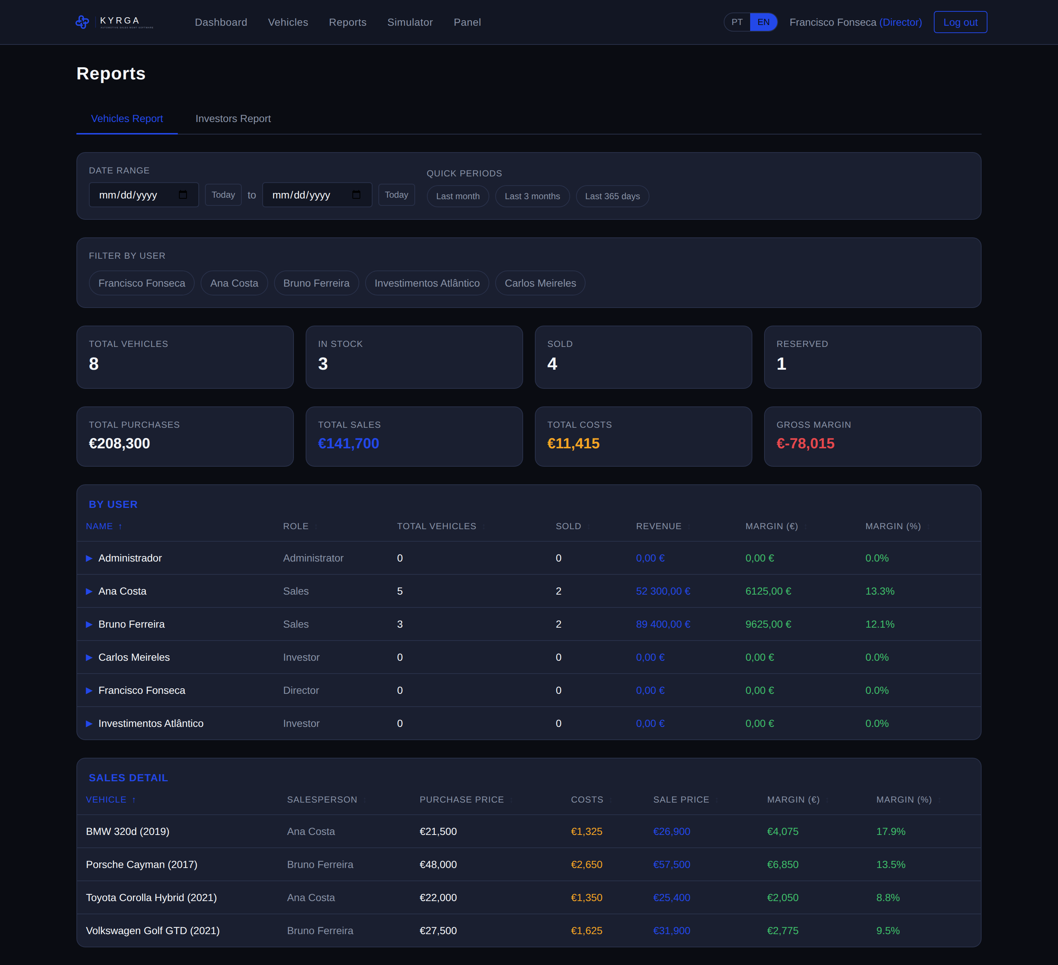
Figure 7: Vehicles report.

Investors Report
Shows each investor’s financial position: capital, vehicles, costs, sales and balance.
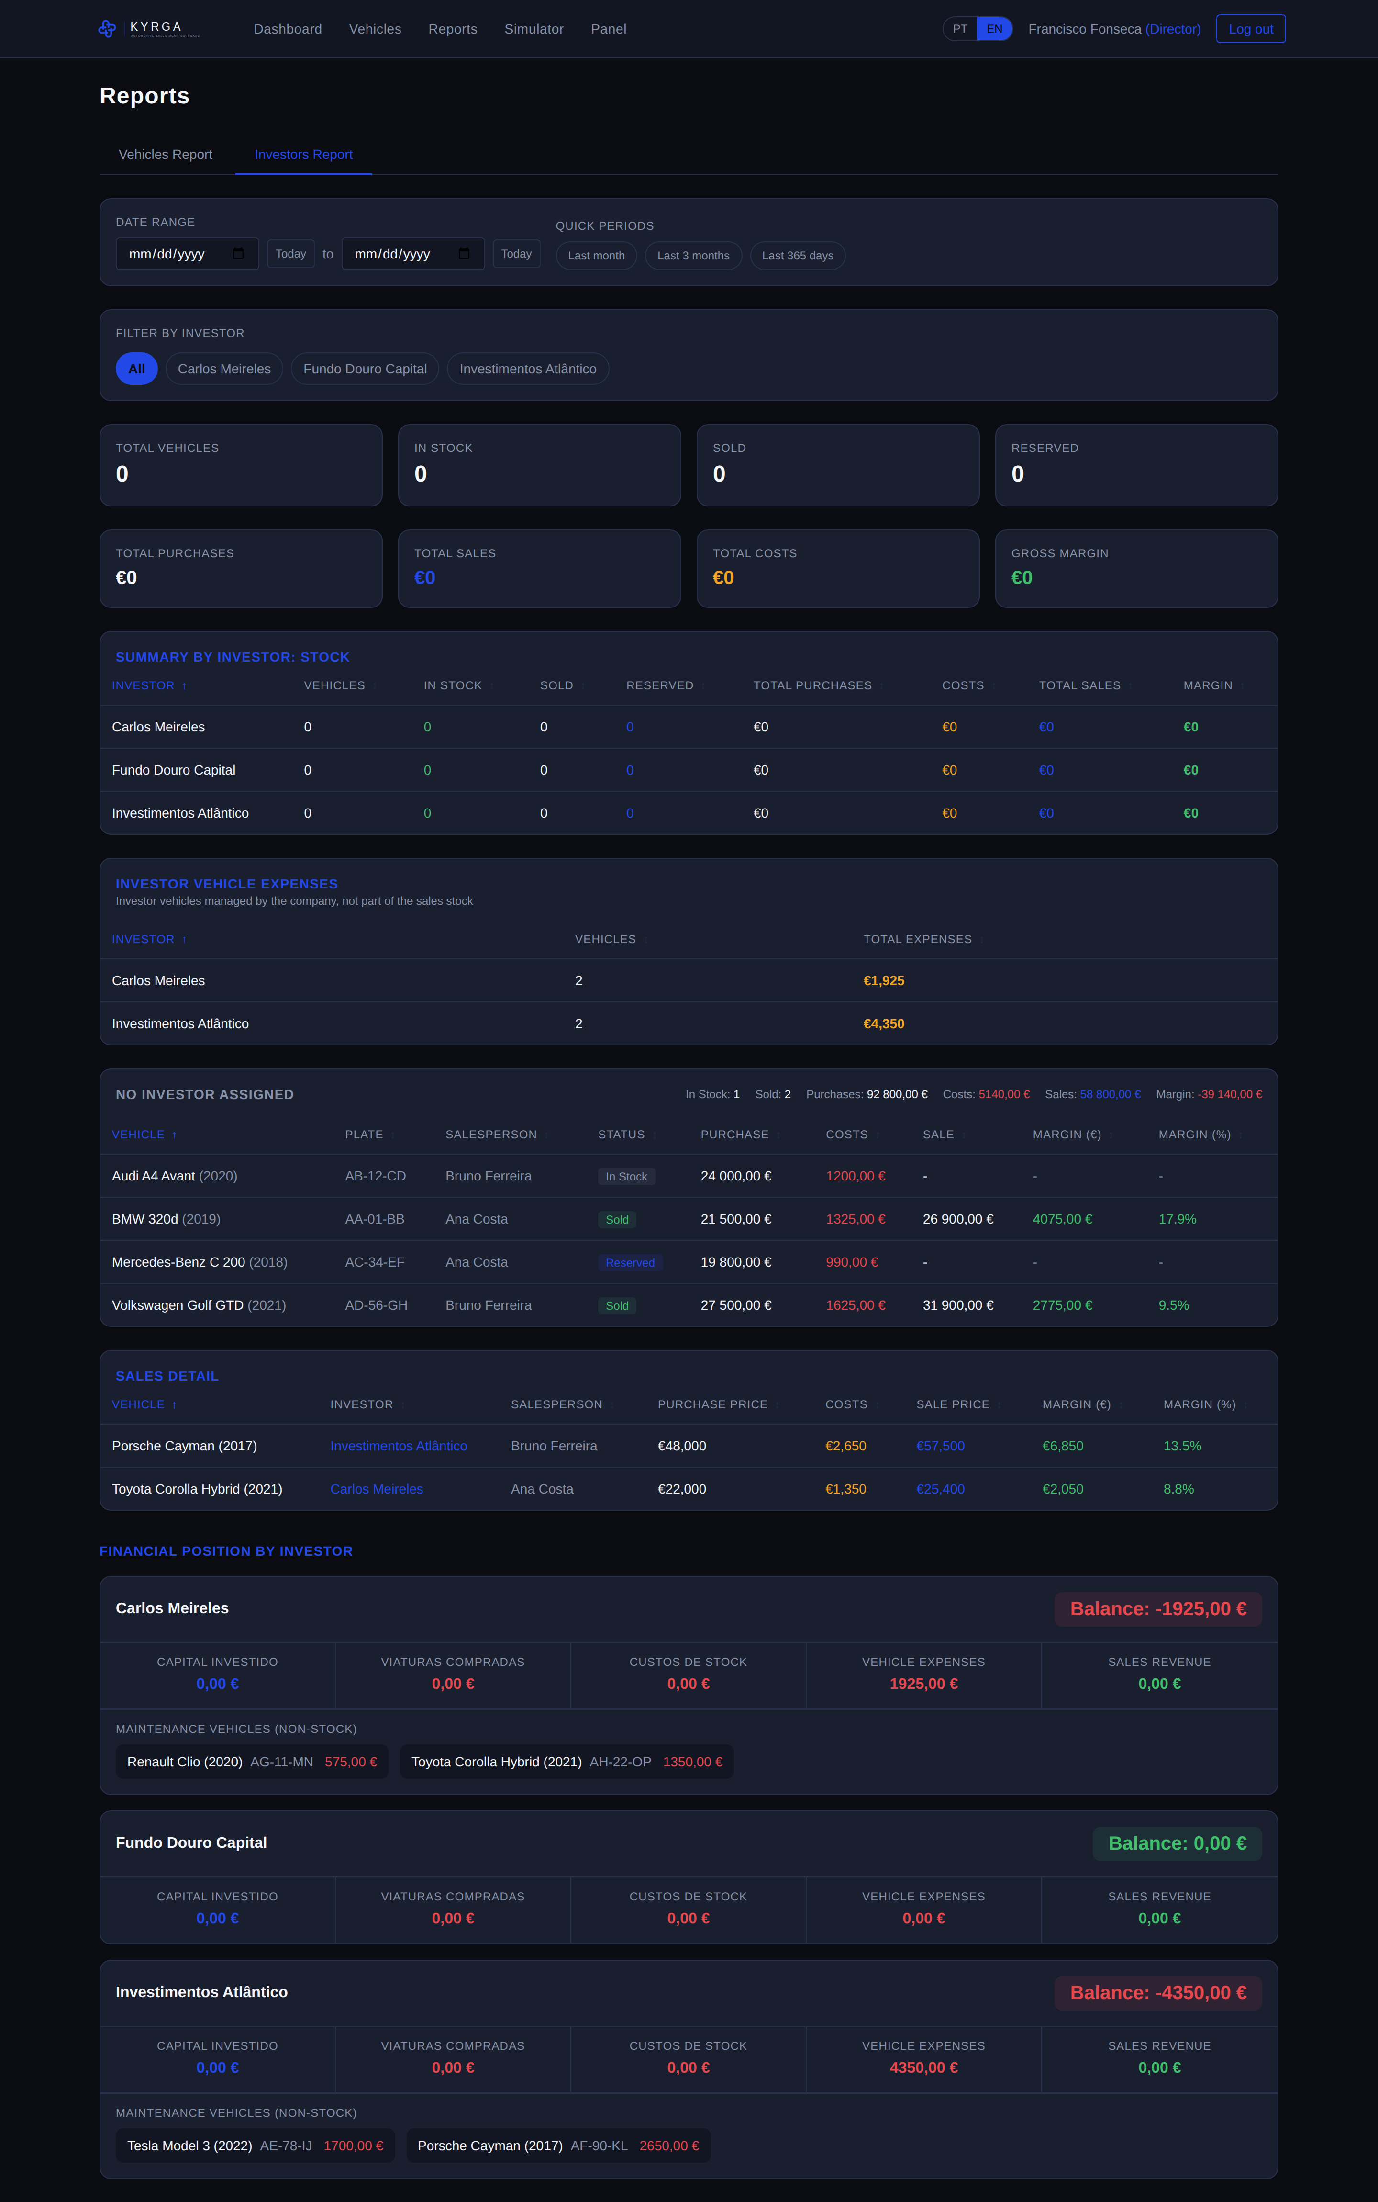
Figure 8: Investors report.

Common features
- Sorting: click any column header to sort.
- Date filter: custom range or quick buttons (last month, 3 months, 365 days).
- «Today» button: fills the date field with the current date.

10. Panel
The «Panel» menu brings together, in a single place, the personal and management settings. The available tabs depend on your role:
- Profile: your personal details and password change (all users).
- Users: team management (director).
- Investors: investor management (director).
- Company: name, logo and colour palette (director).
- Log: audit log with the ability to undo movements (director).

User Management
(Available to Directors)
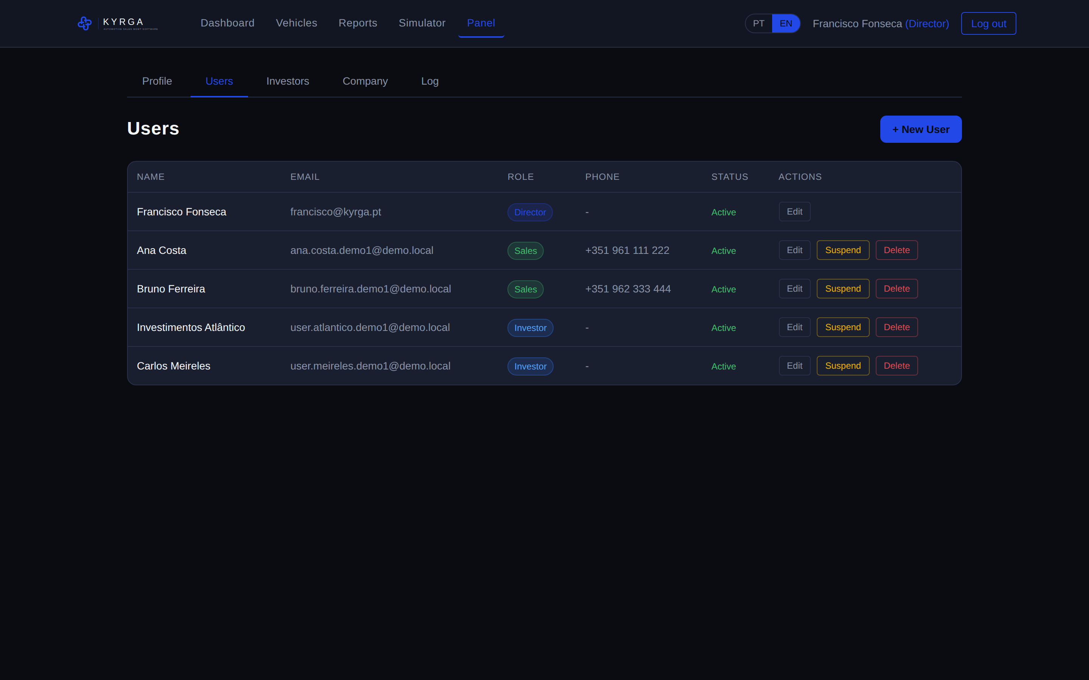
Figure 9: User management.

Creating a user
- In the «Users» tab, enter the person’s email and the intended role.
- An invitation link is generated to send to the person, who uses it to register.

Edit, suspend or delete
- Edit: change name, email, phone and set a new password.
- Suspend: blocks access (reversible with «Reactivate»).
- Delete: permanently removes the account (irreversible).
The director manages the salespeople and investors of their team. Salespeople and investors only see themselves and can change their own password.

My Profile
In the «Profile» tab, all users can view their details, update email and phone, and change their password.
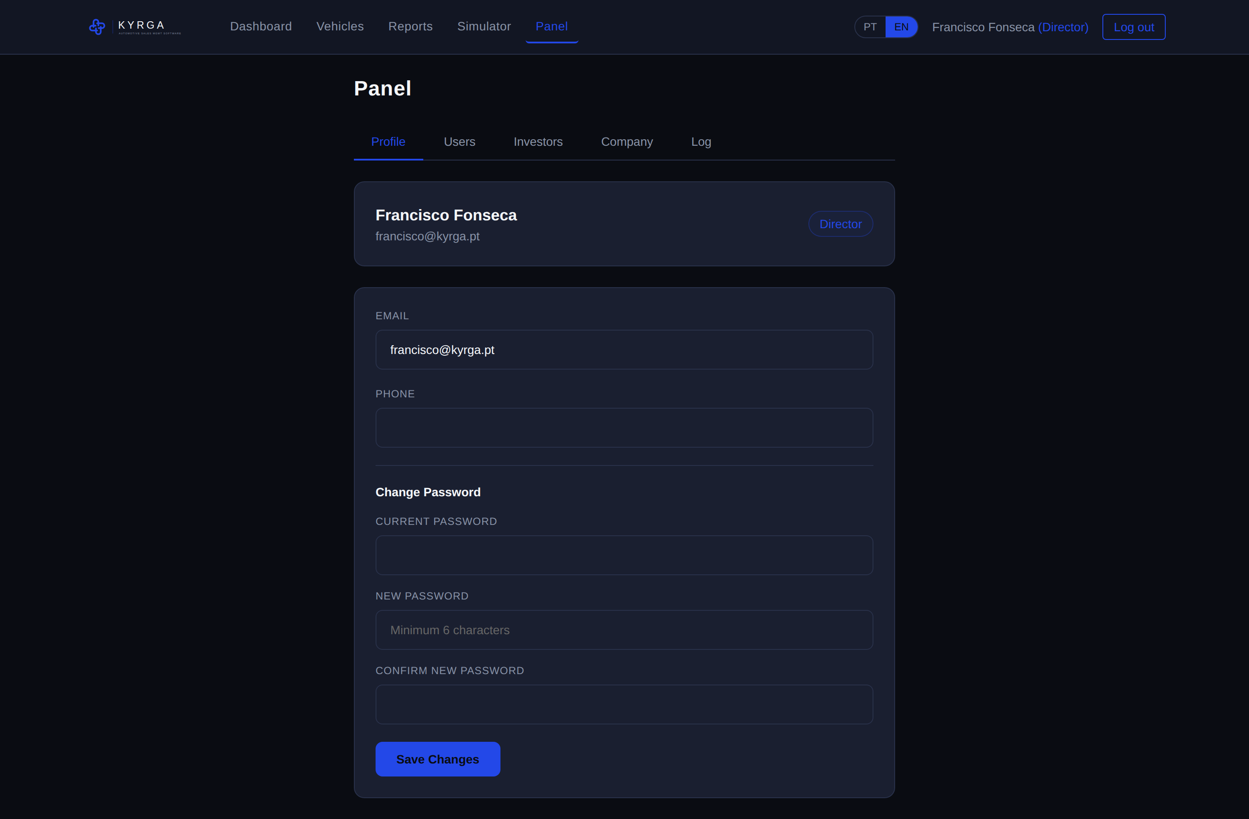
Figure 10: Personal profile page.

11. Personalising the Company (name, logo and colours)
(Available to Directors)
In the «Panel», «Company» tab, the director sets the identity of their company. These settings apply across the whole application (menu, sign-in screen and invitations).
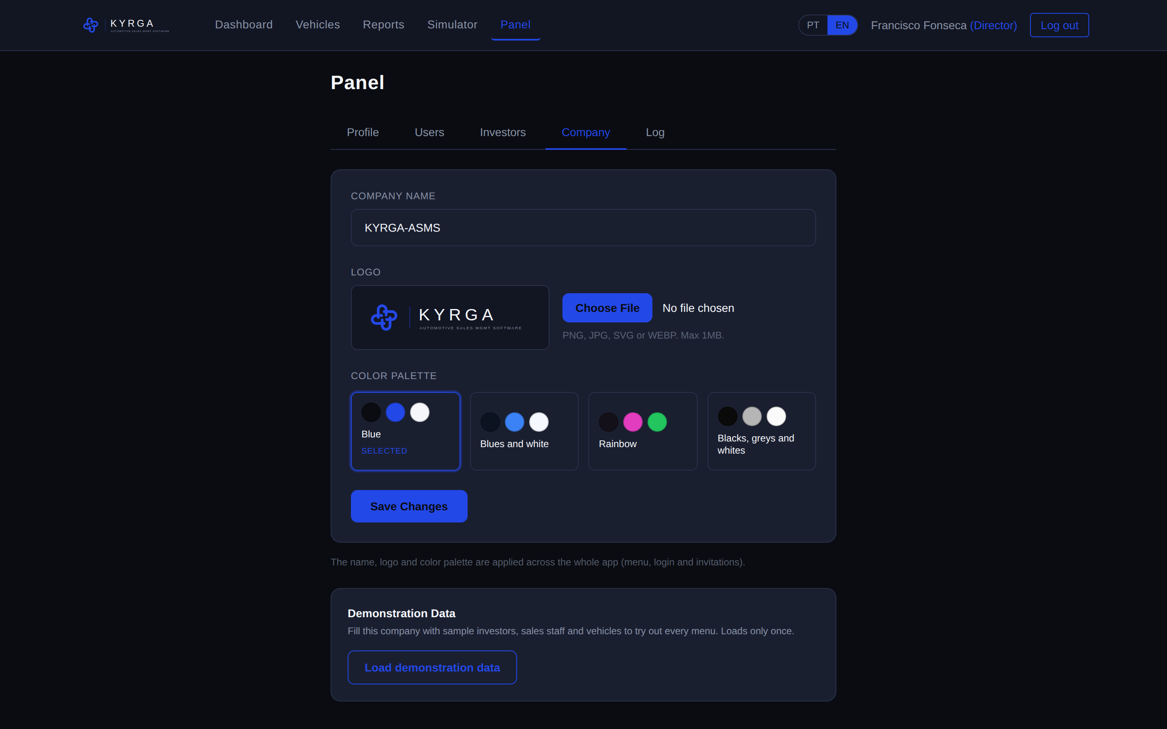
Figure 11: Company personalisation: name, logo and colour palette.

Name and logo
When a company is created, the name and logo are left undefined. On first access, the director enters the name and uploads the logo (an image file up to 1 MB). From that moment, the identity appears across the whole application.

Colour palette
You can choose the application colour palette from the following options: Gold (gold tones on a dark background), Blues and white, Rainbow (dark base with colourful accents) and Blacks, greys and whites. When you select a palette, the application shows a live preview; the colours only become final after «Save».

Demonstration data
To try out every menu, the director can load a set of sample data (investors, salespeople and vehicles) into their company. This can only be done once and the data stays isolated within the company.

12. Audit Log
(Available to Directors)
In the «Panel», «Log» tab, you find the list of all the insertions, changes and deletions made in your company, with an indication of who performed the operation and when.
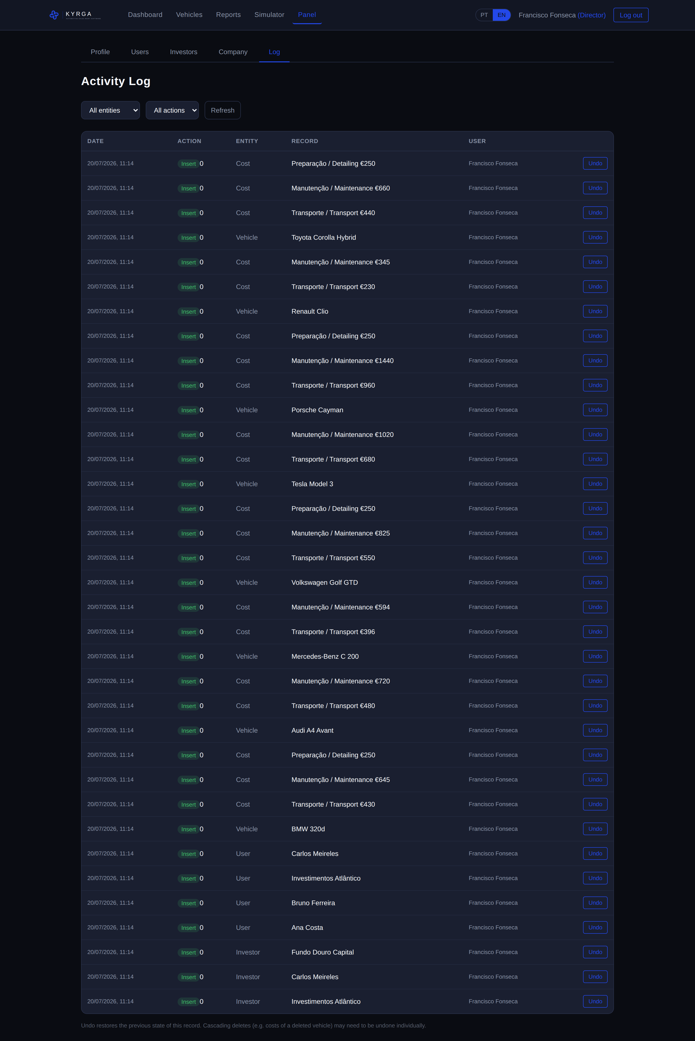
Figure 12: Company audit log.

Undoing a movement
Each movement can be undone. When undone, the operation is reverted and the entry is marked as undone. If the movement concerns a vehicle or a cost, the reversal also appears in that vehicle’s history, as an audit measure.

13. Vehicle Import Simulator
The «Simulator» menu lets you estimate the cost of importing a vehicle into Portugal.
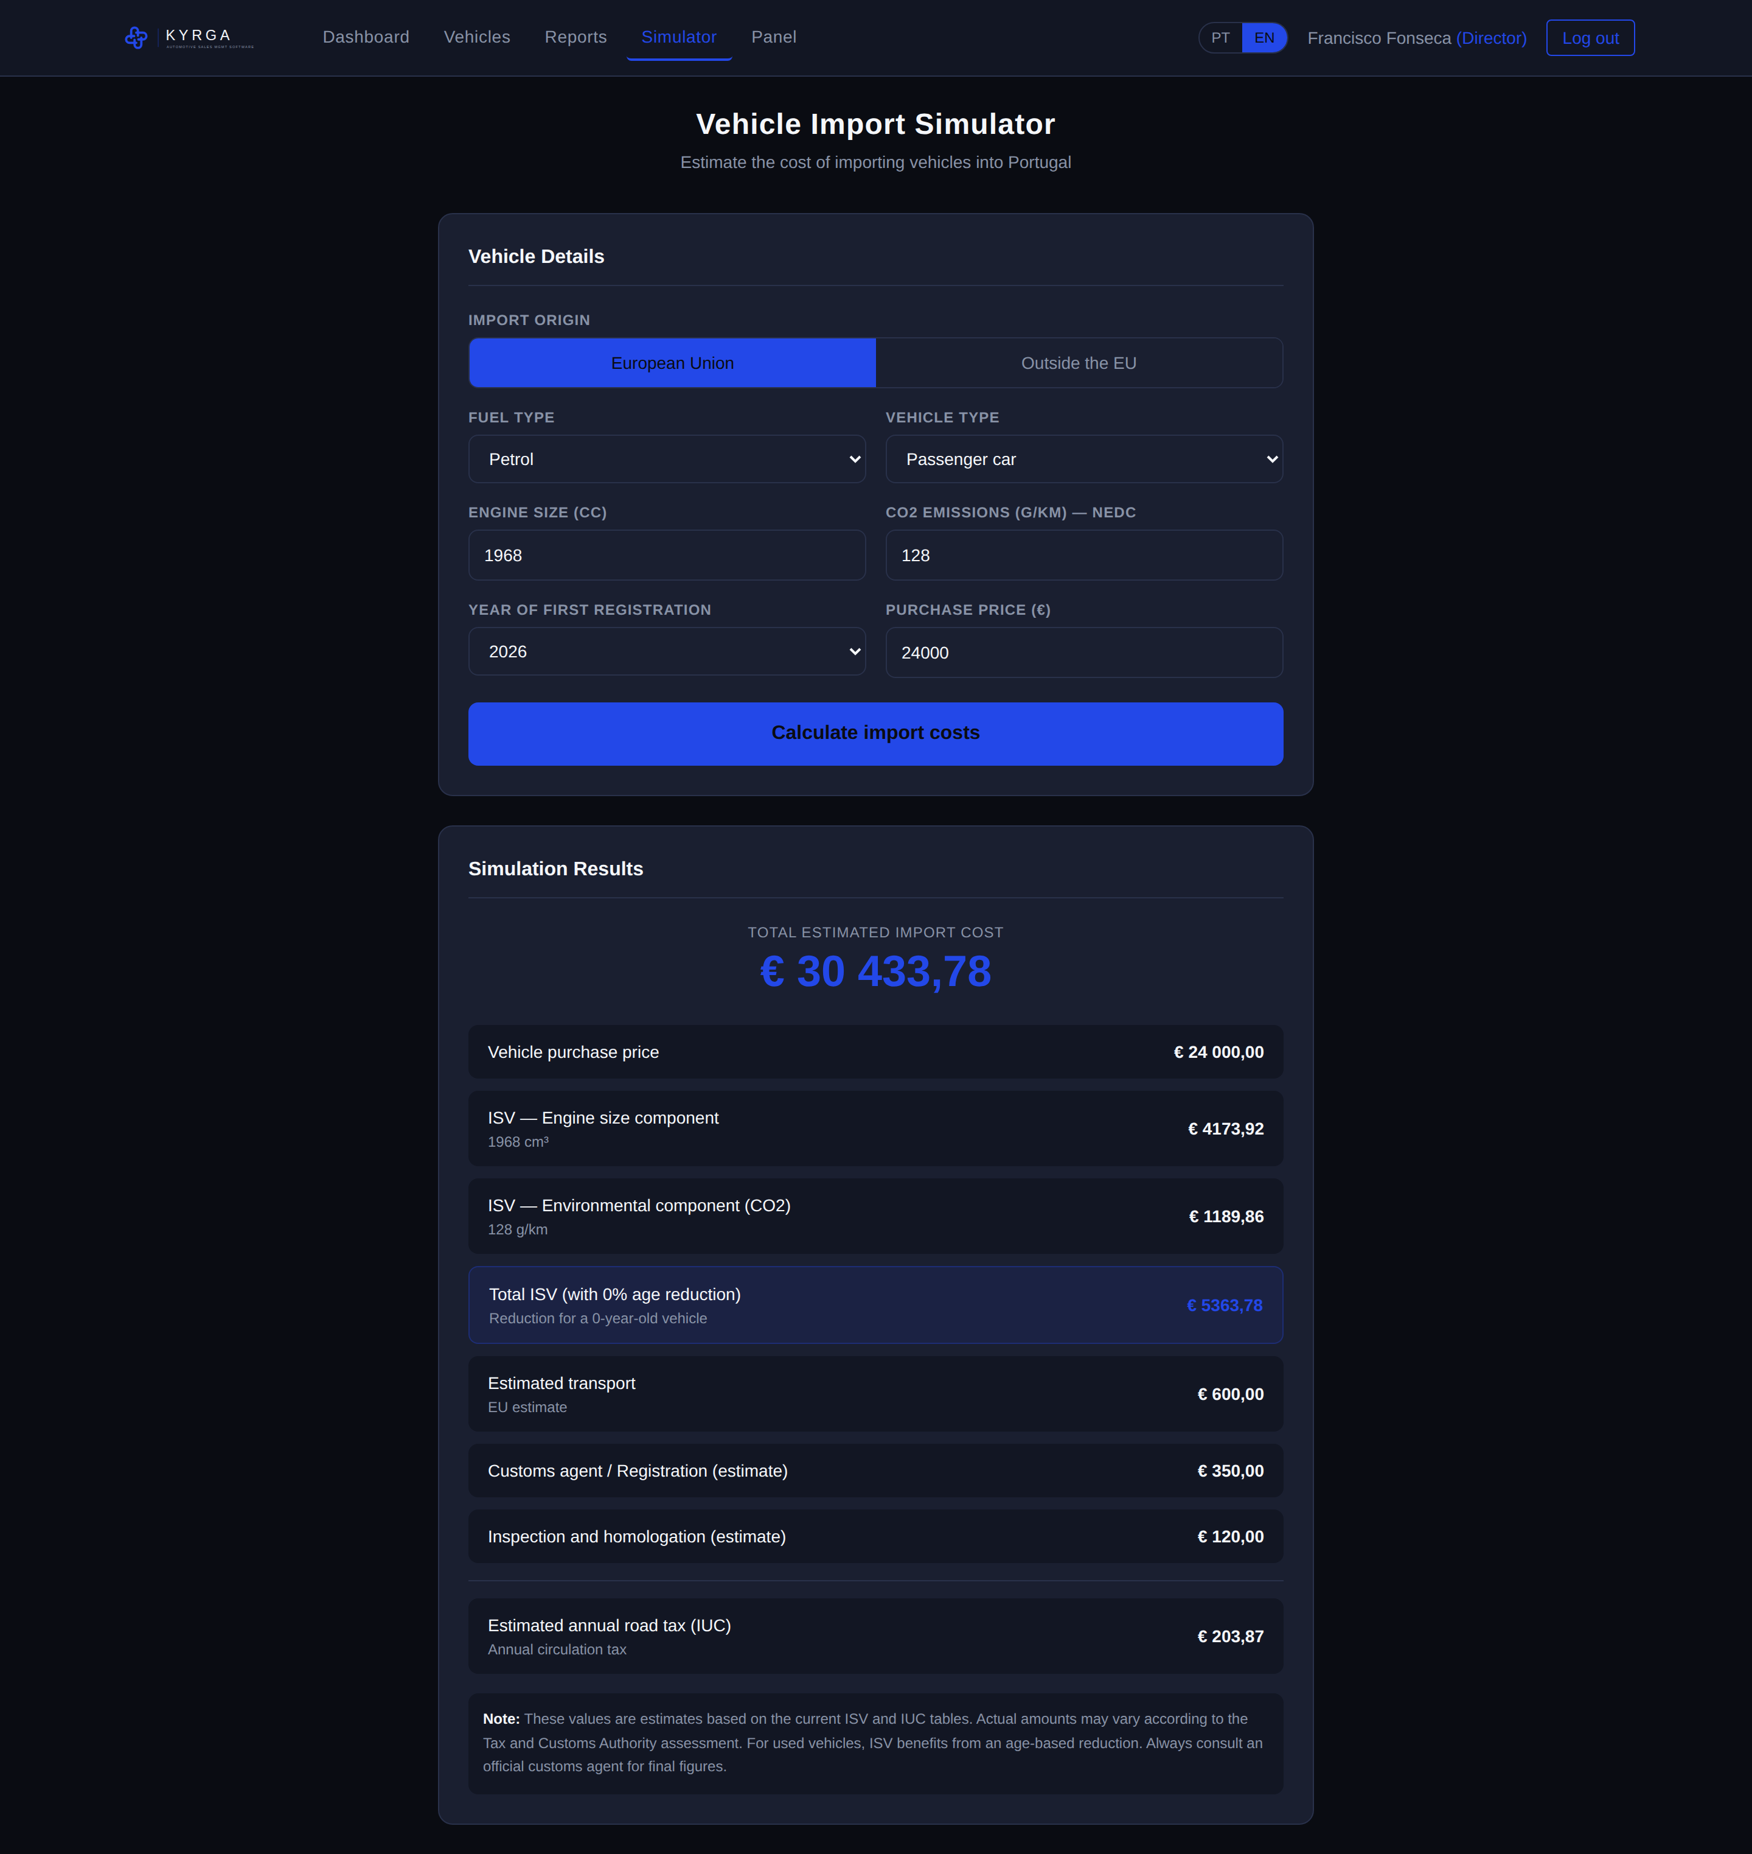
Figure 13: Import cost simulator.

How to use it
- Choose the import origin (European Union or outside the EU).
- Indicate the fuel type and the vehicle type.
- Fill in the engine size and the CO2 emissions (not applicable to electric vehicles).
- Indicate the year of first registration and the purchase price.
- Click «Calculate import costs».
The result shows the estimated ISV (engine size component and environmental component, with an age-based reduction), the customs duties and VAT where applicable, transport, the customs agent, inspection, the total estimated cost and also the estimated annual IUC.
Note: The values are estimates based on the tables in force. The actual amounts may vary according to the assessment by the Tax and Customs Authority. Always consult an official customs agent for final figures.

14. Investor Portal
(Exclusive to users with the Investor role)
When an investor signs in, they access the «Investor Portal», which shows:
- Total invested capital (contributions).
- Vehicles purchased with their investment and their status.
- Total spent on purchases and costs.
- Revenue from sales and gain or loss.
- Current account balance.
- Timeline of all movements.

15. Frequently Asked Questions
I forgot my password. What do I do?
Contact your director, who can set a new password for you.
Why can’t I see the «Users» or «Investors» tabs?
Those tabs are only available to Directors.
Can a vehicle belong to an investor and be in stock?
Yes. It can be In Stock, Reserved or Sold and belong to an investor, since the capital is theirs until the sale.
Who can see the change history?
Any user with access to the vehicle, by expanding the row in the vehicle list.
Are reversals recorded?
Yes. Each reversal is kept in the audit log and, where applicable, also in the affected vehicle’s history.
Can I change the application colours and logo?
Yes. In the «Panel», «Company» tab, the director sets the name, the logo and the colour palette.
Do I lose the data when I sign out?
No. Everything is stored in a cloud database, always available when you sign in again.
End of Manual

