On-Premises Home Lab Infrastructure Validation
Design, Implementation, Administration, Security, and Evidence Integrity
Jeremy Fontenot
Professional Technical Portfolio Documentation
jeremyfontenot.online
June 21, 2026

Abstract
I designed, implemented, secured, and validated a segmented on-premises home lab using a Dell PowerEdge R710, Proxmox VE, pfSense, Windows Server 2022, a Windows workstation, and Ubuntu Server. The environment provides virtualization, network segmentation, Active Directory Domain Services, DNS, DHCP, Group Policy, remote administration, Linux domain integration, firewall controls, snapshots, scheduled backups, and evidence-integrity validation. This document consolidates command-validated evidence exported from the Proxmox host and Linux01 together with screenshots captured during implementation and validation. Evidence files were hashed with SHA-256, packaged, transferred, and reverified to demonstrate traceability and resistance to accidental modification.
Keywords: Proxmox VE, pfSense, Windows Server 2022, Active Directory, DNS, DHCP, Group Policy, Ubuntu Server, SSSD, Kerberos, virtualization, backups, SHA-256

Table of Contents
Update this field in Microsoft Word to populate the table of contents.

Executive Summary
The lab is a small-enterprise simulation rather than a collection of unrelated virtual machines. Proxmox VE provides the virtualization and storage layer. pfSense separates the upstream household network from an isolated 10.10.20.0/24 internal lab network. DC01 provides Active Directory, DNS, DHCP, and Group Policy. WS01 is a domain workstation used for validation. Linux01 extends the environment into Ubuntu administration, Active Directory integration, Kerberos, SSSD, SSH, UFW, sudo delegation, and guest-agent management.
The June 21, 2026 evidence collection confirms the host, network bridges, storage, VM configurations, snapshots, scheduled backups, Linux01 configuration, and evidence hashes. A consolidated archive was copied to a dedicated backup disk and independently rehashed. The resulting documentation is intended as portfolio evidence of practical systems, network, identity, security, backup, and documentation skills.

Scope and Validation Method
This report documents a personal nonproduction lab. Claims are limited to data visible in retained screenshots or contained in command-generated evidence files. A configuration file proves configured state; a successful service query proves service state at collection time; a backup archive listing proves archive presence but not a full application-level restore. These distinctions are maintained throughout the report.
- Direct command output was treated as the strongest evidence.
- Configuration screens were used when the visible fields were the relevant proof.
- Failed attempts were not treated as successful validation.
- SHA-256 hashes were used to verify evidence integrity before and after transfer.
- Screenshots were selected for readability and relevance to the documented claim.

Infrastructure Overview
Component | Role | Validated identifier | Status
Dell PowerEdge R710 | Physical virtualization host | PowerEdge R710 | Implemented
Proxmox VE | Hypervisor, VM, storage, snapshots, backup | proxmox.jeremyfontenot.local / 192.168.0.242 | Validated
pfSense, VM 100 | Firewall, routing, NAT, segmentation | WAN 192.168.0.205; LAN 10.10.20.1 | Validated
DC01, VM 200 | AD DS, DNS, DHCP, Group Policy | 10.10.20.10 / dc01.ad.jeremyfontenot.online | Validated
WS01, VM 300 | Windows domain workstation | ws01 | Validated through VM and DHCP evidence
Linux01, VM 400 | Ubuntu Server and Linux administration | 10.10.20.20 / linux01.ad.jeremyfontenot.online | Validated

Network Architecture
The upstream network uses 192.168.0.0/24. Proxmox management is connected through vmbr0 at 192.168.0.242, and the pfSense WAN interface is connected to the same bridge at 192.168.0.205. The internal lab uses vmbr1 and subnet 10.10.20.0/24. pfSense provides the internal gateway at 10.10.20.1. DC01 uses 10.10.20.10 and Linux01 uses 10.10.20.20. This arrangement isolates directory, DHCP, workstation, and Linux services from the household LAN.
Network | Purpose | Key systems
192.168.0.0/24 | Upstream management and pfSense WAN | Gateway 192.168.0.1; Proxmox 192.168.0.242; pfSense WAN 192.168.0.205
10.10.20.0/24 | Isolated internal lab | pfSense LAN 10.10.20.1; DC01 10.10.20.10; Linux01 10.10.20.20

Proxmox VE Virtualization Platform
The Proxmox evidence export identifies the host as proxmox.jeremyfontenot.local and records vmbr0 as the upstream management bridge and vmbr1 as the isolated internal bridge. VM configuration exports show pfSense with two VirtIO adapters, DC01 and WS01 on vmbr1, and Linux01 on vmbr1 with the Proxmox firewall flag enabled.
VM | CPU | Memory | Disk | Network
100 - pfsense-fw | 2 cores, host CPU | 4096 MB | 32 GB | vmbr0 and vmbr1
200 - dc01 | 2 cores, host CPU | 4096 MB | 80 GB | vmbr1
300 - ws01 | 2 cores, host CPU | 4096 MB | 80 GB | vmbr1
400 - linux01 | 2 cores, host CPU | 2048 MB | 40 GB | vmbr1, firewall enabled

Storage, Snapshots, and Backups
The host uses local directory storage, a thin-provisioned local-lvm pool, and a dedicated ext4 backup disk mounted at /mnt/pve/backup-hdd. At collection time, the thin pool was approximately 21.06% utilized and its metadata was approximately 1.22% utilized. The backup disk provided approximately 916 GB total capacity.
Snapshots preserve validated milestones for each VM. The current retained snapshot names include pfsense-rdp-nat-restricted, dc01-fileshare-it-ok, ws01-localadmin-gpo-ok, and linux01-domain-joined-hardened-agent. The recurring job backup-critical-lab-vms is enabled in snapshot mode, uses zstd compression, runs Sundays at 02:00, targets backup-hdd, and includes VMs 100, 200, 300, and 400.
Control | Validated configuration
Backup job | backup-critical-lab-vms
Schedule | Sunday at 02:00
Mode | Snapshot
Compression | zstd
Storage | backup-hdd
VM membership | 100, 200, 300, 400

Windows Server 2022 and Active Directory
DC01 runs Windows Server 2022 Standard Evaluation, build 20348, as the primary domain controller for ad.jeremyfontenot.online. The forest and domain functional levels are Windows Server 2016. DC01 is a global catalog and holds all five FSMO roles: Schema Master, Domain Naming Master, PDC Emulator, RID Master, and Infrastructure Master.
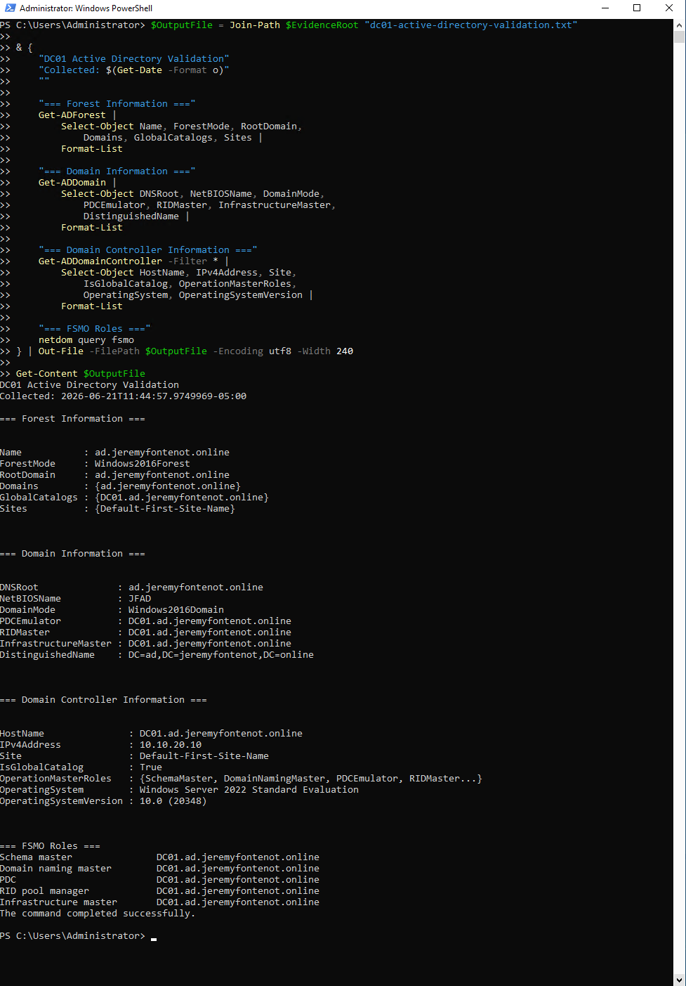
Figure 1. Active Directory forest, domain, domain controller, and FSMO role validation on DC01.

DNS Services
The DNS Server service is configured for automatic startup and was running during validation. AD-integrated forward and reverse zones are present. The ad.jeremyfontenot.online zone uses secure dynamic updates, and the reverse zone 20.10.10.in-addr.arpa is AD integrated. Forward and reverse lookup tests validated DC01 and Linux01.
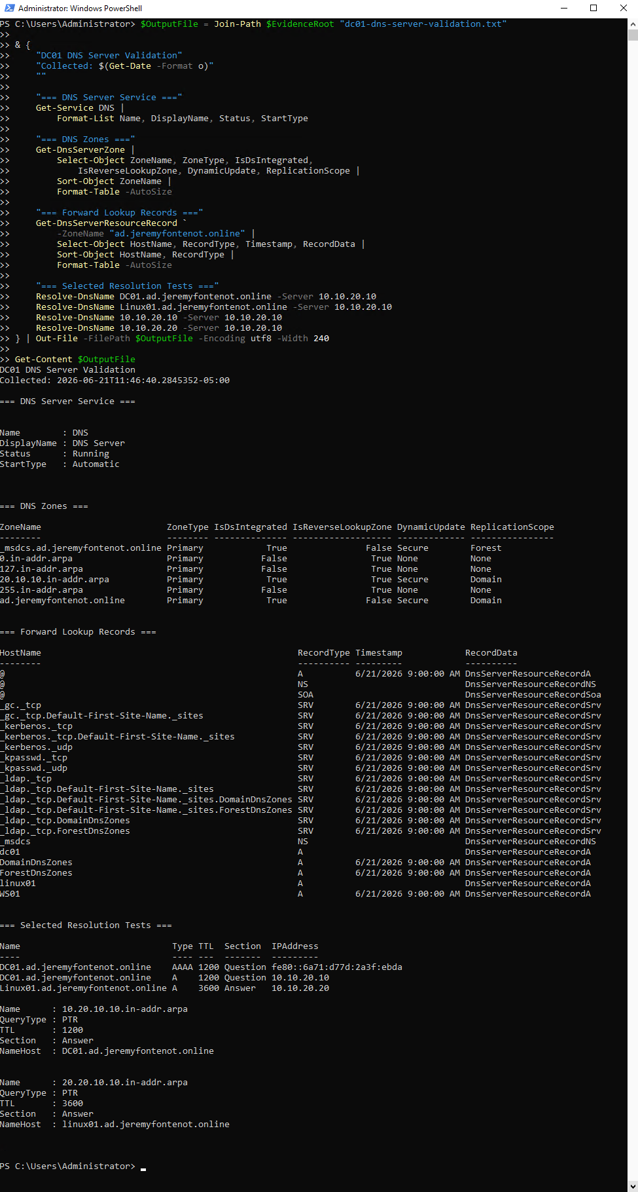
Figure 2. DNS service, AD-integrated zones, records, and forward/reverse resolution tests.

DHCP Services
DC01 is authorized in Active Directory as the DHCP server at 10.10.20.10. The active scope is 10.10.20.0/24 with a pool from 10.10.20.100 through 10.10.20.200. Scope options assign router 10.10.20.1, DNS server 10.10.20.10, and DNS domain ad.jeremyfontenot.online. The lease inventory showed active leases for WS01 at 10.10.20.100 and Linux01 at 10.10.20.101 at the time of collection.
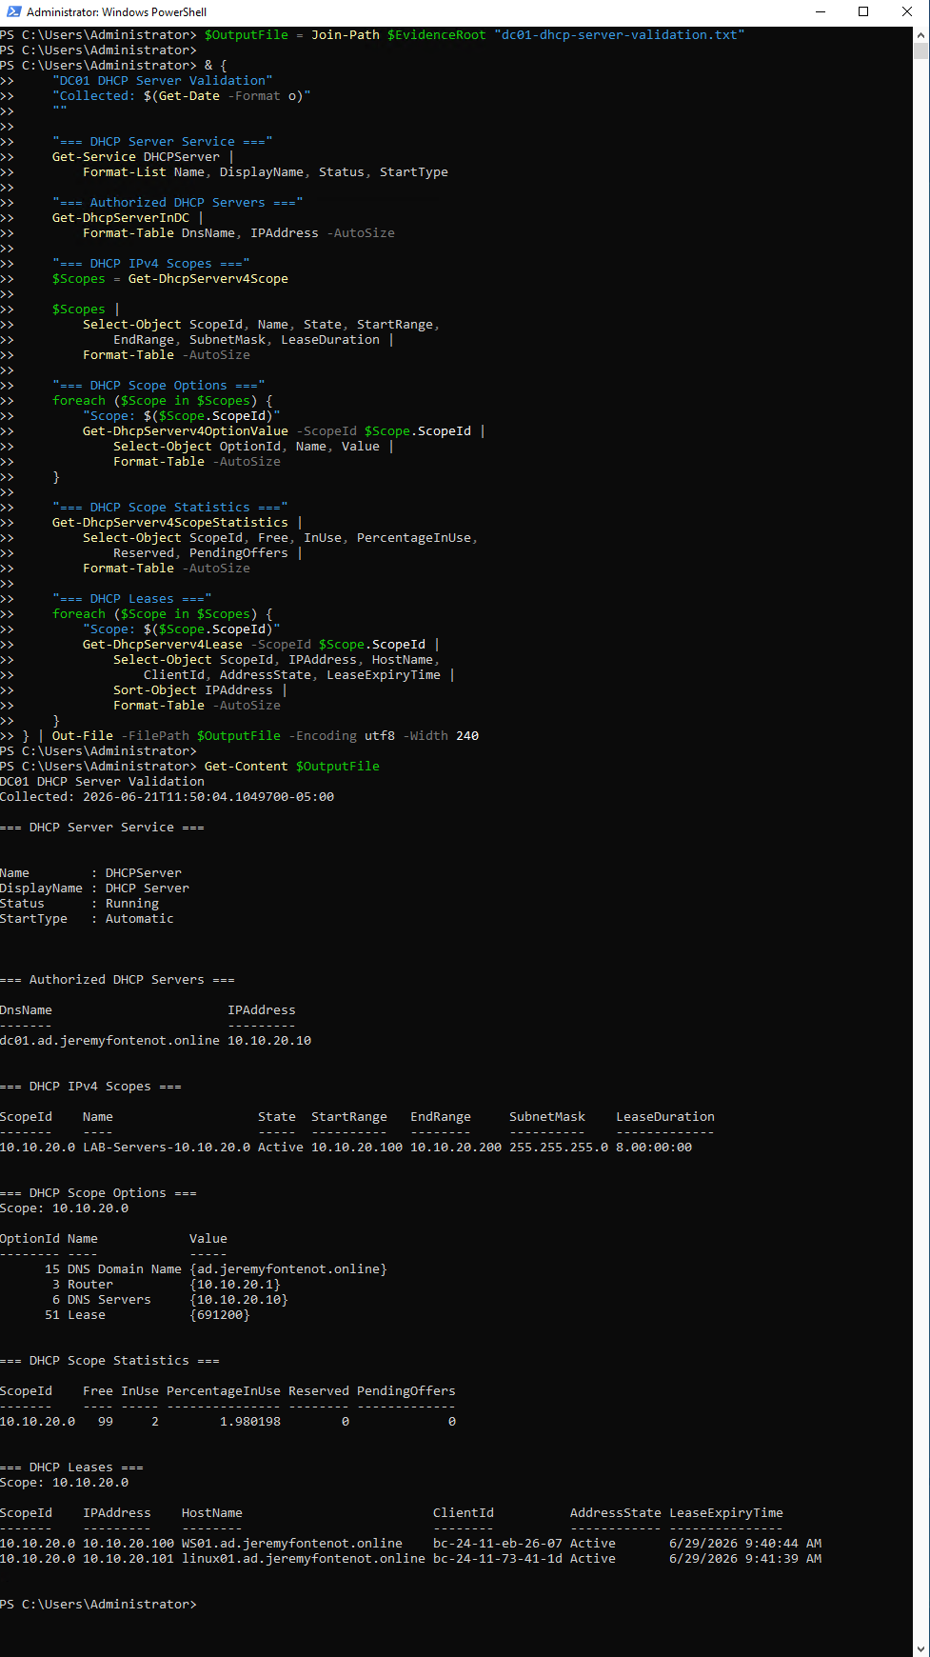
Figure 3. Authorized DHCP server, active scope, scope options, statistics, and leases.

Group Policy and Role-Based Administration
The environment uses domain-linked and OU-linked Group Policy Objects for password policy, account lockout, Windows Firewall, RDP restrictions, PowerShell logging, audit policy, Windows Update, server security, workstation security, controlled local administrators, and user drive mapping. Role-based groups are used instead of assigning permissions directly to individual users.
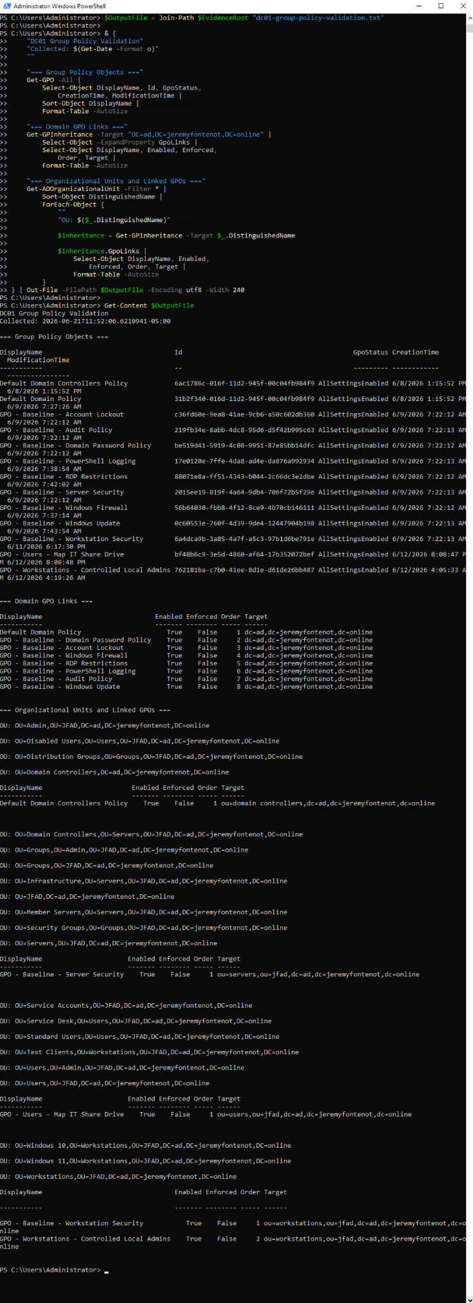
Figure 4. Group Policy Objects and domain/OU link validation.

Ubuntu Server Linux01
Linux01 is Ubuntu Server 26.04 LTS with kernel 7.0.0-22-generic. Proxmox identifies it as VM 400 with two CPU cores, 2 GB memory, a 40 GB VirtIO SCSI disk, a VirtIO network adapter on vmbr1, guest agent enabled, and VM-level firewall integration enabled. The operating system uses static address 10.10.20.20/24, default gateway 10.10.20.1, DNS server 10.10.20.10, and search domain ad.jeremyfontenot.online.
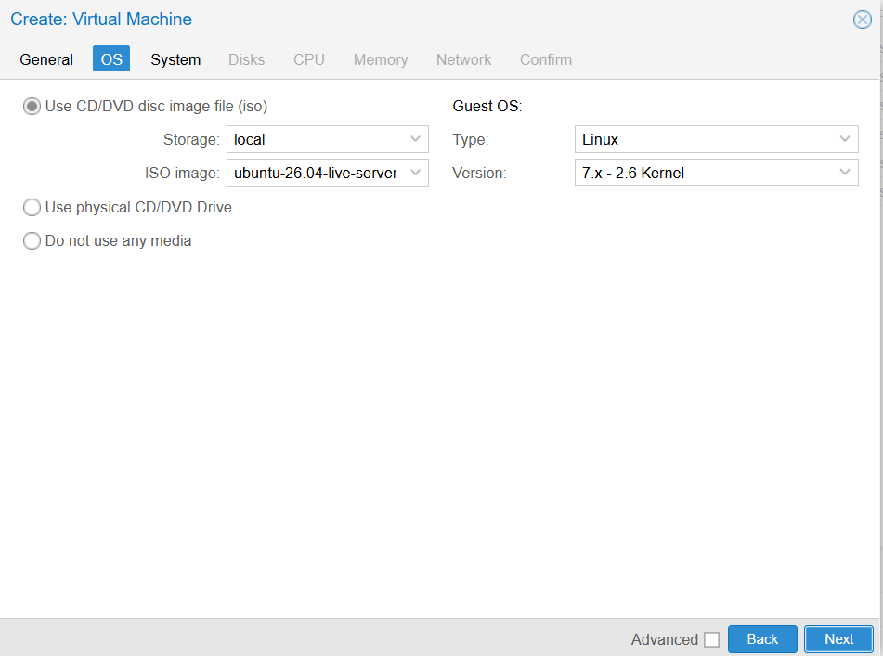
Figure 5. Ubuntu Server operating system selection and installation workflow.
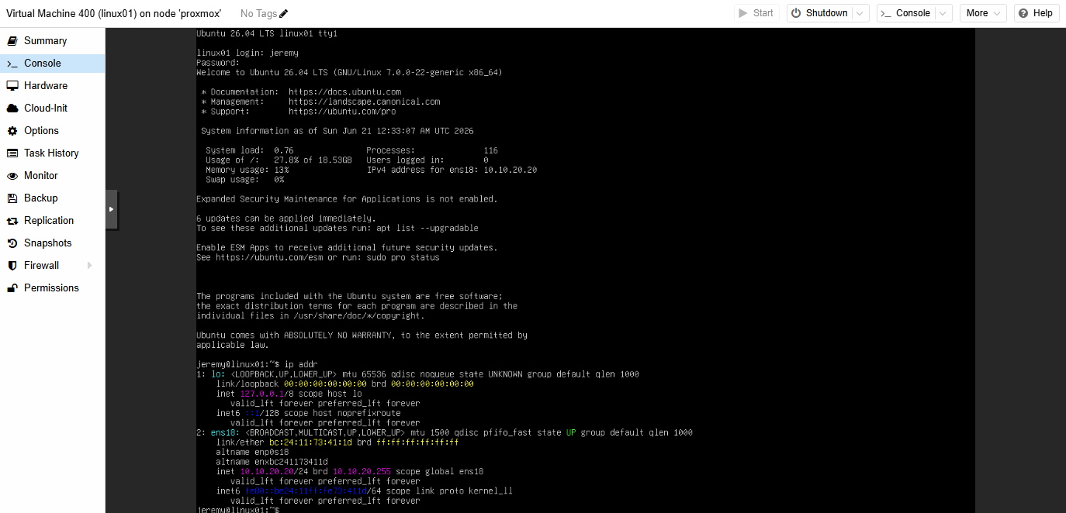
Figure 6. Linux01 static IPv4 addressing configured for the internal lab network.
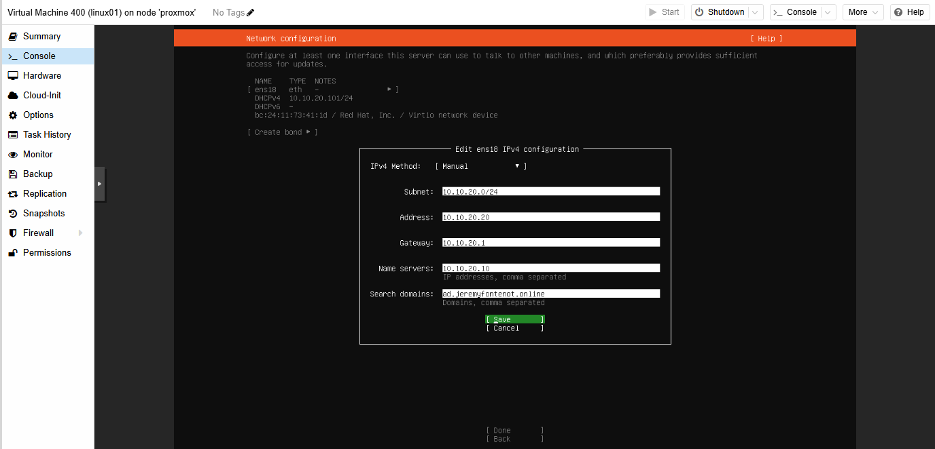
Figure 7. Linux01 network configuration using the internal gateway and domain DNS server.

Linux01 Active Directory Integration
Linux01 is joined to ad.jeremyfontenot.online as a Kerberos member using realmd, SSSD, adcli, NSS, and PAM integration. The realm permits domain logons. The jeremy.fontenot domain account resolves through NSS and belongs to Domain Users, GG-Lab-Admins, GG-RDP-Allowed, Domain Admins, and related replication-control groups. SSSD was both enabled and active.

Linux01 DNS and Kerberos Validation
Forward resolution maps linux01.ad.jeremyfontenot.online to 10.10.20.20, reverse resolution maps 10.10.20.20 back to the Linux01 FQDN, and the domain controller resolves to 10.10.20.10. A valid Kerberos ticket-granting ticket was present for jeremy.fontenot@AD.JEREMYFONTENOT.ONLINE.

Linux01 Security and Maintenance
UFW was active with a default deny policy for incoming connections and an allow policy for outgoing connections. SSH on TCP 22 was limited to 10.10.20.0/24. SSH was enabled and active. The base sudoers file and the domain-admins drop-in parsed successfully, and a delegated sudo test returned root. The QEMU guest agent package was installed and active. No reboot was required at collection time.

Evidence Collection and Integrity
Linux01 evidence files were generated in a dedicated directory, hashed, and packaged into linux01-evidence-2026-06-21.tar.gz. The archive SHA-256 digest was 5c1eff369a0055338808a93c025847cc5997db4f04614a56ede33b43f9e9b8db. The archive was transferred from Linux01 to Proxmox with SCP and rehashed after transfer; the digest matched exactly.
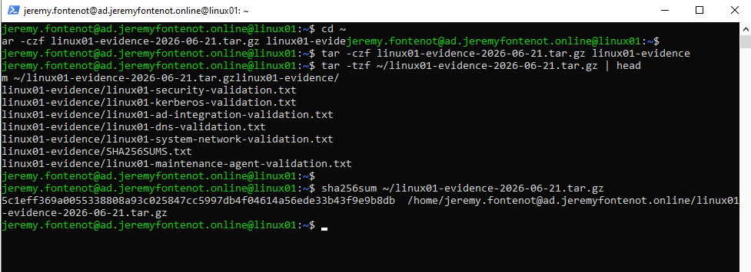
Figure 8. Linux01 evidence archive contents and SHA-256 digest generation.
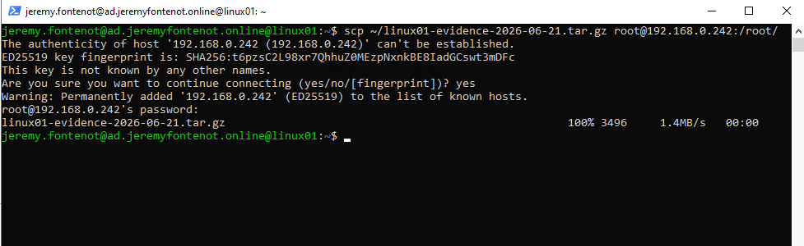
Figure 9. Successful secure copy of the Linux01 evidence archive to the Proxmox host.
The central evidence directory was then repackaged as homelab-evidence-complete-2026-06-21.tar.gz. Its SHA-256 digest was e8a5a40a6960557383ccb152af2da71053e50382d8287d632b9ed5ad85cb7060. A copy was stored on the dedicated backup disk under /mnt/pve/backup-hdd/evidence-bundles, and the destination hash matched the source.

Current Validated State
Area | Validated state | Evidence strength
Hypervisor | Proxmox host, bridges, storage, VM configuration exports | Direct command evidence
Firewall and segmentation | pfSense dual-interface VM and isolated internal network | Configuration and screenshots
Identity | Single-domain AD forest, DC01 global catalog, all FSMO roles | Direct command evidence
DNS | AD-integrated forward/reverse zones and successful Linux01/DC01 lookups | Direct command evidence
DHCP | Authorized server, active scope, options, statistics, WS01/Linux01 leases | Direct command evidence
Group Policy | Domain and OU linked security/operations GPOs | Direct command evidence
Linux | Ubuntu, static network, AD join, SSSD, Kerberos, UFW, SSH, sudo, agent | Direct command evidence
Backups | Scheduled VM backup job and archive inventory including VM 400 | Direct command evidence
Evidence integrity | Nested and consolidated SHA-256 manifests plus transfer verification | Cryptographic hash evidence

Skills Demonstrated
- Enterprise virtualization and VM lifecycle administration with Proxmox VE.
- Layer 2 and Layer 3 network design, segmentation, routing, NAT, and firewall administration.
- Windows Server 2022 deployment and Active Directory forest/domain administration.
- DNS, DHCP, Group Policy, role-based access, and remote administration.
- Ubuntu Server installation, static networking, SSSD/realmd domain integration, Kerberos, SSH, UFW, and sudo.
- Snapshot and scheduled-backup administration with validation of archive presence and storage capacity.
- Evidence handling, SHA-256 integrity verification, secure transfer, and professional technical documentation.

Limitations and Risk Treatment
This environment contains one domain controller and is not designed for production availability. Local snapshots are rollback points rather than independent backups. Backup archive presence does not replace an isolated restore test. Direct RDP port forwarding should remain restricted to a trusted administrative source or be replaced with a VPN. The lab is intentionally scoped as a personal skills-validation environment.

Recommended Next Steps
- Perform and document an isolated restore of one Windows VM and Linux01 to alternate VM IDs.
- Export and retain a current pfSense configuration backup and rule inventory.
- Replace direct RDP forwarding with VPN-based administrative access where practical.
- Add centralized log collection and alerting for Windows, Linux, pfSense, and Proxmox.
- Implement a second domain controller only if the lab is expanded to test replication and resilience.

Conclusion
The completed lab demonstrates a coherent infrastructure stack across hardware, virtualization, networking, identity, Windows administration, Linux administration, security controls, snapshots, backups, and evidence integrity. The command-generated records and retained screenshots provide verifiable support for the documented configuration and show a repeatable process of implementation, validation, correction, and preservation.

Appendix A: Evidence File Inventory
Evidence file | Size
SHA256SUMS.txt | 1,752 bytes
backups/proxmox-backup-validation.txt | 12,573 bytes
backups/vm-400-backup-validation.txt | 565 bytes
guest-bundles/linux01-evidence-2026-06-21.tar.gz | 3,496 bytes
host/proxmox-host-validation.txt | 7,978 bytes
networking/proxmox-network-validation.txt | 374,989 bytes
snapshots/vm-100-snapshots.txt | 378 bytes
snapshots/vm-200-snapshots.txt | 423 bytes
snapshots/vm-300-snapshots.txt | 404 bytes
snapshots/vm-400-snapshots.txt | 462 bytes
storage/proxmox-storage-validation.txt | 5,519 bytes
vm-configs/vm-100-configuration.txt | 589 bytes
vm-configs/vm-200-configuration.txt | 643 bytes
vm-configs/vm-300-configuration.txt | 643 bytes
vm-configs/vm-400-configuration.txt | 593 bytes

Appendix B: Key SHA-256 Digests
Artifact | SHA-256
Linux01 evidence archive | 5c1eff369a0055338808a93c025847cc5997db4f04614a56ede33b43f9e9b8db
Complete evidence archive | e8a5a40a6960557383ccb152af2da71053e50382d8287d632b9ed5ad85cb7060

Appendix C: Key Validation Commands
pvesh get /cluster/backup
pvesm status
qm config 100; qm config 200; qm config 300; qm config 400
qm listsnapshot 100; qm listsnapshot 200; qm listsnapshot 300; qm listsnapshot 400
realm list
id jeremy.fontenot@ad.jeremyfontenot.online
getent passwd jeremy.fontenot@ad.jeremyfontenot.online
resolvectl status
klist
ufw status verbose
systemctl is-enabled ssh sssd qemu-guest-agent
systemctl is-active ssh sssd qemu-guest-agent
sha256sum linux01-evidence-2026-06-21.tar.gz

