We tested for social learning using 56 female *E. striolata* tested in two batches of 28 lizards. We used only females to control for sex effects and because we assumed there would be less conflict and/or social feedback that might constrain social learning. All lizards were collected from the wild in 2013-14 from near Albury (lat long) and maintained in outdoor enclosures while being used in a separate study. During social learning trials, we paired lizards in opaque plastic tubs (690 L)×470(W)×455(H) mm) separated in half by a fixed transparent Perspex- and a removable opaque wooden divider. This allowed us to always keep lizards physically separated while also controlling when they viewed each other. We conducted two trials a day, in the morning (0900-1130 h) and the afternoon (1330-1600 h), with a 2 h interval between trials. All trials were conducted in the lizards home enclosures and were filmed using CCTV cameras (Digital Video Recorder, model no. H. 264).

1. Social demonstration experiments

We followed the same basic protocol as Noble *et al.* (2014). We first trained all lizards to eat baby food (Heinz®, fruity pear flavor) from an open dish (hereafter well; diameter: , height: ) mounted on a small wooden block (Fig. 1). We also covered the well in black tape to prevent the lizard from seeing its contents. At the onset of a trial, we removed the opaque divider, observer lizard’s refuge and water bowl in order to provide an unobstructed view of the demonstrating lizard. After one hour of viewing, the opaque divider was replaced to separate lizards and give the observer lizard the opportunity to perform the task. Lizards were allocated to either a social demonstration (n=15) or social control (n=13) group. In the social demonstration treatment, the observer lizard viewed the demonstrator access the food reward by displacing a cover from the reward-containing well while the control group observed lizards in the absence of any wells. In the case of trials with two wells, the lid was fixed to the incorrect well, thereby preventing the demonstrator from removing it. As a consequence, the observer always received reliable information because it only saw the demonstrator displace the correct lid.

1. Instrumental task

We presented lizards with a single well covered by a yellow lid. We trimmed the lid’s lip to ensure that lizards could displace it without too much manipulation and covered the outside of the well with black tape prevent the lizard from seeing the food. Observer lizards (n=28; 15 social and 13 control) were required to displace an opaque yellow lid off the dish to get the food reward (figure 1a). Lizards were given a maximum of 10 trails to complete the task. And when they successfully displaced the lid in 6/6 trails, the lizards were considered to have learnt this task. All the observer lizards learnt the task in 10 trails.

1. Association task and reversal

We tested for social learning in an associative learning task by presenting observer lizards with a choice of two differently coloured wells, only one of which contained a food reward (figure 1b). The reward-containing well was covered with a blue lid while the remaining well was covered with a white lid and also contained food. Food in the incorrect well was made inaccessible by wire mesh, thereby allowing us to control for any olfactory or vomeronasal cues that might reveal the correct well. We counter-balanced the location of the blue lid across treatments and the position of the blue lid was decided by random across trials. For each trial, we scored: (1) whether or not the lizard chose the correct (blue) dish; (2) latency to choose the correct dish; and 3) whether the lizard displaced the lid from only the correct well or from both wells. Lizards were considered to have learnt the association task if they chose 7/8 consecutive trails correctly. We gave the lizards a total of 26 trails to learn this task. All the lizards learnt the association task in 26 trails.

Once lizards met our learning criterion (7/8?) we presented them with a reversal in which the food reward was accessible from the white well and not the blue well (figure 1 c). We gave the lizards a total of 20 trails to learn this task.

Statistical analysis

Trained demonstrator experimental

Task 1 Instrumental task

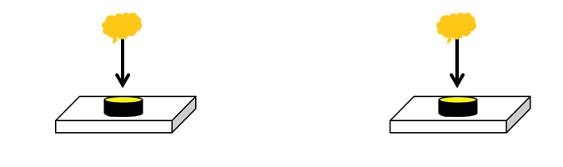

Task 2 Association task

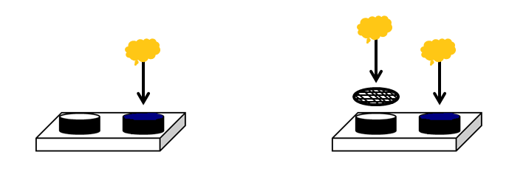

Baby food in blue only Baby food in both dishes,

and only blue can be opened by lizard and steel mess block food in white

Task 3 Reversal task

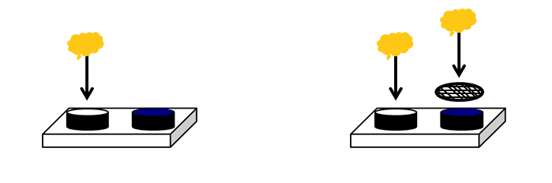

Baby food in white only Baby food in both dishes,

and only white can be opened by lizard and steel mess block food in blue