Nios Avalon UART with FIFOs
Updated 26 Jun 2010

Abstract
The Nios UART is a great little UART. It is much smaller than the 16550 style UARTs. However many times it would be handy to have input and output FIFOs. I have created a New UART base on the standard Nios UART which does exactly that

Introduction
This extended UART is based on the Altera Avalon UART for the Nios processor. In fact, with no special features selected it should generate the same exact Verilog and VHDL. Simulation works the same as the standard Nios as well. This latest version was updated to be compatible with the new _hw.tcl flow used in 8.0 and beyond. However in order to get the correct clock the API call used is only available in 9.1 and later. So this component will only work with quartus/SOPC_Builder 9.1 and later. Note: All my testing has been done with verilog. If there are any VHDL issues let me know and I can usually fix them quickly.

Added Features from the Altera UART
- Added the option to add FIFOs to the transmit and receive pipes.
- Ability to export the use signals on the FIFO for external interrupt generation.
- Ability to not connect the IRQ signal to the Avalon switch fabric and instead export it for use in other logic.
- A hardware controlled CTS – useful for handshaking. ( no software is needed to manage )
- Transmitting pin useful for RS485. It is asserted when there is something in the tx fifo or the tx shift register.
- IRQ based on FIFO depths
- Timer which will force the rx IRQ is a character is orphaned in the rx FIFO for more than a preprogrammed period of time
- Programmable Gap detection. If a character does not arrive within a specified number of character time periods an interrupt can occur.
- Timestamp is now available.
- The driver now supports the new ISR API which is new in 9.1. So the VIC is supported.
- The component is now 32 bits wide

Installation
The FIFOed UART can be place in any of several places. When you unzip make sure you don’t have a Make sure that you don’t have too many folders named Fifoed_avalon_uart9.3 inside of one another.
1- Place the folder Fifoed_avalon_uart in to the standard components directory
C:\altera\x.x\IP\uart
The SOPC_Builder will automatically search for components in any subdirectory under the IP directory. ( do not place it in the altera subdirectory this one has a fixed mapping)
2- Or you can place it in the ip subdirectory under your current project.
3- You can also place it anywhere else you want but you will need to tell SOPC_Builder the path. ( Tools/options)
Then next time you launch SOPC builder you will have a new component in the Interface Protocols/Serial called Fifoed Uart(RS-232 serial port)9.3
Software Driver.
I have seen it where the BSP Editor does not find the software driver. If it has trouble, do the following.
Open the BSP editor and go to Tools/options and select BSP Component Search Paths and select the button Custom Component Search Paths … and then add and direct the path to the fifoed uart and select recursive.

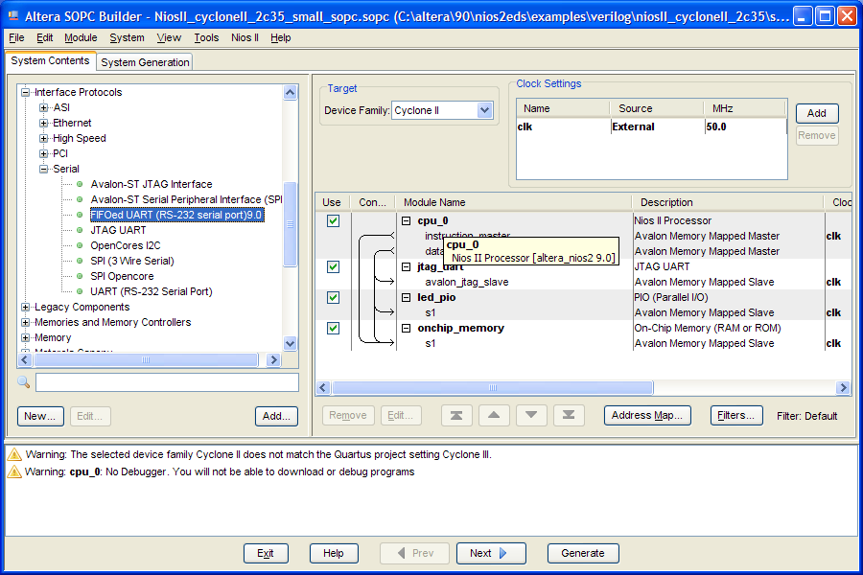

Changes from the Altera UART
GUI
The GUI has been totally changed. It now uses the standard _hw.tcl interface with it’s simplified editing commands. All the standard Avalon UART options are the same and listed first in the Edit Dialogue Box. Anything below the TX FIFO usage is custom logic I have added. 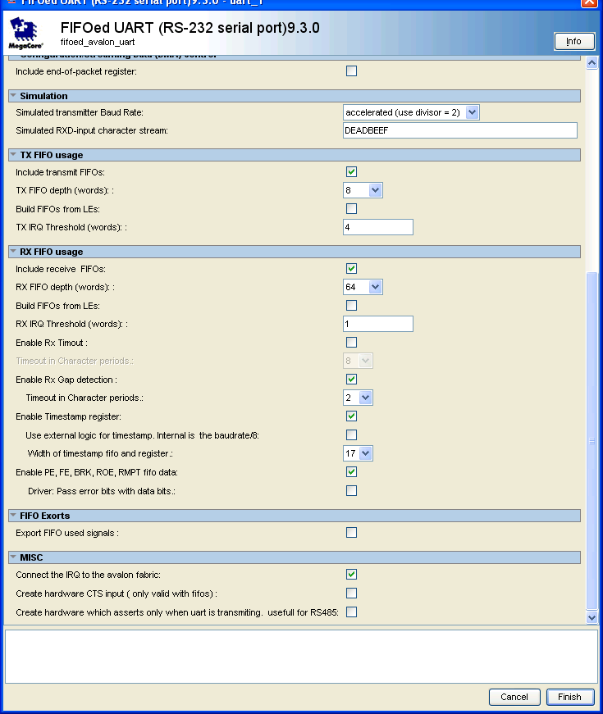
TX FIFO usage
- “Include transmit FIFOs” If selected this option turns on the generation of the Tx FIFOs. If you do not include FIFOs you will generate a standard Nios UART.
- “Tx FIFO depth”. You can select how many words you want to store in the FIFOs. These are implemented as FIFOs.
- “Build FIFOs from LEs” This option allows you to use LE resources for the FIFOs rather then memory blocks in the FPGA.
- “TX IRQ Threshold (words)” When the number of chars stored in the tx fifo is equal to or less than this amount the TRDY IRQ will be asserted. Setting to 1 will disable this feature.

RX FIFO usage
  - “Include receive FIFOs” If selected this option turns on the generation of the Rx FIFOs. If you do not include FIFOs you will generate a standard Nios UART.
  - “RxFIFO depth”. You can select how many words you want to store in the FIFOs. These are implemented as FIFOs
  - “Build FIFOs from LEs” This option allows you to use LE resources for the FIFOs rather then memory blocks in the FPGA.
  - “RX IRQ Threshold (words)” The RRDY IRQ will be asserted once there is at least this number of chars in the rx FIFO. (Setting to 1 will disable this feature)
  - “Enable Timeout” This adds extra logic which starts counting as soon as anything is in the rx fifo. Anytime something new is added the counter is reset and starts from zero again. The exact timeout length is calculated by the following equation; ( (Timeout in chars periods) *8)/(baud rate) is seconds. When the timeout occurs the RRDY IRQ will be asserted provided it is enabled. The purpose of this logic it prevent characters from being orphaned in the receive FIFO.
  - “Timeout in Characters Periods” This is the length to wait before asserting the RRDY IRQ. Do not set to 0
  - “Enable Rx Gap detection” This option adds logic for an additional counter. This counter behaves very much like the Rx timeout except it uses its own interrupt to signal that a gap between bytes receive has exceeded the timeout value. A new bit in the control register has been added to enable the IRQ. Also when this option is enabled a new register is added that allows software to program the value of the timeout. The value is in the number of “Baudrate/8” counts that have passed or approximately chars.
  - “Timeout in Character periods.” This is the value for the Gap timeout. The time is value*8/Baudrate.
  - “Enable Timestamp register” This add an additional FIFO to the uart and register which contains a timestamp for each Character that is received. This timestamp can be internally generated and is incremented at the rate of Baudrate/8 or can be supplied externally. The fifo does not change when it is read. So reading it 50 times will yield the same results. The value is only popped off the FIFO when the RXDATA register is read. In this way they always remain in sync. If you using the option you will need to rewrite the RX driver so that you can do the appropriate things with this data. The default driver does nothing with this register.
  - “Use external logic for timestamp” This exports the timestamp input signals so an external source can provide the value. If not selected the internal source is used and increments at the rate of Baudrate/8
  - “Width of timestamp FIFO and register.” This dictates the width of the FIFO and counter to create for the timestamp.
  - “Enable PE,FE, BRK, ROE,GAP, RxEMPTY fifo data“ This option adds these status bits to the RxData register. Without this feature it would be very difficult to determine where these various error or flagged conditions occurred. All you would know is that they did occurred but not know where.
  - “Driver: Pass error bits.” The intent is that would instruct the driver to pass the error bits on to the application when a getchar is called. However This will not be complete as of this version. This touches a lot of code this will be left to a future release.

FIFO Exports
“Export FIFO used signals”. The option allows you to export ( send out to the SOPC top level) the “used” signals on the fifo. In other words these signals tell how many words/chars are currently sitting in the transmit or receive fifos. This is helpful if you want to say – do hardware handshaking automatically. You could add logic externally that could watch to see is the fifo is say 75% full then it would deassert RTS. ( all external logic) Another thought—logic could be created to through and interrupt when the FIFOs get at a certain threshold. Again you can do anything you want with these.

MISC
- Connect the IRQ to the Avalon fabric” This option should be always set unless you have written your own software drivers and have external logic that needs the IRQ signal.
- “Create hardware CTS input” Unlike the CTS and RTS under Configuration/Flow Control this is actual hardware which controls the flow control. The URAT will respond to the CTS signal without any software intervention. Do not have both selected. ( Is there a need to have RTS in hardware as well?)
- “Create hardware which asserts only when UART is transmitting” Selecting this option creates a transmitting pin which is useful for driving RS485 transceiver.

Baud Rate
The Baud rate is chosen through the GUI. However you can only choose the values predefined in the _hw.tcl file. 9.0 does not provide the option of having a pull down and a user enterable value. I understand this should be fixed in 9.1 or 10.0. So for now if you need a custom baud rate just edit the _hw.tcl file and add the value you want to the list. The choose refresh system and the new option will appear.
set_parameter_property baud ALLOWED_RANGES {921600 460800 230400 115200 57600 38400 31250 28800 19200 14400 9600 4800 2400 1200 300}

INPUT and OUPUT FIFOs
The FIFOs are created using memory blocks available on the ALTERA parts. Quartus II will auto choose which memory is appropriate. The size may vary from 2-8K words ( chars if they data width is 8 bits). You can choose to use LEs if memory is in short supply.
Software Interface
The software interface to the UART is exactly the same as for the standard Altera Avalon Uart documentation. The FIFOs are transparent to all the standard Nios software routines. The only difference from the printed UART documentation is as follows
- trdy only goes low when the when the entire FIFO is full.
- Roe is only asserted if the receive FIFO is full and a new char arrives.
- Toe is only asserted if the FIFO is full and you try and write addition chars to the buffer.
- Two additional registers have been created if you use the FIFOs so you can see the status of the FIFOs.. The are read only and writes have no effect. They indicate the number of chars in the tx or rx FIFO.
  - uartrxfifoused address 6
  - uarttxfifoused address 7
  - gap_timoute_value address 8
  - timestamp address 9

Simulation
The simulation is close to the simulation of the standard UART. I have not done extensive testing here.

Known Issues

