
system architecture
Research report – incident system
September 15, 2025
fontys Class 2 Group 4
Authored by Slobodan Starcevic

Contents
Abstract 2
Conceptual 3
Static 3
Dynamic 4
Artifacts 6
Logical 7
Architecture style 7
Chosen: Hexagonal architecture 7
Not chosen: Micro-kernel architecture 8
Future consideration: Event-driven architecture / pattern 9
Static 10
Dynamic 11
Conclusion 12

Abstract
The incident system is focused on receiving incoming bug related incidents in customers products of Innovactions, classify their severity and sends them to the correct stakeholder for follow-up actions.
For a more detailed overview of what the incident system is, which problem it solves, and its intended functionality, see the project proposal document. For the rest of the document the assumption is made that the reader is aware of what the incident system is, according to the project proposal document.

Conceptual
The goal of this paragraph is to explain the incident system on a conceptual level. We will first look at the situation where the incident system is shown through a static view. To then get a better idea of time, we will look at a dynamic view focusing on the user interactions and the incident system actions.
At this level the system is a black box, so we will look at it from a zoomed-out perspective and only focus on how the system needs to interact with external entities, according to the product requirements.

Static
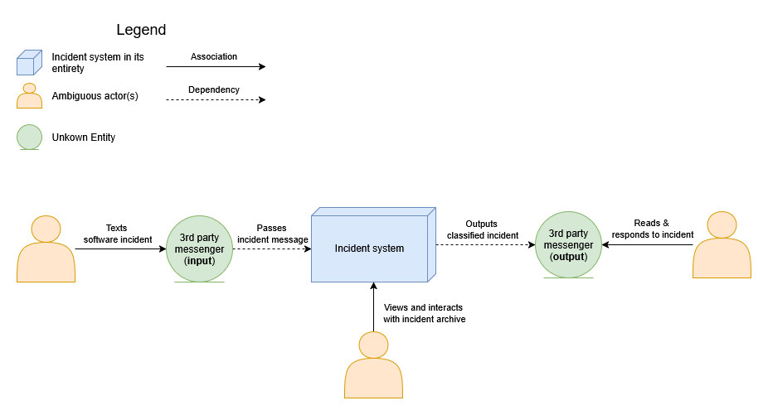
Below is a context diagram of the incident system with its interactions with external entities.

The 3 interactions:
- The user reports an incident which is received by the system like an event (it needs to act on it). The messaging is done through a 3rd party platform, such as Slack, WhatsApp or Email.
- An Innovactions developer receives the incoming incident, which has been classified by the incident system. They can now act on the incident if needed.
- An Innovactions stakeholder queries the API of the incident system to view and interact with the incident archive, think of checking the latest incidents, open/closed in progress incidents etc. This is not done through a dashboard as requested, instead we expose API endpoints.

Dynamic
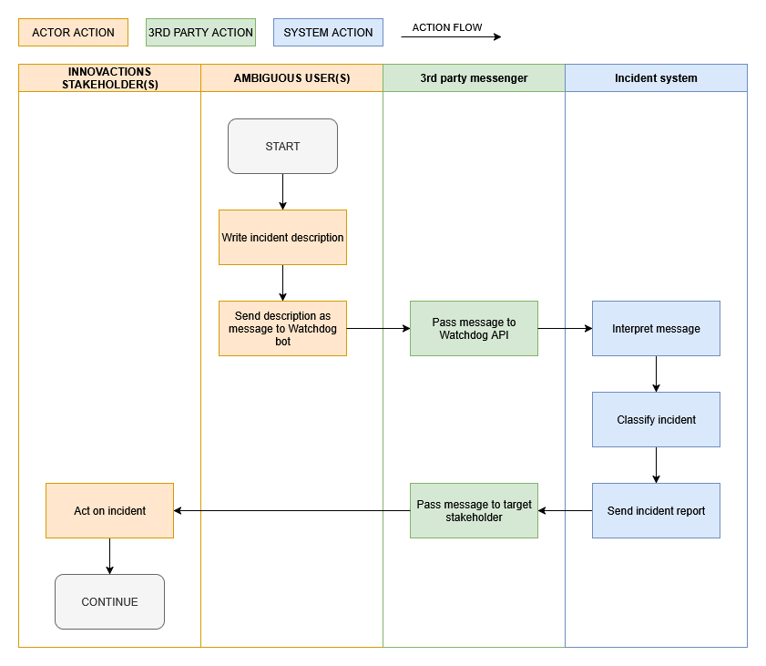
To explain the time-based action flow, we will make use of a swimlane diagram. Here we focus on the synchronous nature of the actions taken to go from one user interaction to the other and showcase what happens in between, abstract.

Notes:
- The user is required to give a proper description of the incident.
- The user can only send incidents to the system through provided bots or addresses. See project scope.
- The way the message is to be interpreted is up in the air. We could use a language model, or we could parse the literal text. Since there are different implementations to this, most ideally it should be a modular component, where we can freely change the implementation easily.
- The classification and interpretation of the message are separate here but can also be combined depending on the implementation. When a decision is made it should be documented why, and if there are drawbacks to them being combined.
- Incident report sending is for now planned to be on Slack only, but it is important to architect the system in such a way that this can be changed, or sending can be done to multiple platforms.

Artifacts
- Backend docker image – one of the requirements will be to run the system on docker. As such we will provide an image for Innovactions to run the Java system.
- Database docker image and volume – as we need to save an archive of incidents, we will make use of a database, which will work based on an image and a volume to safe data permanently.
- Log files – to keep track of the workings of the system, besides console logging we will also do file logging so we can easily look back at system runs. The way we will save them in the docker environment is to be determined.
- Optional docker compose file – As we will most likely have multiple images we could create a docker compose file to orchestrate the different images.

Logical
Now that we have explained the conceptual level, we understand ‘what’ the incident system is. Now we need to determine ‘how’ the incident system will undertake the set requirements.
In the logical view we zoom into the black box and determine the architecture and main components of the system.

Architecture style
Before we start architecting the incident system, we must consider which architecture style to follow. We will first rationalize the chosen architecture style and then also look at other considered architecture styles, why they were a consideration, and why we didn’t go for them.

Chosen: Hexagonal architecture
Theory reference: https://en.wikipedia.org/wiki/Hexagonal_architecture_(software). Please read to get a basic understanding.
Hexagonal architecture is often called one of the core styles associated with microservices. The idea behind hexagonal architecture is that you decouple business logic from incoming and outgoing external services. This enables you to receive messages from any system and send them to any system. Below is a diagram to visualize it.
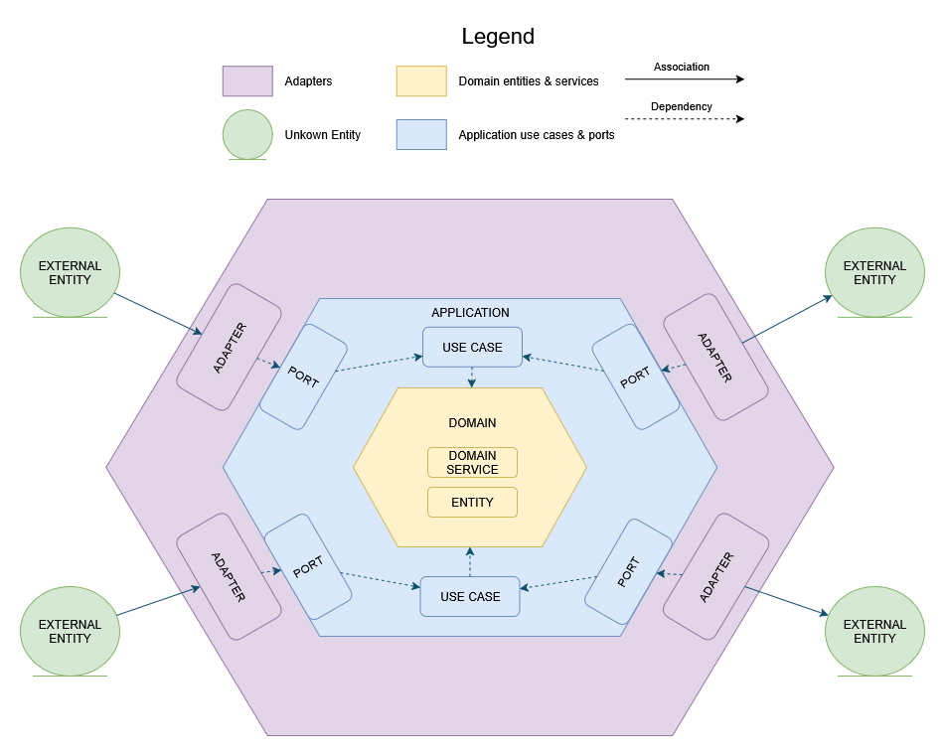
The main part of the hexagonal architecture is the adapters and ports which come perfectly in line with the requirements of the incident system. The system requires adaptability to external systems, being able to take incoming messages from different messaging providers. As currently the outgoing messages are only going to Slack, we can keep the outgoing part simple. But you also need to consider the outgoing logging, persistence and future extension to other ticketing systems as mentioned by the product owner.
As the project grows and more adapters will be needed, as developers we will only need to add or change adapters while making use of existing domain logic, which stays unchanged. This architecture style is modular and extensible and is known as a building block of the micro services architecture style.

Not chosen: Micro-kernel architecture
Theory reference: https://blackberry.qnx.com/en/ultimate-guides/what-is-real-time-operating-system/microkernel-architecture
The microkernel pattern is designed for platforms where the core runtime is minimal and almost all functionality is delivered as dynamic plug-ins that the kernel loads, manages, and isolates.
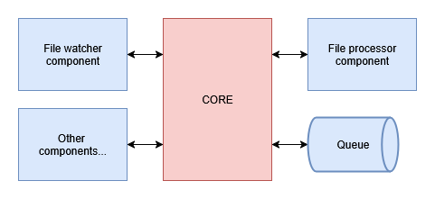
It excels in environments such as operating systems, IDEs, and other extensible platforms, where new modules must be installed, updated, or removed at runtime without redeploying the whole system.

Our incident-management application does not have these requirements. Its core use cases, processing incoming incidents, applying business rules, and sending notifications, are well defined and do not require runtime plug-in loading or live hot swapping of functionality.
While modularity is important, it can be achieved more simply through well-structured services and clearly defined interfaces. Introducing a microkernel would add unnecessary complexity (kernel–plugin lifecycle management, inter-plugin messaging, dynamic discovery) without providing tangible benefits for our context.

Future consideration: Event-driven architecture / pattern
Theory reference: https://en.wikipedia.org/wiki/Event-driven_architecture
Event-driven design is about reacting to and propagating events, domain events, system events, or user actions, via messaging infrastructure (Kafka, RabbitMQ, SNS/SQS).
Components communicate asynchronously by publishing and subscribing to events, which improves scalability and decoupling and is a natural fit for high-volume, loosely coupled systems.
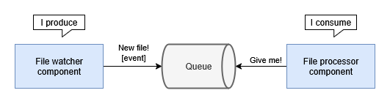
While the incident-management system might eventually benefit from this approach (for example, emitting domain events when an incident is created or resolved so that analytics, auditing, or external integrations can subscribe), our current requirements are simple, a limited set of known inputs (incident reports), a single outbound integration (Slack), no need yet for independent event consumers or eventual consistency.
Because of this, adopting a full event-driven architecture would introduce additional complexity (message brokers, event schema management, consumer groups) without immediate gain.
However, it remains a strong candidate for future evolution.
If the system later needs to fan out events to multiple ticketing systems, analytics services, or other microservices, the existing hexagonal design will allow us to add messaging adapters and event publication without reworking the core domain logic.

Static
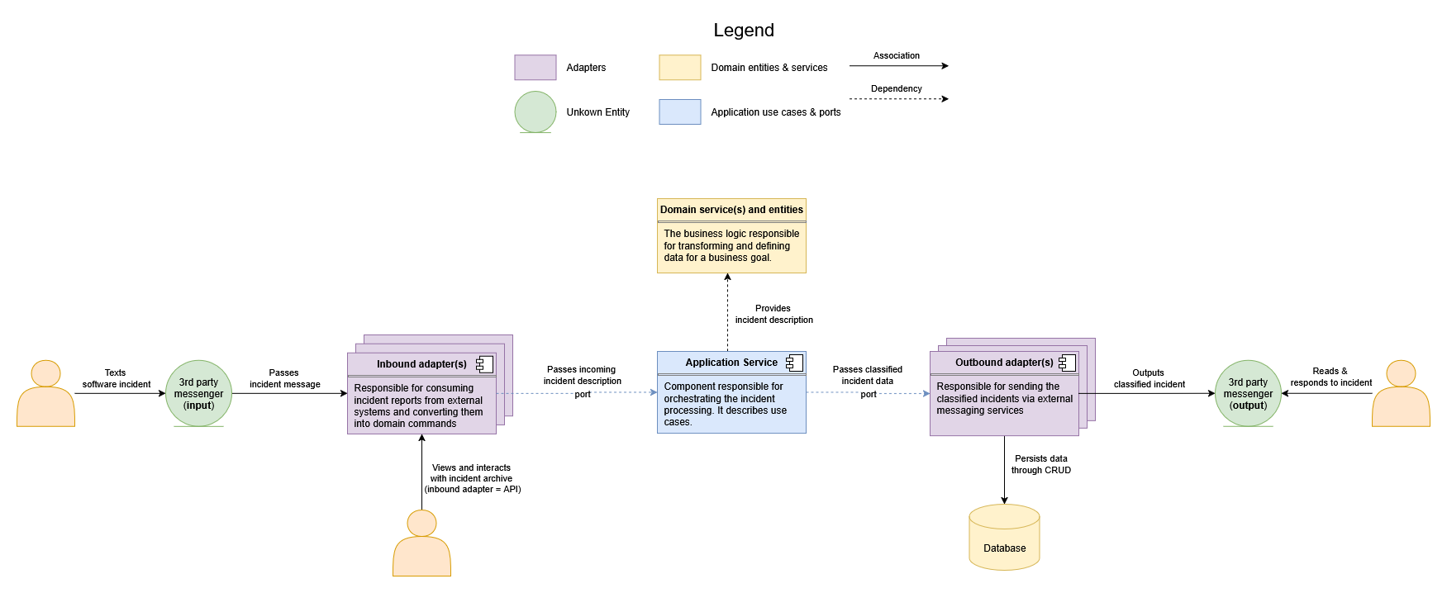
For the static view we are looking at what components the system consists of. Partially introduced already in the hexagonal architecture diagram, we are looking at how we apply the hexagonal components in the context of the incident system.

Notes:
- The main flow goes from left to right where we have an incoming incident that is adapted to the system requirements in the form of a command, given to the application service which orchestrates a use case, in this case the processing and classification of an incident, once done it is given to be adapted for outbound messaging through 3rd party systems.
- Additionally, we are required to have an incident archive, in the form of a local database.
- The database will save incidents through an outgoing adapter as the hexagonal architecture requires, and to access the database a user will be able to talk to an API which will be an inbound adapter.
- The domain entities are not aware of any other component because of the inward dependency structure. This means if changes are made in other components, the domain layer will never need to change, which is a good example of extensibility.

Dynamic
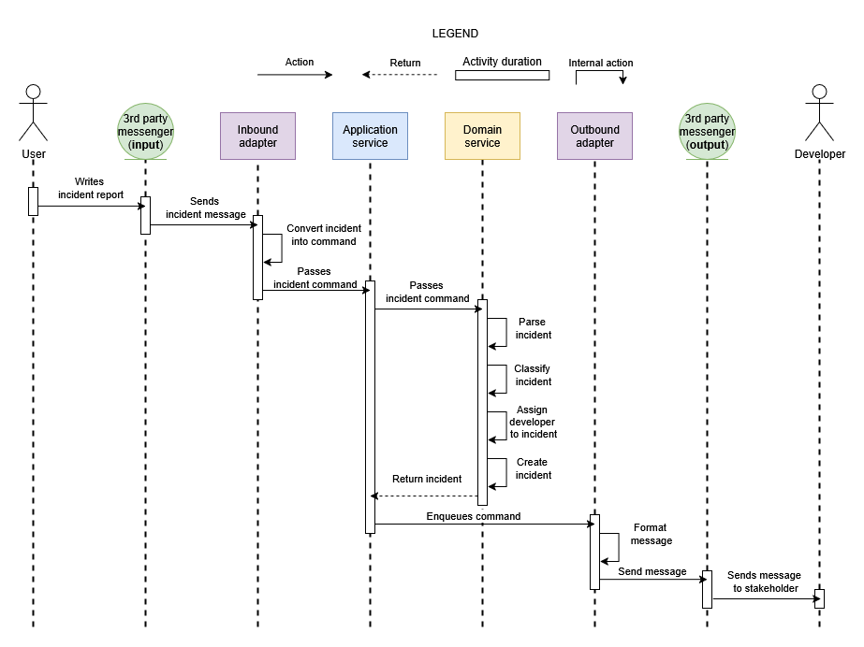
For the dynamic view we are looking to add time to the equation, to get a better idea of data flow and specific interactions. Below you see a sequence diagram.

Notes:
- This is a sequence of the simplest version of the incident system. Here you see that the domain service takes care of all the logic, such as the classification and assigning of employees. In the future a consideration will be AI driven classification, which means that the application service will orchestrate a flow of, pass incident to ai > ai classifies > returns classification > etc. This will require an outbound adapter, which would make this view more complex. But for the most basic use-case this gives a fine explanation of the data through our hexagonal architecture.
- It is important to note that there are multiple inbound and outbound adapters. While multiple inbound adapters means we can take in messages from different systems generically, multiple outbound adapters can be used in the same use case, for example saving data to the database and sending a report to slack.

Conclusion
While there are many differing architecture styles that could be applied, specifically in the context of modularity, the hexagonal architecture stands out as the most extensible architecture for the specific problem with are facing with Innovactions.
Since the beginning Innovations have stated that they are unsure of how they want to extend the platform, but all they know is that they will. This future oriented requirement slashes many design patterns from the get-go as they would be too opinionated, and require excessive resources in maintenance, e.g. man hours or cloud space.
With its’ ‘plug and play’ design hexagonal architecture promotes creating clearly defined business logic, that can then be reused infinitely by any new platform integration through adapters.
This decision does not just accomplish the requirement given by Innovactions, but even goes beyond and ensures a great developer experience maintaining it.

How to extend the system
In this last paragraph I will be talking a bit more about how to extend the system, with our chosen architecture. I will be keeping pictures and links to a minimum and mostly try to refer to knowledge from the rest of this document. This is a simple text guide to understand how to find code and extend it.

Way of thinking
The first thing I want engineers to know and remember as they implement is that hexagonal architecture is part of the ‘inside to outside’ family of architectures, which does not only mean that you implement this way, but also think this way.
Fundamentally this simply means that layers inside don’t depend on outside layers, instead outside layers make use of inside layers through ports (dependency injection).
Please see the image in ‘Chosen: Hexagonal architecture’, as a reference whenever I talk about layers, dependencies etc., as it makes it easier to visualize.

The core – domain layer
The part of the application everyone wants from the outside, and you ensure it is abstracted away from. I don’t need to explain what domain knowledge is, but what I do need to mention is that according to the hexagonal architecture, the only one allowed access to the domain is the application layer. This means that adapters are ABSOLUTELY NOT allowed to touch it. There are rare times where you can ignore this, but please don’t try to do this.
The domain is simply your business logic, that stays within the 6 walls of your backend (hexagon joke, please laugh).
Example: You need to add complex logic regarding the manipulation of incidents. When an incident comes in you want it to go through this new function, before it goes out of the backend. As a developer, in the project files, you go to the domain folder, you create the new function as a service in the service folder. If you need to create models, put them in the models folder.

The orchestrator – application layer
Now that we have our domain to manipulate data however, we like, someone needs to call the domain, which is the SOLE responsibility of the application layer. Here you define services, which must be thin. So do not put heavy logic in here, as the name of the paragraph suggests, the application services are merely orchestrators. They delegate work and know who needs to do what, but don’t do things themselves, compare them to nosy micro-managers.
But the application services don’t just call to the domain, there are also times you need external help to a task, like for example in this project we use AI to determine incident severities, this is also orchestrated by the application service.
But now how is this done cleanly programmatically? Glad I you asked. While you can comfortably call to domain services directly, the same does not go for adapters, as they are the outside layer, and remember in this architecture the outside layer depends on the inside layer, not the other way around. We solve this by using dependency inversion. Ports (interfaces) are owned by the application layer and are merely implemented by adapters. It is important to note that there are inbound and outbound ports/adapters, but we will touch on that in the next chapter.
Lastly, incoming data is seen by the application layer as a ‘command’. As the name describes, when an incident comes in, it is a command for the application service to create an incident out of it, thus you will have the CreateIncidentCommand object. The data passed from the outside to the application layer is EXCLUSIVELY in the form of commands. You can think of commands as DTO’s (data transfer object), which might be more familiar to most.
Example: You are given the task of implementing a new use-case into the backend. Let’s say this system grows to also ingest feature requests, not just incidents triage. What you now do as a developer is, in the project, you go to the application folder, where you can make a new service class. Create a port that this application service implements. Create a command object encapsulating all data you would need in your application service. You can make multiple commands per application service of course, as you might have a CreateRequestCommand and DeleteRequestCommand. Once this is set, you start creating the service methods. Remember! The application service is a thin class, so we do not add business logic to it, this goes into the domain or outbound adapters if its external.

The connector – adapter layer
The last layer is the one that connects the system to the outside world. Simply put you have 2 types of adapters, inbound and outbound.
As the name suggest they are one-directional, with the inbound adapters only being allowed to make simple replies, but not actual side effects. What I mean with this, a slack inbound adapter is allowed, even required, to send back an acknowledgement back for incoming messages. Another good example would be web status codes, or rest endpoint replies. What they are not allowed to do is create side effects, for example when a new incident comes in, an inbound adapter is not allowed to send a message to whatsapp, or save things to the database, all of this needs to first go through the inner layers, the application layer.
An inbound adapter ingests data, and maps it to your given command, then sends it over the port that the application service implements. It is a literal adapter to make incoming data generic, no matter which platform it is from with their formatting quirks. That is it, this is all an inbound adapters needs to and should do, don’t load it with business logic and try to not call other adapters from it, go to the application layer first.
We also have outbound adapters, these get called as a result for the need of side effects, such as database calls, querying developer availability from the company calendar, etc. As I explained before outbound ports are owned by the application layer, the outbound adapters simply implement them, and get used through application services.
Inbound example: Innovactions wants to also get messages in through Instagram dm’s. The nice thing is that incident reporting is a feature already done, meaning the Instagram adapter will simply make use of the existing createIncident function in the existing IncidentApplicationService. You as a developer now need to implement a new, InstagramInboundPort, under the adapter and inbound folders. You figure out how the incoming data format looks, and create a mapper to map said data to the existing CreateIncidentCommand, used by the IncidentApplicationService. Once the data is mapped and you took care of the potential message acknowledgments to Instagram, your inbound adapter is done!
Outbound example: Innovactions does not make use of Gemini, but instead Claude, so they want to move away from the current Gemini incident classifier. As a developer you will now need to create the new ClaudeClassifierOutboundAdapter (or however you would call it), under the adapters and outbound folders. You first ensure you have the data you would need from the application service, and use it as your parameter for the method. You do your implementation and provide a return value for the application service. That’s all, you got an outbound adapter! There are times where you might not have resulting data, in those cases it can of course be a void method, this example just illustrates a potential future action.

End word
I believe the subject of the used architecture has been explained enough for the Innovactions engineers to be able to navigate their way through the project files and start extending it. In case something does not seem clear, there are tons of resources online about this architecture style as its one of the most popular ones used in the micro-services world.

