|  |
| --- |
| Adaptive Robotics minor |
| Hardware Abstraction & Embedded Systems |
|  |

|  |
| --- |
| 28-6-2022 |
|  |

Name: Student number:

Toby van Dueren den Hollander 3679438

Quinvey Etienne 3566293

# Introduction

The Riley is a collaboration project between TMC and Fontys. TMC has approached Fontys with the goal of making their robot platform smarter with the use of additional sensor and logic. These improvements should make it possible to do autonomous reconnaissance of a building.

Because of IP related problems the platform itself could not be obtained from TMC. Therefore a mockup of the platform was made during the first months of the project. The dimensions and general shape of the mockup was modeled in a way to represent the original robot as accurate as possible.

In order to aid human and autonomous operations a few extra functions have to be added to improve control of the RILey robot platform.

# Problem Definition

During operation of the platform a few problems came up regarding movement and perception of the robot in its environment.

### Flipping

The first problem regards accelerating in backwards direction. The robot was initially designed to only drive forward. Accelerating backwards too quickly will result in a rotation flipping the robot as seen in the image below.

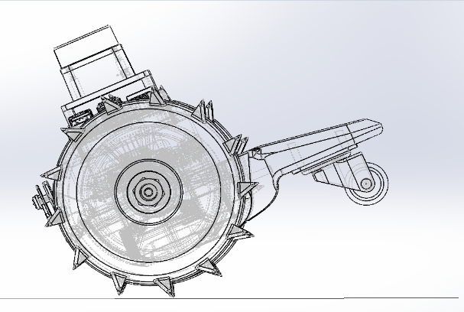

ω_rot

A_accel

Figure 1 Robot rotating

### colliding

Secondly, the lidar is able to visualize the surrounding of the robot. However, when objects are below the height of the lidar, the robot will not be able to detect the obstruction. This results in the robot bumping into smaller objects as seen below.

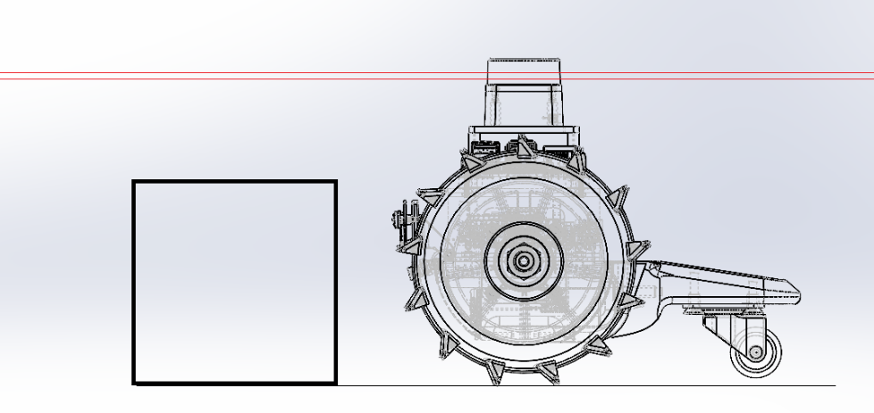

Figure 2 Robot just before hitting object

### Falling

Lastly the robot is not able to detect the presence of gaps, holes or other height differences in terrain. This can result in the robot falling of surfaces such as stairs.

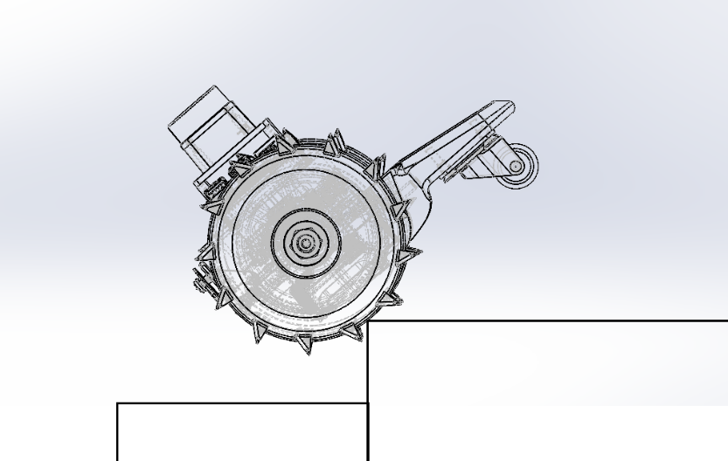

Figure 3 Robot falling of edge

# Solution of the problems

To provide a solution for the problems described above additional sensors are added to the robot. These include the MPU9250 and the VL53L1X. The MPU9250 contains a 3 axis gyroscope. This gyroscope can sense changes in the angular orientation of the robot. This can help preventing the robot from flipping. The VL53L1X Time of Flight sensor can measure distance by using infrared light. This sensor was used to prevent the robot hitting objects or driving into gaps.

Figure 4 MPU9250 (left) and VL53L1X (right)

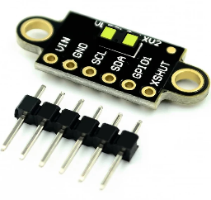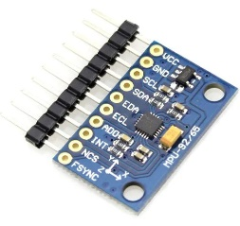

To prevent the robot from hitting a object the measured distance from the sensor cannot be less then a predefined threshold value. If this threshold value is reached, this means that there is a object on the robots track.

If the distance exceeds the threshold value corresponding to a gap value the robot will detect a gap.

In both cases the robot should reverse so that it can easily turn away without hitting the object, or falling into the gap. The descision making is done on the raspberry pi itself. It overwrites input from both the user and/of the autonomous control.

Figure 5 Robot detecting gap

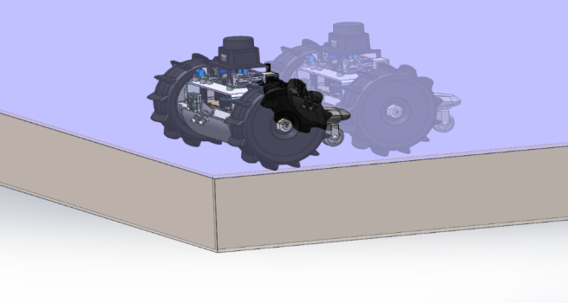

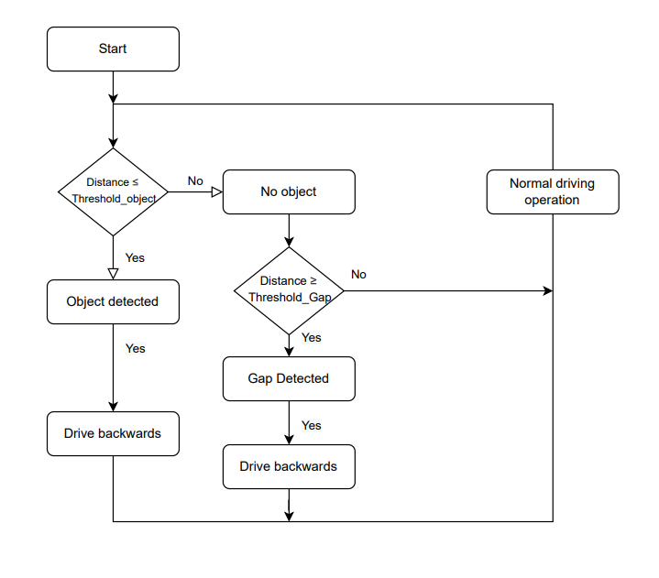

Figure 6 Logic illustrated in a flow chart