AS3 Transition Components (based on AS3 Transition Library v. 2.4.0)

Author: Nikos M.
License: Free
Web: http://nikos-web-development.netai.net
e-mail: nikosms0@gmail.com

Note: This software is provided AS IS no warranty is given as to the functionality or purpose of this software.

Documentation
The transition components are implemented on Actionscript 3.0 and are compatible with Flash CS3/CS4/CS5.
The layout and use of the transition components is similar to the flash-filter.net components. If you have ever used the flash-filter components then you will have no trouble using the transition components. The difference is that the transition components are free and have many different transition effects.

Installation
Just double-click on the supplied file with the extension .mxp. This will open the Adobe Extension Manager which will ask you to accept the default settings for extensions. Click “yes”. The components are now installed. You must restart Flash in order for the changes to take place.
If you have any problem, uninstall and re-install again. If the problem persists feel free to contact me.

Use
In this example I will show you how to use the transition components in the Flash IDE to create image transitions.

Step 1.
Open Flash.
Create a new Actionscript 3 Flash File from File>New.. menu

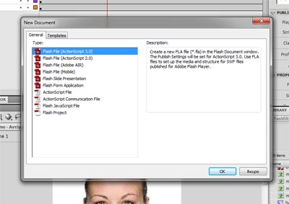
Step 2.
Import your images to the Library from File>Import..>Import to Library menu
In this example I will use 2 images.

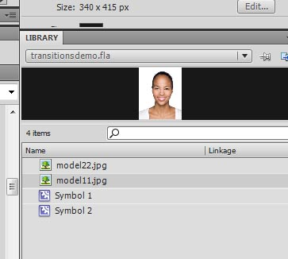

Drag your images to the stage one by one and convert them to movie clip symbols
by pressing F8 key.

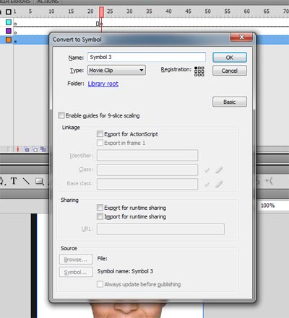
Make sure the registration point is top left.

Step 3.
Create 3 Layers in the timeline and name them “1”,”2” and ”fx” one on top of the other like shown in the picture below.

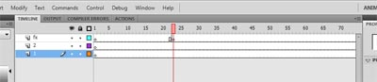

Set the length of the layers to 245 frames, this will be the duration of the movie. You can set this to whatever you like but for this example I will set the duration of the whole movie to 245 frames. Note that the movie framerate is set to 30 FPS. So the movie will last about 8 seconds.
Drag the movieclip of the image that you want to appear last on layer 1 first frame.
Drag the movieclip of the image that you want to appear first to layer 2 first frame.
Name the movie clip instances by selecting them one-by-one and typing an instance name in the Properties Panel in order to use them for the effect as shown below.

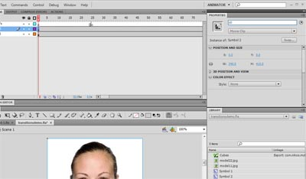
In this example I named the first movie clip instance s0 and the other s1.
Make sure the 2 movie clips are aligned in the same way on stage. Or align them one by one by opening the align window and selecting each one, align them on stage.

Step 4.
Open the components panel if it is not open by Window>Components menu
This will show a folder named nikos-components open the folder by clicking on it.

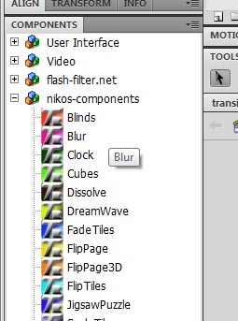

In this example I will use the Cubes Component. On layer fx insert a new keyframe on frame 25.
This is just for the fx to start after the first image has shown for a while. Click on keyframe 25 on layer fx and drag the cubes component onto the movieclip that you want to start with. This will add the Cubes Component to the Library and also show it on stage.

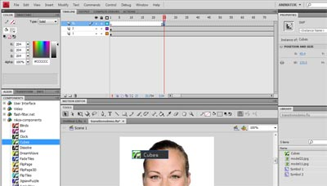
If the Component Inspector is not open open it through Window>Component Inspector menu

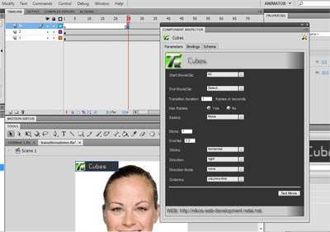
Resize the component inspector panel if needed in order to show the full panel screen.

Step 5.
You see that the Start Movie Clip parameter is set to s0 movie clip instance and that the Cubes Component is aligned to the s0 image movie clip.
Each transition Effect has some parameters in common. These are :
Start MovieClip : The movieclip instance at the start of the effect
End MovieClip : The movieclip instance at the end of the effect
Transition Duration : Duration of the effect in seconds or frames
Use Frames: Whether the duration signifies frames or seconds
Easing: An easing Function to apply to the transition effect.

Also each effect has its own parameters which you can see in the manual of the Transition Library which should accompany this document. For the cubes effect these are the Slices number, the ordering, the overlap, the direction and the direction_mode. See the Transition Library Manual under Cubes Effect to see what these parameters are for.

Select the End Movie Clip for the list shown, for this example the end movie clip is s1 (the other movieclip instance). Set the Transition Duration to 1 and UseFrames to No. This means that the duration for the effect is 1 second. Leave easing to None.
Set slices to 3 and overlap to 0.9. Leave the other parameters to their default values.
Hit Test Movie Button to test your movie and you're done. That's it.

Important Notes
Note1
The transition effects are optimized but the 3D effects will add about 100KB to your exported movie size.
Note2
The effect duration type (ie. frames or seconds) is the same for all effects of the same type even though in the inspector panel the values may be different. This is due to the implementation of the Transition Library. This means that if you have 2 instances of say the Blur Effect and you have set use frames to one and use seconds to the other, if run at the same time they will both use either frames or seconds.
Note3
if you have a fla file which includes many effects and you have problem compiling this is due to Flash having little memory heap to parse large chunks of code (as are the multiple effects). The solution for this would be to quit Flash and set an environment variable with the name JAVA_TOOL_OPTIONS and value -Xmx512M for increasing the size to 512. You should experiment with various values to find the one which allows flash to compile and does not produce problems as Flash will some times say that the Java Runtime cannot be initialized. If this happens quit Flash change the value and try compiling a simple fla file first before compiling the fla which produces the problem.
Note4
if you want to use the transitions in code, then you should use the AS3 Transition Library instead of the components. See the manual of the Transition Library for instructions.

