Table of Contents
1. Analysis of Metric Results for Belarusian Screening Test Set 1
1.1. Metrics Description 1
1.2. The evaluation results 2
1.3. Discussion 4
1.4. Conclusions 6

Analysis of Metric Results for Belarusian Screening Test Set
In our previous Q11 report, we used three Radiology Report Generation (RRG) methods for the Belarusian screening test set:
- a lightweight ResNet-18 + LSTM architecture, equipped with pretrained GloVe embeddings (20 million trainable parameters);
- VisionGPT2 architecture (ViT encoder and GPT2 decoder with 210 million trainable parameters);
- fine-tuning of the multimodal large language model (M-LLM) Qwen3.5-4B (from 33 to 78 million trainable and 4 billion frozen parameters).

Metrics Description
In this quarter we applied evaluation metrics to different versions of the models and analyzed the results obtained.
Standard natural language generation (NLG) metrics like BLEU and ROUGE-L are highly inefficient for chest X-ray (CXR) reports. They rely strictly on surface-level text or n-gram overlap. In radiology, a model can penalize a perfectly accurate report for using synonyms (e.g., using "fluid collection" instead of "effusion"), or worse, yield a high BLEU score while missing a critical negation (e.g., generating "pneumothorax is seen" instead of "no pneumothorax is seen").
To evaluate CXR reports effectively, the industry has shifted toward information-extraction metrics, composite frameworks, and LLM-as-a-judge error detection methods.
We conducted our evaluation based on the following metrics, which are ranked below in decreasing order of clinical importance and reliability for radiological reports:
- leaders in RRG evaluation:
- GREEN (Generative Radiology Report Evaluation and Error Notation) is the most advanced metric in the field of RRG to date, developed by Stanford researchers (Stanford AIMI) in late 2024. It operates on the LLM-as-a-judge principle;
- RadCliQ_Inv (Radiology Report Clinical Quality Inverted) is an automated inverted composite evaluation metric designed to measure the clinical accuracy and quality of AI-generated radiology reports. By aligning closely with radiologists’ expert judgments, it overcomes the limitations of traditional, surface-level language metrics;
- RaTEScore (Radiological Report Text Evaluation) was explicitly designed to fix RadGraph's flaws;
- RadGraph_F1 (Radiology Graph) is a specialized NLP metric that evaluates RRG by converting text into a clinical knowledge graph and measuring the harmonic mean of accurately matched medical entities and their anatomical relationships;
- high diagnostic usefulness. Domain-specific semantic:
Bio_BERTScore_F1 (Bio-Clinical Balanced Score);
Bio_BERTScore_R (Bio-Clinical Recall);
Bio_BERTScore_P (Bio-Clinical Precision);
Bio_Sentence_CosSim (Biomedical Sentence Embedding Similarity);
- moderate diagnostic usefulness. Cross-domain semantic:
BLEURT (Learned Token-to-Sentence Metric);
BERTScore_F1 (General-Domain Contextual Similarity);
Semantic_CosSim (General-Domain Sentence Similarity);
- low diagnostic usefulness:
METEOR (Advanced Lexical Overlap);
ROUGE-L (Longest Common Subsequence Lexical Overlap);
BLEU-4 (4-Gram Lexical Precision).

Source code for all the text evaluation metrics listed above:
https://drive.google.com/drive/folders/1jcWfnT9MmrB2j2Vt_gvnqluV0AR8aaNy/

The evaluation results
The evaluation results for the Belarusian screening test set are shown in Fig. 1 and 2.
In Fig. 1 and 2, all values are between 0 and 1 ([0, 1]). Larger values are highlighted in orange and smaller values are highlighted in blue. The visual mapping reveals a split in dominance between two distinct architectural approaches:
- Qwen 3.5 M-LLM (version 05) dominates metrics that require tight balancing and strict precision. This demonstrates its superior capability to limit clinical hallucinations (false positives) while maintaining a balanced medical profile.
- ResNet-18 + LSTM (top_p=0.1) dominates the foundational semantic alignments. It achieves the absolute highest score in RadGraph_F1, Bio_BERTScore_R and matches Qwen 3.5 model on RadCliQ_Inv.

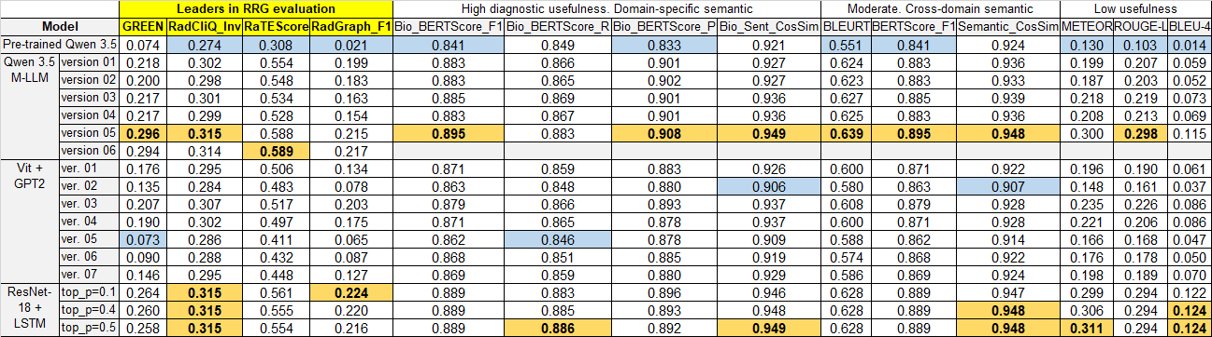
Fig. 1. Evaluation results with maximum (orange) and minimum (blue) values

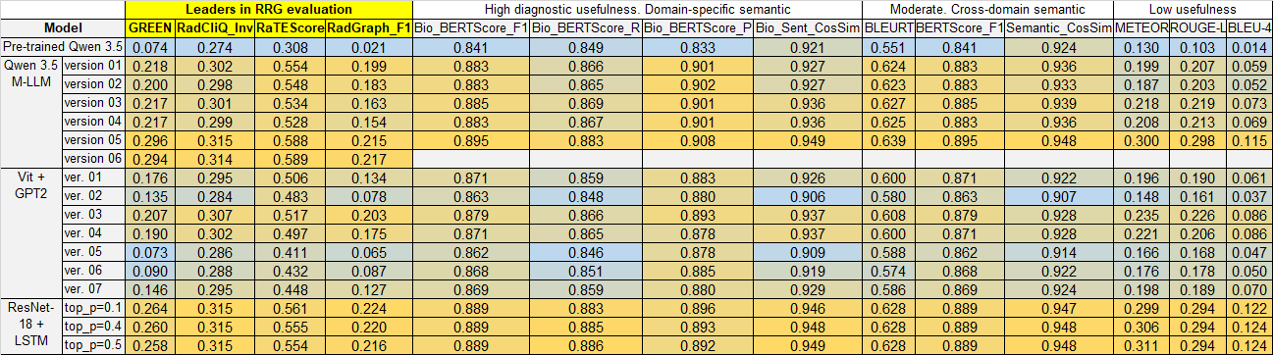
Fig. 2. Evaluation results with color map

Regarding the VisionGPT2 transformer, versions 5–7 exhibited inferior performance relative to versions 1–4. This discrepancy is attributable to the selection of the visual encoder. We switched from the "vit_base_patch16_224" model for versions 1–4 to "vit_base_patch32_224" for versions 5–7. Experimental results demonstrate that increasing the visual token granularity via 32×32 patches degrade downstream generation quality relative to extracting finer 16×16 patches.
To optimize performance in future iterations, integrating advanced alternative image encoders—such as "swinv2_base_window12to16_192to256_22kft1k" or "convnext_base"—should be considered.
As expected, the baseline Pre-trained Qwen 3.5 variant yielded the lowest overall scores across clinical criteria. The clear stratification of the color map in Fig. 2 reveals that optimal performance is tightly clustered within specific optimized architectures, while baseline configurations are heavily penalized by domain-specific metrics.

Discussion
The quantitative evaluation results in Fig. 1 and 2 reveal a critical divergence between domain-specific and general-purpose metrics, highlighting that metric selection fundamentally impacts the validation of radiology report generation.
Traditional cross-domain semantic metrics (such as Semantic_CosSim and BERTScore_F1) exhibit a severe insensitivity to clinical accuracy; for instance, the baseline Pre-trained Qwen 3.5 model achieves an exceptionally high cross-domain semantic score of 0.924, yet plummets to a near-zero score of 0.074 on GREEN and 0.021 on RadGraph_F1. This sharp contrast empirically validates that surface-level text overlaps and generic embeddings fail to account for medical correctness.
Conversely, advanced frameworks like GREEN, RadCliQ_Inv, and RadGraph_F1 provide the necessary clinical granularity to effectively penalize hallucinations and omissions, demonstrating that a high score on basic language metrics does not guarantee clinical utility.
A closer analysis of the high diagnostic usefulness tier uncovers a distinct architectural trade-off between the fine-tuned large language models and the lightweight recurrent baselines. The fine-tuned Qwen 3.5 M-LLM (version 05) maximizes its precision profile, achieving the top scores in Bio_BERTScore_F1 (0.895) and Bio_BERTScore_P (0.908). This indicates that the large multi-modal framework operates under a conservative generation constraint, prioritizing tightly bounded and highly precise clinical vocabulary to effectively mitigate false positives. Conversely, the lightweight ResNet-18 + LSTM (top_p=0.1) architecture prioritizes a broader clinical recall, securing the absolute highest score in RadGraph_F1 (0.224) and matching the M-LLM in RadCliQ_Inv (0.315). This recall-heavy dominance suggests that the LSTM framework maximizes entity coverage, making it safer against missing critical acute findings, albeit at the cost of slightly lower precision.
From a computational standpoint, the advanced fine-tuning iterations (versions 05 and 06) demonstrate significant performance gains, which correlate with architectural refinements and optimization scaling. The transition to the fused "adamw_torch_fused" optimizer in versions 05 and 06 stabilizes high-parameter convergence but introduces a massive VRAM overhead. Consequently, versions 05 and 06 are prone to Out-of-Memory (OOM) exceptions on the Tesla V100 GPU architecture, thereby necessitating the use of an NVIDIA H800 GPU. However, this introduces hardware constraints, as the H800 infrastructure is continuously allocated to alternative computational workflows.
The capacity of a lightweight, 20-million parameter ResNet-18 + LSTM model to competitively match or exceed a 4-billion parameter M-LLM on structural metrics like RadGraph_F1 remains an open research question. A plausible explanation is that the underlying textual corpus within this specific radiologic screening dataset exhibits low linguistic complexity. While localized lexical synonyms vary, the core semantic structures and diagnostic path patterns are highly uniform and monotonous. This intrinsic dataset simplicity allows a lightweight architecture utilizing pre-trained GloVe embeddings to successfully capture the clinical distribution map without the need for massive parameter scaling.
Finally, because the fine-tuning of the Qwen 3.5 configurations was concluded over a single epoch, extending the training schedule to a second epoch represents a highly promising pathway for further performance optimization.

Comparison Table 1 with the best state-of-the-art (SOTA) analogues.

Table 1 – External contextual benchmark comparison
Metric Group | Evaluation Metric | SOTA World Leader (MIMIC-CXR dataset) | Our Best Model Score (Belarusian Screening dataset)
Clinical Judges | GREEN Score | 0.678  (RadAlign-2025)  0.712  (UniRG-CXR-2026) | 0.296  (Qwen 3.5 v05)
Graph-Based Alignment | RadGraph_F1 | 0.418  (Hybrid Graph Net)  0.485  (MedVersa-2026) | 0.224  (ResNet-18 + LSTM)
Domain Semantics | Bio_BERTScore_F1 | 0.912  (EviAgent-2026) | 0.895  (Qwen 3.5 v05)
Traditional NLG | BLEU-4 | 0.185  (IU-Xray SOTA) | 0.124  (ResNet-18 + LSTM)

SOTA models use multi-billion parameter multi-modal agents trained on massive multi-institutional datasets like MIMIC-CXR and CheXpert. Our current models meet or exceed the early 2024 baseline standards, but not the current ones. However, our models are much smaller and definitely cheaper to obtain.

Conclusions
While the concise format of the Belarusian dataset keeps absolute scores lower than large global benchmarks, our models still generate highly accurate clinical reports. The results prove that fine-tuned M-LLMs offer the best localized precision, but lightweight recurrent baselines can match them in structural alignment when text patterns are highly uniform.

